Aggregate pipeline

169> db.orders.insertMany( [ { _id: 0, name: "Pepperoni", size: "small", price: 19, quantity: 10, date: ISODate( "2021-03-13" ) }, { _id: 1, name: "Pepperoni", size: "medium", price: 20, quantity: 20, date : ISODate( "2021-03-13" ) }, { _id: 2, name: "Pepperoni", size: "large", price: 21, quantity: 30, date : ISODate( "2021-03-17" ) }, { _id: 3, name: "Cheese", size: "small", price: 12, quantity: 15, date : ISODate( "2021-03-13" ) }, { _id: 4, name: "Cheese", size: "medium", price: 13, quantity:50, date : ISODate( "2022-01-21" ) }, { _id: 5, name: "Cheese", size: "large", price: 14, quantity: 10, date : ISODate( "2022-01-12" ) }, { _id: 6, name: "Vegan", size: "small", price: 17, quantity: 10, date : ISODate( "2021-01-12" ) }, { _id: 7, name: "Vegan", size: "medium", price: 18, quantity: 10, date : ISODate( "2021-01-13" ) }])
{
acknowledged: true,
insertedIds: { '0': 0, '1': 1, '2': 2, '3': 3, '4': 4, '5': 5, '6': 6, '7': 7 }
}
169> db.orders.aggregate([{$match:{size:"small"}},{$group:{_id:"$name",total:{$sum:"$quantity"}}}])
[
{ _id: 'Pepperoni', total: 10 },
{ _id: 'Cheese', total: 15 },
{ _id: 'Vegan', total: 10 }
]
169> db.orders.aggregate([{$match:{"date": { $gte: new ISODate( "2020-01-30" ), $lt: new ISODate( "2022-01-30" )}}},
... {
..... $group:
..... {
....... _id: { $dateToString: { format: "%Y-%m-%d", date: "$date" } },
....... totalOrderValue: { $sum: { $multiply: [ "$price", "$quantity" ] } },
....... averageOrderQuantity: { $avg: "$quantity" }
....... }
..... },
... {
..... $sort: { totalOrderValue: -1 }
..... }
... ] )
[
{ _id: '2021-03-13', totalOrderValue: 770, averageOrderQuantity: 15 },
{ _id: '2022-01-21', totalOrderValue: 650, averageOrderQuantity: 50 },
{ _id: '2021-03-17', totalOrderValue: 630, averageOrderQuantity: 30 },
{ _id: '2021-01-13', totalOrderValue: 180, averageOrderQuantity: 10 },
{ _id: '2021-01-12', totalOrderValue: 170, averageOrderQuantity: 10 },
{ _id: '2022-01-12', totalOrderValue: 140, averageOrderQuantity: 10 }]

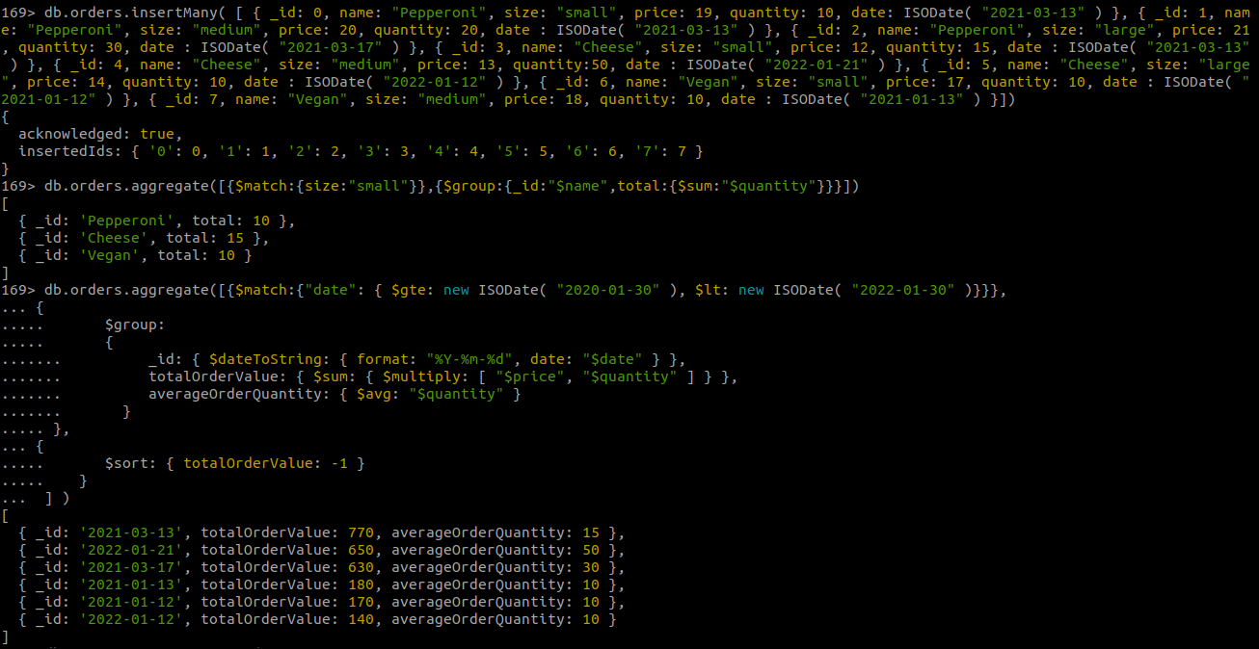

MapReduce
169> var map=function(){emit(this.sec,this.marks)};

169> var reduce=function(sec,marks){return Array.sum(marks);};

169> db.mycollection.mapReduce(map,reduce,{out :"mycollection"});
{ result: 'mycollection', ok: 1 }
169> db.mycollection.find({})
[
{ _id: 'B', value: 193 },
{ _id: 'C', value: 85 },
{ _id: 'A', value: 170 }
]
