Sushma Hegde
1NT19IS169
C2 BATCH
26-05-2022

1.Create a directory named by your name

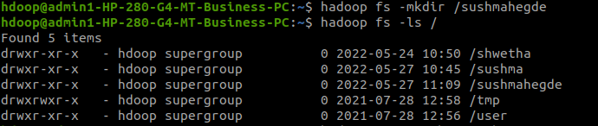
2. Add two empty files into it

3. List all the files in the directory that you have created

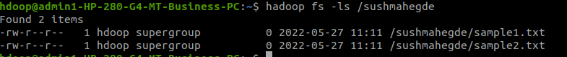
4 Create one more directory by your usn and put that inside the directory of your name

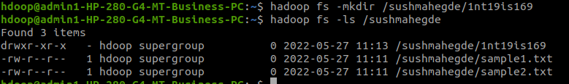
►Put the file usn_name.txt in your hdfs directory called usn

Experiment with cp command:

►Use my command to move files from local file system and hdfs file system

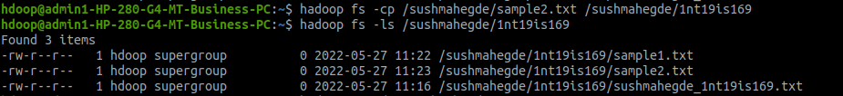
Put empty file of hdfs into the local file system

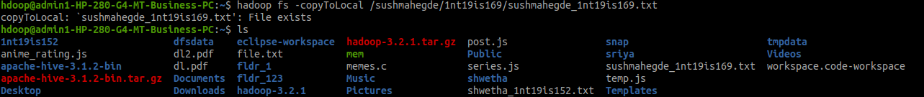
► Display the total size of all the files in name directory
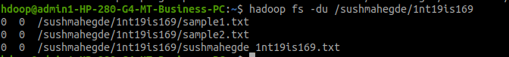
Create a file in your local system by the name_usn.txt and add the contents as
"Syntax to list Is command is hadoop fs -Is "

