#### Power Bi project-Exhaustive analysis of indian

#### Agriculture section using Power Bi

* **First I am install Power Bi desktop app in microsoft store app .**
* **Then I download “ Exhaustive analysis of Indian agriculture section” from whatsapp group .**
* **Then i downoad the given data set .**
* **Then I add it on my power Bi desktop as:**
* **Open power bi app and click on blank report**
* 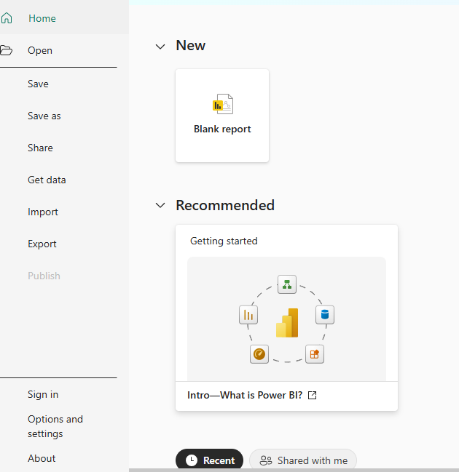
* **Then the blank file is opened like this :**

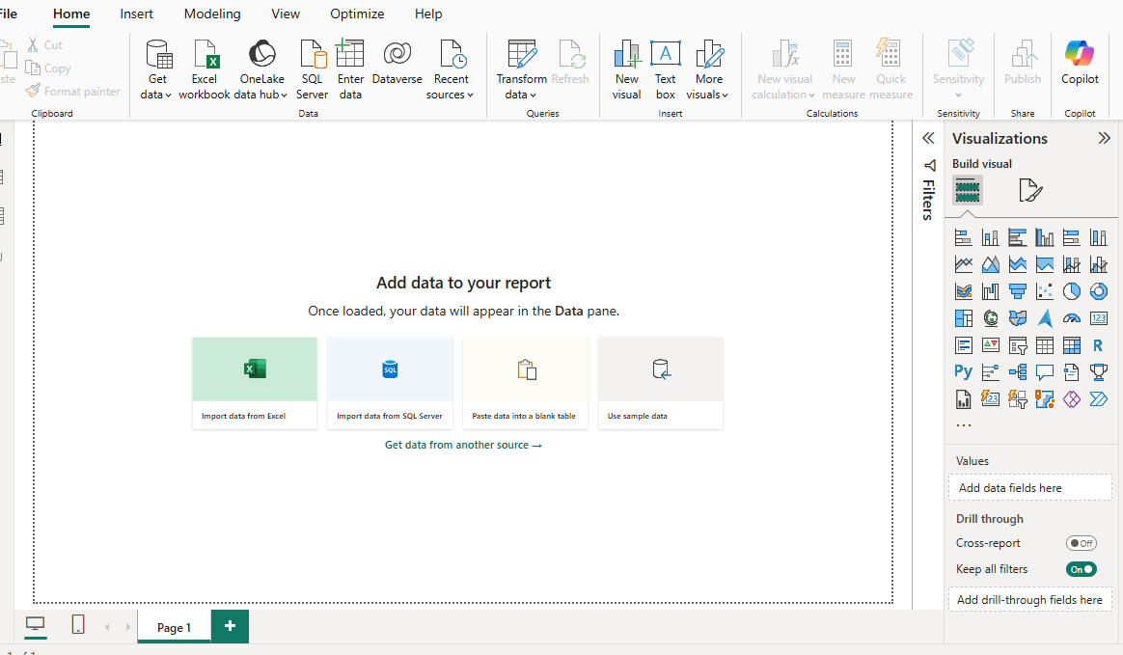

* Then click on the Get Data in the above column . Then we have get some common sources .
* Then click on the Text/CSV Option .Then select the data set on file explorer
* Then we get like this :
* 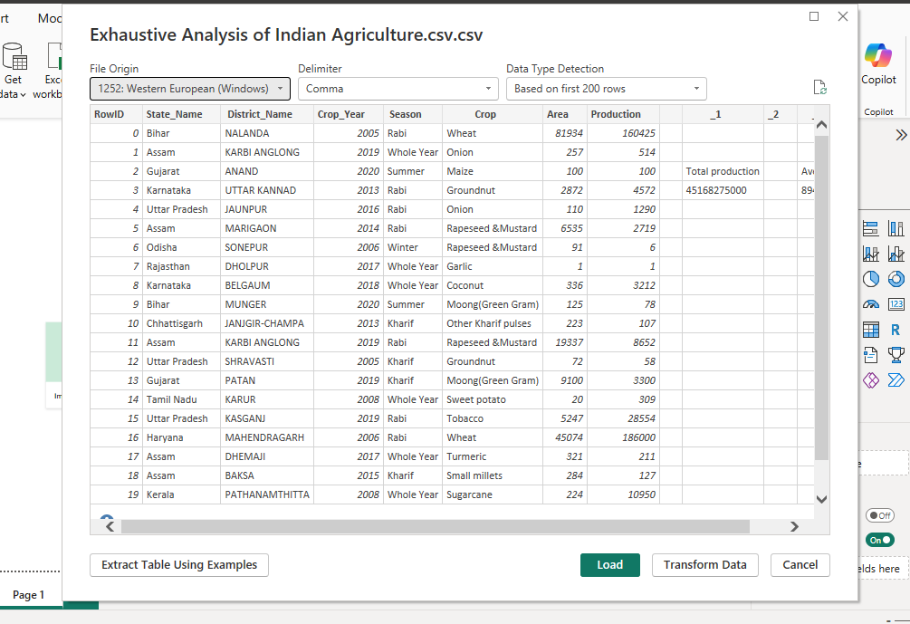
* Then click on the Load button ,then get like this :

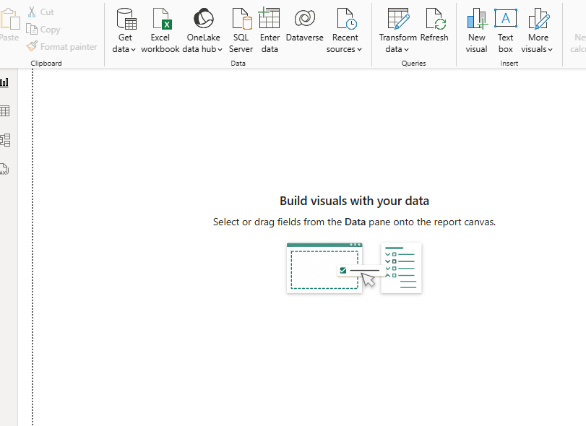

In Report view we get Visualization and in table view we can seethe actual data .

And then we remove the empty rows in the data set and model view for creating relationship among data

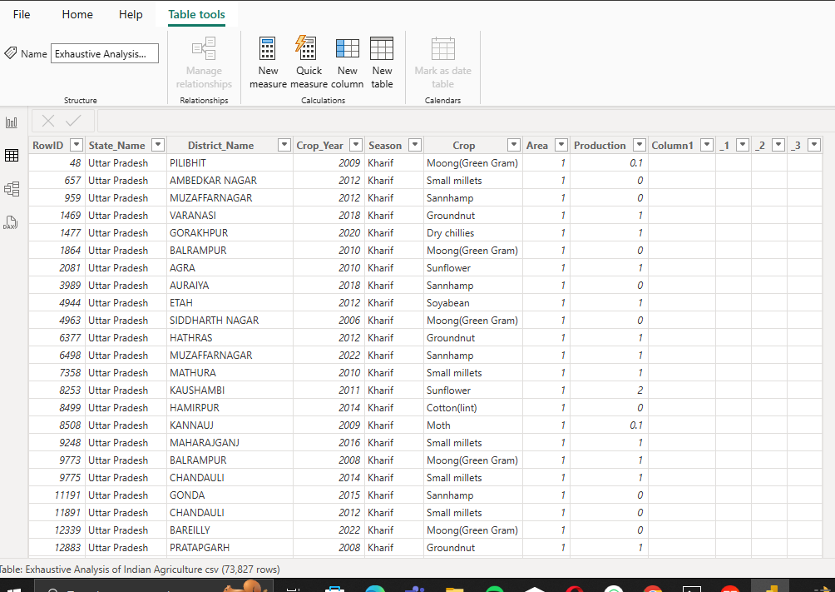

* So,now we can see how to transform data in this data set . For this we can click on Home in top left(second option)

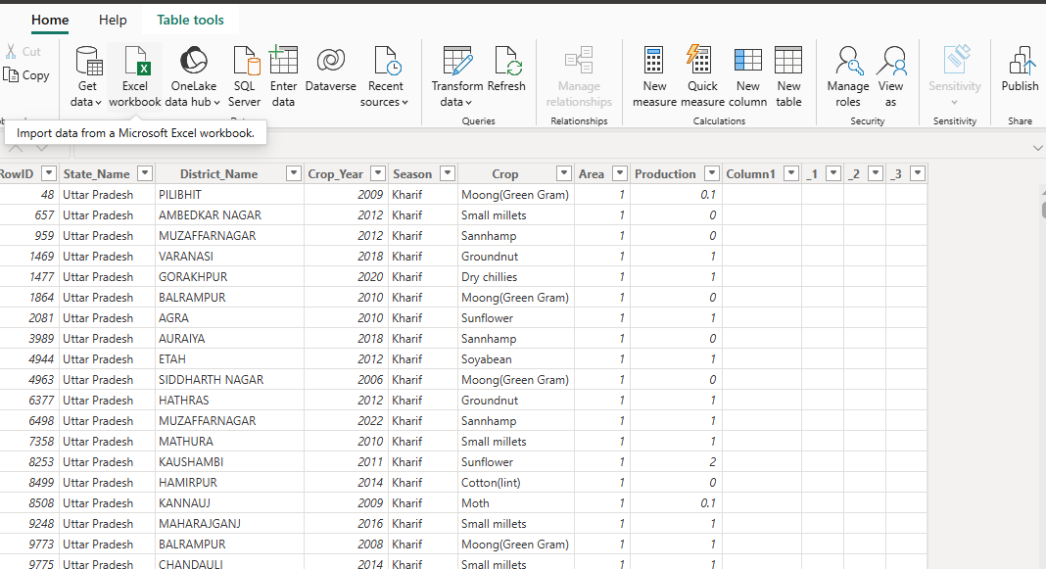

* And click on transform data on top . Then it will go to power Query Editor file like this :

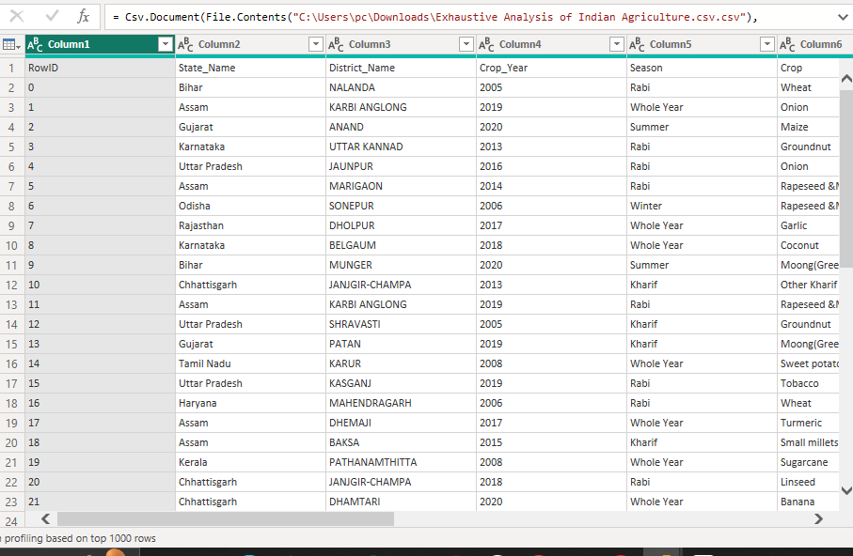

* Then delete the empty rows (Ex : RowId) by right click on the RowId row and select Remove option .
* Then select View option in the top right side and select column quality th see the Errors and Null values in the dataset .

I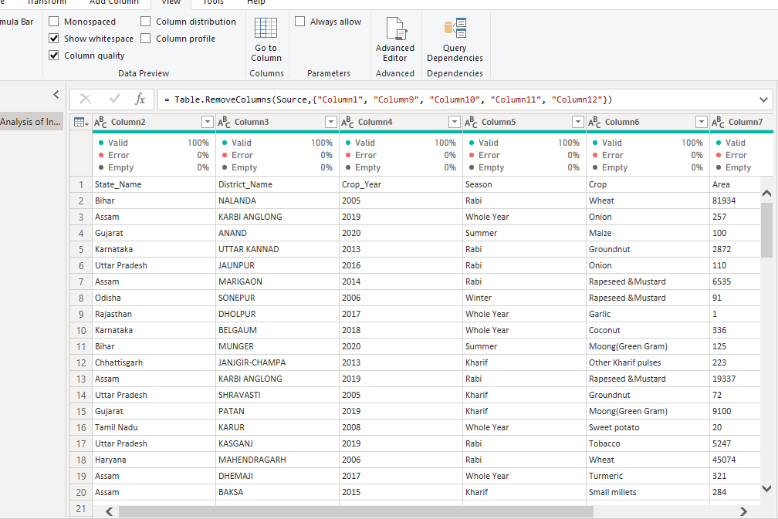

* And for removing columns,rows split columns like that we have so many options in home section .
* And we don’t have to write code for this . we just click on above options
* If we haveany duplictes in the data set then click on remove duplicates in the home section .
* To change the data types of the particular row . Just click on the abc (or) 123 in the left side of row name and then change the datatypes .
* To save the file in Power Bi we need to click on close and apply on the left side top corner .
* To click on this all the changes wil save on the power query file .
* After that it will not show any unneccessary files