DECLARATION

We, the students of INFORMATION TECHNOLOGY, Vasavi college of engineering, Hyderabad declare that the work entitled "CROP YIELD PREDICTION BASED ON WEATHER USING MACHINE LEARNING" has been successfully completed under the guidance of Mrs prasana, Information technology, Vasavi college of engineering, Hyderabad. This dissertation work is submitted in partial fulfillment of the requirements for the award of Degree of Bachelor of Engineering in , Information technology during the academic year 2020 - 2021. Further the matter embodied in the project report has not been submitted previously by anybody for the award of any degree or diploma to any university.

Place:
Date:
Team members:

M.Sushma (1602-19-737-117)

R.Sravya (1602-19-737-109)

ABSTRACT

India is an Agriculture based economy whose most of the GDP comes from farming. The motivation of this project comes from the increasing suicide rates in farmers which may be due to low harvest in crops. Climate and other environmental changes have become a major threat in the agriculture field. Machine learning is an essential approach for achieving practical and effective solutions for this problem. Predicting yield of the crop from historical available data like weather, soil, rainfall parameters and historic crop yield. We achieved this using the machine learning algorithm. We did a comparative study of various machine learning algorithms, i.e., ANN, K Nearest Neighbour, Random Forest, SVM and Linear Regression and chose Random Forest Algorithm which gave an accuracy of 95%. In this project a mobile application has been developed which predicts the crop yield in general and also for a particular crop. Along with that, it also suggests the user if it is the right time to use the fertilizer or not

ACKNOWLEDGEMENT

We take this opportunity to express my sincere gratitude and respect to vasavi college of engineering, Hyderabad for providing me a platform to pursue my studies and carry out my project. We have great pleasure in expressing my deep sense of gratitude to TSIC for their constant encouragement. We consider it a privilege and honour to express our sincere gratitude to Mrs.prasana, Professor, Department of Information technology, for the valuable guidance throughout the tenure of this project. We also extend my thanks to all the faculty of information technology who directly or indirectly encouraged us. Finally, we would like to thank my parents and friends for all their moral support they have given me during the completion of this work.

INTRODUCTION
India is ranked 2nd worldwide in farm output [9]. Agriculture and allied sectors like forestry and fisheries accounted for 16.6 percent of the GDP 2009, about 50 percent of the overall workforce [10]. The monetary contribution of agriculture to India‘s GDP is regularly declining. The crop yield of plants relies on different factors like on climatic, geographical, organic, political and financial elements. For farmers, it is difficult when there is more than one crop to grow especially when the market prices are unknown to them. Citing the Wikipedia statistics, the farmer suicide rate in India has ranged between 1.4 and 1.8 per 100000 total population, over a 10-year period through 2005. While 2014 saw 5650 farmer suicides, the figure crossed 8000 in 2015 [11].
Crop yield prediction is an important agricultural problem. Every farmer always tries to know how much yield will be produced and whether it meets their expectations. In the past, yield prediction was calculated by analyzing a farmer's previous experience on a particular crop. The Agricultural yield is primarily dependent on weather conditions pests and planning of harvest operation. Accurate information about the history of crop yield is an important thing for making decisions related to agricultural risk management.
Problem Statement
The Problem Statement revolves around prediction of crop yield using Machine Learning Techniques. The goal of the project is to help the users choose a suitable crop to grow in order to maximize the yield and hence the profit.
The system proposed tries to overcome the drawbacks of existing systems and make predictions by analyzing structured data. The solution we are proposing is to design a system taking into consideration the most influencing parameters to grow a crop and to get a better selection of crops which can be grown over the season. This would help reduce the difficulties faced by the farmers in selecting the crop to get high yield and thus maximize profits which in turn will reduce the suicide rates.
The system consists of two main modules:
i. Yield Prediction Module - In this module, the user is given two options where they can either select a particular crop & get the yield for it or they can view top 5 crops that have the highest yield among all other crops.
ii. Fertiliser Module - This module helps the user decide whether a particular time is right for using fertilisers.
Scope of the Project
Integrating farming and machine learning, we can lead to further advancements in agriculture by maximizing yield and optimizing the use of resources involved. Previous year‘s production data is an essential element for predicting the current yield.
The goal of this project is to help the farmers by combining agriculture and technology. The end result is an application that is available on the web as well as mobile.
Methodology
The system uses machine learning to make predictions of the crop and Python as the programming language since Python has been accepted widely as a language for experimenting in the machine learning area. Machine learning uses historical data and information to gain experiences and generate a trained model by training it with the data. This model then makes output predictions. The better the collection of dataset, the better will be the accuracy of the classifier. It has been observed that machine learning methods such as regression and classification perform better than various statistical models.
Datasets
A dataset in machine learning is, quite simply, a collection of data pieces that can be treated by a computer as a single unit for analytic and prediction purposes. This means that the data collected should be made uniform and understandable for a machine that doesn't see data the same way as humans do.
Fig : Soil and Crop data sample
EDA Performed:
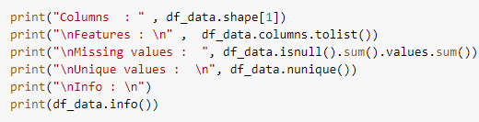
clc
%%
load('data.mat');
load('data_2014.mat');
%%
err = zeros(20,6);
error = strings(20,8);
%% KNN
KNNproduction = zeros(10,6);
production_KNN = strings(10,7);
x = 0;
id = 0;
erc = 1;
for i = 1 : 10 : 100
mn = 10000;
x = x + 1;
for j = i : 1 : (i+9)
temp = abs(data(j,1) - data_2014(x,1));
rain = abs(data(j,2) - data_2014(x,2));
humid = abs(data(j,3) - data_2014(x,3));
ds = sqrt((temp*temp)+(rain*rain)+(humid*humid));
if (mn > ds)
mn = ds;
id = j;
end
end
for k = 4 : 1 : 9
er = ((abs(data(id,k) - data_2014(x,k)))*100)/data_2014(x,k);
KNNproduction(x,k-3) = data(id,k);
production_KNN(x,k-3) = data(id,k);
err(erc,k-3) = er;
error(erc,k-3) = er;
end
error(erc,7) = cls(1,:);
error(erc,8) = region(x,:);
production_KNN(x,7) = region(x,:);
erc = erc + 2;
end
%% MLR
b1 = zeros(10,6);
b2 = zeros(10,6);
b0 = zeros(10,6);
MLRproduction = zeros(10,6);
production_MLR = strings(10,7);
x = 0;
erc = 2;
for i = 1 : 10 : 100
x1 = 0;
x2 = 0;
y = zeros(1,6);
my1 = zeros(1,6);
my2 = zeros(1,6);
m = 0;
x22 = 0;
x12 = 0;
x = x + 1;
for j = i : 1 : (i+9)
x12 = x12 + (data(j,1) * data(j,1));
x22 = x22 + (data(j,2) * data(j,2));
m = m + (data(j,1) * data(j,2));
x1 = x1 + data(j,1);
x2 = x2 + data(j,2);
y(1,1) = y(1,1) + data(j,4);
y(1,2) = y(1,2) + data(j,5);
y(1,3) = y(1,3) + data(j,6);
y(1,4) = y(1,4) + data(j,7);
y(1,5) = y(1,5) + data(j,8);
y(1,6) = y(1,6) + data(j,9);
my1(1,1) = my1(1,1) + (data(j,1) * data(j,4));
my1(1,2) = my1(1,2) + (data(j,1) * data(j,5));
my1(1,3) = my1(1,3) + (data(j,1) * data(j,6));
my1(1,4) = my1(1,4) + (data(j,1) * data(j,7));
my1(1,5) = my1(1,5) + (data(j,1) * data(j,8));
my1(1,6) = my1(1,6) + (data(j,1) * data(j,9));
my2(1,1) = my2(1,1) + (data(j,2) * data(j,4));
my2(1,2) = my2(1,2) + (data(j,2) * data(j,5));
my2(1,3) = my2(1,3) + (data(j,2) * data(j,6));
my2(1,4) = my2(1,4) + (data(j,2) * data(j,7));
my2(1,5) = my2(1,5) + (data(j,2) * data(j,8));
my2(1,6) = my2(1,6) + (data(j,2) * data(j,9));
end
x12 = x12 - ((x1 * x1) / 10);
x22 = x22 - ((x2 * x2) / 10);
x1x2 = m - ((x1 * x2) / 10);
cn = 4;
for k = 1 : 1 : 6
x1y = my1(1,k) - ((x1 * y(1,k)) / 10);
x2y = my2(1,k) - ((x2 * y(1,k)) / 10);
b1(x,k) = ((x22 * x1y) - (x1x2 * x2y)) / ((x12 * x22) - (x1x2 * x1x2));
b2(x,k) = ((x12 * x2y) - (x1x2 * x1y)) / ((x12 * x22) - (x1x2 * x1x2));
b0(x,k) = (y(1,k) / 10) - (b1(x,k) * (x1 / 10)) - (b2(x,k) *(x2 / 10));
MLRproduction(x,k) = b0(x,k) + (b1(x,k) * data_2014(x,1)) + (b2(x,k) * data_2014(x,2));
production_MLR(x,k) = MLRproduction(x,k);
er = ((abs(MLRproduction(x,k) - data_2014(x,cn)))*100) / data_2014(x,cn);
err(erc,cn-3) = er;
error(erc,cn-3) = er;
cn = cn + 1;
end
production_MLR(x,7) = region(x,:);
error(erc,7) = cls(2,:);
error(erc,8) = region(x,:);
erc = erc + 2;
end
%%

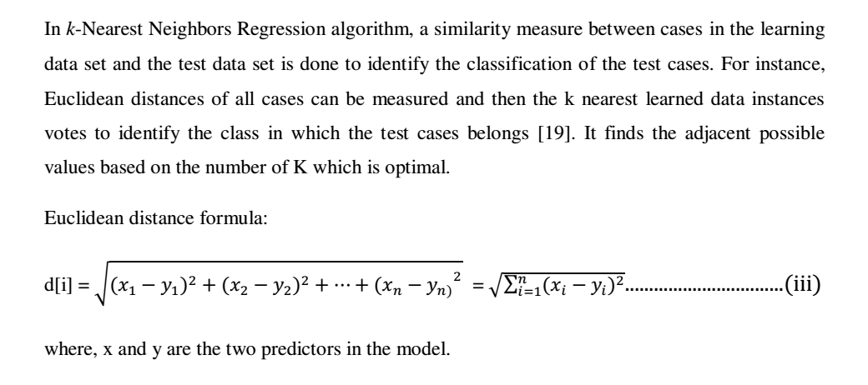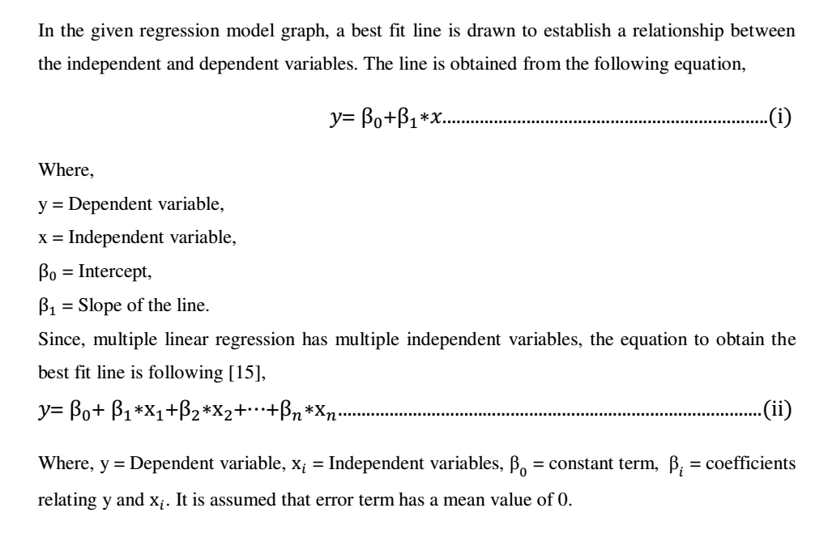

Algorithms Used

Machine Learning offers a wide range of algorithms to choose from. These are usually divided into classification, regression, clustering and association. Classification and regression algorithms come under supervised learning while clustering and association comes under unsupervised learning.
• Classification: A classification problem is when the output variable is a category, such as ―red‖ or ―blue‖ or ―disease‖ and ―no disease‖. Example: Decision Trees
• Regression: A regression problem is when the output variable is a real value, such as ―dollars‖ or ―weight‖. Example: Linear Regression
• Clustering: A clustering problem is where you want to discover the inherent groupings in the data, such as grouping customers by purchasing behaviour. Example: k means clustering
• Association: An association rule learning problem is where you want to discover rules that describe large portions of your data, such as people that buy X also tend to buy Y.

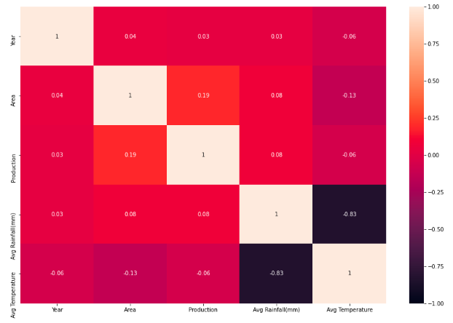
Sno. | Algorithm | Accuracy
1. | Artificial Neural Networks (ANN) | 80%
2. | Support Vector Machine (SVM) | 72%
3. | Multivariate linear Regression | 59%
4. | Random Forest | 93%
5. | K Nearest Neighbours (KNN) | 75%

Prediction of Crop Yield Using Machine Learning

Author: Rushika Ghadge, Juilee Kulkarni, Pooja More, Sachee Nene, Priya R L
Publication: International Research Journal of Engineering and Technology (IRJET) Volume 05, Issue 02, Feb-2018
This paper states, most of the existing systems are hardware based which makes them expensive and difficult to maintain and lack to give accurate results. Some systems suggest crop sequence depending on yield rate and market price. In this paper, the system proposed tries to overcome these drawbacks and predicts crops by analyzing structured data. Being a totally software solution, it does not allow maintenance factor to be considered much. Also the accuracy level would be high as compared to hardware based solutions, because components like soil composition, soil type, pH value, weather conditions all come into picture during the prediction process.
SYSTEM REQUIREMENTS SPECIFICATION

A software requirements specification (SRS) is a description of a software system to be developed. It lays out functional and nonfunctional requirements, and may include a set of use cases that describe user interactions that the software must provide. It is very important in a SRS to list out the requirements and how to meet them. It helps the team to save upon their time as they are able to comprehend how are going to go about the project. Doing this also enables the team to find out about the limitations and risks early on.

Functional Requirements

A Functional Requirement is a description of the service that the software must offer. It describes a software system or its component. A function is nothing but inputs to the software system, its behaviour, and outputs. It can be a calculation, data manipulation, business process, user interaction, or any other specific functionality which defines what function a system is likely to perform. In software engineering and systems engineering, a Functional Requirement can range from the high-level abstract statement of the sender's necessity to detailed mathematical functional requirement specifications. Functional software requirements help you to capture the intended behaviour of the system.
Non-Functional Requirements
Non-Functional Requirement (NFR) specifies the quality attribute of a software system. They judge the software system based on Responsiveness, Usability, Security, Portability andother non-functional standards that are critical to the success of the software system. Failing to meet non-functional requirements can result in systems that fail to satisfy user needs. Non-functional Requirements allows you to impose constraints or restrictions on the design of the system across the various agile backlogs.
Software Requirements
The software requirements are description of features and functionalities of the target system. Requirements convey the expectations of users from the software product. The requirements can be obvious or hidden, known or unknown, expected or unexpected from client‘s point of view.
- Jupyter Notebook: The Jupyter Notebook is an open source web application that you can use to create and share documents that contain live code, equations, visualizations, and text. Jupyter ships with the IPython kernel, which allows you to write your programs in Python, but there are currently over 100 other kernels that you can also use. The Jupyter Notebook combines three components:

- Python: It is an object-oriented, high-level programming language with integrated dynamic semantics primarily for web and app development. It is extremely attractive in the field of Rapid Application Development because it offers dynamic typing and dynamic binding options. Python is relatively simple, so it's easy to learn since it requires a unique syntax that focuses on readability.

- Ionic Development Tools: Ionic makes it easy to build high-performance mobile and Progressive Web Apps (or PWAs) that look and feel beautiful on any platform or device. Ionic‘s open source Framework and developer-friendly tools and services power apps for some of the world‘s best-known brands - from highly successful consumer apps like Sworkit, Untappd and Dow Jones MarketWatch, to mission-critical apps supporting Nationwide, Amtrak, and NASA.

System Architecture
Architecture diagrams can help system designers and developers visualize the high-level, overall structure of their system or application for the purpose of ensuring the system meets their users' needs. They can also be used to describe patterns that are used throughout the design. It's somewhat like a blueprint that can be used as a guide for the convenience of discussing, improving, and following among a team.
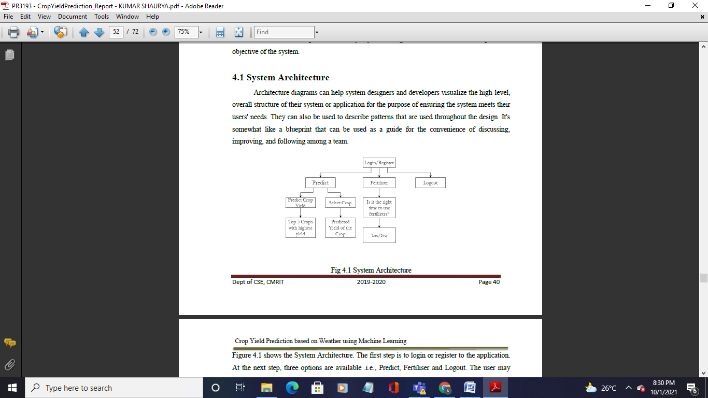
Use Case Diagram
A use case is a methodology used in system analysis to identify, clarify and organize system requirements. The use case is made up of a set of possible sequences of interactions between systems and users in a particular environment and related to a particular goal. A use case document can help the development team identify and understand where errors may occur during a transaction so they can resolve them.
Sequence Diagram
A sequence diagram simply depicts interaction between objects in a sequential order i.e. the order in which these interactions take place. We can also use the terms event diagrams or event scenarios to refer to a sequence diagram. Sequence diagrams describe how and in what order the objects in a system function.
RESULTS AND DISCUSSION
In the final implementation of the application the first screen the user can view is the login page. Here, the user can register or login using his/her credentials into the application as seen in the Fig.

TESTING
Software testing is an investigation conducted to provide stakeholders with information about the quality of the software product or service under test. Software testing can also provide an objective, independent view of the software to allow the business to appreciate and understand the risks of software implementation. Test techniques include the process of executing a program or application with the intent of finding software bugs (errors or other defects), and verifying that the software product is fit for use.
CONCLUSION
This system is proposed to deal with the increasing rate of farmer suicides and to help them to grow financially stronger. The Crop Recommender system helps the farmers to predict the yield of a given crop and also helps them to decide which crop to grow. Moreover, it also tells the user the right time to use the fertiliser.
Appropriate datasets were collected, studied and trained using machine learning tools. The system tracks the user‘s location and fetches needed information from the backend based on the location. Thus, the user needs to provide limited information like the soil type and area.

REFERENCES

* Predicting Yield of the Crop Using Machine Learning Algorithm by P.Priya, U.Muthaiah & M.Balamurugan, International Journal of Engineering Sciences & Research Technology (IJESRT), April, 2018
*A Survey on Crop Prediction using Machine Learning Approach by Sriram Rakshith.K,
Dr. Deepak.G, Rajesh M, Sudharshan K S, Vasanth S & Harish Kumar, International Journal for Research in Applied Science & Engineering Technology (IJRASET) Volume 7, Issue IV, Apr 2019

