**ATM SOFTWARE**

**M.SUSHMA-117**

**U.SNEHA-107**

**USE-CASE DIAGRAM**

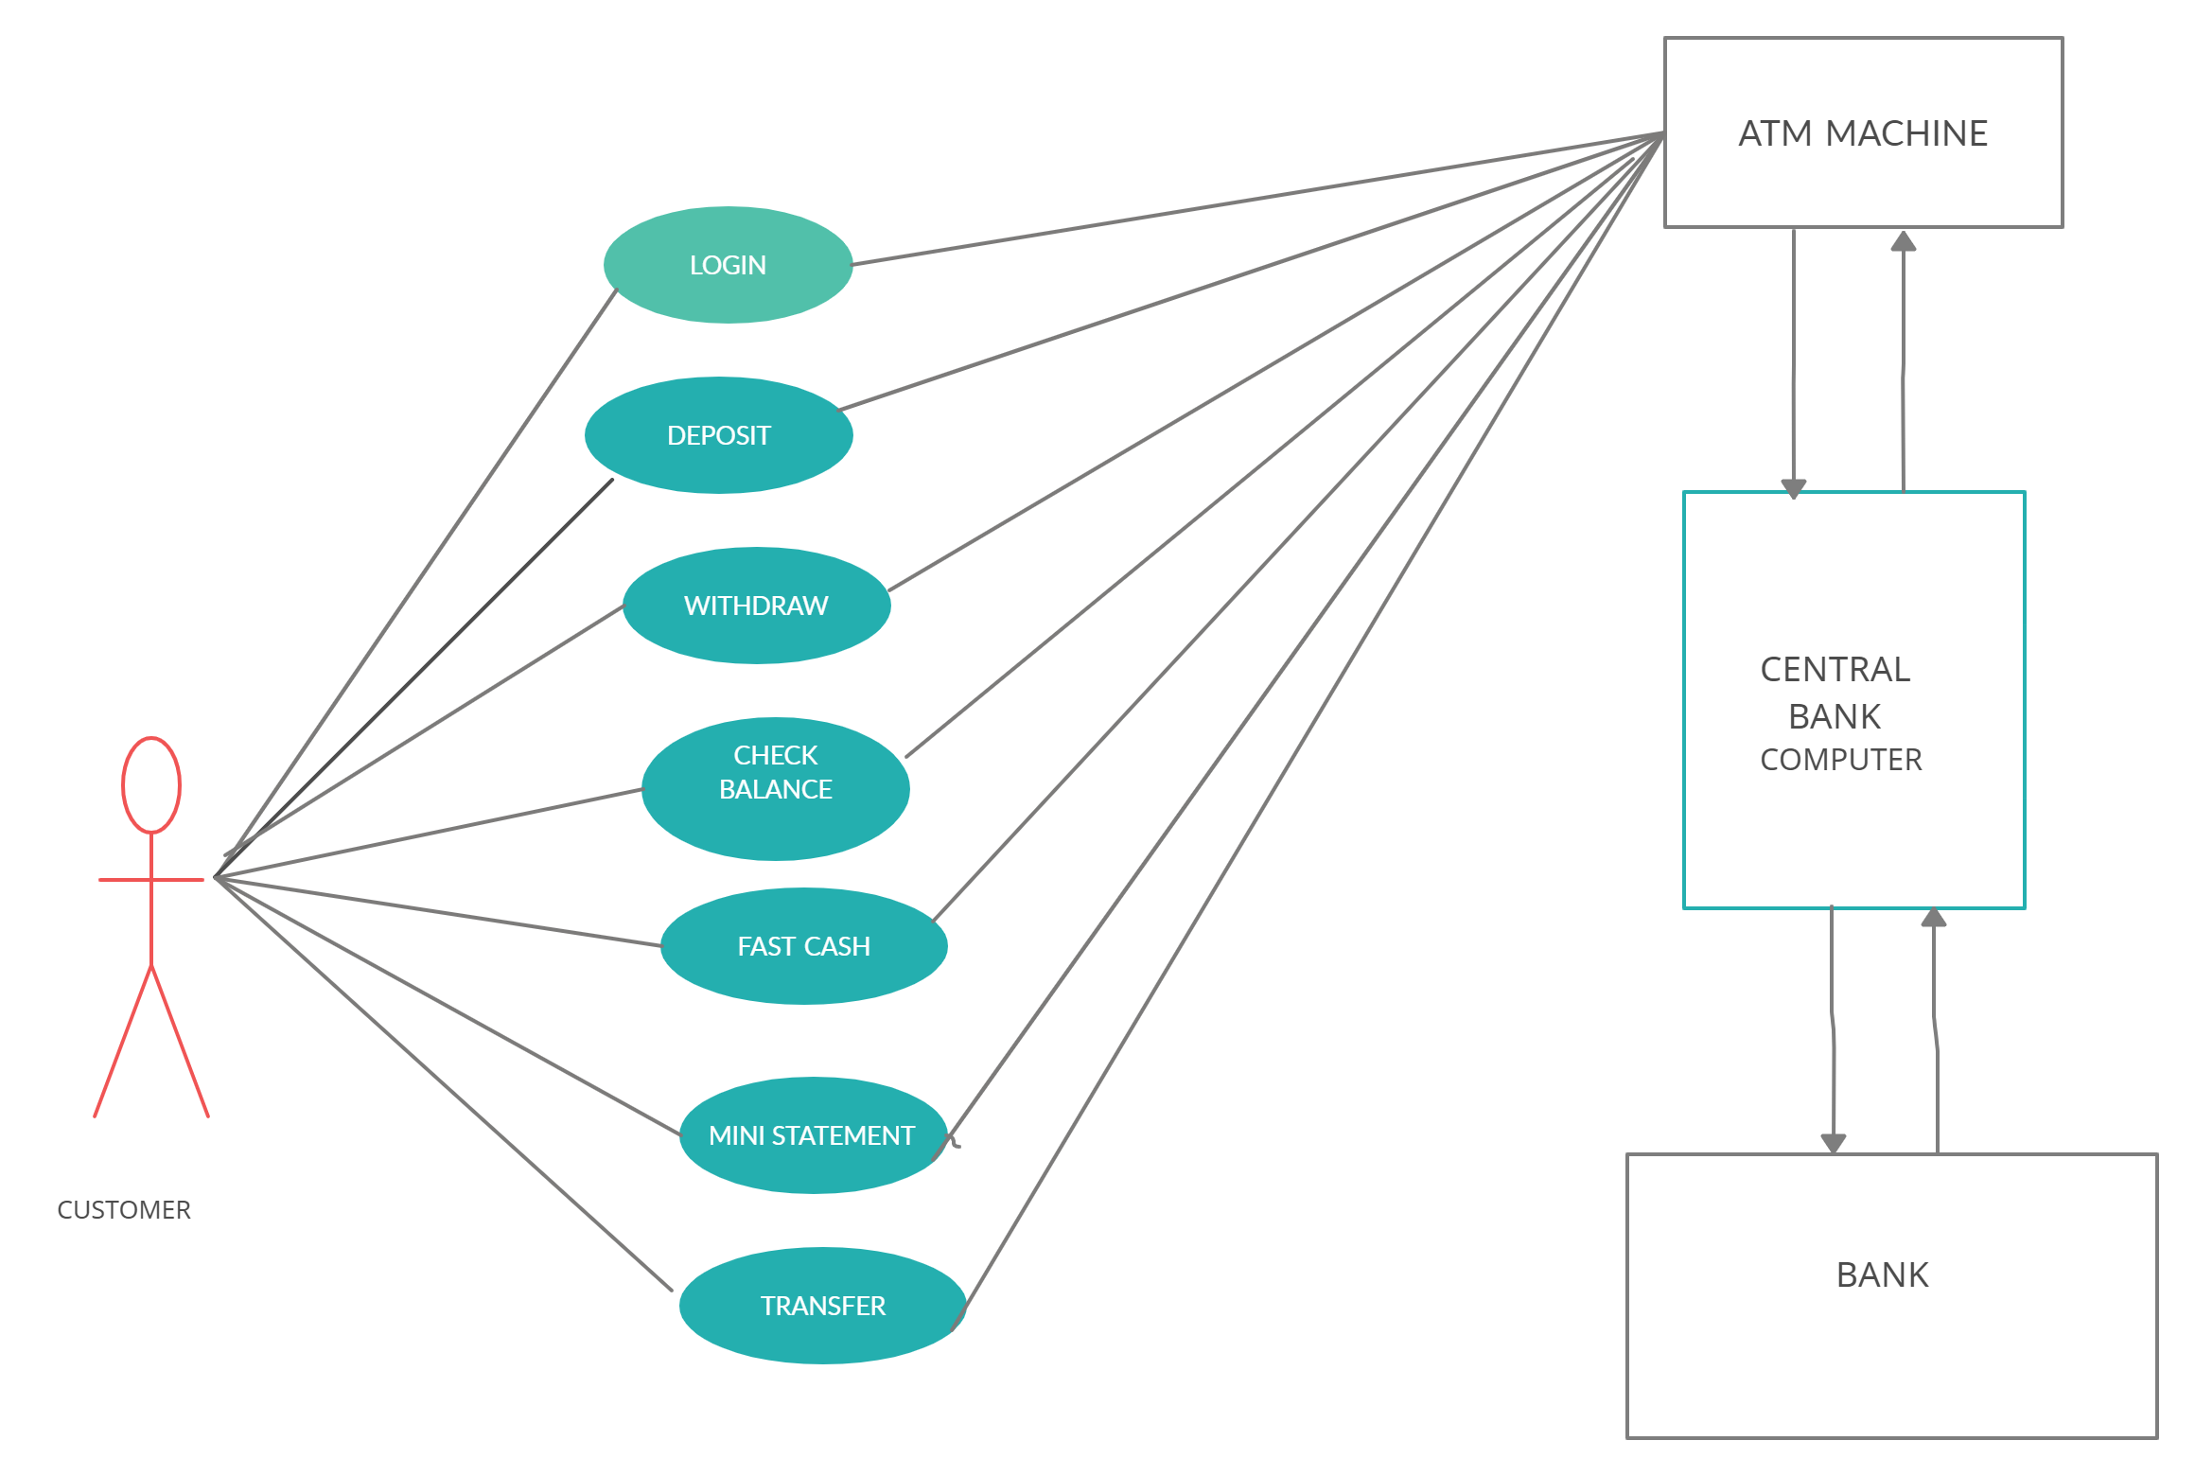

**USE –CASE DESCRIPTIONS**

**Use Case ID :** UC01

**Name :** Login

**Actors :** User

**Description :** User enters the name and PIN number

**Pre-conditions :** Must have account in the bank.

**Post-conditions :** Card and PIN entered by user are verified

**Main Flow :**

|  |  |
| --- | --- |
| **USER** | **SYSTEM** |
| **1)Enter card number** |  |
|  | **2)Verify the card number** |
| **3)Enter PIN of respective card** |  |
|  | **4)Authenticates the PIN number**  **4.1)If PIN number is valid,it process further**  **4.2)If PIN is invalid,an error message will be generated**  **4.3)If PIN is entered wrong more than 3 times card gets blocked** |

**Use Case ID :** UC02

**Name :** Deposit

**Actors :** User

**Description :** Allows user to deposit money and verify balance

**Pre-conditions :** Entered amount must be in multiples of 100 and less than 10000

**Post-conditions :** Checks the entered amount and displays balance amount.

**Main Flow :**

|  |  |
| --- | --- |
| **USER** | **SYSTEM** |
| **1)Enter the amount** |  |
|  | **2)Verify the amount entered** |
| **3)Gets conformation** |  |
|  | **4)Displays balance amount** |

**Use Case ID :** UC03

**Name :**  Withdrawal

**Actors :** User

**Description :** After choosing withdrawal option ,user must enter amount and confirm it

**Pre-conditions :** Amount entered must be less than available balance

**Post-conditions :** Available balance and entered amount are verified and successful message will be displayed.

**Main Flow :**

|  |  |
| --- | --- |
| **USER** | **SYSTEM** |
| **1)Choose withdraw option** |  |
| **2)Enter amount to be withdrawn** |  |
|  | **3)Checks the available balance in account**  **3.1)If entered amount is less than available balance it proceeds further**  **3.2)If entered amount is greater than available balance, a message will be displayed** |
| **4)Confirm the amount** |  |

**Use Case ID :** UC04

**Name :** Check Balance

**Actors :** User

**Description :** Checks the balance amount in his/her account

**Pre-conditions :** None

**Post-conditions :** The balance amount in the account will be displayed

**Main Flow :**

|  |  |
| --- | --- |
| **USER** | **SYSTEM** |
| **1)Enter the check balance option** |  |
|  | **2)Checks the balance in account and displays it.** |
| **3)Ask for printed slip** |  |
|  | **4)Prints the contents on slip and displays it** |

**Use Case ID :** UC05

**Name :** Fast cash

**Actors :** User

**Description :**  The transaction is done and money will be returned

**Pre-conditions :** None

**Post-conditions :** Money will be in the ATM tray

**Main Flow :**

|  |  |
| --- | --- |
| **USER** | **SYSTEM** |
| **1)Confirm the amount** |  |
|  | **2)Transaction is done and money will be in cash tray and meaasge will be sent to user mail-id.** |
| **3)Process further** |  |

**Use Case ID :** UC06

**Name :** Mini Statement

**Actors :** User

**Description :** If user wants to get the information regarding recent transactions,balance with a printed statement.

**Pre-conditions :** None

**Post-conditions :** The informqation of recent transactions wil be printed on paper

**Main Flow :**

|  |  |
| --- | --- |
| **USER** | **SYSTEM** |
| **1)Enter the option Mini Statement** |  |
|  | **2) Gives a printed statement** |

**Use Case ID :** UC07

**Name :** Transfer

**Actors :** User

**Description :** User can transfer the amount from one account to another account

**Pre-conditions :** Both the accounts must exists

**Post-conditions :** It transfers the amount and displays the balance in account

**Main Flow :**

|  |  |
| --- | --- |
| **USER** | **SYSTEM** |
| **1)Enter the account number from which amount must be transfered.** |  |
|  | **2)Checks if the account exists or not.** |
| **3) Enter the account number to which amount has to be transfered.** |  |
|  | **4)Checks if the account exists or not and proceeds further.** |
| **5)Enter the amount that has to be transfered** |  |
|  | **6)If the amount is less than avilable balance then money gets transferred** |