1. Create an HTML page to validate Name and Email. (Use Bootstrap, JQuery wherever applicable)

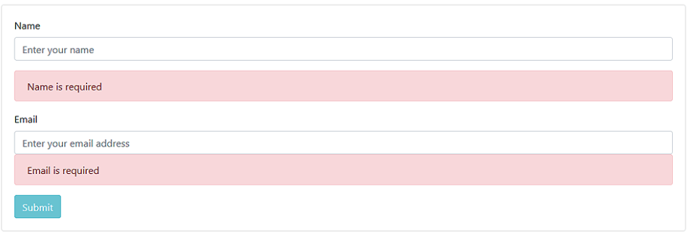

2. If the name and email entered are correct it should dynamically add the details to the below table. The table should look like below:

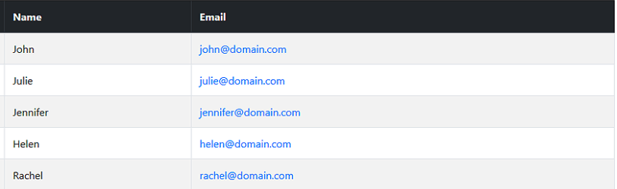

1 and 2:

<!DOCTYPE html>

<html>

<head>

    <script>

        function add() {

            var userName = document.getElementById("nameId").value;

            var email = document.getElementById("emailId").value;

            var table = document.getElementById("oldTable");

            var newRow = document.createElement('tr');

            newRow.setAttribute('id', 'row1');

            var newData1 = document.createElement('td');

            newData1.setAttribute('id', 'data1');

            var newData2 = document.createElement('td');

            newData1.setAttribute('id', 'data2');

           newData1.innerHTML = userName

           newData2.innerHTML = email

            newRow.appendChild(newData1);

            newRow.appendChild(newData2);

            table.appendChild(newRow);

        }

    </script>

</head>

<body>

    <form >

    <h1 align="center"></h1>

    <table cellpadding="10" cellspacing="10" align="center">

        <tr>

            <td>

                Name:

            </td>

            <td>

                <input type="text" id="nameId" required>

            </td>

        </tr>

        <tr>

            <td>

                email:

            </td>

            <td>

                <input type="email" id="emailId" required autocomplete="on">

            </td>

        </tr>

        <tr>

            <td>

                <button id="Add" onclick="add()" >Submit</button>

            </td>

        </tr>

    </table>

    <div id="myDiv"></div>

    <table id="oldTable" cellspacing="10" cellpadding="10" align="center" border="1px" >

        <th>Name</th>

        <th>email</th>

    </table>

</body>

</html>

1. Create a user form like below and perform the validation as shown in the below images:

**Image - 1-4**

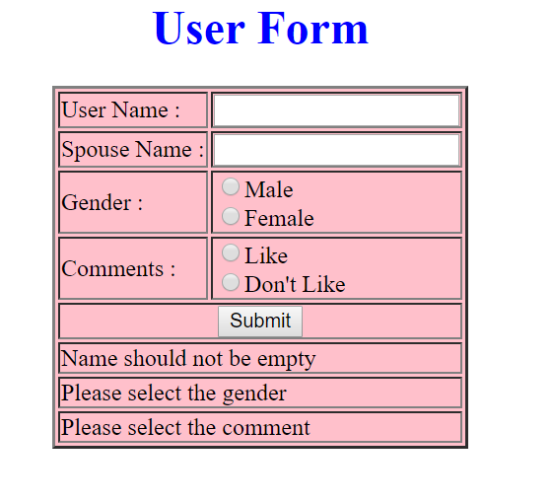

**Image - 2-4**

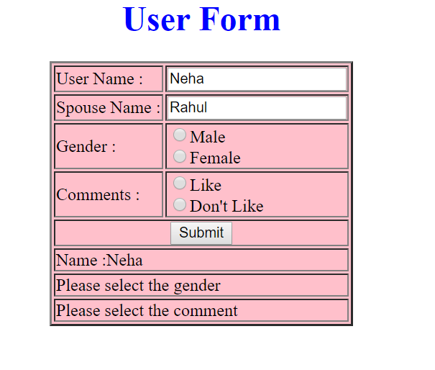

**Image - 3-4**

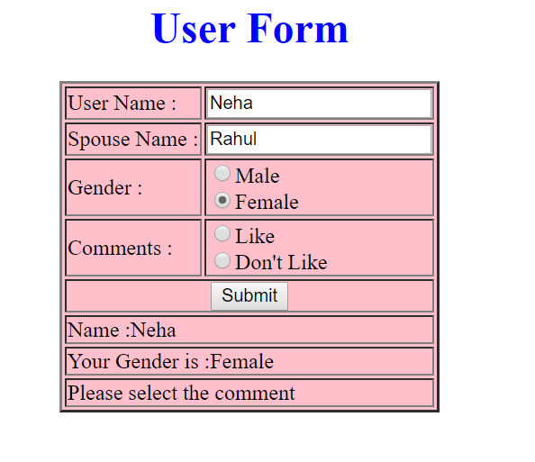

**Image - 4-4 (Success)**

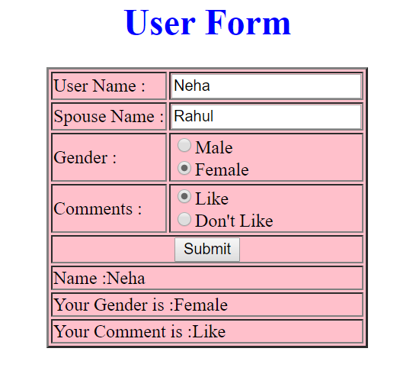

3: <html>

    <head>

        <script>

            function check(){

                var span1=document.getElementById("errName");

                var span2=document.getElementById("errGender");

                var span3=document.getElementById("errComment");

                var uname=document.getElementById("username").value;

                var spname=document.getElementById("spousename").value;

                var gender=document.getElementById("gender");

                var comments=document.getElementById("comment");

                function name(){

                if(uname.length!=0){

                span1.innerHTML="name";

                }

                else{

                    span1.innerText=""

                }

                }

                if(gender.checked=="true"){

                span2.innerHTML=gender.value

                }

                if(comments.checked=="true"){

                span3.innerHTML="comments.value "

                }

            }

        </script>

<style type="text/css">

    #myDiv

    {

    background: pink;

    border: 10px solid black;

    padding: 10px;

    font-size: 14px;

    line-height: 50px;

    text-align: justify;

    width: 500px;

    }

    </style>

    </head>

    <body>

        <form>

         <div id="myDiv"><center>

         <table border="1">

         <tr>

            <td><strong>username:</strong></td>

            <td><input type="text" name="username" id="username" onblur="name(this)" ></td>

         </tr>

         <tr>

            <td><strong>spouseName:</strong></td>

            <td><input type="text" name="spouseName" id="spousename"></td>

         </tr>

         <tr>

            <td><strong>Gender:</strong></td>

            <td><input type="radio" name="gender" id="gender" value="male">Male<br>

            <input type="radio" name="gender" id="gender" value="female">Female</td>

         </tr>

        <tr>

            <td><strong>comments</strong></td>

            <td><input type="radio" name="comment" id="comment" value="like">Like<br>

            <input type="radio" name="comment" id="comment" value="dont like">Dont Like</td>

        </tr>

        <tr>

            <td colspan="2">

            <center><input type="submit" value="submit"  id="btn" onclick="check()"  />

            </td>

        </tr>

        <tr >

                <td colspan="2" align="center"><span  id="errName">please enter ur name</span></td>

             </tr>

        <tr>

            <td colspan="2" align="center">

            <span id="errGender">plese select Gender</span>

            </td>

        </tr>

        <tr>

            <td colspan="2" align="center">

            <span id="errComment">please select comment</span>

            </td>

        </tr>

        </table>

         </center>

    </div>

    </form>

    </body>

    </html>

4.

CyberShoppe, Inc. sells toys and books in the United States. It has three branches in different parts of the country. Currently, the three branches maintain data on their local computer systems. The IT manager at CyberShoppe has identified that a centralized data repository on the products sold through its   
e-commerce site is required. The data from all branches must be collated and housed in a centralized location. This data must be made available to the Accounts and Sales sections at the individual branches, regardless of the hardware and software platforms being used at the branches.

1. In addition, the sales personnel require access to the data using palmtops and cellular phones. The product details of CyberShoppe consist of the product name, a brief description, the price, and the available quantity on hand. A product ID uniquely identifies each product. Create a responsive web page to capture these details.
2. The various products at CyberShoppe are purchased from their suppliers through their branch offices. The purchase order details are sent to the head office to generate reports. To ensure that the data can be accessed across all hardware and software used at the head office, the branch offices. On receiving this data, the head office needs to verify that all branches have specified the required information in a consistent format.

The purchase order details sent by the branch offices include the product ID, order ID, date of the purchase order, name and address of the supplier, quantity ordered, and price per unit.

1. The product Id must start with P following by 5 digits
2. The order Id must start with OD followed by 4 digits
3. The remaining fields are mandatory.
4. The look and feel should be consistent throughout the website.

Use jQuery, Bootstrap, JavaScript .

4:

<html>

    <head>

        <link rel="stylesheet" href="css/bootstrap.css">

        <link rel="stylesheet" href="Customstyles.css">

        <script>

                function check(){

                        var productId=document.getElementById("pId").value

                        var orderId=document.getElementById("oId").value

                        if(productId.length==0)

                        {

                               alert("product ID is Mandatory ")

                        }

                        else if(productId.length!=6 ){

                                alert(" product id should contain 6digits ")

                         }

                        else if(productId.charAt(0)!='P'){

                              alert("product ID should start with 'P'")

                        }

                        else{

                                alert("correctt")

                        }

                         /* if(orderId.length==0)

                        {

                               alert("order ID is Mandatory ")

                                return false

                        }

                        else if(orderId.length!=6 ){

                                alert(" order id should contain 6digits ")

                                return false

                         }

                        else if(orderId.charAt(0)!='O')&&(orderId.charAt(1)!='D'){

                              alert("order ID should start with 'OD'")

                                return false

                        }

                        else{

                                alert("correct")

                        }  */

                }

        </script>

    </head>

    <body>

            <form class="form-group">

                <div class="container">

                    <div class="row">

                        <div class="col-md-4 col-md-offset-3">

                            product Id:<input type="text" id="pId" class="form-control" required>

                        </div>

                    </div>

                    <div class="row">

                            <div class="col-md-4 col-md-offset-3">

                               order Id:<input type="text" id="oId" class="form-control" required>

                            </div>

                    </div>

                    <div class="row">

                            <div class="col-md-4 col-md-offset-3">

                               date of purchase:<input type="date" class="form-control" required>

                            </div>

                    </div>

                    <div class="row">

                            <div class="col-md-4 col-md-offset-3">

                               name:<input type="text" class="form-control" required>

                            </div>

                    </div>

                    <div class="row">

                            <div class="col-md-4 col-md-offset-3">

                               address:<input type="text" class="form-control" required>

                            </div>

                    </div>

                    <div class="row">

                            <div class="col-md-4 col-md-offset-3">

                               quantity:<input type="number" class="form-control" required>

                            </div>

                    </div>

                    <div class="row">

                            <div class="col-md-4 col-md-offset-3">

                               price:<input type="text" class="form-control" required>

                            </div>

                    </div>

                    <div class="btn-group btn-group-md col-md-offset-3  ">

                            <button onclick="check()" class="btn btn-primary">GO</button>

                </div>

    </body>