StreamSync — Product Specification v2.3

Overview
StreamSync is a real-time data synchronization tool for e-commerce inventory. Version 2.3 introduces multi-region replication and a redesigned conflict resolution engine that reduces sync latency by roughly 40%.

Key Features
Multi-region active-active replication, automatic conflict resolution using last-write-wins with manual override, webhook-based change notifications, and a REST + GraphQL dual API surface.

Pricing Tiers

Tier | Price/mo | Sync Regions | Support
Free | $0 | 1 | Community
Pro | $29 | 3 | Email (24h)
Enterprise | $149 | Unlimited | Dedicated Slack + phone

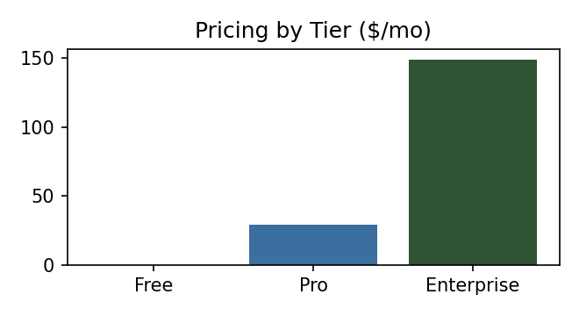

Release Timeline
Beta released March 2026 to 50 design-partner accounts. General availability targeted for August 2026, followed by an Enterprise SOC 2 compliance addendum in Q4 2026. A mobile SDK is planned for early 2027 but is not yet scoped.

