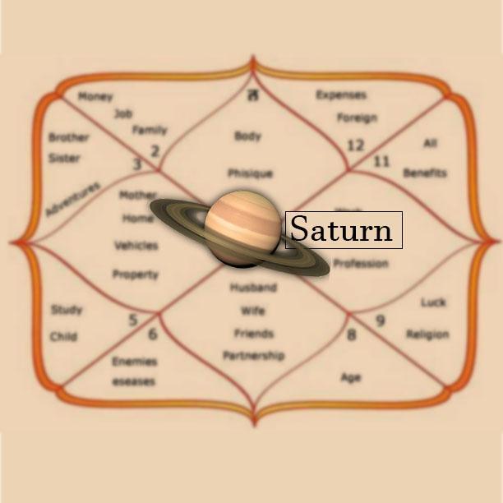

Saturn: The Master of Karma
In Vedic Astrology, Saturn (Shani) is often misunderstood as a planet of suffering, delays, and obstacles. Yet, those who truly understand Saturn know that it is one of the greatest teachers in the cosmic system.

Saturn is the Master of Karma—the divine force that ensures every action receives its appropriate result. It does not punish; it educates. It does not destroy; it restructures. Its purpose is to guide the soul toward maturity, responsibility, and spiritual evolution.
Why Saturn is Called the Master of Karma
Saturn governs discipline, hard work, accountability, patience, and justice. While other planets may offer opportunities, Saturn determines whether we have earned them.
It rewards:
• Honesty
• Perseverance
• Humility
• Commitment
• Service to others
It challenges:
• Ego
• Laziness
• Shortcuts
• Dishonesty
• Misuse of power
Saturn teaches that lasting success is built on strong foundations.
Signs Saturn is Working in Your Life
• Delays in career or relationships
• Increased responsibilities
• Financial restrictions
• Lessons through authority figures
• Need for patience and endurance
• Strong desire for self-improvement
These experiences are often Saturn's way of strengthening character and preparing the soul for greater achievements.
Saturn and Pending Karma
Saturn is closely linked with karmic debts carried from previous lives. Its placement in the birth chart often reveals:
• Areas requiring maturity
• Past-life lessons
• Karmic responsibilities
• Hidden fears and insecurities
• The path toward spiritual growth
The house occupied by Saturn often indicates where the soul must develop discipline and wisdom.
The Gift of Saturn
While Saturn's lessons may feel difficult, its rewards are unmatched. What Saturn gives remains stable, enduring, and meaningful.
People blessed by Saturn often become:
• Wise leaders
• Spiritual seekers
• Successful entrepreneurs
• Trusted advisors
• Individuals of strong character
Saturn's greatest gift is not wealth or status—it is inner strength.
How to Harmonize Saturn's Energy
• Respect time and commitments
• Serve the elderly and underprivileged
• Practice humility
• Maintain discipline in daily life
• Speak truthfully
• Perform selfless service
• Strengthen spiritual practices
When we align with Saturn's principles, obstacles begin transforming into opportunities.

Final Thoughts
Saturn is not a planet to fear. It is a planet to understand.
The Master of Karma teaches that every challenge carries a lesson and every lesson carries the potential for growth. When we embrace responsibility, patience, and integrity, Saturn becomes one of our greatest allies on the journey of life.
By Gitika Sharma
Soul Purpose Mavin
Vedic Astrology | Pending Karma Analysis | Astro Vastu | Numerology | Soul Guidance
Website:

