# Project Report

**Group Members:**

**1. Sanket Achari, UFID: 71096329,** [**sanketachari@ufl.edu**](mailto:sanketachari@ufl.edu)

**2. Sushmit Dharurkar, UFID: 14969578,** [**sushmitdharurkar@ufl.edu**](mailto:sushmitdharurkar@ufl.edu)

**Implementation Details:**

In our implementation, when a particular node receives a rumor 10 times, it stops transmitting the rumor. We have assumed that the convergence of the Gossip algorithm occurs when 90% of the nodes in the network have heard the rumor. We terminate the algorithm after convergence and measure the time taken to run the algorithm.

For Push-Sum algorithm, we assume that the convergence of a node happens when its average estimate (S/W value) does not change more than 10-10 in three consecutive message receive rounds. We terminate the algorithm after all the nodes in the network achieve convergence.

**Graphs plotting convergence time vs size of the network for different topologies and**

**algorithms:**

**Gossip Algorithm:**

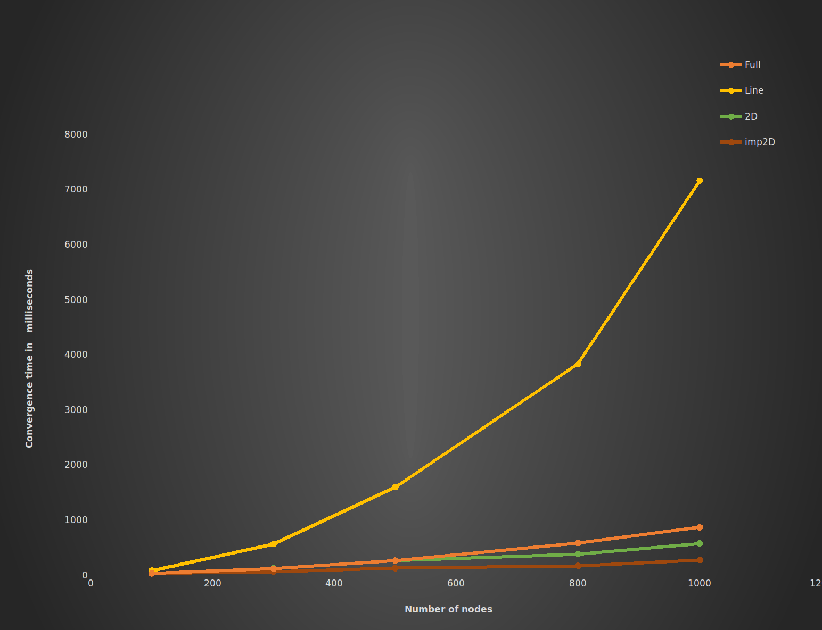

The above graph plots the convergence times of gossip algorithm vs number of nodes for different topologies.

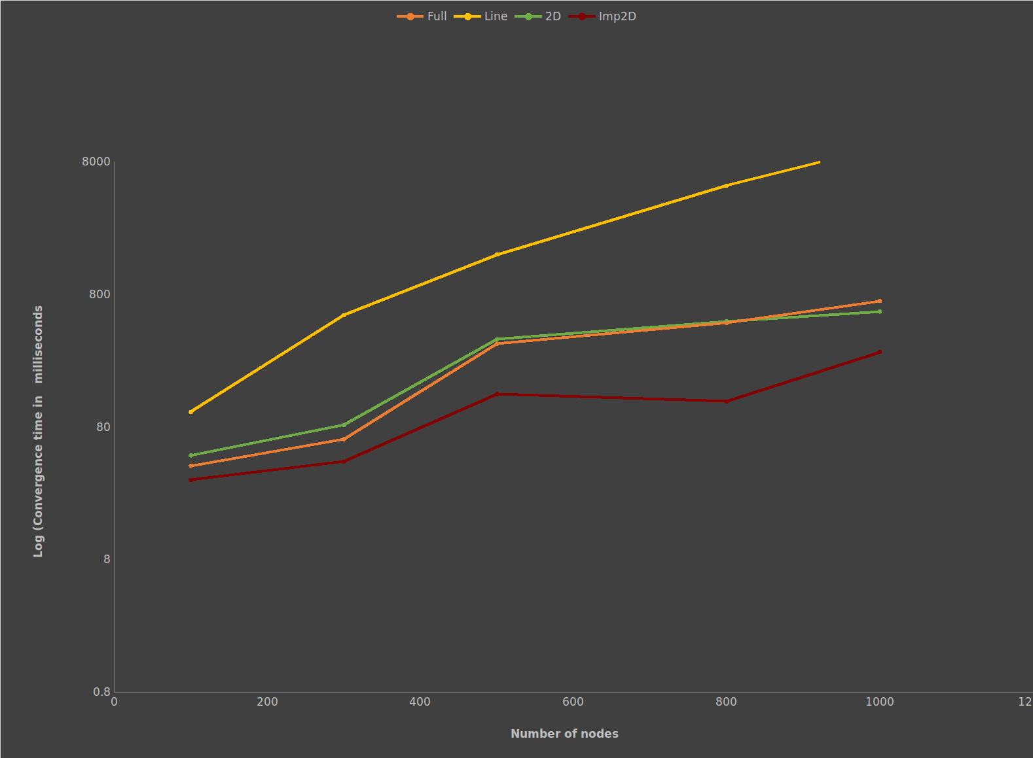

The above graph plots the log of convergence times of gossip algorithm vs number of nodes for different topologies.

**Push-Sum Algorithm:**

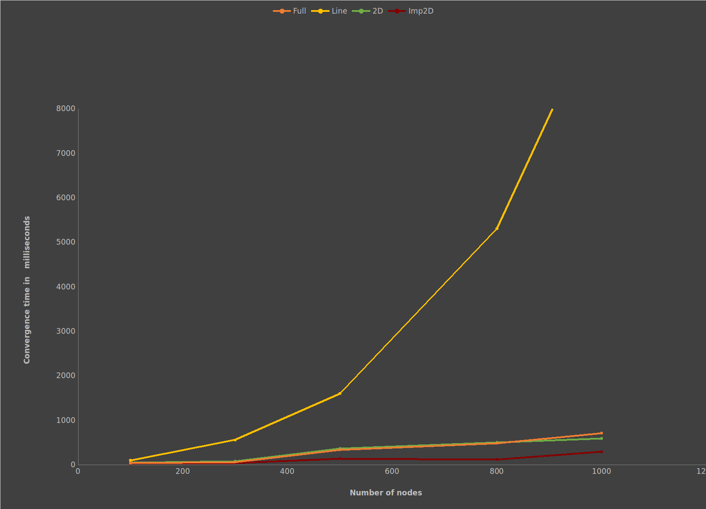

The above graph plots the convergence times of push-sum algorithm vs number of nodes for different topologies.

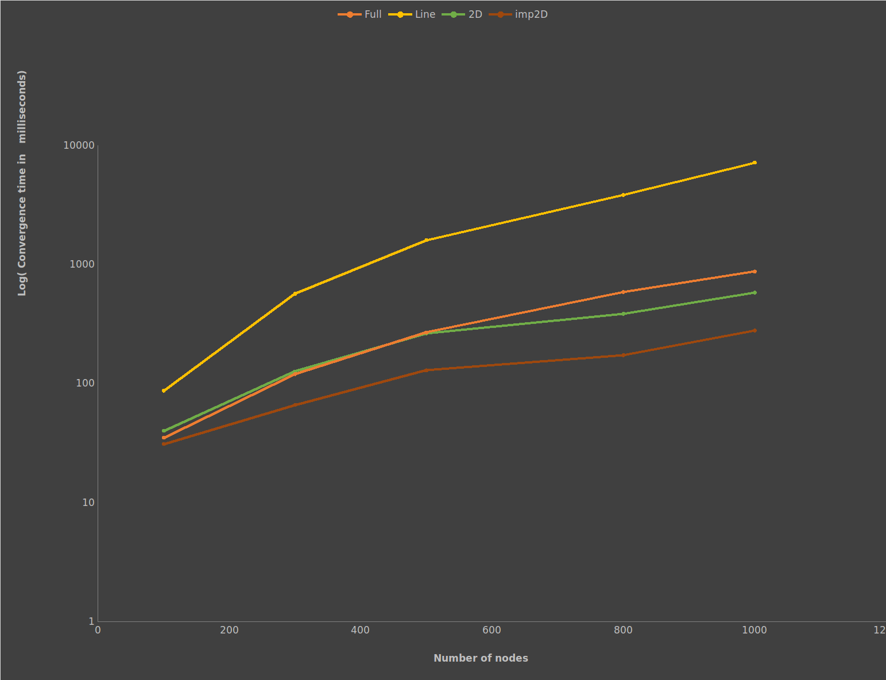

The above graph plots log of the convergence times of push-sum algorithm vs number of nodes for different topologies.

**Interesting Observations:**

1. Line topology showed the maximum convergence times in both algorithms. This must be due to the fact that each node has a maximum of 2 neighbours. This leads to slow propagation of the rumour in the network.
2. We intuitively thought that full topology will have the least convergence time due to interconnection between each node but from the results it’s clear that this assumption was wrong.
3. The imperfect 2D had the least amount of convergence time. This happened due to adding that random neighbour to each node, due to which the rumour spread quickly in the network and led to quicker convergence.
4. Push-sum and gossip algorithm showed similar results and had similar graphs. This must be due to the fact that both share an underlying similarity in sharing the message.