Apache Kafka — Notes
Pub/Sub Fundamentals, Architecture, CLI Usage, and a Spring Boot Microservice Example

1. What Is Apache Kafka?
Apache Kafka is a distributed messaging system that allows different parts of a software system to exchange data without talking to each other directly. Instead of one service calling another service's API, both services talk to Kafka — one writes data in, the other reads data out.
Kafka is built around the publish/subscribe (pub/sub) model. There are two roles:
- Producer — the service that sends (publishes / writes) messages to Kafka.
- Consumer — the service that receives (subscribes / reads) messages from Kafka.
A producer never sends a message directly to a consumer. It publishes the message to a named channel called a topic. A consumer never receives data automatically either — it must subscribe to a topic to start receiving whatever gets published to it.
A simple analogy: a YouTuber (producer) uploads a video to their channel (topic). Every subscriber (consumer) who has subscribed to that channel receives the new video. The YouTuber never sends the video to each subscriber individually — YouTube (Kafka) handles the distribution. Multiple consumers can subscribe to the same topic, and all of them receive whatever is published, without the producer needing to know who — or how many — consumers exist.
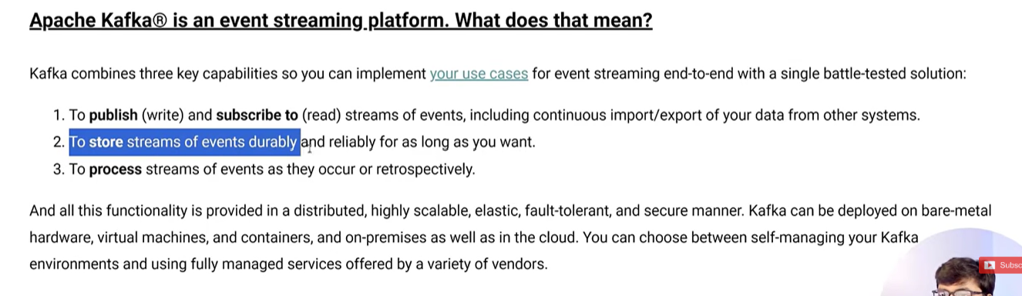
Official description: Apache Kafka as an event streaming platform (publish/subscribe, durable storage, and stream processing).

Why Use Apache Kafka?
Example — Zomato-style delivery tracking: A delivery partner's app updates the customer's app with the rider's live location as they move toward the delivery address. Suppose the location has to be updated 10 times during a single delivery.
A naive approach would be: every time the rider's location changes, write it straight to the database and have the customer's app read from the database to display it. This works fine for one user — but Zomato has millions of simultaneous orders. If every location ping for every rider directly hits the database, the number of database read/write operations explodes far beyond what the database can handle, and the database can crash under the load.
Kafka solves this by sitting in between as a buffer:
- The rider's app publishes each location update to a Kafka topic (instead of writing to the DB every single time).
- A backend service subscribes to that topic and pushes the update to the customer's app (e.g. via WebSocket/push notification).
- The database is written to less frequently — e.g. in batches, or only the final/important checkpoints — rather than on every single ping.
This is the core reason Kafka is used for this kind of use case: it absorbs a high volume of fast-moving data and prevents the database from being hit directly by every single update from every single user.

Key Reasons to Use Kafka
- High throughput — capable of handling millions of reads/writes in a very short time.
- Fault tolerance — data is replicated, so multiple copies exist across brokers; losing one broker doesn't lose the data.
- Durability — messages are stored for a configurable retention period, not discarded immediately after delivery.
- Scalability — more brokers, partitions, and consumers can be added to handle growing load.
- Decoupling — the producer and consumer don't need to be online at the same time or know about each other.

2. Kafka Architecture
A Kafka deployment is made up of several nested layers of structure. From the outside in:
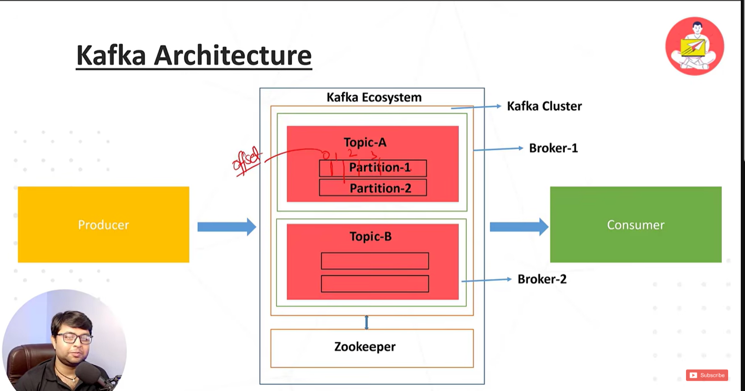
Kafka architecture: cluster → brokers → topics → partitions → offsets, with Zookeeper coordinating the cluster.

Kafka Cluster
A cluster is a group of Kafka servers working together. It is the outermost boundary — everything (brokers, topics, partitions) lives inside a cluster.

Broker
A broker is a single Kafka server instance within the cluster (e.g. Broker-1, Broker-2). Each broker stores a portion of the cluster's data. Running multiple brokers is what provides fault tolerance and horizontal scalability — if one broker fails, the others can continue serving data, provided replication has been configured.

Topic
A topic is a named feed or category of messages, such as Topic-A or Topic-B. Producers publish to a topic; consumers subscribe to a topic. It can be thought of as a table name or a channel name that groups related messages together.

Partition
A topic is not stored as a single log — it is split into partitions (e.g. Partition-1, Partition-2 under Topic-A). Splitting a topic into partitions gives two benefits:
- Parallelism — different partitions can be read and written independently and spread across multiple brokers, allowing multiple consumers to process data in parallel.
- Ordering guarantee — Kafka only guarantees message order within a single partition, not across an entire topic. If strict ordering matters for related events (e.g. all location updates for one specific order), those messages should be keyed so they always land in the same partition.

Offset
Within a partition, every message is assigned a sequential number called an offset (0, 1, 2, 3, ...). The offset is how Kafka tracks the position of each message, and how a consumer tracks how far it has already read. A consumer periodically commits its current offset — so if it crashes and restarts, it can resume exactly where it left off instead of re-reading everything or losing messages.

Zookeeper
Zookeeper is a separate coordination service that historically sat underneath the Kafka cluster. It kept track of cluster metadata: which broker is the leader for which partition, which brokers are alive, and overall configuration.
Note
Newer versions of Kafka (2.8+) have removed the Zookeeper dependency in favor of KRaft, Kafka's own built-in consensus protocol, and Zookeeper support is being phased out entirely from Kafka 4.0 onward. Setups following the classic bin\windows\zookeeper-server-start.bat workflow are using the older, pre-KRaft architecture — which is still fine for learning.

Consumer Groups
When multiple consumers subscribe to the same topic as part of the same consumer group, Kafka divides the topic's partitions among them, so each message is processed by only one consumer in that group (load balancing). If those consumers instead belong to different groups, each group receives its own full, independent copy of every message (fan-out), which is the mechanism behind the earlier YouTube-subscribers analogy.

3. Installing and Starting Kafka Locally
- Download the Kafka zip file from the official Apache Kafka website.
- Extract the zip file.
- Start Zookeeper.
- Start the Kafka server (broker).
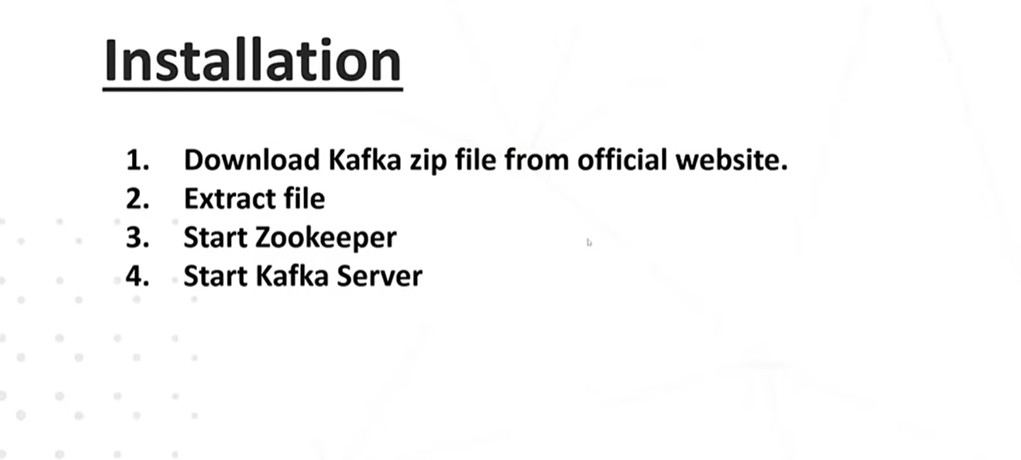
Installation steps overview.

Commands (Windows)
Start Zookeeper (in one terminal):
C:\kafka>bin\windows\zookeeper-server-start.bat config\zookeeper.properties
Start the Kafka broker (in a second terminal):
bin\windows\kafka-server-start.bat config\server.properties
At this point Zookeeper and the Kafka broker are both running locally, ready to accept producers and consumers.

4. Testing with the Command-Line Producer and Consumer
Start a console producer for a topic called test-topic:
C:\kafka>bin\windows\kafka-console-producer.bat --topic test-topic --bootstrap-server localhost:9092
>HVKIV
>KUBGU
>JBJB
>sushmita
>hubkli
>dhiedh
>neu
>comp science
>e
Each line typed after the > prompt is a separate message published to the test-topic topic.
Start a console consumer to read those messages:
bin\windows\kafka-console-consumer.bat --topic test-topic --bootstrap-server localhost:9092
Correction
The class-based invocation "java -cp \"C:\\kafka\\libs\\*\" kafka.tools.ConsoleConsumer ..." is an old, low-level approach, and kafka.tools.ConsoleConsumer is deprecated/removed in recent Kafka versions. The standard, supported command — matching the producer's syntax — is kafka-console-consumer.bat, as shown above. Adding --from-beginning to that command replays every message from offset 0 instead of only new messages published after the consumer starts.
It is also possible to run more than one consumer against the same topic at the same time — each will receive the published messages independently (pub/sub fan-out), or share the load if placed in the same consumer group.

5. Building a Two-Microservice Example with Spring Boot
To demonstrate real inter-service communication, two independent Spring Boot projects were generated from Spring Initializr with the same Kafka-related dependencies:
- deliveryboyapp — acts as the producer (publishes location updates).
- enduser — acts as the consumer (subscribes and prints location updates).
The two services never call each other directly over HTTP — they communicate exclusively through the Kafka broker, exactly like real decoupled microservices.
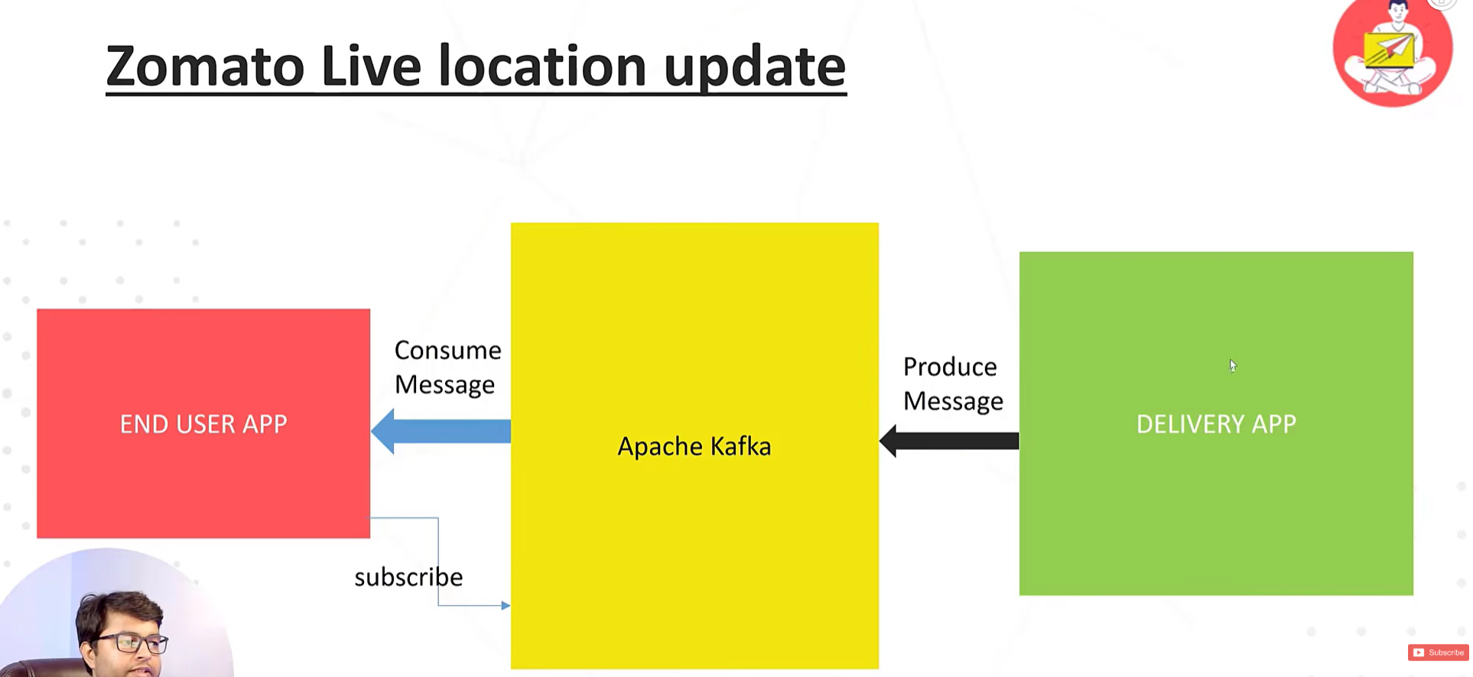
Target flow: Delivery App produces location messages to Apache Kafka; End User App subscribes and consumes them.

5.1 deliveryboyapp (Producer)
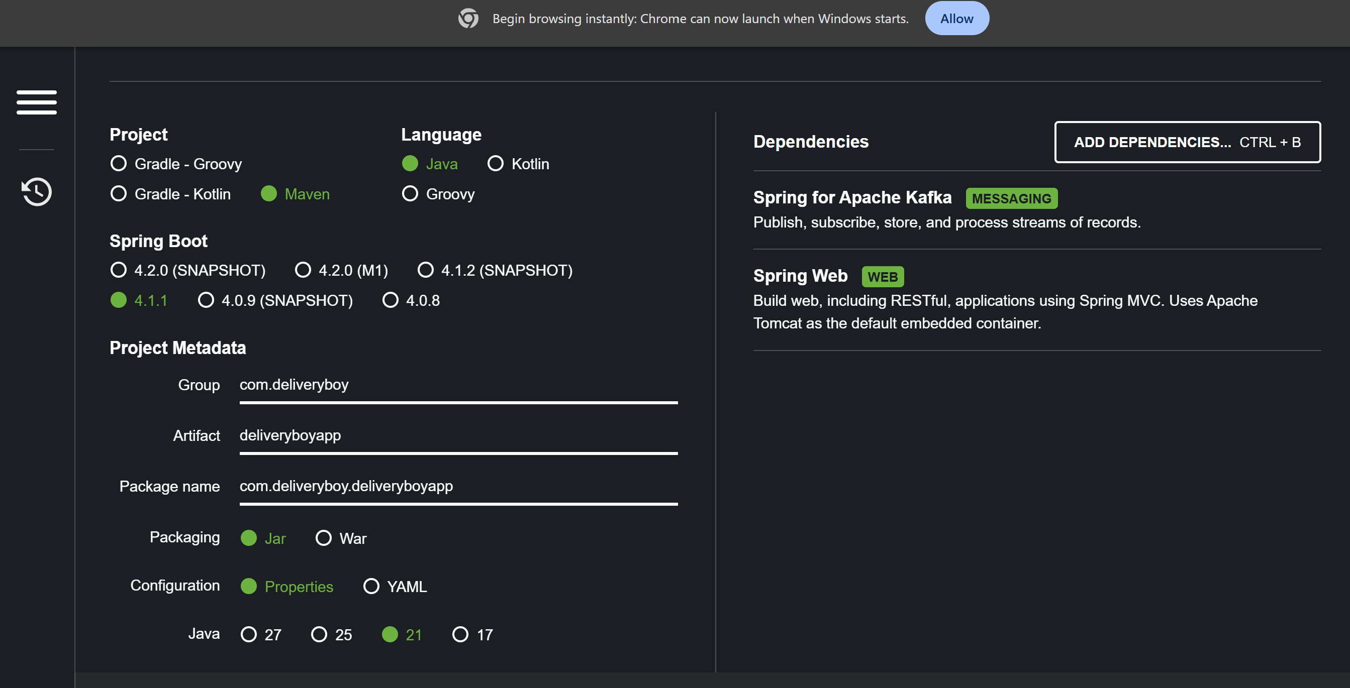
Spring Initializr setup for deliveryboyapp — Maven, Java 21, Spring Boot 4.1.1, with Spring for Apache Kafka and Spring Web dependencies.

AppConstants
package com.deliveryboy.deliveryboyapp.config;

public class AppConstants {
public static final String LOCATION_TOPIC_NAME= "location-update-topic";
}
Holds the topic name as a constant to avoid hardcoding/typing the string in multiple places.

KafkaConfig
@Configuration
public class KafkaConfig {

@Bean
public NewTopic topic() {
return TopicBuilder
.name(AppConstants.LOCATION_TOPIC_NAME)
// .partitions()
// .replicas()
.build();
}
}
This NewTopic bean tells Spring Boot to automatically create the topic on the broker at application startup (via KafkaAdmin) if it doesn't already exist — it is idempotent, so it does nothing if the topic is already there. Since .partitions() and .replicas() were left commented out, Kafka falls back to the broker's default configuration, which on a fresh single-node local install is typically 1 partition and 1 replica. This is exactly why the consumer log later only shows a single partition: location-update-topic-0.

LocationController
@RestController
@RequestMapping("/location")
public class LocationController {

@Autowired
private KafkaService kafkaService;

@PostMapping("/update")
public ResponseEntity<?> updateLocation()
{
for(int i=1; i<=100;i++) {
this.kafkaService.updateLocation("( " + Math.round(Math.random() * 100) + " , " + Math.round(Math.random() * 100) + ")");
}
return new ResponseEntity<>(Map.of("message", "Location updated"), HttpStatus.OK);
}
}
Hitting POST /location/update simulates 100 rapid location pings from a delivery rider in a single API call, so a burst of messages can clearly be observed flowing through Kafka instead of a single request.

KafkaService
@Service
public class KafkaService {

@Autowired
private KafkaTemplate<String, String> kafkaTemplate;

private Logger logger = LoggerFactory.getLogger(KafkaService.class);

public boolean updateLocation(String location) {
this.kafkaTemplate.send(AppConstants.LOCATION_TOPIC_NAME,location);
this.logger.info("message produced");
return true;
}
}
KafkaTemplate.send() publishes the message to the given topic. This call is asynchronous — it returns a CompletableFuture immediately without waiting for the broker's acknowledgement ("fire and forget"). Because the future isn't captured here, a silent failure to send (e.g. broker unreachable) wouldn't be surfaced in the application logs. In production code it is common to attach a callback such as .whenComplete((result, ex) -> { ... }) to log failures explicitly.

application.properties — Producer Configuration
spring.application.name=deliveryboyapp

#Producer Configuration
spring.kafka.producer.bootstrap-servers=localhost:9092
spring.kafka.producer.key-serializer=org.apache.kafka.common.serialization.StringSerializer
spring.kafka.producer.value-serializer=org.apache.kafka.common.serialization.StringSerializer
bootstrap-servers tells the producer which broker(s) to connect to initially, in order to discover the rest of the cluster. The serializer properties tell Kafka how to convert the Java key/value into raw bytes before sending them over the network, since Kafka only transmits bytes, never Java objects directly.

5.2 enduser (Consumer)
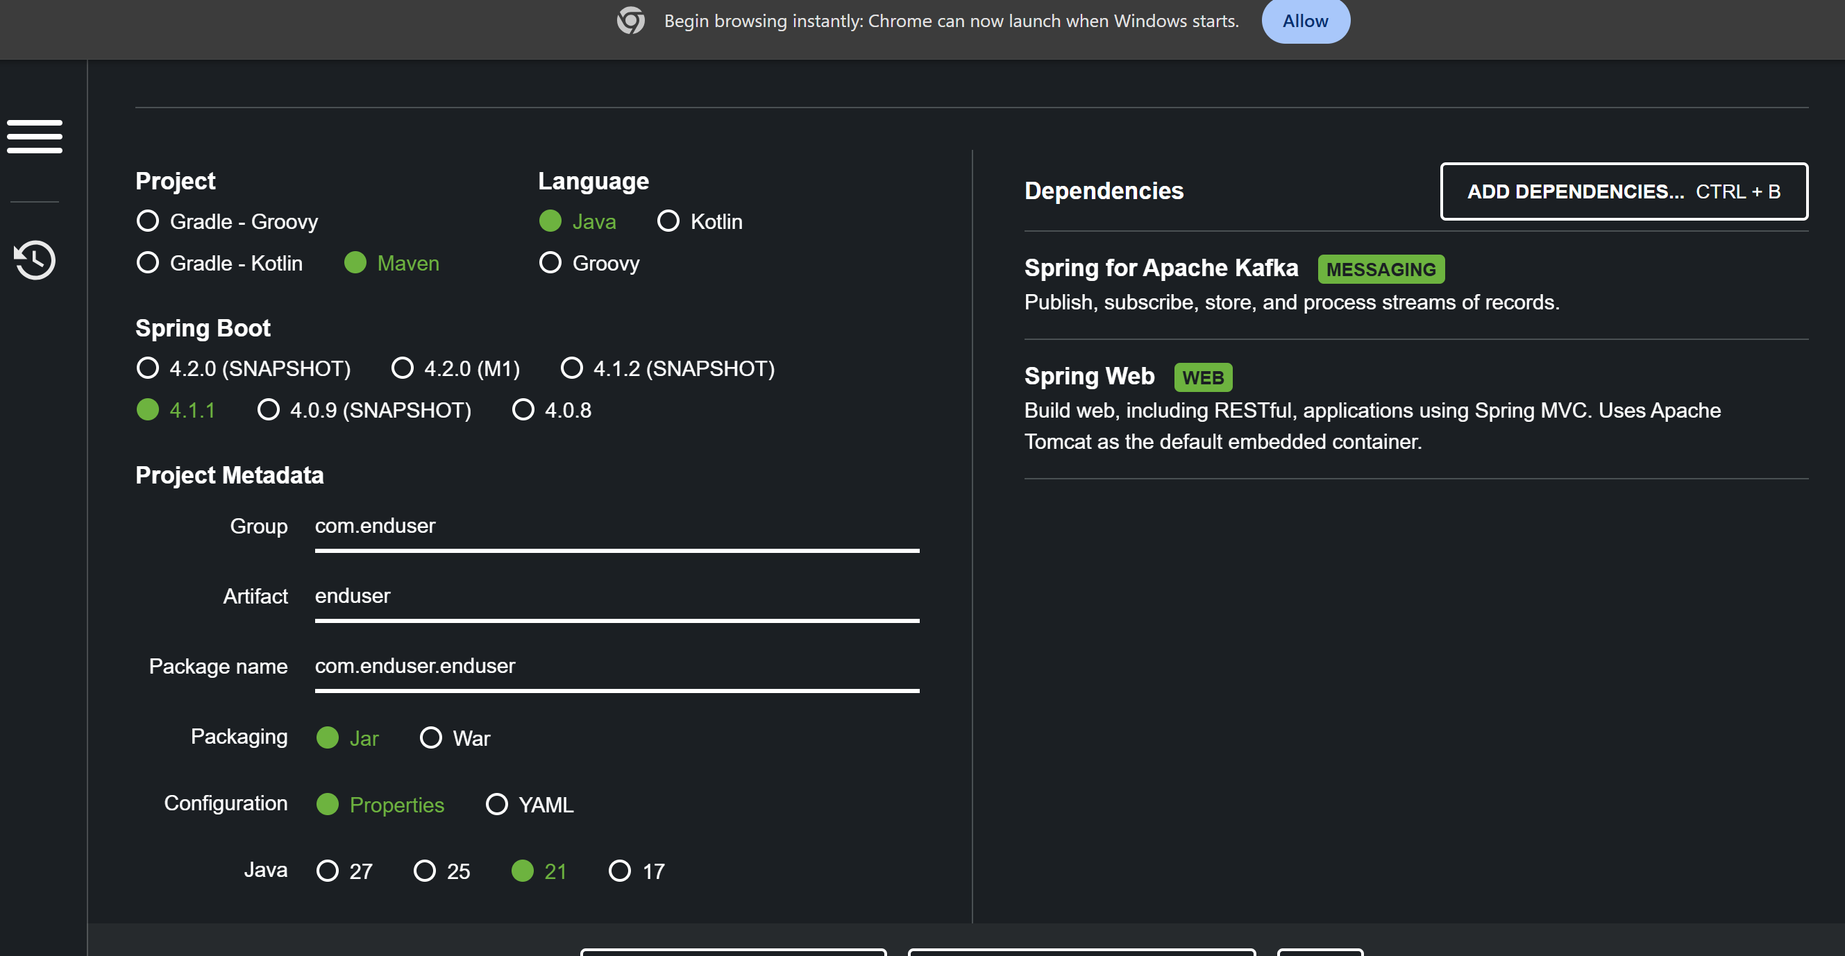
Spring Initializr setup for enduser — Maven, Java 21, Spring Boot 4.1.1, with Spring for Apache Kafka and Spring Web dependencies.

AppConstants
package com.enduser.enduser;

public class AppConstants {
public static final String LOCATION_UPDATE_TOPIC="location-update-topic";
public static final String GROUP_ID="group-1";
}
GROUP_ID now matches the group-id declared in application.properties (group-1), so the consumer group name is consistent across both configuration sources.

KafkaConfig (Listener)
@Configuration
public class KafkaConfig {

@KafkaListener(topics = AppConstants.LOCATION_UPDATE_TOPIC, groupId = AppConstants.GROUP_ID)
public void updatedLocation(String value)
{
System.out.println("Updated location: "+value);
}
}
@KafkaListener turns this method into a subscriber. Spring runs a background polling loop that continuously fetches new records from the partitions assigned to this consumer, invoking this method once per message received. Spring Boot's Kafka starter auto-configures the underlying listener container, so no explicit @EnableKafka is required. Any Spring-managed bean (@Component, @Service, or, as used here, @Configuration) can host a @KafkaListener method — the important requirement is simply that the class is a registered Spring bean.

application.properties — Consumer Configuration
spring.application.name=enduser
server.port= 8081

#Consumer Configuration
spring.kafka.consumer.bootstrap-servers=localhost:9092
spring.kafka.consumer.group-id=group-1
spring.kafka.consumer.auto-offset-reset=earliest
spring.kafka.consumer.key-deserializer=org.apache.kafka.common.serialization.StringDeserializer
spring.kafka.consumer.value-deserializer=org.apache.kafka.common.serialization.StringDeserializer
auto-offset-reset=earliest only matters when there is no previously committed offset for that consumer group on a given partition. It instructs Kafka to start reading from the very first available message rather than the default behaviour (latest), which would skip anything published before the consumer connected.

6. Running Both Services and Reading the Logs
With both applications running, a POST request to /location/update was sent via Postman on the deliveryboyapp:
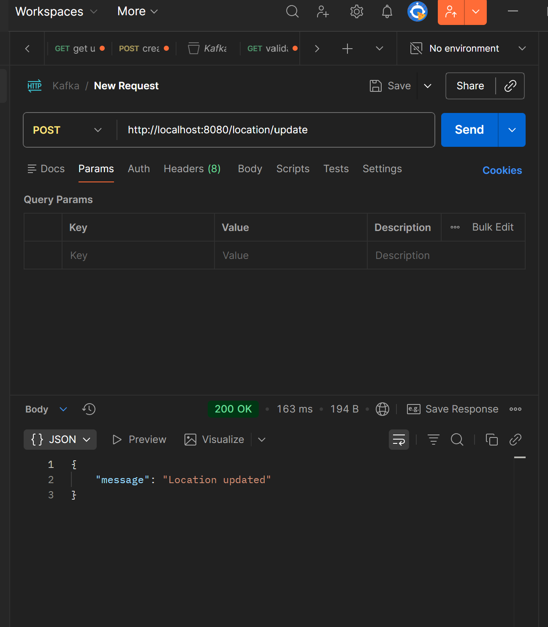
Postman — POST http://localhost:8080/location/update returns 200 OK with { "message": "Location updated" }.
This produced the following log on the producer side:
2026-09-24T21:12:32.610-04:00 INFO 9512 --- [deliveryboyapp] [nio-8080-exec-1] c.d.deliveryboyapp.service.KafkaService : message produced
2026-09-24T21:12:32.721-04:00 INFO 9512 --- [deliveryboyapp] [yapp-producer-1] o.a.k.c.p.internals.TransactionManager : [Producer clientId=deliveryboyapp-producer-1] ProducerId set to 1000 with epoch 0
The ProducerId/epoch line comes from Kafka's idempotent producer feature (enabled by default since Kafka 3.0). Each producer session is assigned a unique ProducerId and epoch, which the broker uses to detect and drop duplicate writes caused by retries — guaranteeing each message is written exactly once per partition even across network hiccups.
On the enduser (consumer) side, the following was logged when the consumer started up and began receiving messages:
2026-09-24T21:37:21.705-04:00 INFO 36652 --- [enduser] [ntainer#0-0-C-1] o.a.k.c.c.internals.ConsumerCoordinator : [Consumer clientId=consumer-group=1-1, groupId=group=1] Notifying assignor about the new Assignment(partitions=[location-update-topic-0])
2026-09-24T21:37:21.706-04:00 INFO 36652 --- [enduser] [ntainer#0-0-C-1] k.c.c.i.ConsumerRebalanceListenerInvoker : [Consumer clientId=consumer-group=1-1, groupId=group=1] Adding newly assigned partitions: [location-update-topic-0]
2026-09-24T21:37:21.722-04:00 INFO 36652 --- [enduser] [ntainer#0-0-C-1] o.a.k.c.c.internals.ConsumerUtils : Setting offset for partition location-update-topic-0 to the committed offset FetchPosition{offset=104, ...}
2026-09-24T21:37:21.724-04:00 INFO 36652 --- [enduser] [ntainer#0-0-C-1] o.s.k.l.KafkaMessageListenerContainer : group=1: partitions assigned: [location-update-topic-0]
Updated location: ( 84 , 6)
Updated location: ( 59 , 92)
Updated location: ( 65 , 65)
...
Updated location: ( 96 , 72)
This block of logs is the consumer group join / rebalance protocol in action: when the consumer starts, it joins group group=1, the broker's group coordinator assigns it the topic's single partition (partition 0, since it is the only member of the group), and the consumer then looks up the last committed offset for that group on that partition.
Notably, the consumer resumed from offset=104 rather than 0, even though auto-offset-reset=earliest is configured. This is expected: earliest only takes effect when there is no committed offset at all for that group. Since this consumer group had evidently been run before, Kafka already had a committed offset stored, so it correctly resumed from that point instead of replaying every message from the beginning — demonstrating Kafka's ability to let a consumer resume exactly where it left off after a restart.
Finally, the 100 "Updated location: (x, y)" lines are the @KafkaListener method firing once per message consumed, in the order they were produced. This confirms the end-to-end result: the deliveryboyapp never called the enduser app directly (no shared HTTP endpoint, no direct database write from one service into the other) — all 100 location updates flowed purely through the Kafka topic, exactly matching the decoupled producer/consumer architecture described earlier in these notes.
The same messages can also be verified independently of the enduser app by reading the topic directly from the command line:
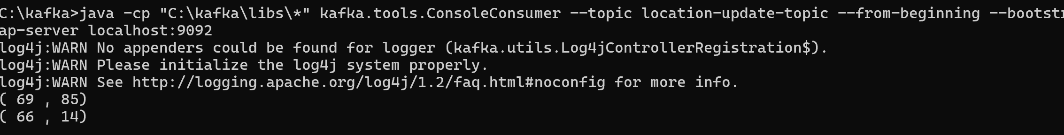
Console consumer reading location-update-topic from the beginning, showing the same (x, y) coordinates produced by the app.
This confirms the messages genuinely live inside the Kafka topic itself — any consumer that subscribes, whether it's the enduser Spring Boot app or a plain CLI consumer, sees the same data.

7. Remaining Points Worth Tightening Up
The group-id mismatch (group=1 vs group-1) and the value-seriaizer typo noted earlier have both since been corrected in the code. Two smaller, optional improvements remain:
Location | Issue
deliveryboyapp KafkaConfig | .partitions() and .replicas() are commented out, so the topic is created with the broker's default of 1 partition / 1 replica — fine for local testing, but worth setting explicitly for parallelism or fault tolerance.
KafkaService.updateLocation() | kafkaTemplate.send() is fire-and-forget; the returned CompletableFuture isn't checked, so a failed send wouldn't be logged or surfaced anywhere in the application.

8. Suggested Next Steps
- Increase partitions on the topic and run multiple consumer instances in the same consumer group to observe load-balanced parallel processing.
- Replace the raw String payload with a proper LocationUpdate DTO, serialized as JSON using JsonSerializer / JsonDeserializer instead of StringSerializer / StringDeserializer.
- Attach a callback to kafkaTemplate.send() to log or handle publish failures instead of firing and forgetting.
- Fix the group-id and serializer typos identified above.

