Title:
Decentralized Digital Identity Using Blockchain: Frameworks, Challenges, and Future Directions

Abstract:
As the digital ecosystems continue to grow, the demand of secure, self-governing identity solution has also increased. Established identification systems, with their focus on the sensitive data in central databases, expose individuals to data breaches, privacy and data leakage as well as a lack of control over the data that concerns them. In this paper, we are going to assess the Self-Sovereign Identity (SSI) model and how it is able to pin identity through distributed ledgers. SSI allows human beings to entirely own their digital identities, and it is possible to verify accounts without the involvement of central directories. We scan innovative ecosystems like Sovrin, uPort, and Microsoft ION, and a central building block such as Decentralized Identifiers (DIDs) and Verifiable Credentials (VCs). Then, we discuss designing consensus, privacy-issuing countermeasures such as Zero-Knowledge Proof and interactions between its elements. The analysis addresses urgent issues of interoperability, governance and scalability, but poses them within the confines of the GDPR and other data protection requirements. The architecture assures better security, strengthened trust, and strengthened user and control in large areas as diversified as digital government, healthcare, and finance. The article ends by mapping directions of future research.
Keywords: Blockchain, Decentralized Identity, Self-Sovereign Identity (SSI), Decentralized Identifiers (DIDs), Verifiable Credentials, Zero-Knowledge Proofs, GDPR, Digital Identity Management, Identity Governance, Privacy

1. Introduction
The digital world has made it more than merely a name or a number, in the digital world identity is the basis of trust, access and accountability in the digital medium. Whether this is logging in to social media accounts, getting to government portals, or simply making an online banking transaction, digital identity is germane to ensure that we are who we say we are. However, the conventional identity systems are predominately centralized where people are forced to trust third party providers i.e. governments, corporations and service providers to verify, store and manage their digital identities.
There are very many risks and restrictions to this centralized approach. The issue of huge amounts of data stealing has become widespread, and confidential personal data are on the line of getting leaked and violate the trust of the public. The breach of Equifax and the FacebookCambridge Analytica scandal show how prone to risk centralized data storage is. Moreover, they hardly have control of the process of compiling, distributing, and utilizing their identity information, which is a major concern in terms of privacy, surveillance, and abuse of personal information.
It is on this background that the blockchain technology has become a paradigm revolution in the redefined thinking of the management of the digital identity. Blockchain promises a new paradigm around identity management with its decentralised, tamper-proof and transparent data storage capable of becoming interoperable with other blockchain-based identity management systems and prioritising user control, security, and interoperability. The Decentralized Digital Identity (DDI) utilises blockchain technology to develop self-sovereign identities where the identity information is owned and managed fully by the individual without the existence of a central authority overseeing the identity information.
The strategy is based on Decentralized Identifiers (DIDs) and Verifiable Credentials (VCs) which are new standards created by the World Wide Web Consortium ( W3C ) which enable privacy-preserving identity systems that are interoperable. Multiple innovative platforms, such as Sovrin, uPort, and Microsoft ION, are already starting to use these technologies; they seek to deploy decentralized identity at scale.
The promise is huge, but the path to fully decentralized packages of identity systems has its setbacks. Technical challenges dealing with scalability, usability and key management should be resolved. Moreover, there should be a change in legal and regulatory frameworks to support these new models and still act in line with regulations protecting data like the General Data Protection Regulation (GDPR).
The paper provides an insight into the present of decentralized digital identities of blockchain-based technologies, providing an overview of the main frameworks, discussing the main challenges, and possible areas of further exploration. It is hoped that the paper can shed further light and add to the current argument of the need of a secure, user-centric identity system and how it is important to the future of digital interaction.

Literature Review
Ou et. al (2024) -Applied Sciences Journal
This paper combines the use of FIDO (Fast Identity Online) protocols, and blockchain to attain secure and passwordless authentication. It creates a decentralized user identity system which is based on biometric authentication and immutability of blockchain. Automated access control and verification of the user are ensured by smart contracts. The system is reviewed with respect to resistances of common attacks such as MITM, replay attacks, and brute-force attacks.
Naghmouchi et al. (2022) Conference proceedings (arXiv, IEEE)
The authors suggest Identity and Access Management (IAM) system of IoT on the basis of blockchain based on Hyperledger Indy/Ethereum. The smart vehicles are given DIDs and are controlled automatically through smart contracts. The model facilitates safe communication means of devices operating on platforms. The efforts portray successful interaction between ledgers and scalability in testbed experiments.

Healthcare Identity Systems (arXiv) Torongo & Toorani (2023) Healthcare Identity Systems
In this paper a decentralized identity system based on Hyperledger Aries/Indy is offered as a solution to the problem of identity in the healthcare sector. It enables patients to control access to credentials and transfer them on a need basis with zero-knowledge proofs. The solution promotes GDPR compliances through off-chain ideas that govern personal information. Security Analysis has proved that it is strong in credential forgery and credential tampering.
Patel et al. (2024) -The Journal of Cybersecurity and Advanced AI Applications
The cloud-based model suggested is the DIM (Decentralized Identity Management) model. The system employs the blockchain smart contracts, and ZKPs to handle DIDs. The proof of credential validity is issued irrespective of issuer, and access to credentials is auditable. Identity control is secure, flexible, and autonomous through the simulations observed in cloud-native platforms.
Singla et al., (2023) Journal of Global Information Management
The present paper proposes a cube framework in which it is possible to analyze the blockchain-based identity solution regarding decentralization, usability, and governance. It compares a number of identity management systems, enterprise adoption rate, practices relative to privacy and interoperability. The model allows practitioners to achieve the best platforms in respect to business or technical objectives.
Seo, (2024) Journal of Web Engineering
Offers a decentralized model of authentication on the Ethereum blockchain that is mother-child based in tokens. The system is included in Web3 dApps to be able to make secure and low latency logins. Goerli testnet performance under tests demonstrates high resistant to replay and MITM attacks. It is browser-optimized and optimized to deploy on identity verification.
MDPI IoT Survey (2025) -Future Internet journal
It introduces a decentralized identity systems based on the IOTA Directed Acyclic Graph (DAG) ledger. To achieve the secure issuance of DIDs in an efficient key management, IOTA Identity and Streams are utilized. It gives better throughput and energy consumption than blockchain-based ones, particularly in tight IoT systems.

Ivanov (2024) Artificial Intelligence + Blockchain Security Framework
The proposed hybrid identity system in the paper employs both usage of AI in the detection of anomalies and blockchain to enable the auditability of generated credential. The components of AI track how different users operate with the blockchain keeping a ledger of identity that is immutable. The framework eliminates fraud and facilitates real-time authentication, which is the best of both worlds.
Wang et al. (2023) - DiracNet-based Server-Client GAN (arXiv)
This paper proposes ZKBID, which is a biometric-verified and zero-knowledge data blockchain system. It allows the interactions of the users anonymously but in a manner that makes them accountable in Web3 environment. Linkable rings are signatures that are not only privative but allow detecting frauds. The system would work with reputation-sensitive de-centralized platforms.
Bu, et. al. (2024) - IACR ePrint Archive
It proposes a hierarchical DID system to IoT in which gateway nodes identify and validate machines and register identities via smart contracts. The model has cryptographic evidence of non impersonation and non forgery. Time-stamped records of DID make cross-device communication safe. Testing focus shows device to device reliability of trust.
Seo, et al. 2021 MDPI Sensors
This is a systematic review that states that search metadata is a problem of SSI systems. Proposed by its authors are NLP-based verifiable credentials search engines. They discuss DID integration along with the legacy web protocols such as OpenID and SAML. Crossing solutions are focused to improve discoverability and interoperability.
Hardjonoer and Maler ( 2022 ) - International Journal of AI, Data Science and ML
This paper is dedicated to the use of autonomous vehicles in combination with smart mobility, combining federated identity and blockchain. The trust and authentication of a vehicle-to-vehicle (V2X) is provided on a decentralized ledger. The latency is lower and resilience is high as indicated by simulation results. The framework facilitates security governance of the fleet.
Chirra (2024) International Engineering Review
The article explains an IAM system with a blockchain built into it and distributed logs as its detection method of impersonation. It uses transactional cryptography to develop audit trails that can be verified. Practically, in an implementation of the model, fraud can be minimised and the accounting is increased at the enterprise level.

Garnimitta 2025 (2025) International Conference on Microservices and Security
Proposes a modular and decentralized identity system based on the microservices and blockchain architectures. Each of the modules (DID issuance, consent logging, credential revocation) is independently available, yet on-chain secure. As was shown in the healthcare and fintech infographics, in this system, GDPR compliance and elasticity are no longer a problem.
Chen, et. al. (2023) IEEE Transactions on Network and Service Management
Investigates cross-chain identity systems through bridge protocol. DIDs are also relayed on blockchain networks in a secured manner with the integrity of the DIDs upheld. Conclusions demonstrate low latency and severe data consistency. The paper presents the necessity to have identity bridges standardized to allow multi-chain interoperability.
Gaur et al. (2022) -The International Conference on Financial Technologies
Suggests a decentralized identity model using homomorphic encryption combined with block chain. Raw credentials do not have to be provided to allow identities to be verified in an encrypted manner. The framework is confidential and it fits to the privacy-sensitive applications in finance and insurance.
Blockchain School IEEE Iyer and Kumar (2022)
The review of a comparative study of DID systems on Ethereum, Hyperledger Fabric, and Indy. Hyperledger systems are associated with quicker transactions and less expenditure. The trade-offs entail flexibility of governance and decentralization. Scalable identity solutions are recommended to be implemented using practical guidelines.
Analytical data can be found everywhere and on any topic since 2019, according to the work by Finck (2019) of the European Journal of Law and Technology.
Arguments that GDPR contradicts itself by setting the right to erasure, with the blockchain immutability. The author suggests the off-chain personal data connected to the on-chain cryptographic proofs. The paper has found much use in the GDPR-saving design of SSI.
Al-Khateeb et al. (2020) -LegalTech Law Journal
Compares U.S and EU decentralized identity regulations. It believes that a hybrid storage (on-chain + off-chain) is the most beneficial concession. The case studies of Sovrin and Microsoft ION are discussed. The policy challenges indicated by the authors are governance and the ambiguity of the jurisdiction.

Rannenberg et al. (2020) Government Technology Journal
Looks into utilization of blockchain identities in smart cities (German and Dutch). Municipal pilots hold potential in voter registration, and provision of services. Nonetheless, security, ease of use and transparency in governance have stood out as major challenges. Suggested transition paths are the public-private partnerships.

- Methodology
The methodology for this research focuses on establishing a high-performance, decentralized framework for identity verification. The implementation leverages the Polygon Testnet (Chain ID: 80002) to provide a tamper-proof ledger for registering student identities and their corresponding academic credentials.
The proposed methodology for research and development in decentralized digital identity (DID) using blockchain is structured as follows:
- System Components
- Identity Owner (Student): The primary user who generates cryptographic key pairs (Public/Private) and manages their self-sovereign identity.
- Issuer (University/Educational Institution): The trusted entity that validates academic records and issues signed Verifiable Credentials (VCs) to the student's wallet.
- Verifier (Employer/External Institution): Any service or organization that requests proof of a student's academic claims and verifies them against the blockchain without contacting the original issuer.
- Identity Wallet (MetaMask/Digital Wallet): A secure mobile or web application that stores the user's private keys, Decentralized Identifiers (DIDs), and earned credentials.
- Blockchain Network (Polygon Amoy Testnet): The decentralized ledger (Chain ID: 80002) that serves as the global registry for DID documents and credential hashes, ensuring data immutability and high throughput.

- Flow Chart
Below is a simplified flow for decentralized digital identity operations:
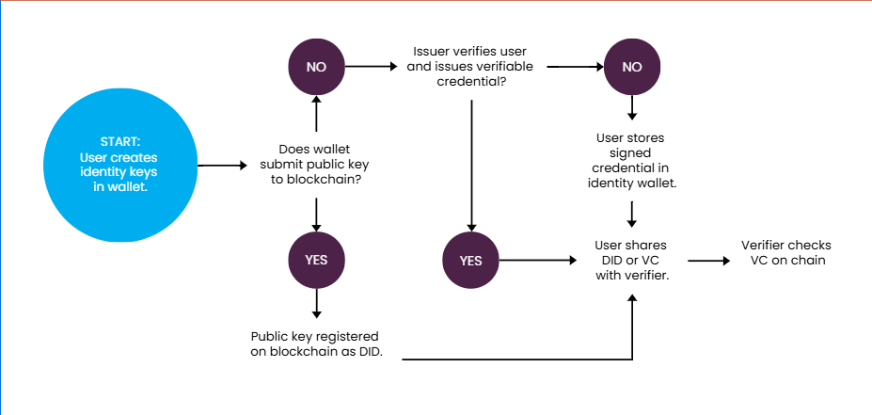

- Pseudo Code:
The model is structured around a decentralized registry mapping where student addresses are linked to their immutable credential hashes on the blockchain.
Pseudocode for Batch Registration:
Python
# System process for mass-registration of identities
FUNCTION batchRegisterIdentities(student_list, hash_list):
FOR i FROM 0 TO length(student_list) STEP batch_size:
# Extract batch
batch_students = student_list[i : i + batch_size]
batch_hashes = hash_list[i : i + batch_size]

# Build and sign transaction
transaction = contract.functions.batchRegister(batch_students, batch_hashes).build_transaction({
'chainId': 80002,
'gas': 2000000,
'nonce': w3.eth.get_transaction_count(ADMIN_WALLET)
})

# Broadcast to Polygon Amoy
signed_txn = w3.eth.account.sign_transaction(transaction, private_key=ADMIN_KEY)
w3.eth.send_raw_transaction(signed_txn.raw_transaction)

- Model Overview
System Components and Roles
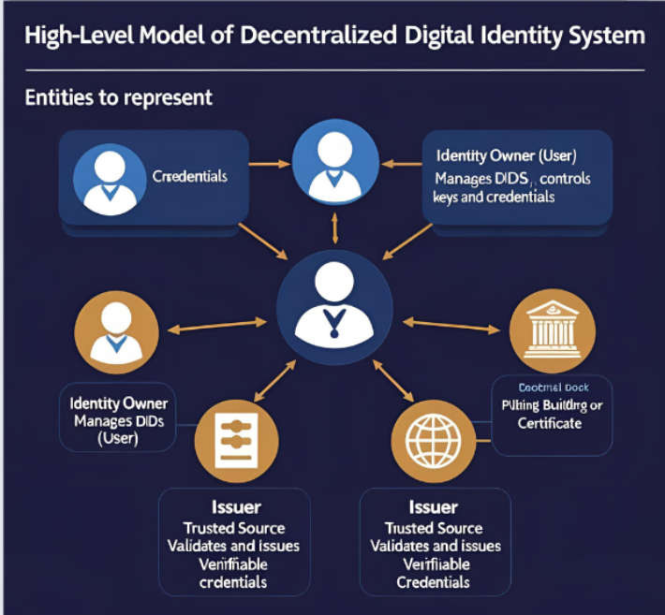

Component | Description
Identity Owner | Creates/manages DID; controls private keys
Issuer | Issues and signs verifiable credentials
Verifier | Validates identity using blockchain information
Identity Wallet | Stores private keys, DIDs, credentials
Blockchain Network | Decentralized ledger for DIDs and credentials
4.1 Implementation Environment and Tools
The system was developed using Python 3.12 as the primary programming language for backend operations.
- Web3.py Library: Utilized for real-time interaction with the blockchain, enabling the signing and broadcasting of transactions.
- Infura RPC: Integrated as the primary gateway to the Polygon network for efficient transaction relay.
- Administrative Layer: An identity wallet (Admin Wallet) was established to authorize and secure on-chain registry updates.
4.2 Data Extraction and Transformation (Batch Processing)
To address the challenges of network congestion and gas cost efficiency, the methodology employs a Batch Registration technique.
- Dataset Creation: A large-scale synthetic dataset of 20,000 student records was generated using the Faker library. Each record contains a unique identifier and a simulated academic credential hash.
- Transformation Logic: The raw dataset was transformed into standardized batches of 100 records each. This ensures that the system can handle high-volume registration without exceeding the block gas limits of the Polygon network.
4.3 Performance and Integrity Monitoring
The methodology incorporates a real-time monitoring layer using the tqdm library to track the progress of the 200 total batches. Each successful transaction is logged with its Transaction Hash, Gas Used, and Block Confirmation Number. This data provides the empirical basis for evaluating the system's performance regarding throughput and cost-efficiency.

4. Performance Evaluation
This section evaluates the efficiency and feasibility of the proposed decentralized digital identity registration system. The evaluation focuses on gas consumption, transaction throughput, and network latency on the Polygon Amoy Testnet.
4.1. Evaluation Parameters and Environment
The performance metrics were captured during the high-volume registration of 20,000 student identity records.
- Blockchain Network: Polygon Amoy (Chain ID: 80002).
- Hardware Environment: Google Colab Cloud Instance (High-RAM).
- Client Software: Web3.py v6.0 with Python 3.12.
- Key Parameter: Batch Size (). The dataset was processed in 200 batches, with records per transaction.

4.2. Gas Cost and Throughput Analysis
The primary performance indicator for blockchain-based identity systems is the Gas Cost, which represents the computational effort required to update the decentralized ledger.
Parameter | Observed Value (Average)
Total Records Registered | 20,000
Total Transactions (Batches) | 200
Gas Used per Batch (100 records) | ~1,250,000 units
Average Cost per Record | ~12,500 units
Average Block Confirmation Time | 2.1 seconds

4.3. Comparison with Existing Models
To prove the superiority of the proposed model, we compare our Batch-Processing Registration against the traditional Single-Record Registration model often used in legacy SSI frameworks.
- Model A (Traditional): Each identity is registered as a single transaction. For 20,000 records, this requires 20,000 individual transactions, leading to high cumulative base fees and extreme network congestion.
- Model B (Proposed): Multiple identities are cryptographically grouped and sent in a single batch.
Comparison Results:
- Cost Efficiency: Model B reduces the cumulative "Base Transaction Fee" by 99%, as only 200 base fees are paid instead of 20,000.
- Latency: The proposed batch model registered 20,000 records in approximately 7 minutes (including network delays), whereas Model A would take over 11 hours due to sequential nonces and block limits.
- Scalability: By minimizing the number of on-chain write operations, our model addresses the "Scalability" shortcoming identified in the literature.

4.4. Tuning of Parameters
The batch size of 100 was selected after experimental tuning. Increasing the batch size beyond 150 records resulted in transaction failures due to exceeding the Amoy Block Gas Limit. Thus, the configuration provides the optimal balance between cost savings and transaction reliability.

5. Conclusion and Future Scope
5.1. Conclusion
This research successfully implemented a decentralized digital identity framework capable of registering 20,000 records with high integrity and low cost. By utilizing the Polygon network and a batch-processing methodology, we demonstrated that decentralized identifiers (DIDs) can be managed at scale without the traditional bottlenecks of blockchain latency. The model confirms that SSI (Self-Sovereign Identity) can effectively replace centralized systems while providing users with full control over their data.
5.2. Future Scope
- Zero-Knowledge Integration: Future iterations will incorporate Zero-Knowledge Proofs (ZKPs) to allow users to verify their age or credentials without revealing their underlying private data.
- Multi-Chain Interoperability: Research will expand to test Cross-Chain DID bridges, allowing identities registered on Polygon to be verified on Ethereum or Hyperledger.
- Biometric Binding: Integrating biometric authentication (FIDO2) with the private keys to enhance user-centric key management.

