**CSYE7280 Assignment 1  
Sushmita Maity (001092534)**

Doordash is a SF based on-demand prepared food delivery service available in web version and as mobile app version.

This is a review of the Doordash iOS app.

**Part 1:**

**Cool User Experience Aspects/Features:**

1. Easy selectable pickup and delivery options available on landing page & on all restaurant pages.  
   Graphical user interface, application

   Description automatically generated



1. Group order feature: It lets share a common order link with friends/family to place an order together under the same bill. This feature also includes the ability to order from multiple places on single order.  
   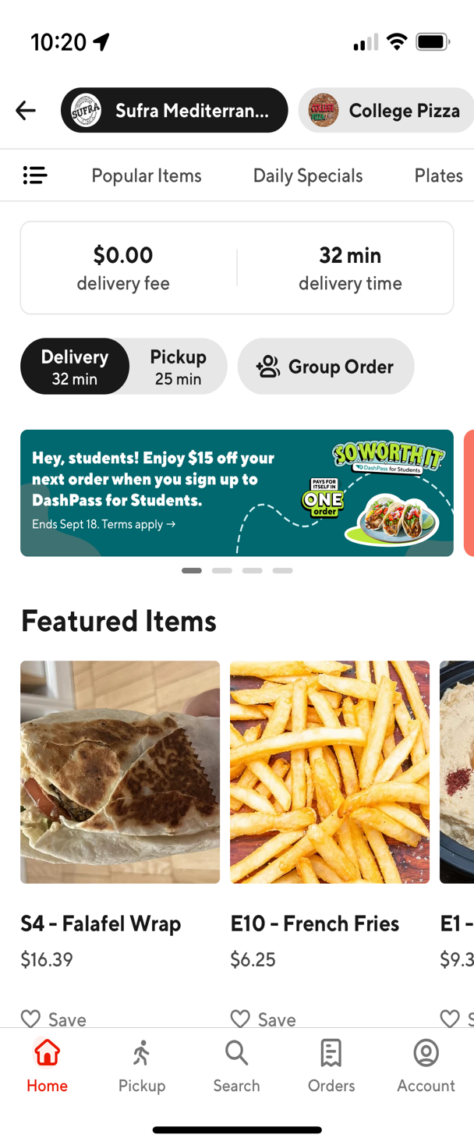Graphical user interface, application

   Description automatically generated



1. Save favorite restaurant store feature which is visible in my accounts page. Restaurants saved can be easily accessed here.  
   Graphical user interface, application

   Description automatically generated



1. The other options to shop in the same app are appreciable. It provides an easy option of one stop solution for grocery, convenience etc.  
   Graphical user interface, application

   Description automatically generated



1. Items in the restaurant are rated if popular/most ordered ensuring great options for the user.



**Improvements:**

1. Current mobile application does not have a search bar on the landing page instead has a search icon which is not very visible. A search bar helps in quick search of stores/ dishes/ products which is the goal of the app.
2. The search results are not sorted according to ratings/distance/price/delivery time which makes scrolling and finding right option disconnected. In the current button filters, an additional feature could be added to filter/sort the results for ratings, distance, price. New filter suggestions: Open now, delivery time.
3. After adding desired items on cart, editing the current item is not simple. The item must be long pressed which is not very user intuitive. An edit button could be added to easily edit the current added item in the cart.
4. Calls from unidentified number during delivery by dasher/Lack of live chat with the dasher (who will be delivering the order). Although updates are provided and order can be tracked, there could be need to contact the dasher for any delivery issues.
5. Placement of restaurant suggestions ordering could be in a more relevant manner. Places previously ordered, and nearby restaurants which are open and most ordered from cards should be suggested on top than other restaurants.
6. Food restrictions filter, for example vegetarian filter.

**Part 2:**

**Lightweight Use Cases:**

|  |  |
| --- | --- |
| **Use Case 1** | **Better placement of cards** |
| **Actor** | **Doordash Customer** |
| **Basic Flow** | Customer logs in/ opens the door dash app to order.  Customer is suggested with nearby currently delivering restaurants and places previously ordered from with promotions. |

**Middleweight Use Cases:**

|  |  |
| --- | --- |
| **Use Case 2** | **Search** |
| **Actor** | **Doordash Customer** |
| User searches stores/products/dishes to place order from the search bar. |  |
| **Alternative Flow 1** | Customer types food item on search bar and gets suggested with food restaurants having that dish delivering nearby. |
| **Alternative Flow 2** | Customer types specific restaurant on search bar and gets search results as restaurants delivering currently. |
| **Alternative Flow 3** | Customer searches for options from previously placed search suggestions and gets search results. |

|  |  |
| --- | --- |
| **Use Case 3** | **Checkout** |
| **Actor** | **Doordash Customer** |
| After adding the item to cart, if the user wants to edit the item order, an edit button is available beside the delete button to edit the order. |  |
| **Alternative Flow 1** | Customer edits already added food item by clicking on edit button, by adding more customized toppings |
| **Alternative Flow 2** | Customer edits added food items, by increasing ordered units. |
| **Alternative Flow 3** | Customer edits added food items, by adding customized instructions. |

**Heavyweight Use Cases:**

|  |  |
| --- | --- |
| **Use Case 4** | **Filtering** |
| **Actor** | **Doordash Customer** |
| **Use Case Overview** | After searching for options, the search results are displayed with a default sorted manner. Also, there are options to sort the results according to parameters: ratings/ distance/ price. |
| **Subject Area** | **Customer filters the search results.** |
| **Trigger** | **Searched food item/resutaurant will show search results.** |
| **Precondition 1** | **Customer should be logged in/signed up.** |
| **Precondition 2** | **Customer should search for items/restaurants.** |

**Basic Flow:**

|  |  |
| --- | --- |
| **Description** | **Customer searches for product and finds the desired product by filtering/ applying filters.** |
| **1.** | **Customer searches for food/restaurant.** |
| **2.** | **Search results are populated in the UI.** |
| **3.** | **Customer can see 3 filters: restaurant/ food item ratings, distance and estimated time filter and price filter.** |
| **4.** | **Customer filters/ chooses to sort results by low to high prices.** |
| **5.** | **Customer sorts restaurants by nearest to farthest.** |
| **6.** | **Customer filters the restaurants above 4 ratings.** |
| **Termination Outcome** | **Customer finds desired product quicker by sorting results in ascending to descending or vice versa in desired filter area: distance/ price/ ratings.** |

**Alternative Flow 4A:**

|  |  |
| --- | --- |
| **Description** | **Customer wants the search results to be sorted by minimum to max price and distance.** |
| **4A1** | **Customer searches for food items.** |
| **4A2** | **Search results are displayed with a default filter set by customer as high to low ratings.** |
| **4A3** | **Customer first selects price filter to show results with high ratings and minimum to high price.** |
| **4A4** | **Customer secondly selects distance filter to show results filtered on top of the price which are nearest.** |
| **4A5** | **Results are displayed which are nearest with price from low to high.** |
| **Termination Outcome** | **Customer can select from results with the optimized desired price range and distance.** |

**Alternative Flow 4B:**

|  |  |
| --- | --- |
| **Description** | **Customer wants the highest rating restaurant which is nearest.** |
| **4B1** | **Customer places search for restaurants with default filter as low to high price.** |
| **4B2** | **Search results are displayed to cutomer.** |
| **4B3** | **Customer applies distance filter to get the nearest to farthest restaurants delivering.** |
| **4B4** | **Customer adds highest rating filter.** |
| **4B5** | **Search results with highest ratings and nearest restaurants are populated on the UI.** |
| **Termination Outcome** | **Customer can select restaurant which is nearest and has the highest rating so that they can decide to deliver or pick up.** |

|  |  |
| --- | --- |
| **Use Case 5** | **Identifiable calling number** |
| **Actor** | **Doordash Customer** |
| **Use Case Overview** | When dasher reaches the customer’s location, dasher places call to the user to notify that the order has reached from an identifiable number marked from Doordash. |
| **Subject Area** | **Successful delivery after placing order** |
| **Trigger** | **Dasher will arrive to deliver order to customner.** |
| **Precondition 1** | **Customer should be logged in/signed up, searched for desired items/restaurants.** |
| **Precondition 2** | **Customer should have added items to cart and placed order.** |

**Basic Flow:**

|  |  |
| --- | --- |
| **Description:** | **Customer receives phone call from identifiable Doordash marked business phone number so that it does not show spam or customer does not miss call.** |
| **1.** | **Customer places order.** |
| **2.** | **Dasher picks up order and commutes to location.** |
| **3.** | **Dasher places call to customer to pick up package.** |
| **4.** | **Customer receives call from verified phone number and recognizes order from Doordash.** |
| **5.** | **Customer receives phone call and is able to collect order from dasher.** |
| **Termination Outcome** | **Customer can receive order successfully by getting in touch with the dasher.** |

**Alternative Flow 5A:**

|  |  |
| --- | --- |
| **Description** | **Customer’s delivery location is not very clear from the map, and the dasher calls the customer to find location accurately** |
| **5A1** | **Customer has placed order with no special instructions to find their ambiguous address.** |
| **5A2** | **Dasher collects order and commuted near address.** |
| **5A3** | **Dasher is not sure about the final location for delivery.** |
| **5A3** | **Dasher places phone call to customer before estimated time delivery to confirm location.** |
| **5A4** | **Customer picks up phone call from dasher.** |
| **5A4** | **Dasher and customer communicate successfully and are able to meet to complete the order.** |
| **Termination Outcome** | **Dasher can locate the location and successfully complete order delivery.** |

**Alternative Flow 5B:**

|  |  |
| --- | --- |
| **Description** | **Customer missed initial calls coming from dasher because phone was silent causing the dasher to call again and wait for delivery** |
| **5B1** | **Customer placed order.** |
| **5B2** | **Dasher has arrived location to deliver order.** |
| **5B3** | **Dasher places call to customer.** |
| **5B4** | **Customer misses call as their phone is on silent. And then sees the missed phone calls.** |
| **5B5** | **Customer immediately picks up phone call as they recognize the verified phone number from Doordash.** |
| **5B6** | **Dasher can communicate that he has arrived the location.** |
| **Termination Outcome** | **Dasher can successfully deliver order when Customer picks up call from verified phone number.** |