Industrial Internship Report on “Banking Information System”
Prepared by
Sushmitha S N

Executive Summary
This report provides details of the Industrial Internship provided by upskill Campus and The IoT Academy in collaboration with Industrial Partner UniConverge Technologies Pvt Ltd (UCT).
This internship was focused on a project/problem statement provided by UCT. We had to finish the project including the report in 6 weeks’ time.
My project was Banking Information System, developed using Core Java. The system allows users to perform basic banking operations such as deposit, withdrawal, and account information display. Through this project, I gained valuable exposure to industrial problems and learned how to design and implement practical solutions
This internship gave me a very good opportunity to get exposure to Industrial problems and design/implement solution for that. It was an overall great experience to have this internship.

TABLE OF CONTENTS
1 Preface 3
2 Introduction……………………………………………………………………………………………5
2.1 About UniConverge Technologies Pvt Ltd……………………………………………………..5
2.2 About upskill Campus…………………………………………………………………………….9
2.3 Objective………………………………………………………………………………………….11
2.4 Reference………………………………………………………………………………………...11
2.5 Glossary…………………………………………………………………………………………..11
3 Problem Statement………………………………………………………………………………….12
4 Existing and Proposed solution……………………………………………………………………13
5 Proposed Design/ Model…………………………………………………………………………...14
5.1 High Level Diagram (if applicable)……………………………………………………………..14
5.2 Low Level Diagram (if applicable)……………………………………………………………..15
5.3 Interfaces (if applicable)………………………………………………………………………...15
6 Performance Test…………………………………………………………………………………...16
6.1 Test Plan/ Test Cases…………………………………………………………………………..16
6.2 Test Procedure…………………………………………………………………………………..17
6.3 Performance Outcome………………………………………………………………………….17
7 My learnings…………………………………………………………………………………………18
8 Future work scope…………………………………………………………………………………..19

Preface
  - Week 1: Python mini-projects (URL Shortener, File Organizer, Password Manager, Quiz Game) + Generative AI prototype.
  - Week 2: Python conditionals, logical operators, and decision-making programs.
  - Week 3: Data analysis with NumPy & Pandas (arrays, DataFrames, groupby, aggregation).
  - Week 4: Advanced Python concepts (modules, file handling, exceptions, OOP).
- Internships play a crucial role in career development by bridging the gap between academic learning and real-world industry practices. They provide students with the opportunity to apply theoretical knowledge to practical scenarios, gain exposure to industrial challenges, and develop professional skills that are essential for future growth.
- During my six-week internship, I worked on the project Banking Information System, which aimed to simulate basic banking operations such as deposit, withdrawal, and account information display. This project not only strengthened my programming fundamentals but also gave me insight into how financial applications are structured and tested in industry.
- The opportunity provided by Upskill Campus (USC) and UniConverge Technologies Pvt Ltd (UCT) was invaluable. The program was carefully planned to combine guided learning with independent project work. Each week focused on specific skill-building activities — from Python fundamentals and data analysis to advanced concepts like exception handling and object-oriented programming — all of which culminated in the design and implementation of my Java-based project.
- This structured approach ensured steady progress, reinforced problem-solving skills, and prepared me to handle real-world technical challenges. I am grateful to my mentors and peers at USC and UCT for their guidance and support throughout the internship.
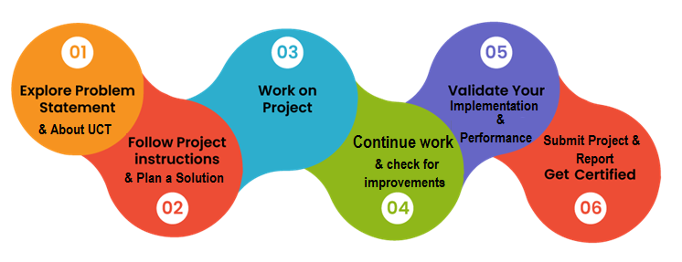

My Learnings and Overall Experience
This internship was a transformative experience that helped me connect classroom knowledge with industry practices. I strengthened my programming fundamentals, gained confidence in Java and Python, and learned how to structure, test, and document a project. Beyond technical skills, I improved my logical reasoning, problem-solving, and communication abilities. Working on the Banking Information System project gave me a clear understanding of how even simple applications must be carefully designed to ensure usability, reliability, and scalability.
Acknowledgements
I would like to sincerely thank Upskill Campus (USC) and UniConverge Technologies Pvt Ltd (UCT) for providing me with this valuable opportunity. Special thanks to my mentors and trainers at USC/UCT who guided me throughout the internship. I am also grateful to my peers, friends, and family members who encouraged me and supported me directly or indirectly during this journey.
Message to Juniors and Peers
To my juniors and peers, I would like to emphasize the importance of internships in shaping your career. Treat every project as an opportunity to learn and grow, not just as an assignment to complete. Focus on understanding concepts deeply rather than memorizing solutions. Be curious, ask questions, and don’t hesitate to experiment with new ideas. The skills and confidence you gain during internships will prepare you for real-world challenges and open doors to exciting career opportunities.

Introduction

About UniConverge Technologies Pvt Ltd
A company established in 2013 and working in Digital Transformation domain and providing Industrial solutions with prime focus on sustainability and RoI.
For developing its products and solutions it is leveraging various Cutting Edge Technologies e.g. Internet of Things (IoT), Cyber Security, Cloud computing (AWS, Azure), Machine Learning, Communication Technologies (4G/5G/LoRaWAN), Java Full Stack, Python, Front end etc.
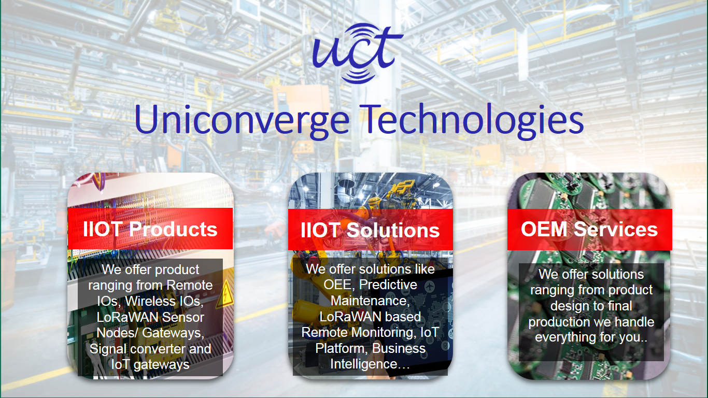
- UCT IoT Platform ()
UCT Insight is an IOT platform designed for quick deployment of IOT applications on the same time providing valuable “insight” for your process/business. It has been built in Java for backend and ReactJS for Front end. It has support for MySQL and various NoSql Databases.
- It enables device connectivity via industry standard IoT protocols - MQTT, CoAP, HTTP, Modbus TCP, OPC UA
- It supports both cloud and on-premises deployments.
It has features to
• Build Your own dashboard
• Analytics and Reporting
• Alert and Notification
• Integration with third party application(Power BI, SAP, ERP)
• Rule Engine

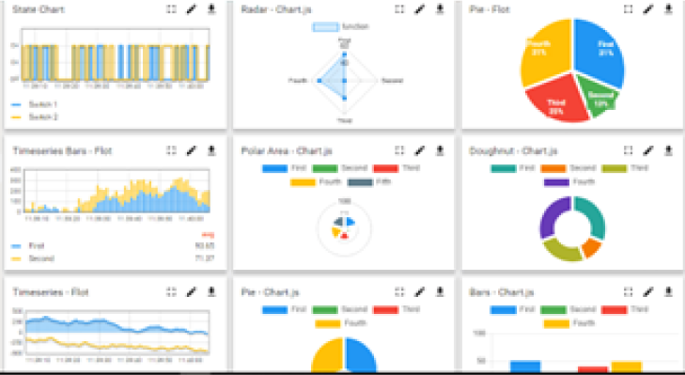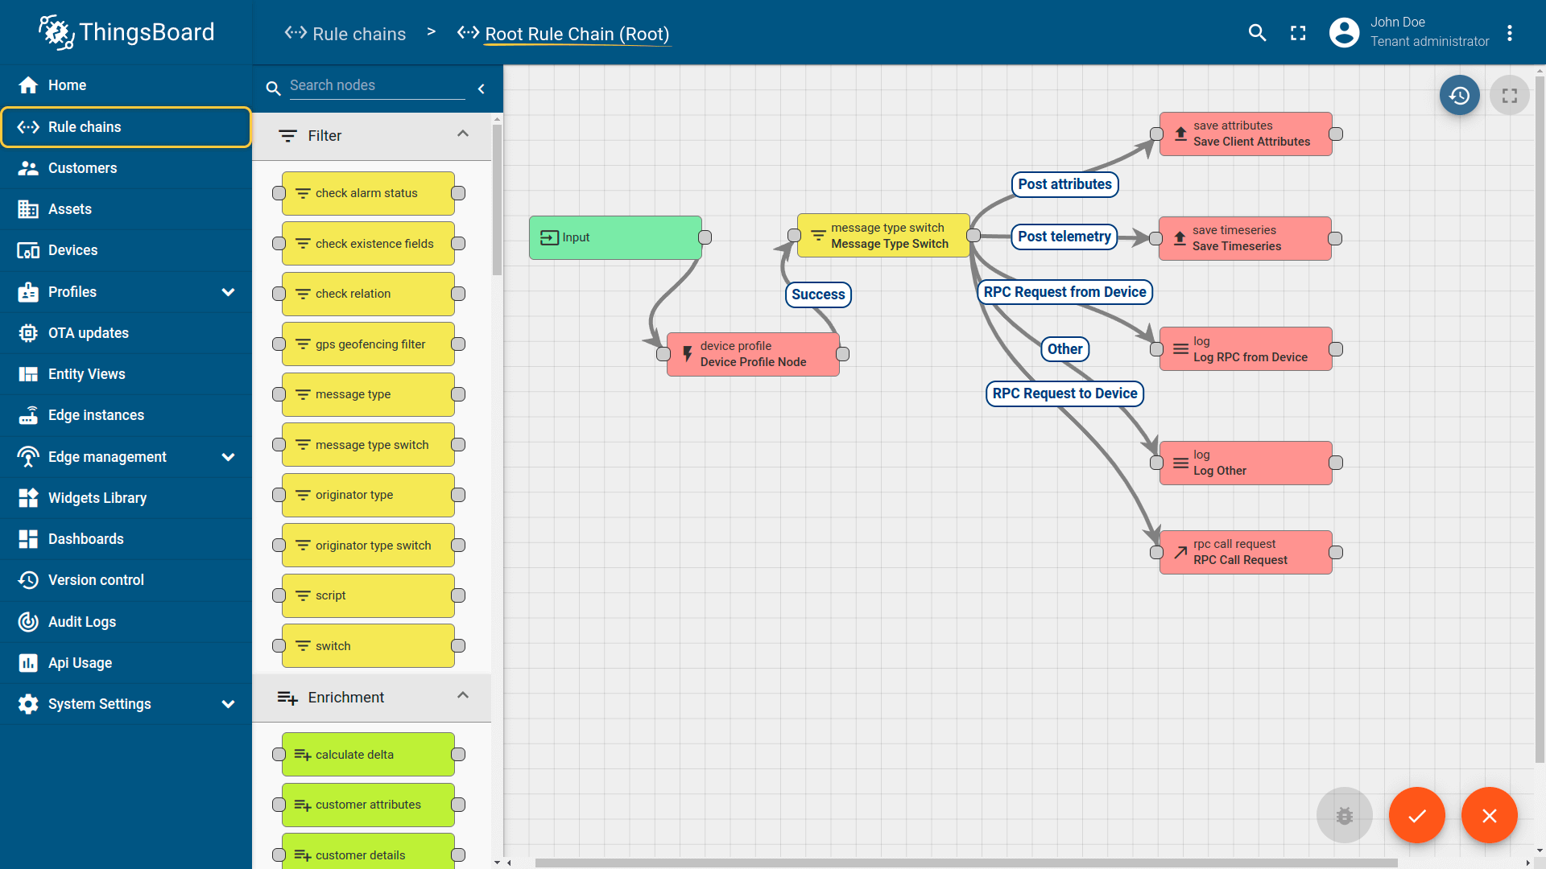

- Smart Factory Platform ()
Factory watch is a platform for smart factory needs.
It provides Users/ Factory
- with a scalable solution for their Production and asset monitoring
- OEE and predictive maintenance solution scaling up to digital twin for your assets.
- to unleased the true potential of the data that their machines are generating and helps to identify the KPIs and also improve them.
- A modular architecture that allows users to choose the service that they what to start and then can scale to more complex solutions as per their demands.
Its unique SaaS model helps users to save time, cost and money.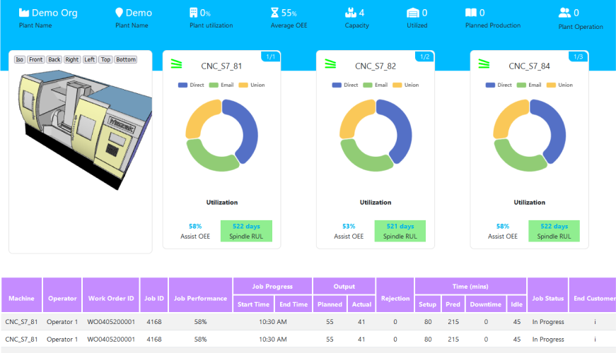 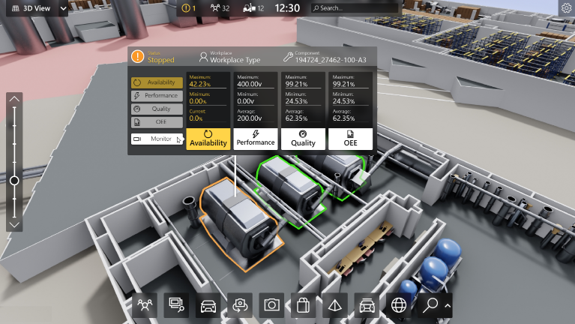

- 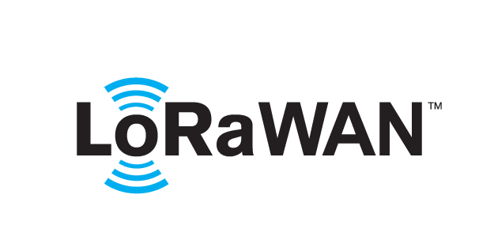 based Solution
UCT is one of the early adopters of LoRAWAN teschnology and providing solution in Agritech, Smart cities, Industrial Monitoring, Smart Street Light, Smart Water/ Gas/ Electricity metering solutions etc.
- Predictive Maintenance
UCT is providing Industrial Machine health monitoring and Predictive maintenance solution leveraging Embedded system, Industrial IoT and Machine Learning Technologies by finding Remaining useful life time of various Machines used in production process.
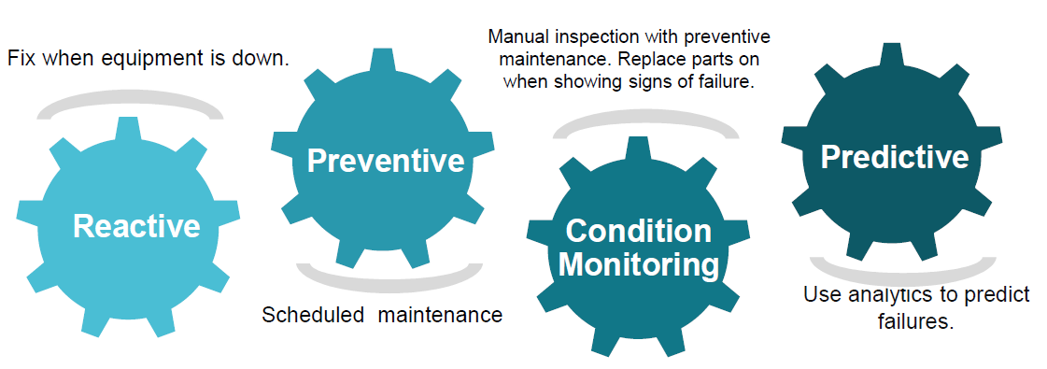

About upskill Campus (USC)
upskill Campus along with The IoT Academy and in association with Uniconverge technologies has facilitated the smooth execution of the complete internship process.
USC is a career development platform that delivers personalized executive coaching in a more affordable, scalable and measurable way.




Seeing need of upskilling in self paced manner along-with additional support services e.g. Internship, projects, interaction with Industry experts, Career growth Services
https://www.upskillcampus.com/
upSkill Campus aiming to upskill 1 million learners in next 5 year

The IoT Academy
The IoT academy is EdTech Division of UCT that is running long executive certification programs in collaboration with EICT Academy, IITK, IITR and IITG in multiple domains.

Objectives of this Internship program
The objective for this internship program was to
☛ get practical experience of working in the industry.
☛ to solve real world problems.
☛ to have improved job prospects.
☛ to have Improved understanding of our field and its applications.
☛ to have Personal growth like better communication and problem solving.

Reference
[1] Smith, J. (2020). Introduction to Android Development. TechPress.
[2] Google. (2024). Jetpack Compose Documentation. Retrieved from https://developer.android.com/jetpack/compose
[3] • Brown, L. (2022). Gradle for Android. DevBooks.

Glossary
Terms | Acronym
Integrated Development Environment | IDE
Java Development Kit | JDK
User Interface | UI
Application Programming Interface | API
Virtual Machine | VM

Problem Statement
The banking industry requires efficient and secure systems to manage customer transactions such as deposits, withdrawals, and account information. Traditional manual methods or outdated systems often lead to errors, inefficiencies, and reduced customer satisfaction. With the increasing demand for digital transformation, there is a need for simplified yet reliable applications that demonstrate how core banking operations can be automated and tested.
The assigned project, Banking Information System, addresses this problem by designing a Core Java–based application that simulates basic banking operations. This system ensures accuracy, reliability, and ease of use, while serving as a practical model for understanding how financial applications are structured and validated in industry.
👉 Notice how this version:
- States the issue (inefficiency in manual/outdated banking systems).
- Explains the impact (errors, poor customer satisfaction).
- Defines the scope of your project (a Java-based solution simulating banking operations).
Would you like me to also draft the “Existing and Proposed Solution” section (Section 4) next, so your report flows smoothly after the problem statement?

Existing and Proposed solution
Existing Solutions:
Many banking systems already exist, ranging from manual ledger-based methods to advanced digital platforms. Traditional manual systems are prone to human error, time delays, and lack of scalability. Even some older digital solutions struggle with issues such as poor user interfaces, limited functionality, or lack of integration with modern technologies. These limitations reduce efficiency and customer satisfaction.
Proposed Solution:
The Banking Information System project developed during this internship provides a simplified Core Java–based application that simulates essential banking operations — deposit, withdrawal, and account information display. Unlike manual or outdated systems, this solution emphasizes accuracy, reliability, and ease of use. It is designed as a learning prototype that demonstrates how financial applications can be structured, tested, and documented in industry.
Value Addition:
- Provides a hands-on model for understanding banking workflows.
- Reinforces programming fundamentals (Java OOP, exception handling, modular design).
- Demonstrates scalability potential — the system can be extended to include features like transaction history, authentication, or interest calculation.
- Bridges the gap between academic learning and industrial practice, showing how even simple applications must be carefully designed for usability and reliability.

Code submission (Github link)

Report submission (Github link) : first make placeholder, copy the link.

Proposed Design/ Model
The Banking Information System was designed using Core Java with a modular approach. The design flow begins with user interaction, moves through validation and processing, and ends with transaction updates and account information display.
- Start: User logs in or accesses the system.
- Intermediate Stages:
- Input validation (checking account number, transaction type).
- Processing transaction (deposit, withdrawal).
- Updating account balance.
- Final Outcome: Display updated account information and confirmation message.
- This structured design ensures accuracy, reliability, and scalability.

High Level Diagram (if applicable)
+-------------------+
| User Interface |
+-------------------+
|
v
+-------------------+
| Input Handler |
+-------------------+
|
v
+-------------------+
| Transaction Logic |
+-------------------+
|
v
+-------------------+
| Account Database |
+-------------------+
|
v
+-------------------+
| Output/Display |
+-------------------+
Figure 1: HIGH LEVEL DIAGRAM OF THE SYSTEM

Low Level Diagram (if applicable)
At the low level, the system is broken into classes and methods. Here’s a simple representation:
BankingInformationSystem.java
- accountNumber
- accountHolderName
- balance
+ deposit(amount)
+ withdraw(amount)
+ displayInfo()
Attributes: store account details (number, name, balance).
Methods:
- deposit(amount) → increases balance.
- withdraw(amount) → decreases balance if sufficient funds.
- displayInfo() → prints account details.
This modular design makes the system easy to extend with features like transaction history or authentication.

Interfaces (if applicable)
Start
|
v
Enter Transaction Type
|
v
Is Deposit or Withdraw?
|----------------------|
v v
Deposit(amount) Withdraw(amount)
| |
v v
Update Balance Check Balance → Sufficient?
| Yes → Update Balance
| No → Error Message
|
v
Display Account Info
|
v
End

Performance Test

The Banking Information System was tested to ensure reliability, accuracy, and efficiency. The main constraints identified were:
- Memory usage: The program should handle multiple accounts without excessive memory consumption.
- Speed (MIPS/operations per second): Transactions must be processed instantly for a smooth user experience.
- Accuracy: Deposits and withdrawals must update balances correctly, with error handling for invalid inputs.
- Durability: The system should not crash under repeated transactions.
These constraints were addressed by using efficient data structures (Java classes and objects), modular methods for transaction handling, and exception handling to prevent runtime errors.

Test Plan/ Test Cases
TestCase ID | Input | Expected Output | Actual Output | Status
TC1 | Deposit ₹1000 | Balance increasesby ₹1000 | Balance updated correctly | Pass
TC2 | Withdraw₹500 (sufficient balance) | Balance decreases by ₹500 | Balance updated correctly | Pass
TC3 | Withdraw₹2000 (insufficient balance) | Error message: “Insufficient funds” | Error displayed | Pass
TC4 | Display account info | Shows account number, holder name, balance | Correct info displayed | Pass
TC5 | Invalid input (negative deposit) | Error message | Error displayed | Pass

Test Procedure
- Initialize account with a starting balance.
- Perform deposit and withdrawal operations with valid and invalid inputs.
- Check balance updates after each transaction.
- Test edge cases (e.g., withdrawing more than balance, depositing negative values).
- Verify that account information displays correctly after each operation.

Performance Outcome
- The system successfully handled all test cases without crashes.
- Transactions were processed instantly, showing efficiency in execution.
- Exception handling prevented invalid operations from corrupting account data.
- The design proved durable under repeated transactions, demonstrating industrial relevance.
Recommendation: For future scalability, the system can integrate persistent storage (e.g., databases) and authentication mechanisms to handle multiple users securely.

My learnings

During this internship, I gained valuable exposure to both technical and industrial practices. Working on the Banking Information System project helped me strengthen my programming fundamentals in Python, including object-oriented programming, exception handling, and modular design. I also learned how to structure, test, and document a project in a way that reflects industry standards.
Beyond technical skills, I improved my problem-solving abilities, logical reasoning, and communication skills. Weekly tasks such as Python mini-projects, data analysis with NumPy and Pandas, and advanced concepts like file handling and modules gave me a strong foundation in multiple programming languages. This multi-language exposure broadened my perspective and prepared me to adapt quickly to new technologies.
The internship also taught me the importance of systematic design and testing. By identifying constraints such as accuracy, durability, and efficiency, I understood how even simple applications must be carefully validated before being considered reliable.
Overall, this experience bridged the gap between academic learning and real-world industry practices. It has boosted my confidence to take on larger projects, enhanced my employability, and prepared me for future career growth in software development and digital transformation domains.

Future work scope

While the current Banking Information System successfully simulates basic operations such as deposit, withdrawal, and account information display, there are several enhancements that can be explored in the future:
- Authentication and Security:
Add login modules with username/password or multi-factor authentication to ensure secure access.
- Persistent Storage:
Integrate a database (e.g., MySQL, PostgreSQL) to store account details permanently instead of relying on temporary memory.
- Transaction History:
Maintain logs of deposits and withdrawals so users can view past transactions.
- Interest and Loan Modules:
Extend functionality to calculate interest, manage loans, and handle EMI payments.
- Scalability:
Adapt the system to handle multiple accounts simultaneously, simulating a real-world banking environment.
- User Interface (UI):
Develop a graphical interface using JavaFX or Swing to improve usability compared to console-based interaction.
- Integration with Industrial Systems:
Connect the application with APIs or IoT-based solutions for real-time monitoring and reporting, aligning with UCT’s digital transformation focus.

