DIGITAL WELLBEING ANALYTICS
Predicting Smartphone Addiction Using Machine Learning
Project Report
Submitted by: Lavanuru Sushmitha
Course: Bachelor of Technology
Department: Computer Science
College: SR International Institute of Technology
Academic Year: 2023–2027
Contents
1.Abstract 2
2. Problem Statement 2
3. Objectives 2
4. Dataset Description 3
5. Technologies and Tools Used 3
6. Methodology 4
7. Exploratory Data Analysis — Key Findings 5
8. Feature Engineering Results 6
9. Machine Learning Results 6
10. Model Feature Importance 7
11. Prediction System 8
12. Conclusion 9
13. Limitations 9
14. Future Scope 10
15. References 10

1.Abstract
Smartphone usage has become an important part of everyday life, but excessive usage may negatively affect individuals’ daily routines and digital well-being. This project, titled “Digital Wellbeing Analytics: Predicting Smartphone Addiction Using Machine Learning,” analyses smartphone usage patterns and develops machine-learning models to predict the likelihood of smartphone addiction.
The project uses a dataset containing information about screen time, social media usage, gaming, sleep duration, notifications, application usage, stress levels, and other digital habits. Data preprocessing, exploratory data analysis, feature engineering, and machine-learning techniques were applied to understand usage patterns and build predictive models.
Logistic Regression and Random Forest algorithms were trained and evaluated using accuracy, precision, recall, F1-score, and ROC-AUC. A simple prediction system was also developed to accept user details and generate an estimated addiction classification.
The project demonstrates how data science and machine learning can be applied to analyse digital habits and identify patterns associated with smartphone addiction.

2. Problem Statement
Excessive smartphone usage has become a growing digital-wellbeing concern. Users may spend significant amounts of time on social media, gaming, and other smartphone activities without being fully aware of their usage patterns. Therefore, there is a need to analyse smartphone usage data and identify patterns that can be associated with higher levels of smartphone addiction.
This project addresses the problem by applying data analysis and machine-learning techniques to smartphone usage data and developing a predictive system that classifies whether a user is likely to be addicted based on their digital usage patterns.

3. Objectives
- To analyse smartphone usage and digital-wellbeing patterns.
- To clean and preprocess the smartphone usage dataset.
- To perform exploratory data analysis and identify important usage patterns.
- To engineer meaningful features from existing smartphone usage variables.
- To develop machine-learning models for predicting smartphone addiction.
- To evaluate the models using appropriate performance metrics.
- To identify the features that contribute most to model predictions.
- To develop a simple prediction system for new user inputs.

4. Dataset Description
The project uses a smartphone usage and addiction dataset containing 7,500 records and 16 original attributes. Each record represents smartphone usage information for an individual user.
The dataset contains numerical and categorical variables related to smartphone usage, lifestyle, and digital behaviour. The target variable, addicted_label, is used to classify users into two categories: addicted and not addicted.
Important attributes in the dataset include:
- Age
- Gender
- Daily screen time
- Social media usage
- Gaming hours
- Work/study hours
- Sleep hours
- Notifications per day
- App opens per day
- Weekend screen time
- Stress level
- Academic/work impact
- Addiction level
- Addicted label
The dataset contained 7,500 records, with 5,308 records labelled as addicted (1) and 2,192 records labelled as not addicted (0).

5. Technologies and Tools Used
The following technologies and tools were used to develop the project:
Programming Language
- Python
Libraries
- Pandas — data manipulation and analysis
- NumPy — numerical computations
- Matplotlib — data visualization
- Seaborn — statistical visualization
- Scikit-learn — machine learning and model evaluation
- Joblib — saving and loading trained machine-learning models
Development Environment
- Jupyter Notebook
- Anaconda
Data Storage
- CSV files
Documentation
- Microsoft Word

6. Methodology
The project follows a systematic data-science and machine-learning workflow. The major stages are:
1. Data Understanding
The dataset structure, dimensions, columns, data types, missing values, duplicates, and target distribution were examined.
2. Data Cleaning
The dataset was inspected and prepared for analysis. Missing values and duplicate records were checked, and the cleaned dataset was saved separately.
3. Exploratory Data Analysis
Statistical analysis and visualizations were used to understand relationships between smartphone usage variables and the addiction label.
4. Feature Engineering
New features such as total leisure hours, screen-to-sleep ratio, weekend screen-time increase, notification intensity, and productive-time ratio were created to provide additional information to the machine-learning models.
5. Machine Learning
Logistic Regression and Random Forest classification models were trained using the engineered dataset. Categorical variables were encoded and numerical variables were scaled during preprocessing.

6. Model Evaluation
The models were evaluated using accuracy, precision, recall, F1-score, confusion matrices, and ROC-AUC.
7. Prediction System
The trained Random Forest model was saved and used to create a simple prediction system capable of accepting user information and generating an estimated addiction classification

7. Exploratory Data Analysis — Key Findings
Exploratory Data Analysis (EDA) was performed to understand the relationship between smartphone usage behaviour and the addicted_label target variable.
The dataset contained 5,308 users classified as addicted and 2,192 users classified as not addicted.
The analysis showed that several screen-time-related variables had stronger relationships with the addiction label. The average daily screen time was approximately 5.16 hours for users classified as not addicted and 8.47 hours for users classified as addicted.
Similarly, average social media usage was approximately 2.25 hours for users classified as not addicted and 3.70 hours for users classified as addicted.
Weekend screen time also showed a noticeable difference, with averages of approximately 6.89 hours for users classified as not addicted and 10.21 hours for users classified as addicted.
In comparison, variables such as age, gaming hours, sleep hours, notifications per day, and work/study hours showed relatively smaller differences between the two groups.
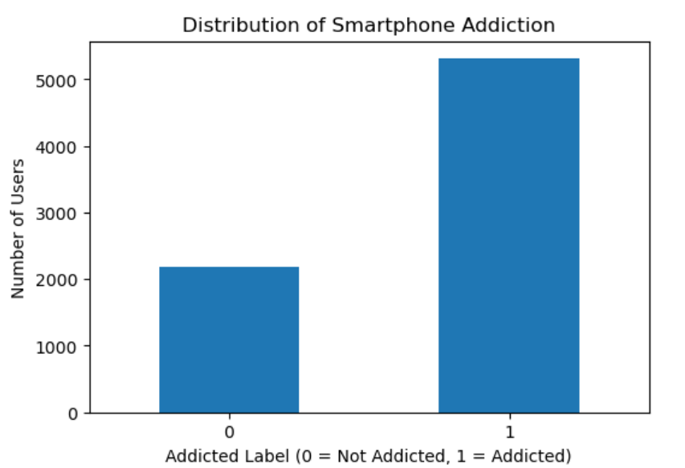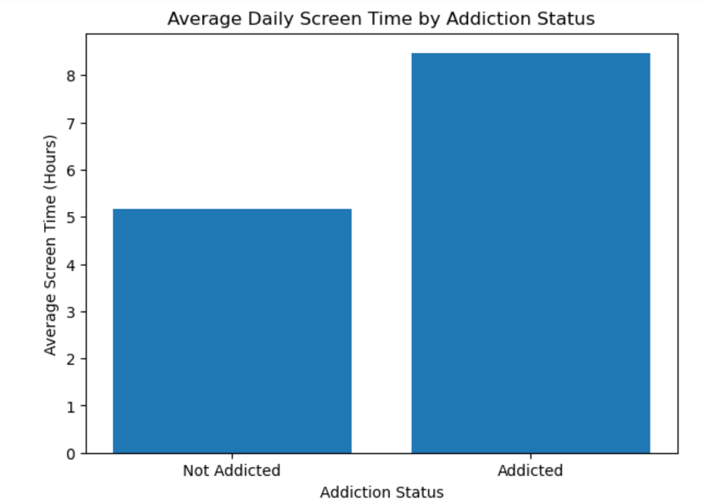
Distribution of smartphone addiction classifications Average daily screen time by addiction classification

Overall, the EDA indicated that screen-time-related behaviour, particularly daily screen time, social media usage, and weekend screen time, was strongly associated with the target classification in this dataset.

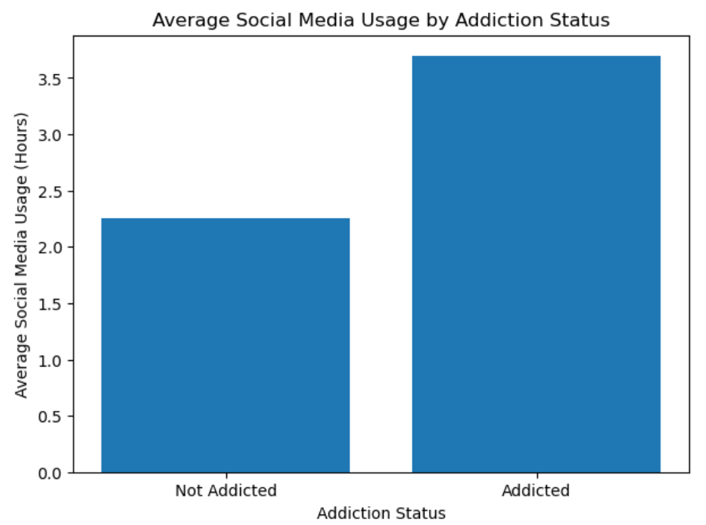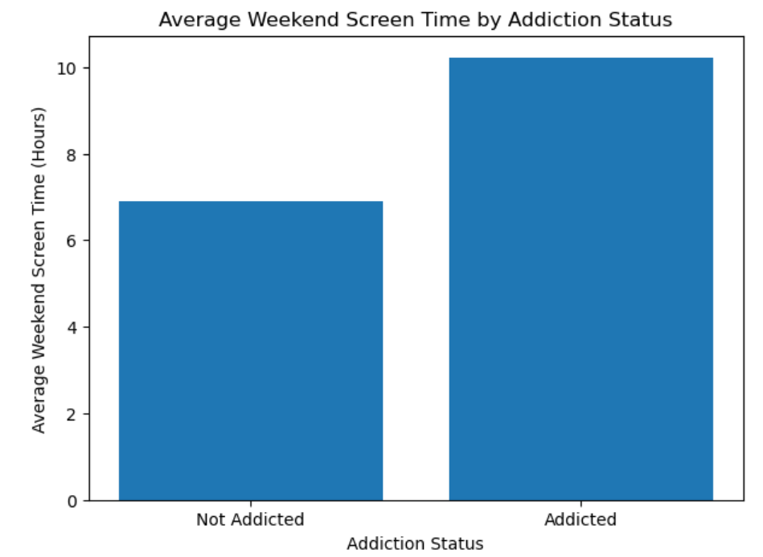
Average social media usage by addiction classification Average weekend screen time by addiction classification

8. Feature Engineering Results
Five additional features were created to provide the machine-learning models with more meaningful representations of user behaviour:
- Total Leisure Hours — calculated using social media hours and gaming hours.
- Screen-to-Sleep Ratio — calculated by dividing daily screen time by sleep hours.
- Weekend Screen-Time Increase — calculated as weekend screen time minus daily screen time.
- Notification Intensity — calculated as notifications per day divided by app opens per day.
- Productive-Time Ratio — calculated using work/study hours relative to work/study hours plus daily screen time.
After feature engineering, the dataset contained 7,500 rows and 21 columns. The newly created features contained no missing or infinite values.

9. Machine Learning Results
Two classification algorithms were implemented for predicting smartphone addiction:
- Logistic Regression
- Random Forest Classifier
The dataset was divided into 80% training data and 20% testing data using stratified sampling. This resulted in 6,000 training records and 1,500 testing records.
Categorical variables were encoded using One-Hot Encoding, while numerical variables were standardized before model training.
The Random Forest model achieved an overall accuracy of approximately 93%, with an F1-score of approximately 0.95 for the addicted class and 0.89 for the not-addicted class.
The models were additionally evaluated using precision, recall, F1-score, ROC-AUC, classification reports, and confusion matrices.
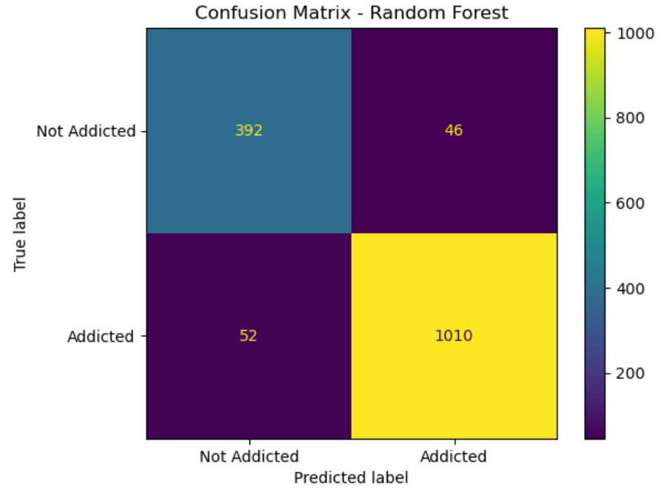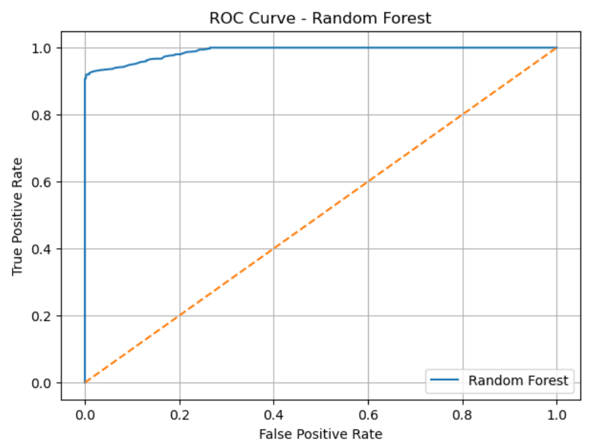
Random Forest confusion matrix Random Forest ROC curve

10. Model Feature Importance
Feature importance analysis was performed using the trained Random Forest model. The analysis identified the features that contributed most strongly to the model's predictions.
Feature | Importance
Social media hours | 26.72%
Daily screen time | 20.97%
Weekend screen time | 13.90%
Screen-to-sleep ratio | 10.42%
Total leisure hours | 8.92%
The top features were:

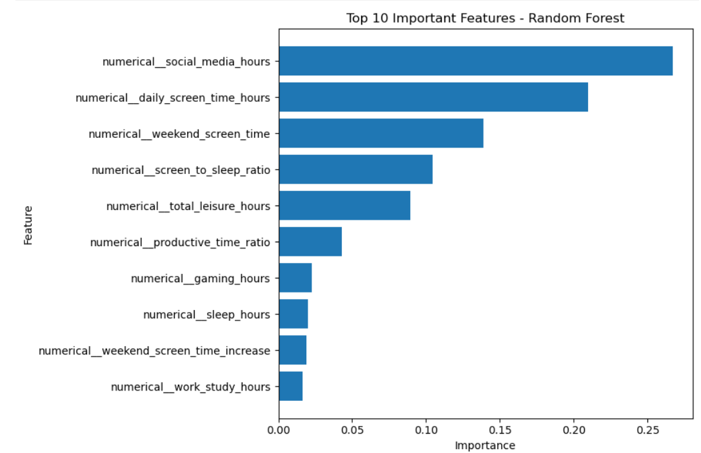
Top features contributing to Random Forest prediction
The results indicate that social media usage and screen-time-related variables were the most influential features in the Random Forest model.
It is important to note that feature importance represents the contribution of variables to the model's predictions and does not establish a direct causal relationship with smartphone addiction.

11. Prediction System
A simple smartphone addiction prediction system was developed using the trained Random Forest model. The trained model was saved using Joblib and loaded into the prediction notebook.
The system accepts user information such as age, gender, daily screen time, social media usage, gaming hours, work/study hours, sleep duration, notifications, application opens, weekend screen time, stress level, and academic/work impact.
Based on the entered information, the system automatically calculates the engineered features required by the model. The Random Forest model then predicts whether the user is likely to be classified as addicted or not addicted.
The system also provides the predicted probabilities for both classes. This allows the prediction result to be presented in a more informative way rather than providing only a binary classification.
A sample user input was tested using the system, and the model classified the user as Likely Addicted, with an estimated 88% probability of the addicted class and 12% probability of the not-addicted class.
The prediction results were also saved as a CSV file for further reference.

12. Conclusion
This project demonstrated the use of data science and machine learning techniques to analyse smartphone usage patterns and predict smartphone addiction classification.
The project followed the complete machine-learning workflow, including data understanding, data cleaning, exploratory data analysis, feature engineering, model development, model evaluation, feature importance analysis, and prediction.
The analysis showed that screen-time-related variables, particularly social media usage, daily screen time, and weekend screen time, were important in the model's predictions for this dataset.
Two machine-learning algorithms, Logistic Regression and Random Forest, were implemented and evaluated. The Random Forest model achieved approximately 93% accuracy on the test dataset and provided strong classification performance for both target classes.
A simple prediction system was also developed to allow new user information to be entered and classified by the trained model.
Overall, the project demonstrates how machine learning can be used to identify patterns in digital usage data and build a practical prediction system for digital-wellbeing analysis.

13. Limitations
The project has several limitations that should be considered when interpreting the results.
- The analysis is based on the available dataset and its recorded variables. The results may not represent smartphone usage behaviour in every population or geographical region.
- The target variable represents a classification provided in the dataset. The machine-learning model predicts the dataset's classification patterns rather than providing a medical or psychological diagnosis.
- The dataset contains observational usage information. Therefore, relationships identified by the analysis should not be interpreted as proof that a particular smartphone behaviour directly causes addiction.
- The prediction system depends on the quality and accuracy of the information entered by the user. Incorrect or unrealistic inputs may affect the prediction.
- Although the Random Forest model achieved strong performance on the available test data, its performance may differ when applied to a different dataset or real-world population.

14. Future Scope
The project can be further improved and extended in several ways:
- Larger and more diverse datasets can be used to improve the generalizability of the model.
- Additional behavioural features such as app categories, usage time by hour, screen unlock frequency, and daily usage patterns could be incorporated.
- Advanced machine-learning algorithms such as Gradient Boosting, XGBoost, or other ensemble techniques could be explored and compared.
- Hyperparameter tuning could be performed to optimize the performance of the machine-learning models.
- The prediction system could be converted into a web-based application using frameworks such as Streamlit or Flask.
- A dashboard could be developed to provide users with visual insights into their smartphone usage patterns.
- The system could be extended to provide personalized digital-wellbeing insights based on the user's usage patterns.
- Future versions could incorporate real-time smartphone usage data where appropriate, allowing the system to analyse changing usage patterns over time.

15. References
- Python Documentation — Documentation for the Python programming language.
- Pandas Documentation — Documentation for data manipulation and analysis using Pandas.
- NumPy Documentation — Documentation for numerical computing with Python.
- Matplotlib Documentation — Documentation for data visualization using Matplotlib.
- Seaborn Documentation — Documentation for statistical data visualization using Seaborn.
- Scikit-learn Documentation — Documentation for machine-learning algorithms, preprocessing, model evaluation, and pipelines.
- Joblib Documentation — Documentation for saving and loading Python objects and trained machine-learning models.
- Jupyter Documentation — Documentation for interactive computing and Jupyter Notebooks.

