**UserManagement App:**

CRUD application which allow users to see , search based on the criteria, add,edit and update, delete the users

**FrontEnd** - React js, Redux , ReactBootstrap, Material UI,react tostify

**Backend** - Express, Node js, mongo

**To start Backend , FrontEnd**: the command is **npm start**

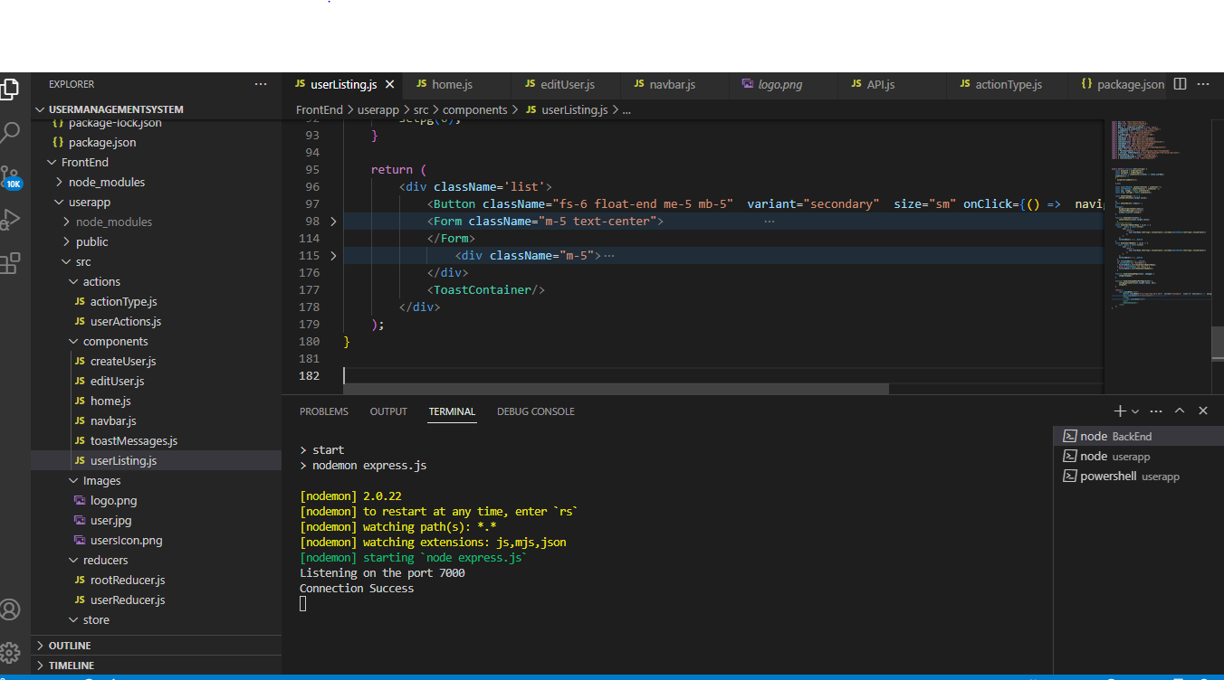

FrontEnd:

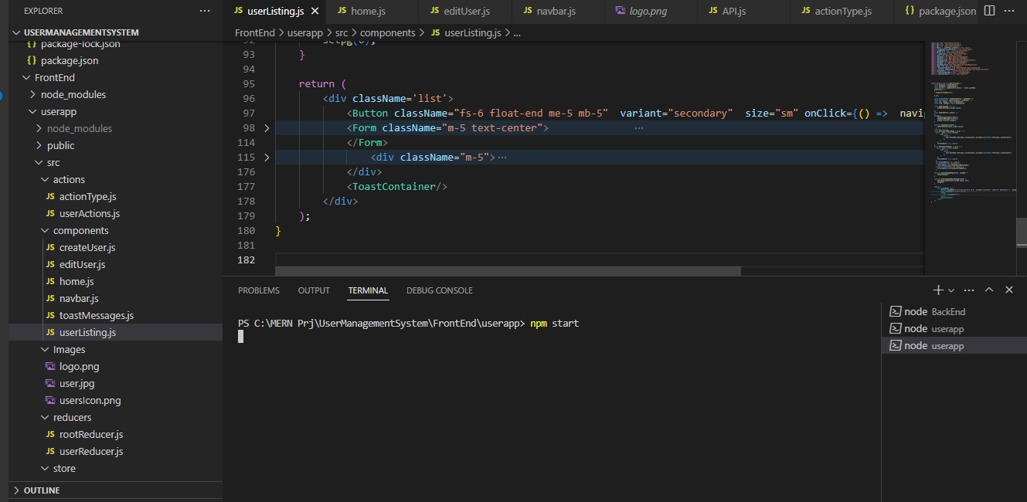

This is the Home page - dashboard shows the 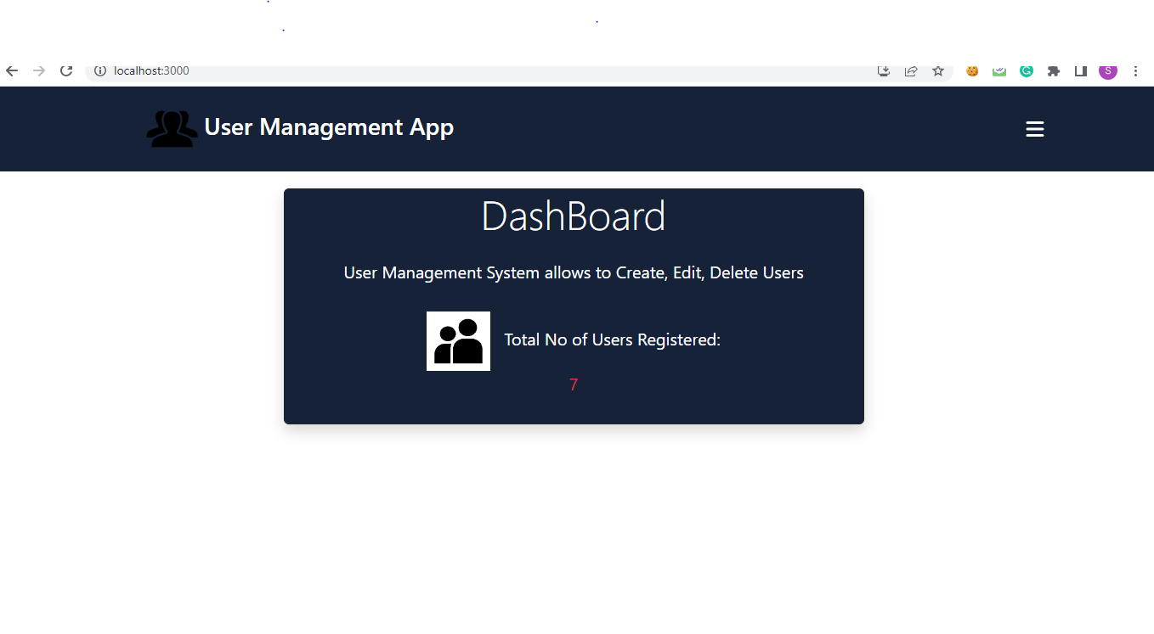

There is a icon right side on click it will show the side with pages to navigate

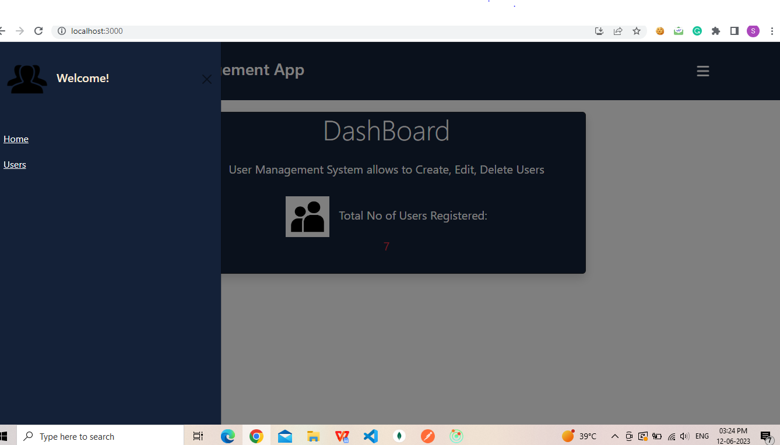

Users -

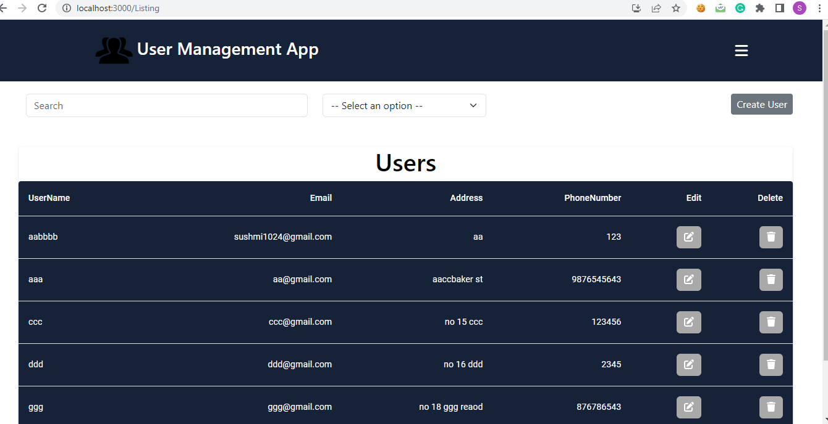

Users pages with search with option such as UserName, Email

It contains a list of users so far registered with pagination to navigate to next and previous options

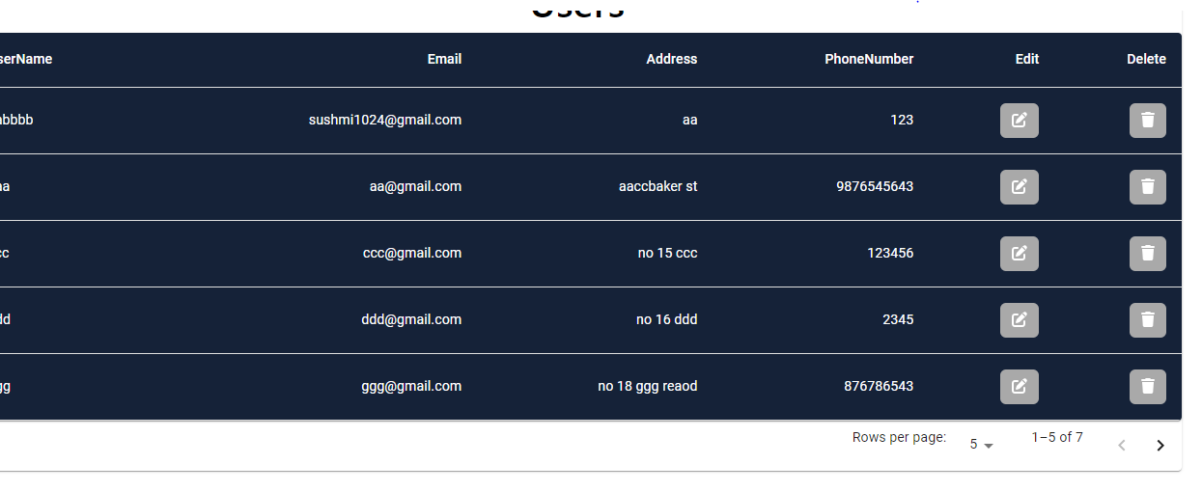

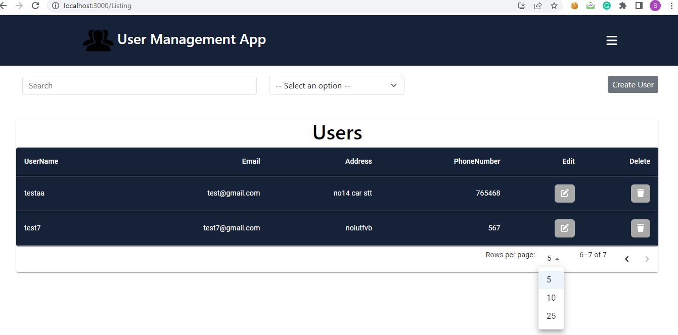

Create User - react tostify to show the validation messages

Email are unique so uer cannot register with same Email again

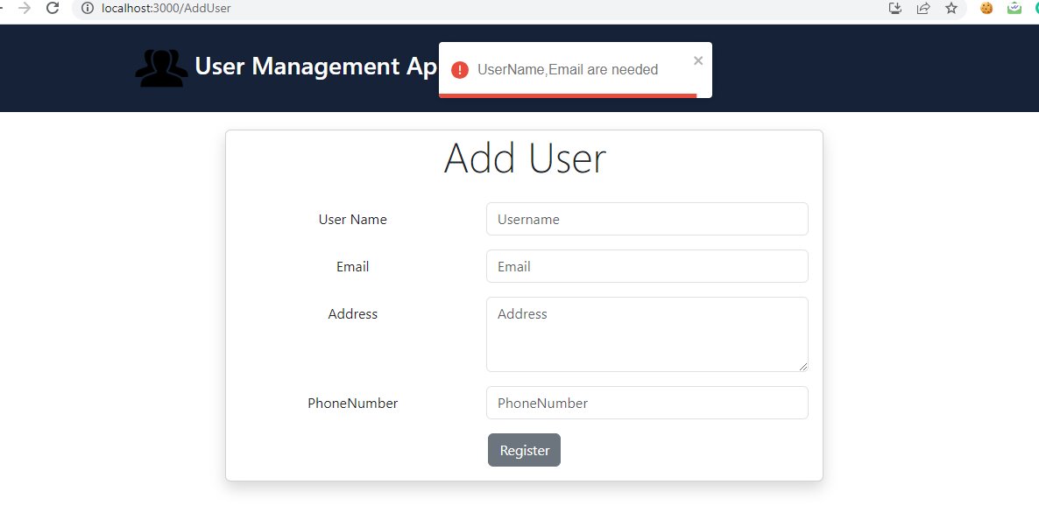

Edit User - with populated data

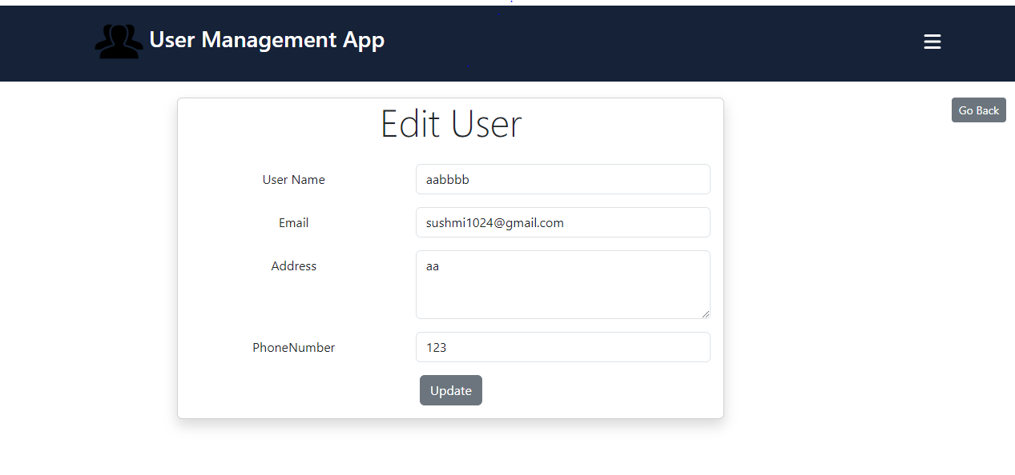

Delete-once the user deleted it shows the message and will be removed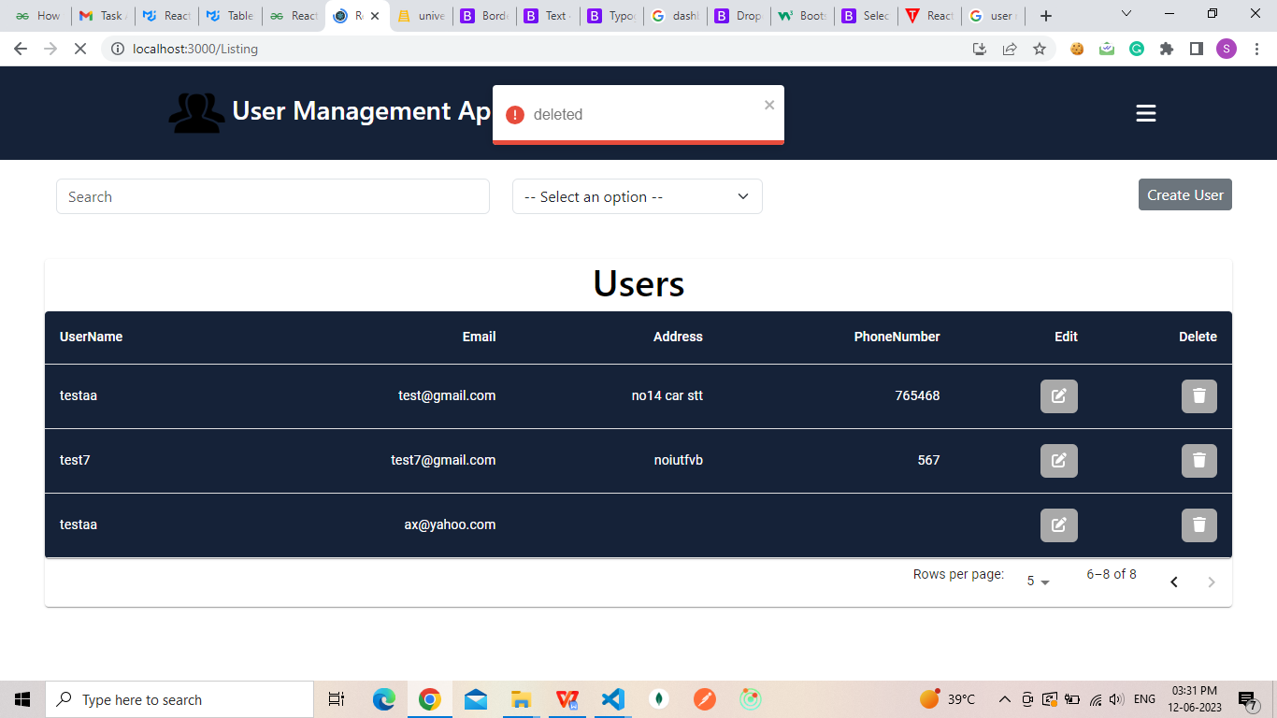

Search--

