# Makefile to organize Tableau project files

# Variables

SRC_DIR = "C:\Users\Sushmitha\OneDrive\Documents\My Tableau Repository"

DEST_DIR = "C:\Users\Sushmitha\OneDrive\weather_dashboard\Documents\My Tableau Repository\images"

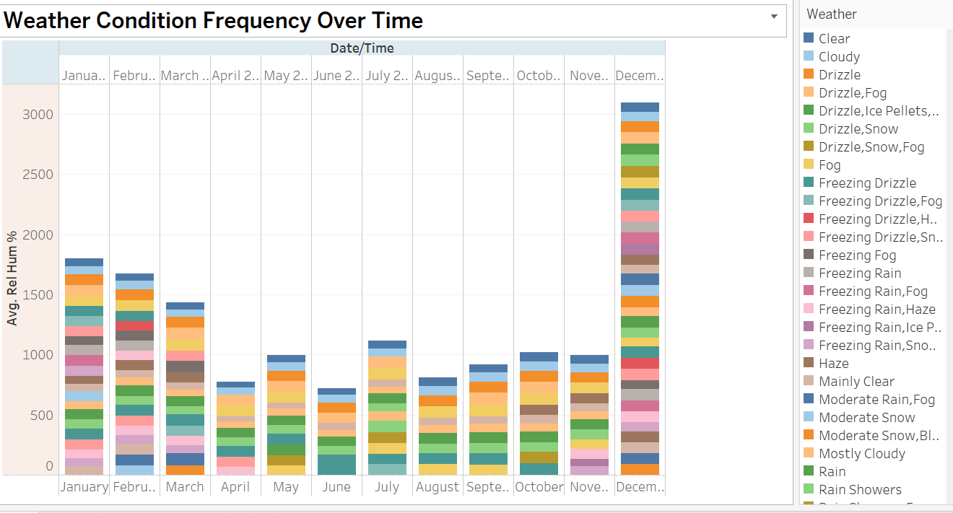

# Screenshots to move

SCREENSHOTS = "Humidity trend.png" "Pressure Temp Weather patterns.png" "Seasonal Patterns.png"

# Move screenshots

move_screenshots:

for %%f in ($(SCREENSHOTS)) do move "$(SRC_DIR)\%%f" $(DEST_DIR)

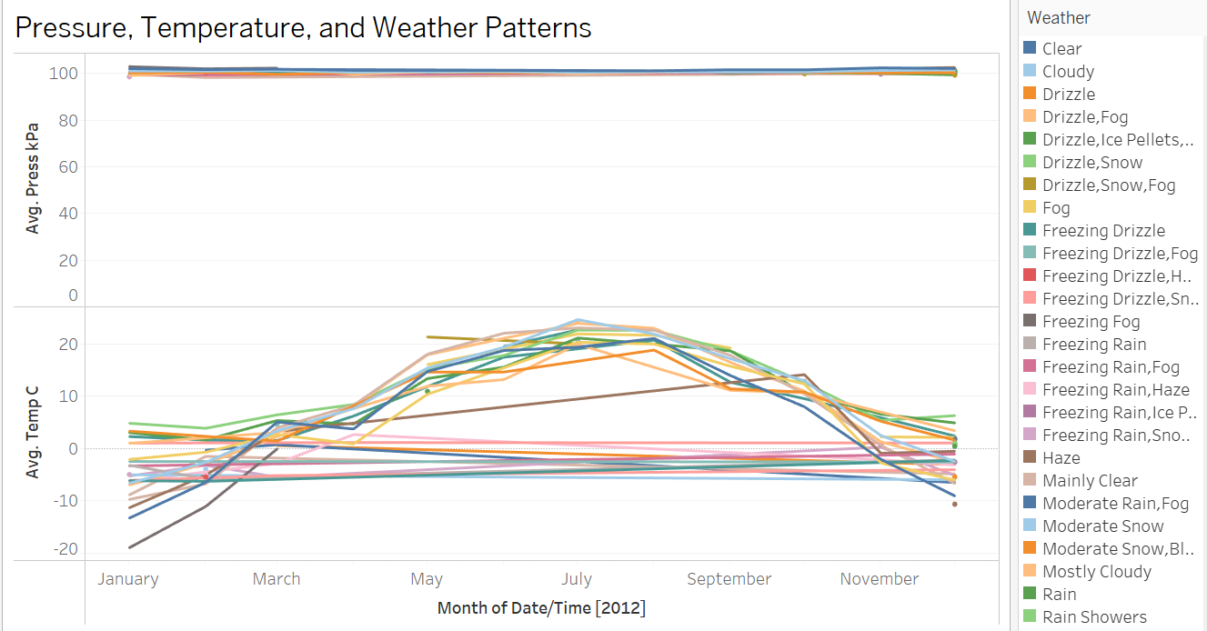

# Optional: Add all files to Git and push (requires git installed)

git_push:

git add .

git commit -m "Add workbook and screenshots"

git push

