**RDS Tasks**

1) Create mariadb db on ec2.

Step 1: Connect to EC2 via SSH

Step 2: Install MariaDB

sudo dnf update -y

sudo dnf install mariadb105-server -y

Step 3: Start and Enable MariaDB

sudo systemctl start mariadb

sudo systemctl enable mariadb

Step 4: Secure MariaDB Installation

sudo mysql_secure_installation

* + - Set a root password (if prompted).
    - Remove anonymous users: Y
    - Disallow root login remotely: Y (optional)
    - Remove test database: Y
    - Reload privilege tables: Y

Step 5: Create a Database and User

Log into MariaDB:

sudo mysql -u root -p

Create a database and user:

CREATE DATABASE mydb;

CREATE USER 'myuser'@'%' IDENTIFIED BY 'MyStrongPassword!';

GRANT ALL PRIVILEGES ON mydb.* TO 'myuser'@'%';

FLUSH PRIVILEGES;

EXIT;

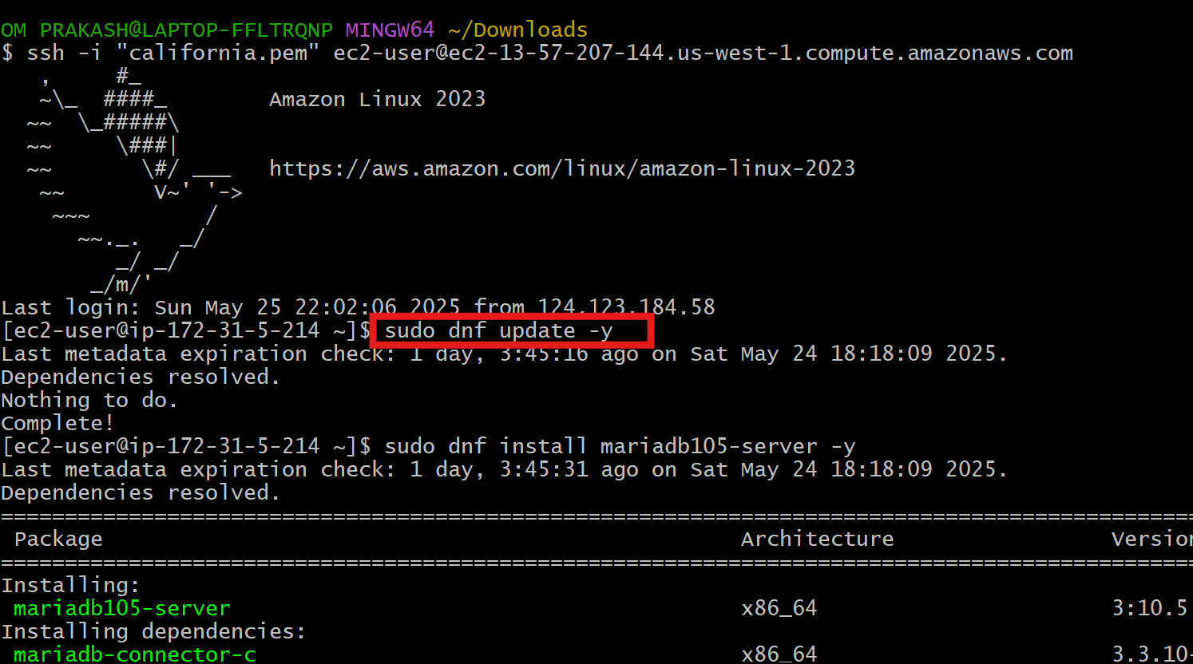

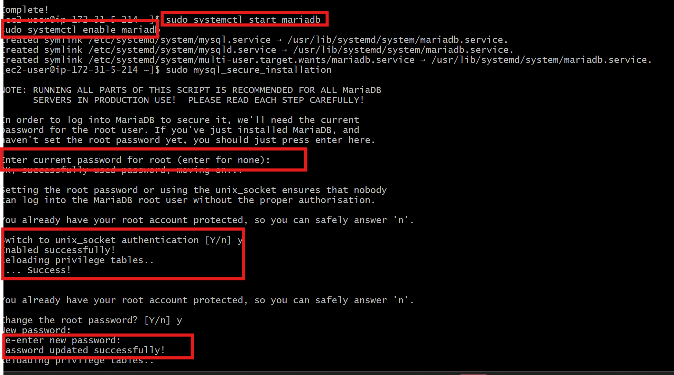

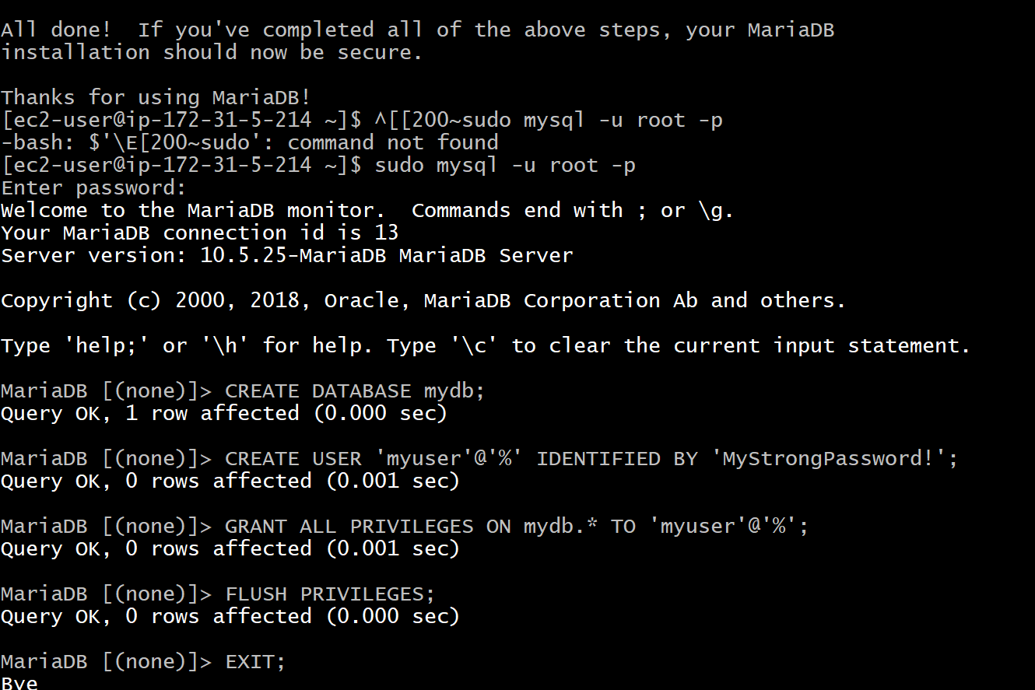

2) Insert some dummy data

Step 1: Log in to MariaDB

sudo mysql -u root -p

Step 2: Use the mydb database

USE mydb;

Step 3: Create a Table

CREATE TABLE employees (

id INT AUTO_INCREMENT PRIMARY KEY,

name VARCHAR(100),

position VARCHAR(100),

salary DECIMAL(10,2)

);

Step 4: Insert Dummy Data

INSERT INTO employees (name, position, salary) VALUES

('Alice Johnson', 'Software Engineer', 85000.00),

('Bob Smith', 'Data Analyst', 62000.00),

('Carol White', 'Project Manager', 95000.00),

('David Lee', 'DevOps Engineer', 88000.00),

('Eva Brown', 'UX Designer', 72000.00);

Step 5: Verify the Data

SELECT * FROM employees;

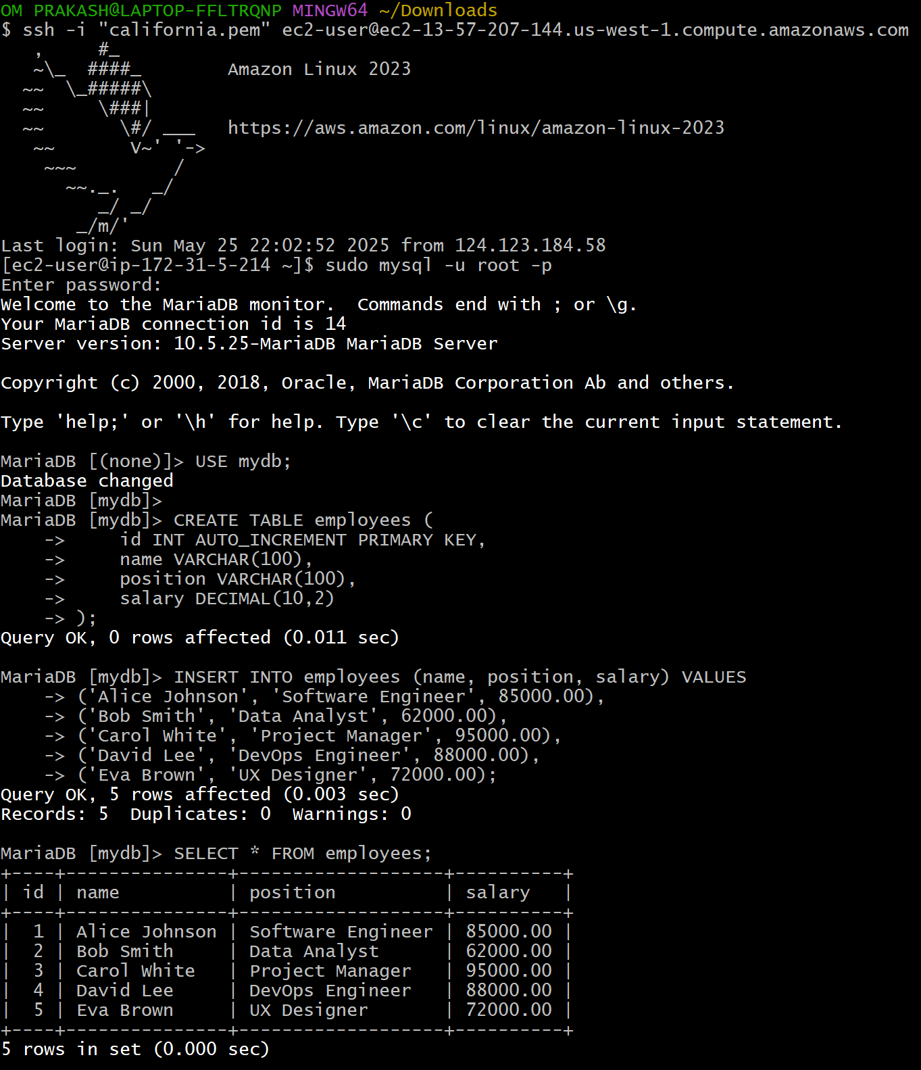

3) Take the backup of dummy data on ec2

Step 1: Run the Backup Command

**mysqldump -u root -p mydb > mydb_backup.sql**

* You'll be prompted for the MariaDB **root password**.
* This will create a file called mydb_backup.sql in the current directory.

Step 2: Verify the Backup File

**ls -lh mydb_backup.sql**

You should see something like:

-rw-r--r-- 1 ec2-user ec2-user 5.0K May 26 12:45 mydb_backup.sql

Step 3: inspect the contents

**head mydb_backup.sql**

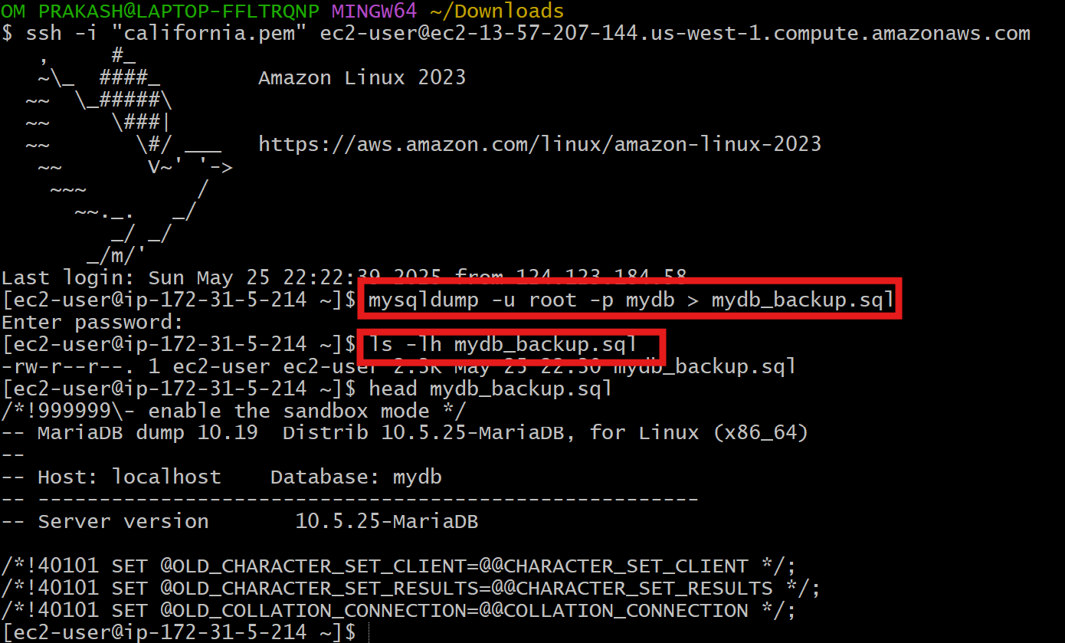

4) launch Mariadb RDS instance.

Step 1: Go to RDS Console

Click **"Create database**

Step 2: Select Database Creation Method

**Choose a database creation method**: Select **Standard Create**

Step3: Engine Options

* **Engine type**: Select **MariaDB**
* **Version**: Choose the latest available version

Step 4: Settings

* **DB instance identifier**: mariadb-demo
* **Master username**: admin
* **Master password**: Choose a strong password
* **Confirm password**: Enter again

Step 5: DB Instance Class

* For testing: Choose **Burstable classes (e.g., db.t3.micro)**
* For production: Choose **db.t3.medium** or higher

Step 6: Storage

* Select **General Purpose (SSD)**
* Set size (e.g., 20 GiB)

Step 7: Connectivity

* **Virtual Private Cloud (VPC)**: Choose your existing VPC
* **Subnet group**: Default or custom
* **Public access**:
  + Set **Yes** if you want to access from outside (e.g., from your laptop)
  + Set **No** for internal (e.g., accessed only by EC2)
* **VPC security group**:
  + Choose **Create new** or select an existing one
  + Make sure it allows **inbound on port 3306** from your IP or EC2

Step 8: **Database Authentication**

Choose **Password authentication**

Step 9: Create Database

* Click **"Create database"**
* Wait for status to become **"Available”**

Step 10: Connect to RDS

* Go to **Databases > your-db-instance**
* Copy **Endpoint** (e.g., mariadb-demo.abcd1234.us-east-1.rds.amazonaws.com)
* From an EC2 instance or your local machine (if public access is enabled):

**mysql -h database-1.c5wm4om2itwn.us-west-1.rds.amazonaws.com -u admin -p**

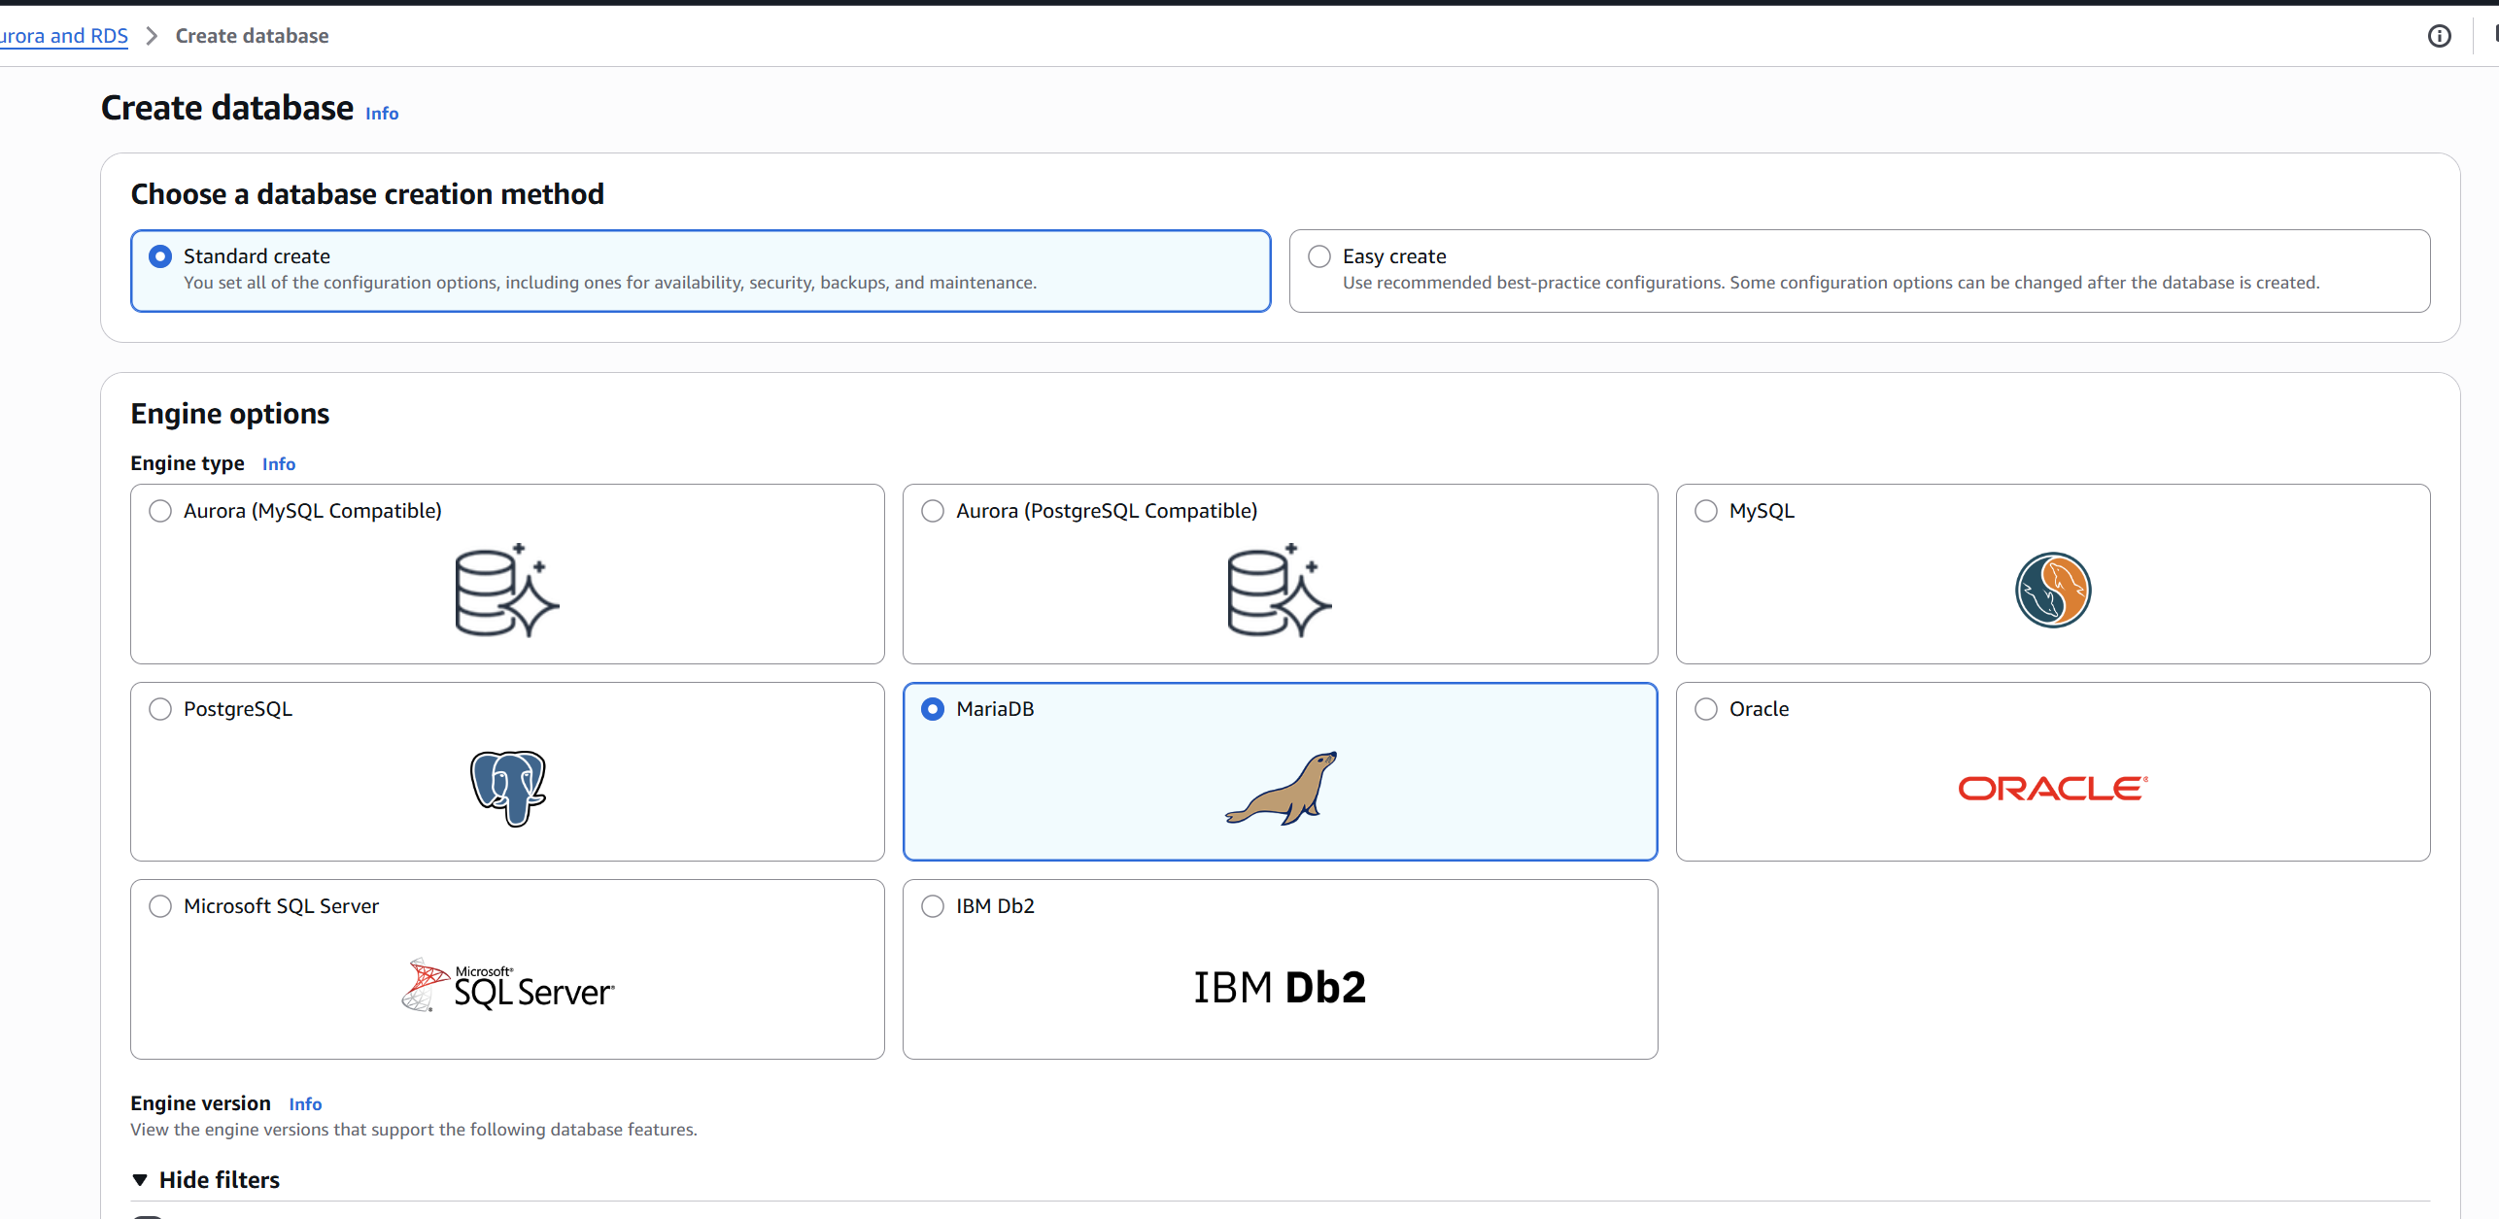

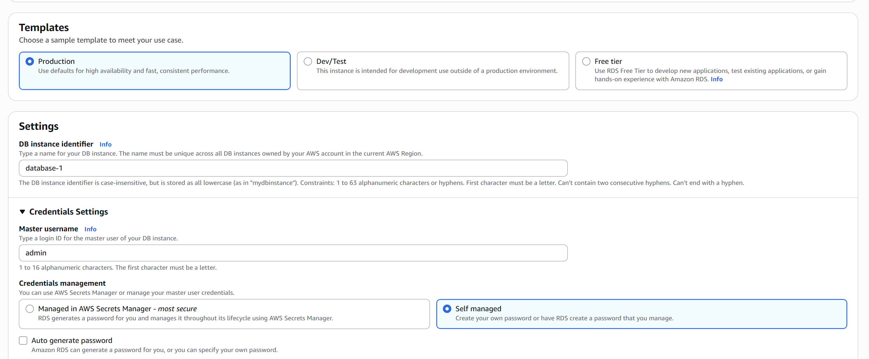

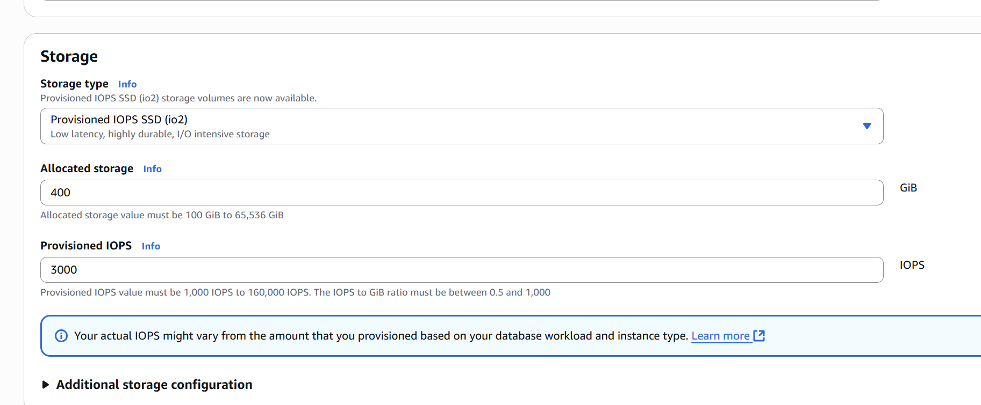

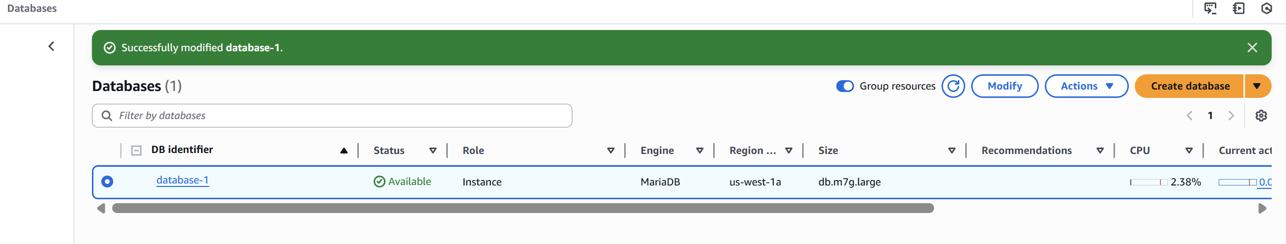

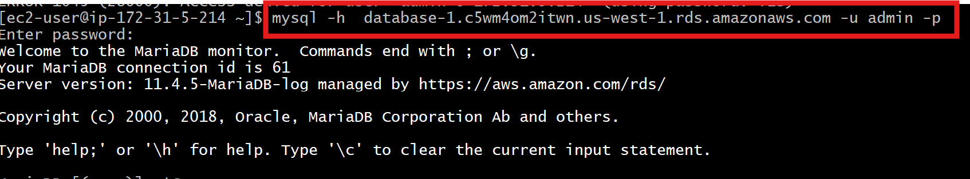

5) Migrate database from ec2 to RDS.

Step 1: Connect to your EC2 instance

**ssh -i <your-key.pem> ec2-user@<ec2-public-ip>**

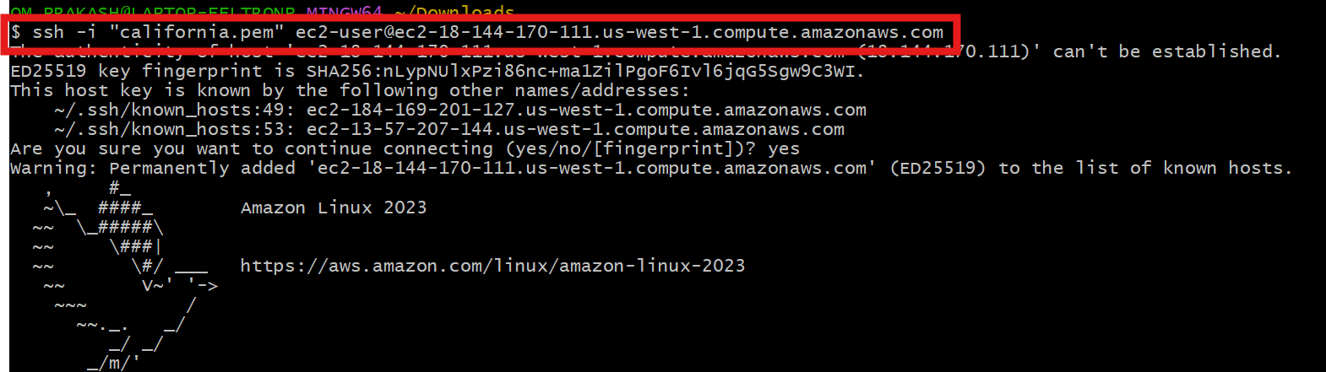

Step 2: Start the MariaDB server

**sudo systemctl start mariadb**

**sudo systemctl enable mariadb**

**systemctl status mariadb**

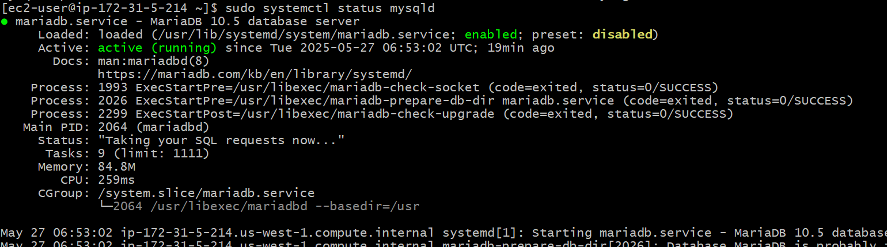

step3: Log into MariaDB and verify the database

**sudo mysql -u root -p**

then SHOW DATABASES;

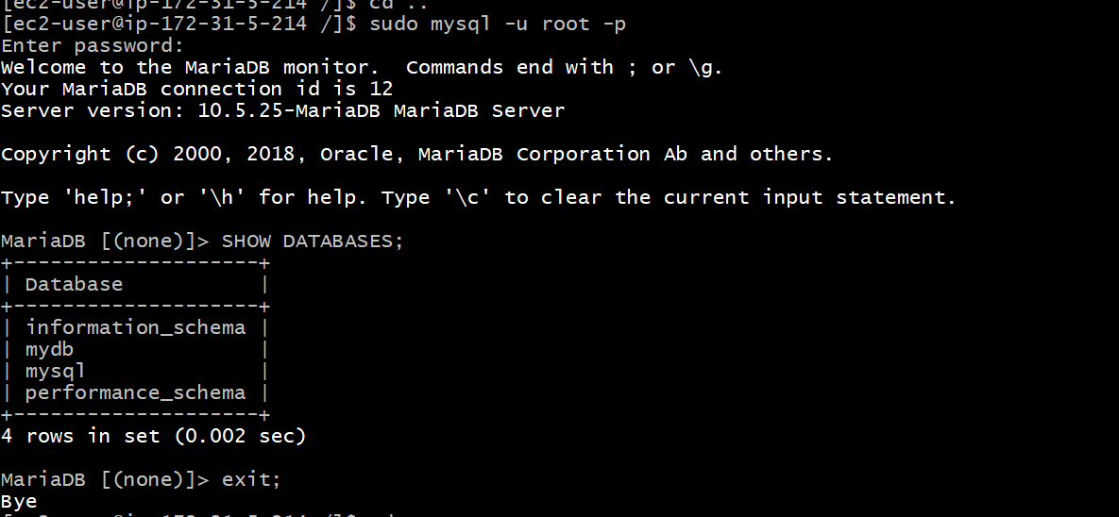

Step 4: Create and grant permissions to a user

**CREATE USER 'myuser'@'%' IDENTIFIED BY 'Sushmadb12';**

**GRANT SELECT, LOCK TABLES, SHOW VIEW ON `database-1`.* TO 'myuser'@'%';**

**FLUSH PRIVILEGES;**

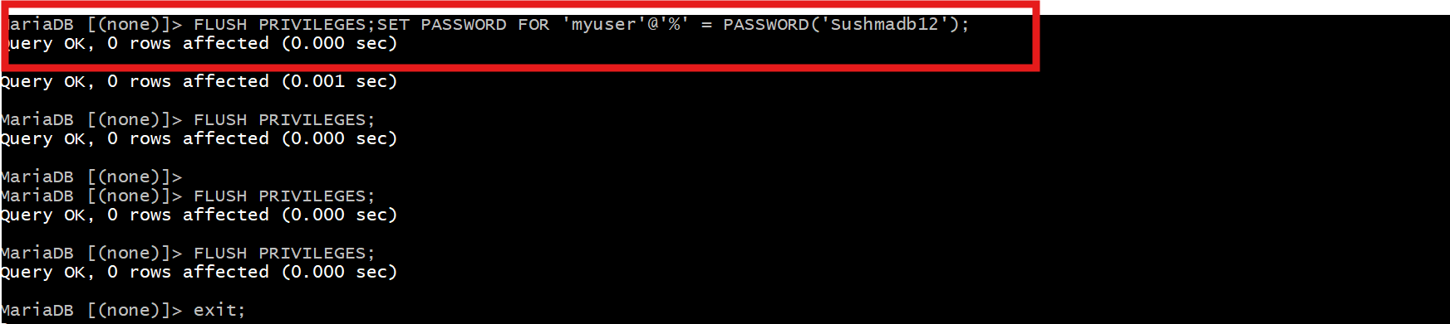

Step 5: Export the database using mysqldump

**mysqldump -u myuser -p database-1 > ec2_backup.sql**

Step 6: Connect to Amazon RDS

**mysql -h <rds-endpoint> -u admin -p**

Create a database on RDS:

**CREATE DATABASE mydb;**

**EXIT;**

Step 7: Import the dump into RDS

mysql -h <rds-endpoint> -u admin -p mydb < ec2_backup.sql

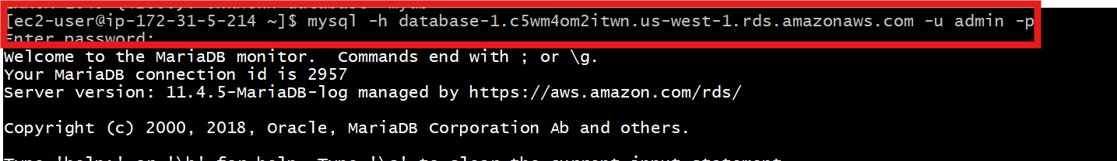

Step 8: Verify the import

Log into the RDS instance:

**mysql -h <rds-endpoint> -u admin -p**

then

**USE mydb;**

**SHOW TABLES;**

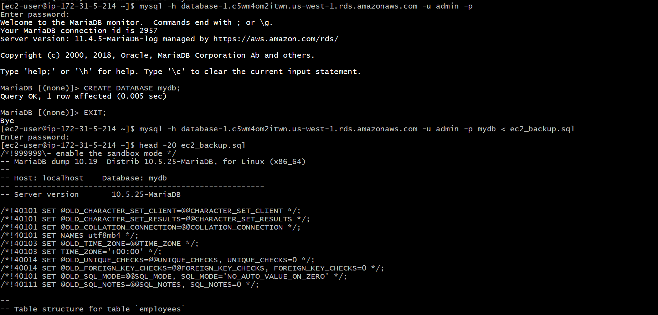

Verification:

**head -20 ec2_backup.sql**

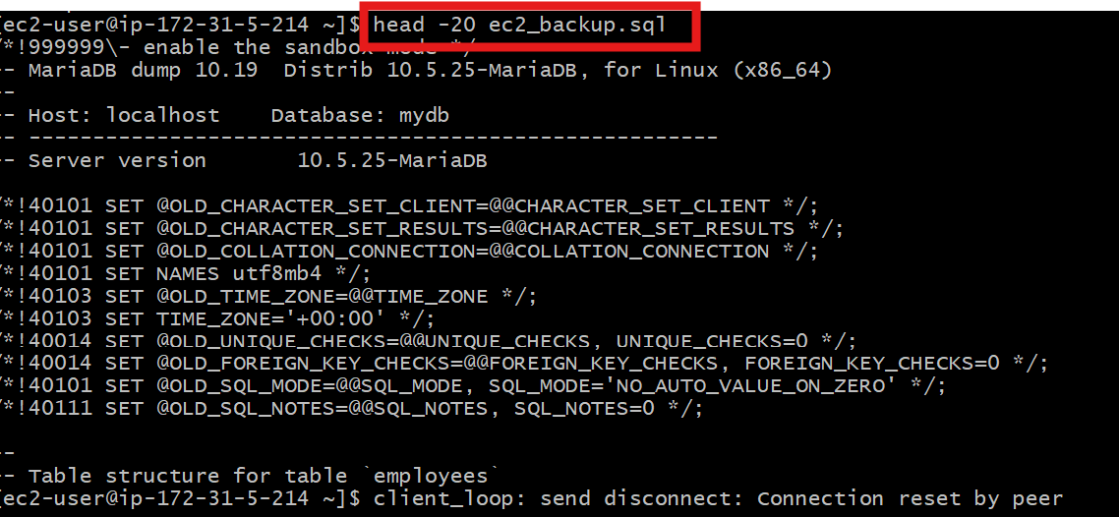

6) Install mysql db on ec2

Step 1: Connect to your EC2 instance

Step 2: Update the system

**sudo dnf update -y**

Step 3: Enable the MySQL 8.0 repository

**sudo dnf install -y https://dev.mysql.com/get/mysql80-community-release-el9-1.noarch.rpm**

**sudo dnf config-manager --enable mysql80-community**

Step 4: Install MySQL Server

**sudo dnf install -y mysql-community-server**

Step 5: Start and enable MySQL service

**sudo systemctl start mysqld**

**sudo systemctl enable mysqld**

Step 6: Check MySQL status

**systemctl status mysqld**

Step 7: Log into MySQL

**mysql -u root -p**

Step 8: Verification

SHOW DATABASES;

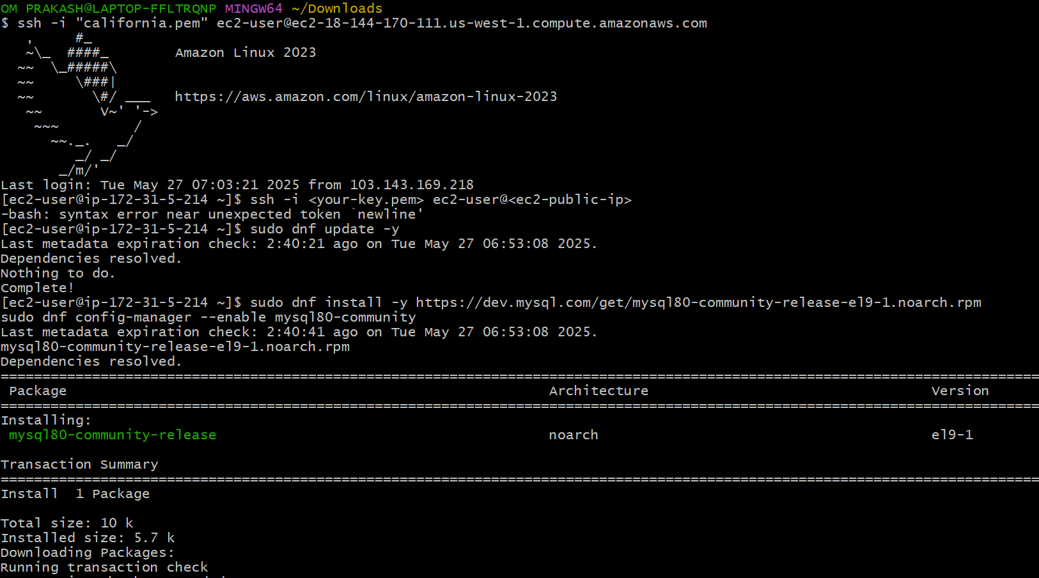

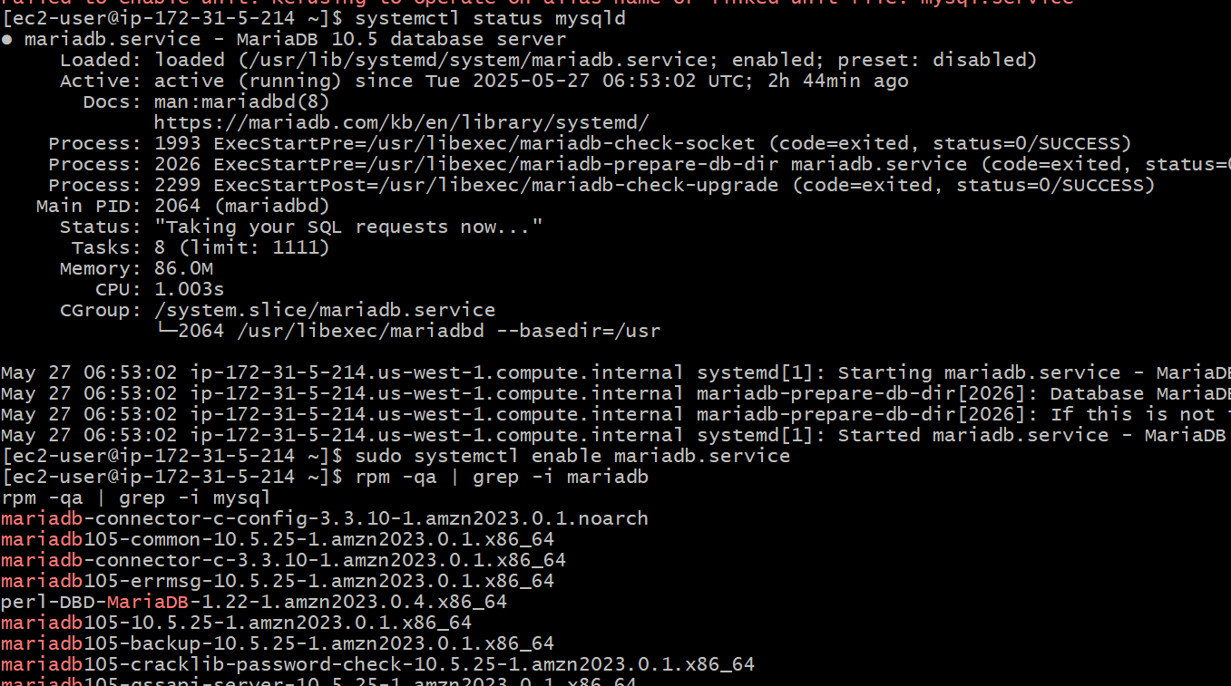

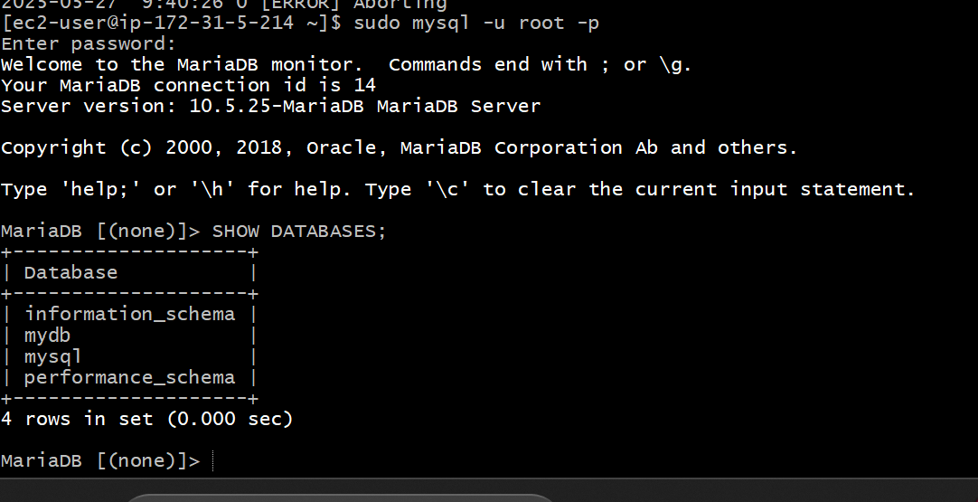

7) Launch mysql RDS image

Step 1: Open RDS Console

**Click "Create database"**

Step 2: Select Database Creation Method

Choose **Standard Create**

Step 3: Engine Options

**Engine type:** MySQL

Step 4: Template

Choose a template:

* **Free tier** (if eligible)
* Or **Dev/Test** for low-cost setup

Step 5: Settings

Fill in the DB instance details:

* **DB instance identifier:** mydb-mysql
* **Master username:** admin
* **Password:** Sushmadb12

Step 6: DB Instance Class

* Free tier: db.t3.micro
* Or choose based on your needs

Step 7: Storage

* **Storage type:** General Purpose (SSD)
* **Allocated storage:** e.g., 20 GB

Step 8: Connectivity

* **VPC:** Choose default or your custom VPC
* **Subnet group:** Default
* **Public access:** YES (if you want to connect from outside)
* **VPC security group:** Create new or select existing
  + Allow port 3306 in inbound rules

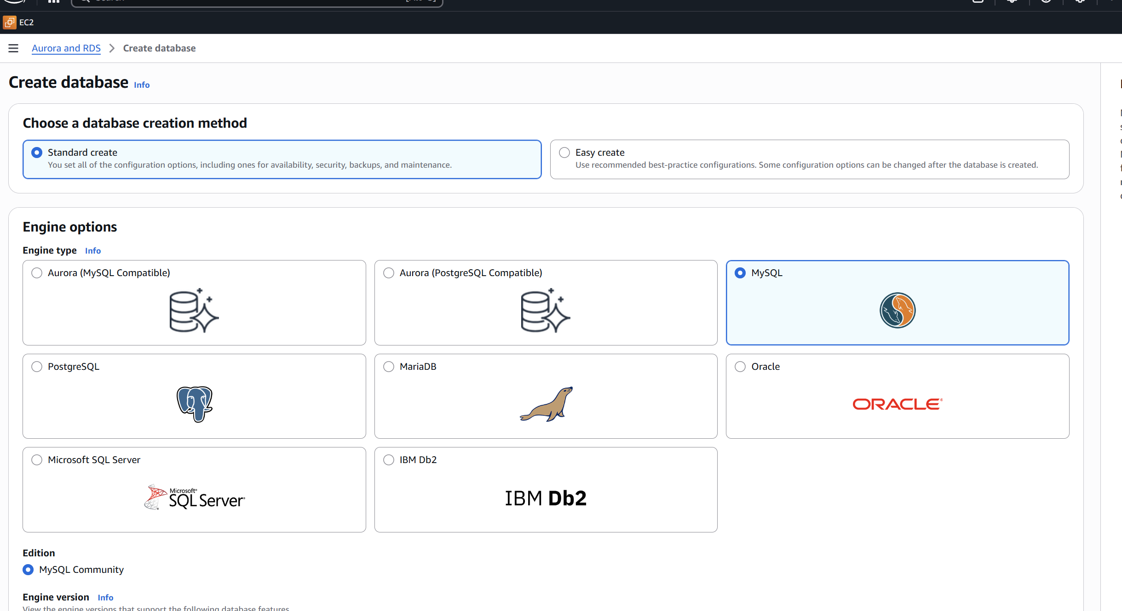

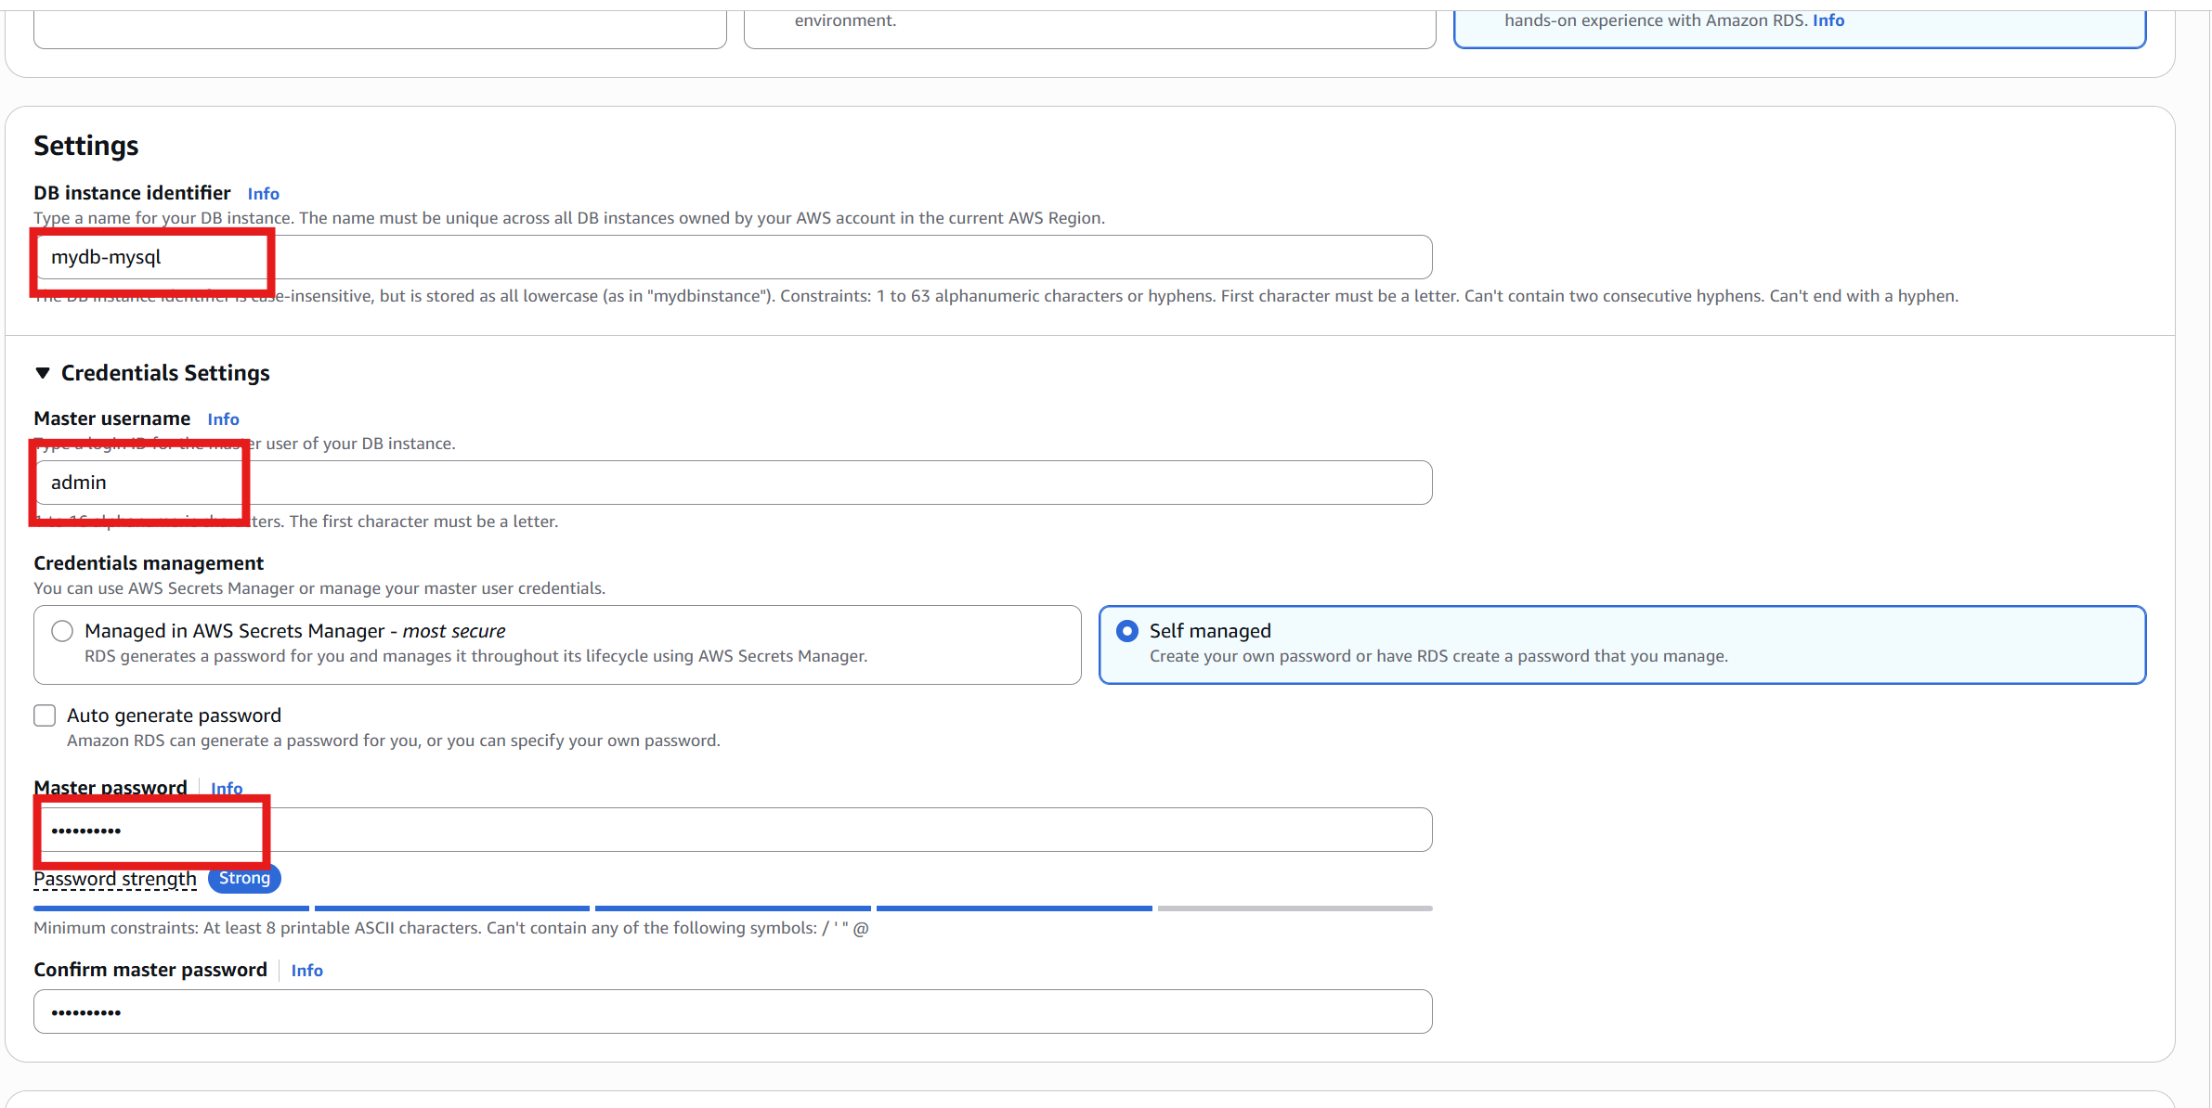

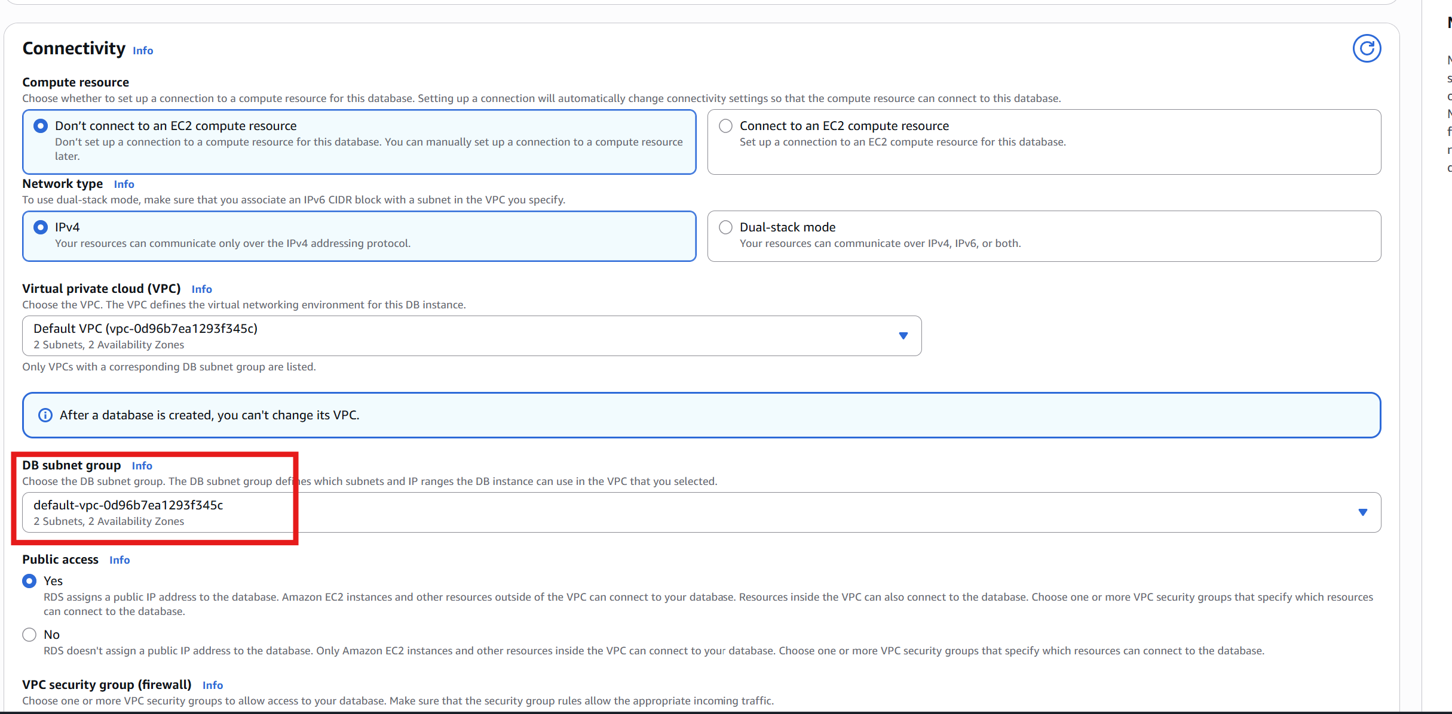

Step 10: Create Database

Click **"Create database"**

It will take a few minutes to provision.

Step 11: Verification

**Find RDS Endpoint**

Once available:

* Go to **Databases > mydb-mysql**
* Copy the **Endpoint** and **Port (3306)**
* Connect from EC2 or your local system

**mysql -h mydb-mysql.c5wm4om2itwn.us-west-1.rds.amazonaws.com -P 3306 -u admin -p**

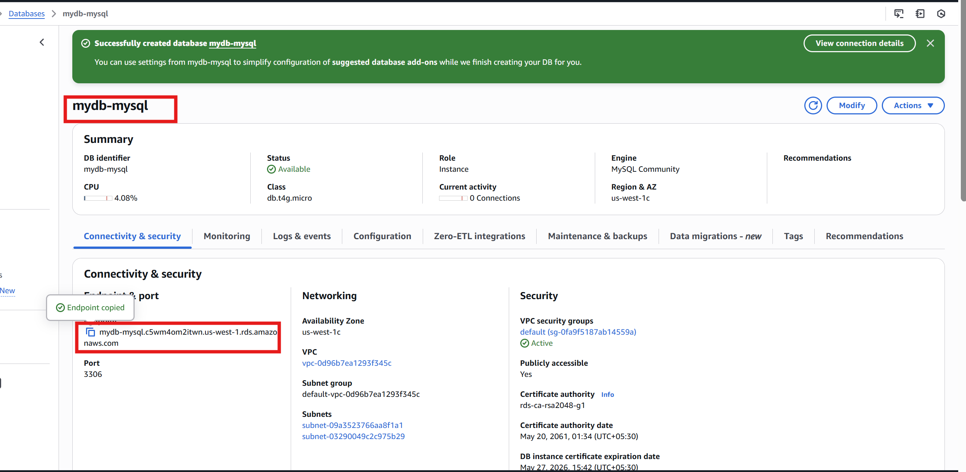

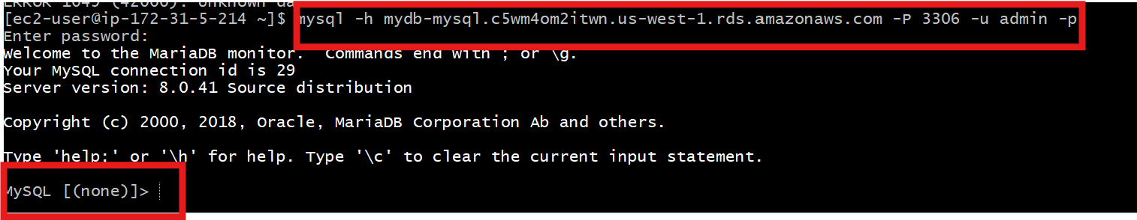

8) COnfigure multi AZ

When creating a new RDS instance**Go to AWS Console > RDS Dashboard.**  
During the creation wizard:

* Under **Availability & durability**, select **Create a standby instance (Multi-AZ)**.
* Proceed with other configurations.

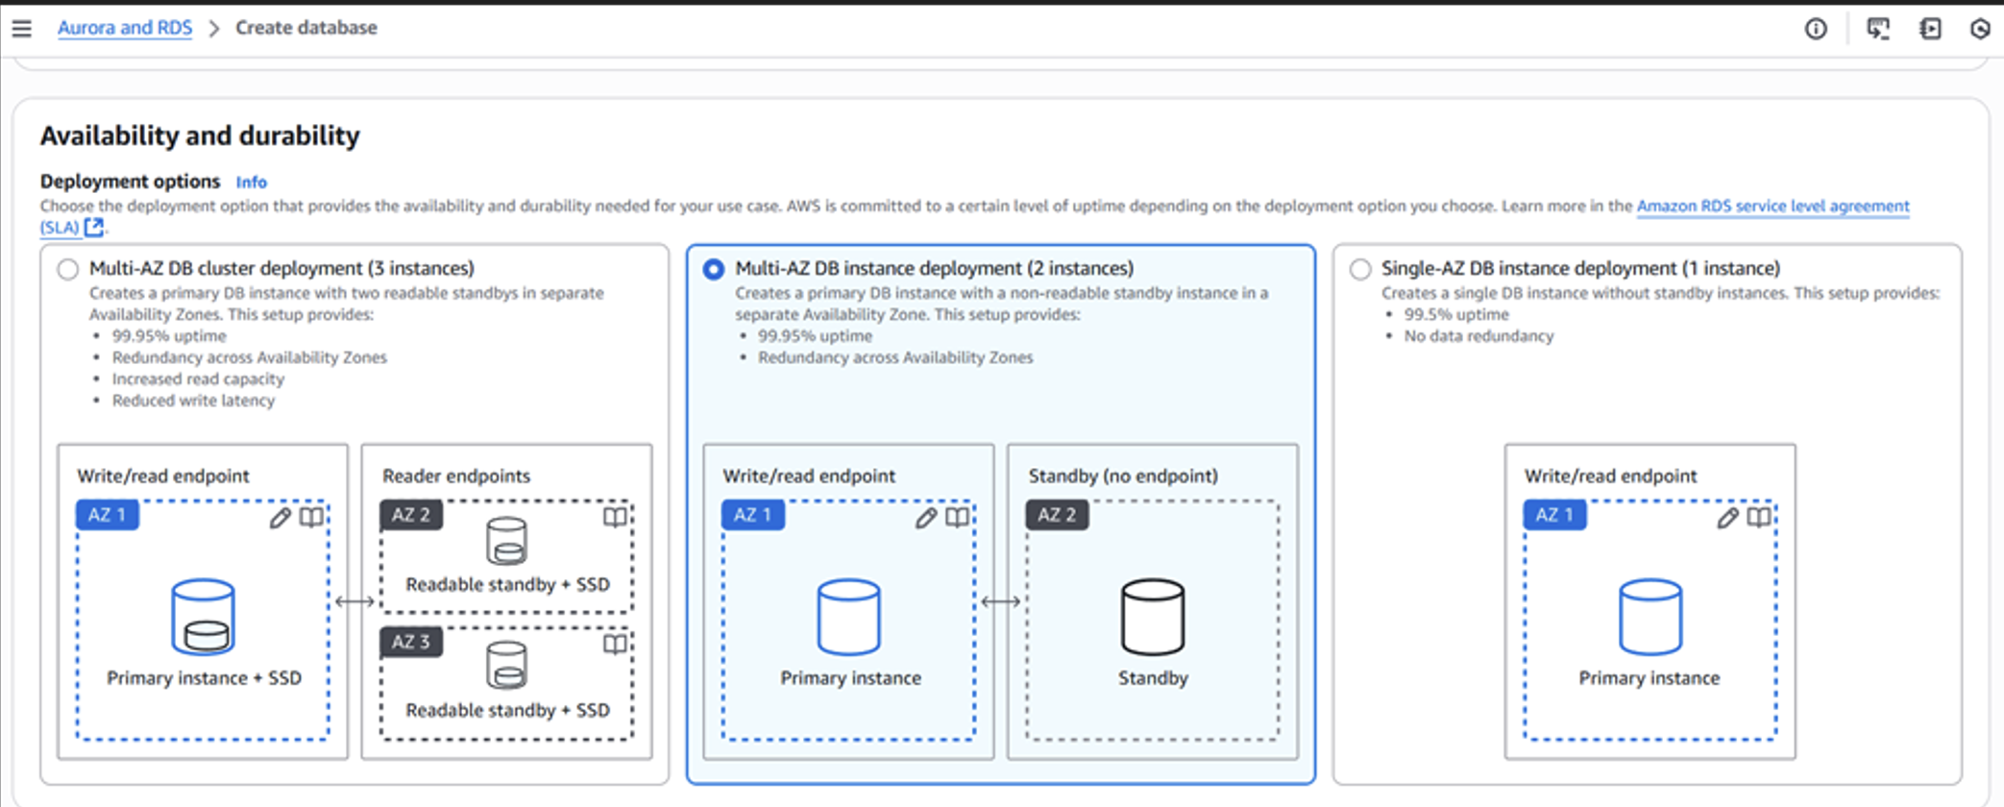

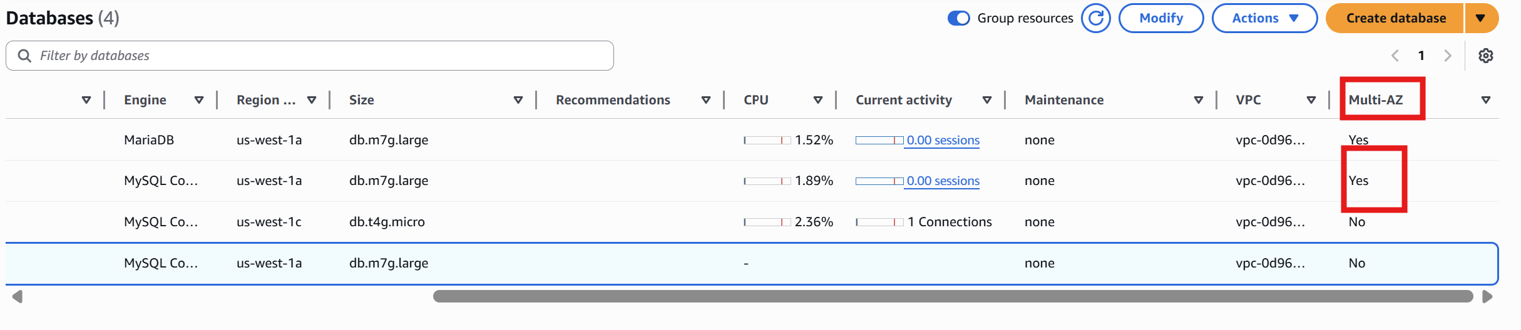

9) Take Backup of db and restore the DB

Step 1: **Backed up the mysql system database**

**mysqldump -u root -p mysql > mysql_backup.sql**

step 2: **Created a new database** called mydb:

**mysql -u root -p -e "CREATE DATABASE IF NOT EXISTS mydb;"**

step 3: **Restored the backup into the mysql database** (same database you backed up from):

**mysql -u root -p mysql < mysql_backup.sql**

step 4:verify the database list using:

**SHOW DATABASES;**

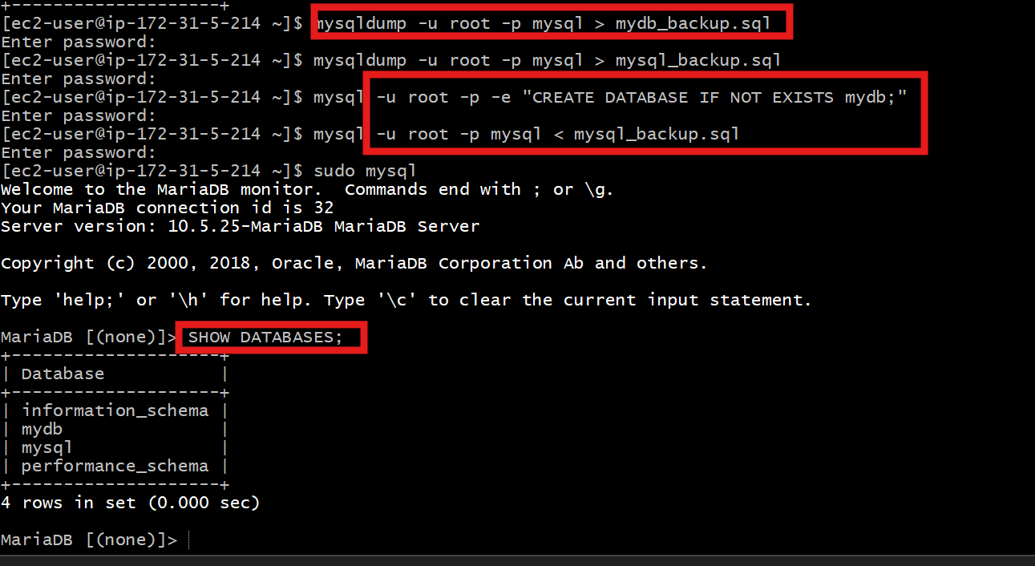

10) Create ReadReplca

Step1: **Go to**: [RDS Dashboard](https://console.aws.amazon.com/rds/)

* Click **Databases**
* Select your **MySQL RDS instance**
* Click **Actions > Create read replica**

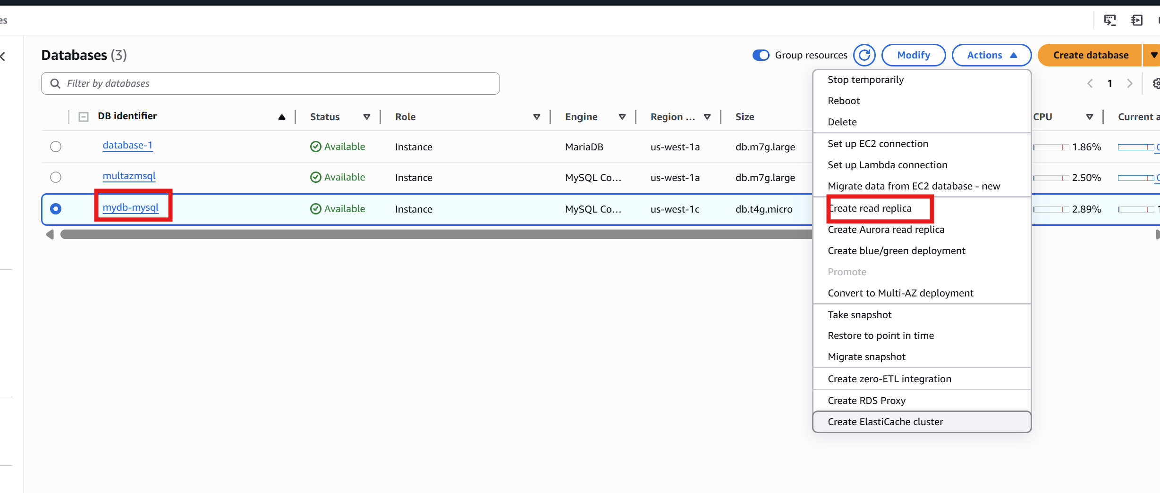

Step 2:    Configure the following:

* **DB instance identifier**: e.g., mydb-replica-1
* **Instance class**: Choose the same or smaller size as the primary
* **Multi-AZ**: Optional (for high availability of the replica)
* **Public access**: Set Yes if needed
* **VPC/security groups**: Keep the same as primary, unless needed otherwise
* Click **Create read replica**

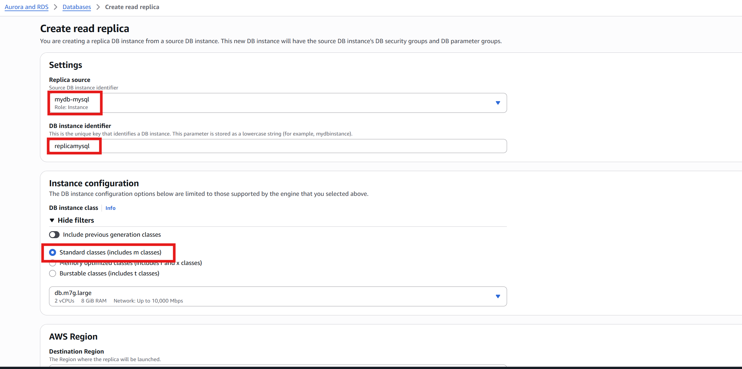

Step 3: Verify Read Replica

* In RDS Console > Databases:
  + We get the instance with **Role: Replica**
  + **Replication state**: Replicating

