GIT&GITHUB Tasks

1)Install git.

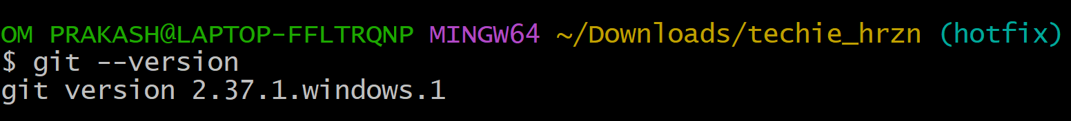

2)Create a repo in github with README.md and .ignore file.

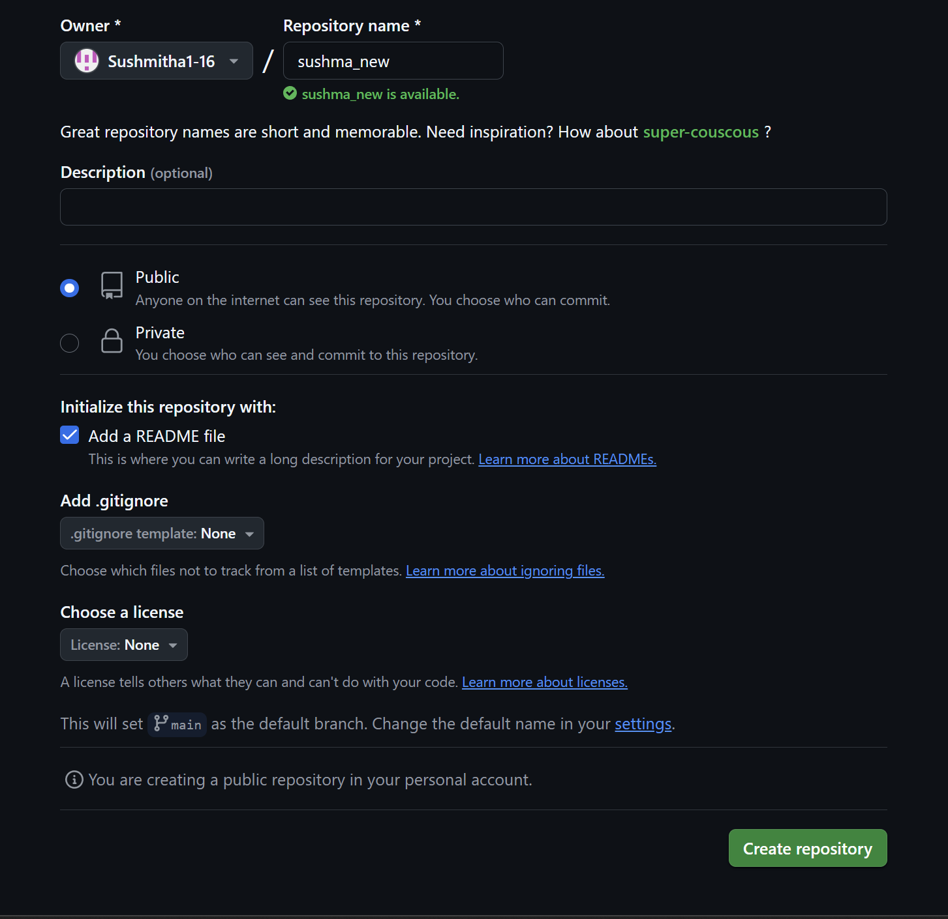

3)Clone the created repo to local.

* To clone the repo **Git clone ssh of Repo**

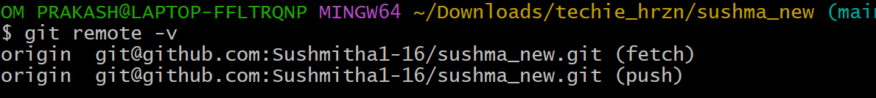

4)Create two files in local repo.

* Created two files txtf1.yml and txtfr.yml using touch command.

And saved by using vi command

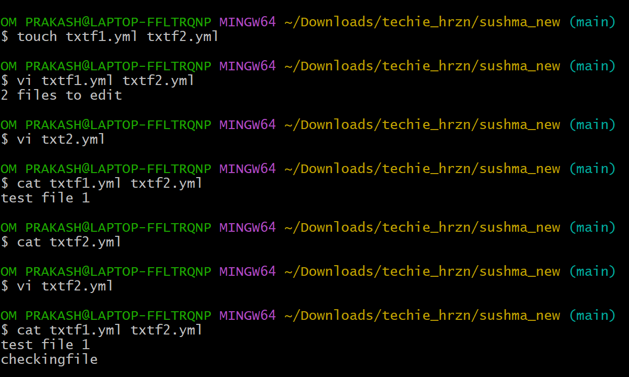

5)Commit two files and push to central Repository.

* After saving files need to track by using **git add** .
* Then commit **git commit -m “message”**
* Then check the log **git log**
* Then push the files **git log push origin main**

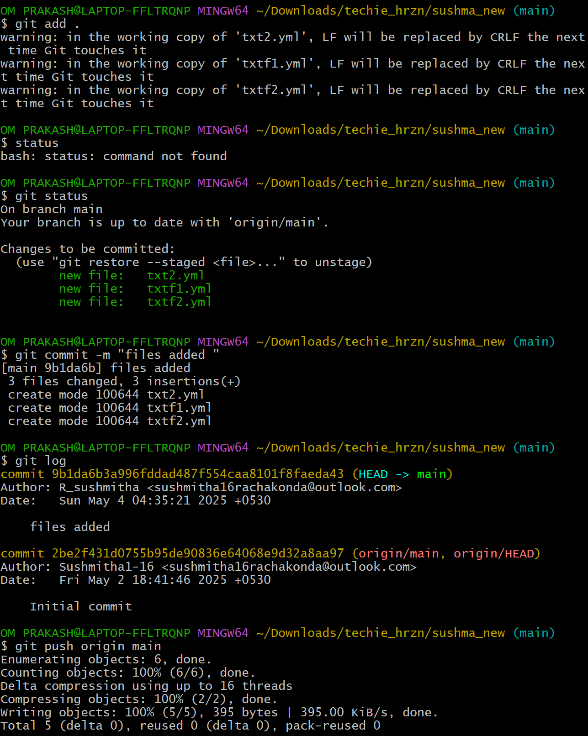

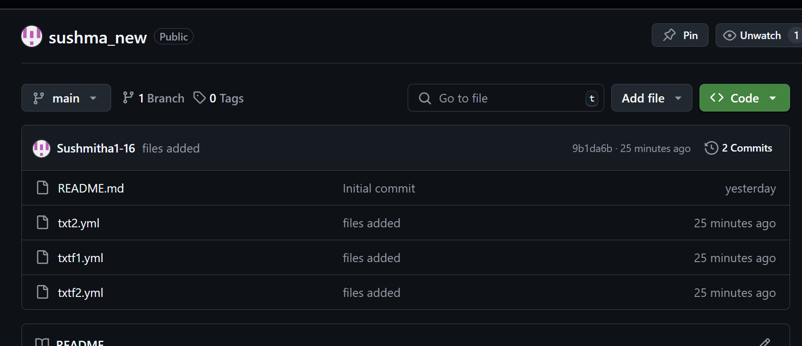

6)Create a branch in local and create a sample file and push to central.

* Created branch development using **git branch development**
* check the list by **git branch –list**

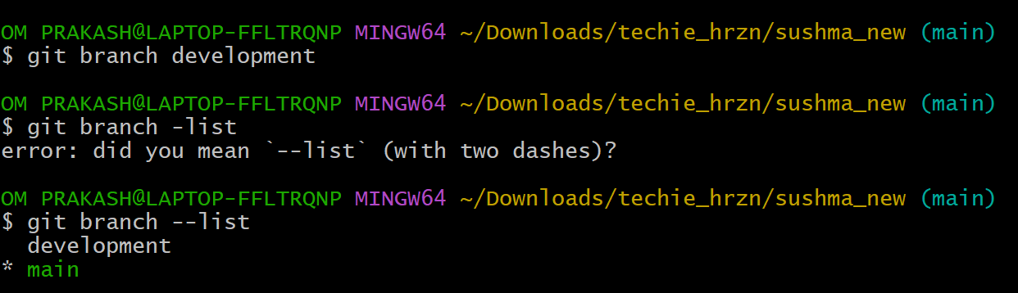

* switch the branch using  **git checkout development**
* created a file **filedevl.yml**  and  **saved**
* check status by  **git status**
* added to tracking by **git add .**
* commit by  **git commit -m “message”**
* push to the central repo by **git push origin development**

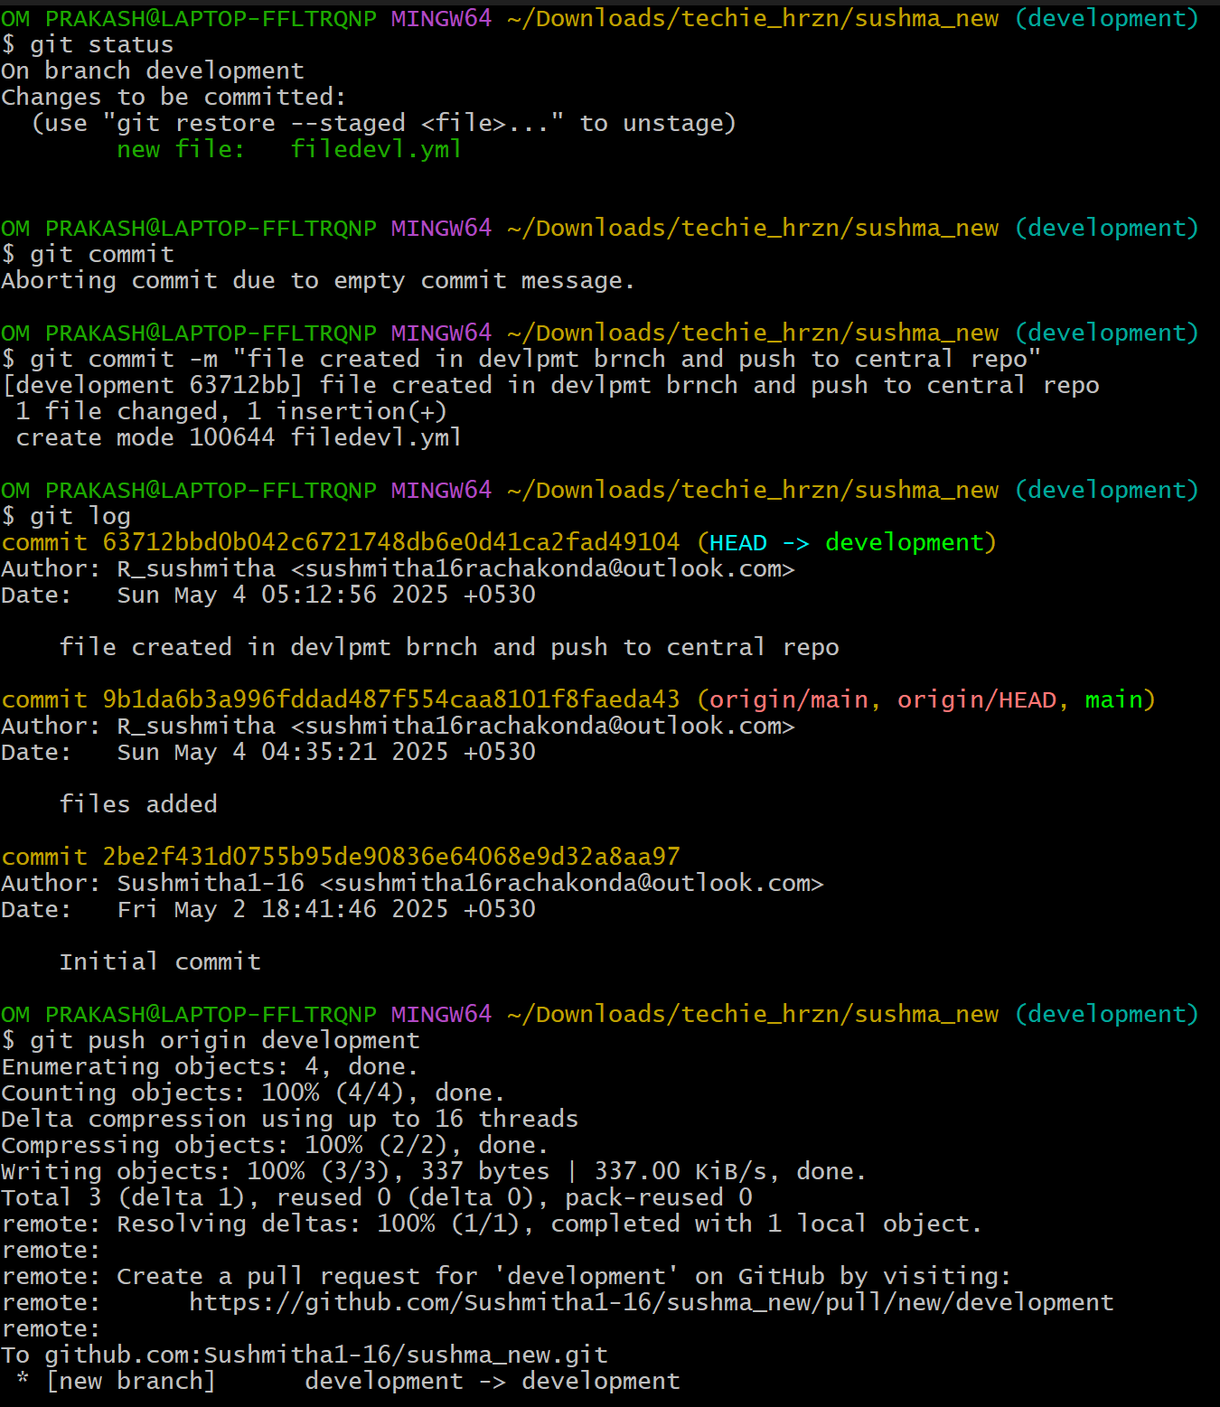

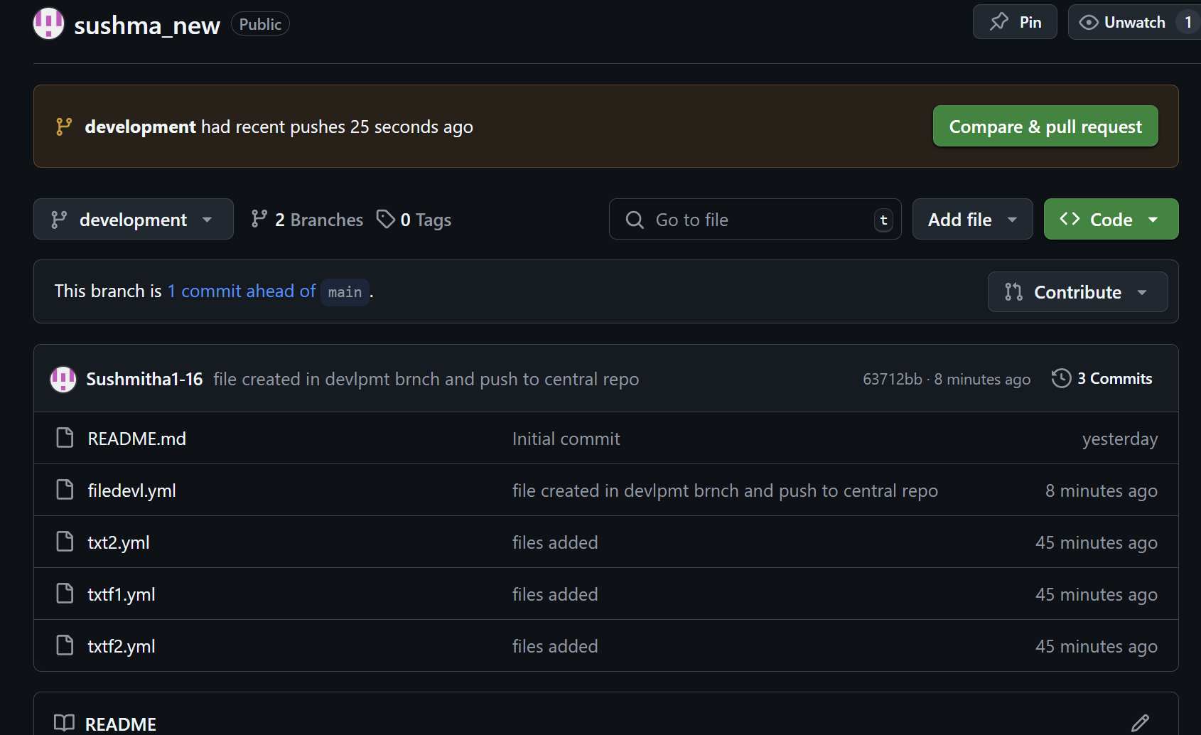

7)Create a branch in github and clone that to local.

* Create a branch (**hotfix)**  in github
* Fetch the branch from central repo to local repo by **git fetch origin**
* Then clone the central repo branch to local by

**git checkout -b hotfix origin/hotfix**

* Then check the branch list by  **git branch –list**

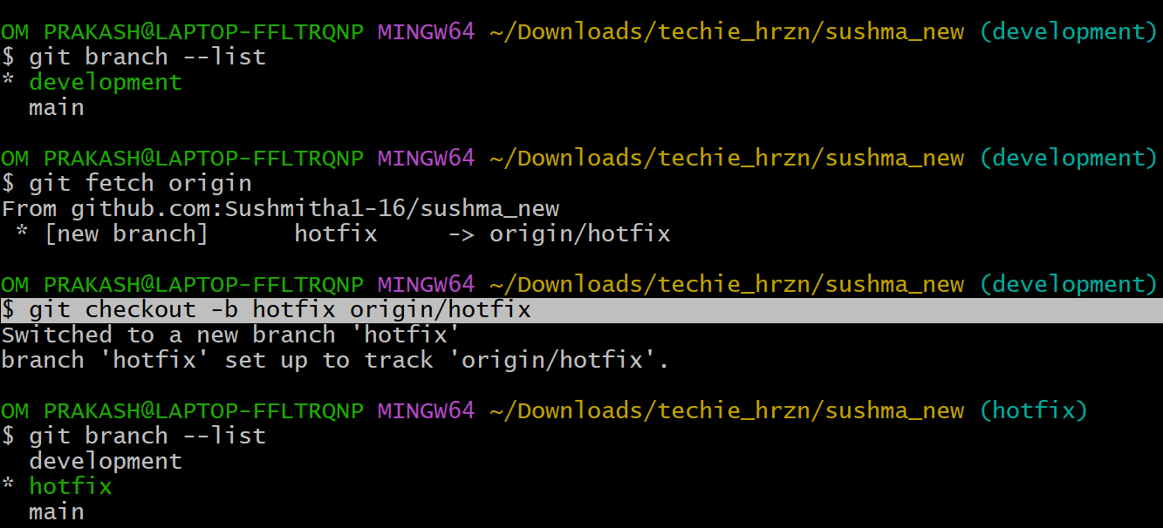

8)Merge the created branch with master in git local.

* Switch to main branch by **git checkout main**
* Then clone with central repo branch hotfix by **git merge hotfix**

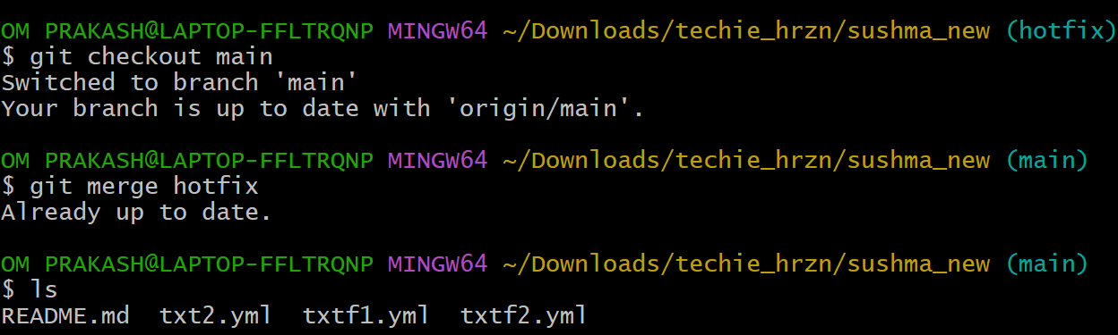

9)Merge the created branch with master in github by sending a pull request.

* Go to the github **pull request**🡪**new pull request**
* Then set **base->main , compare->hotfix**
* **Create pull request**🡪**merge**

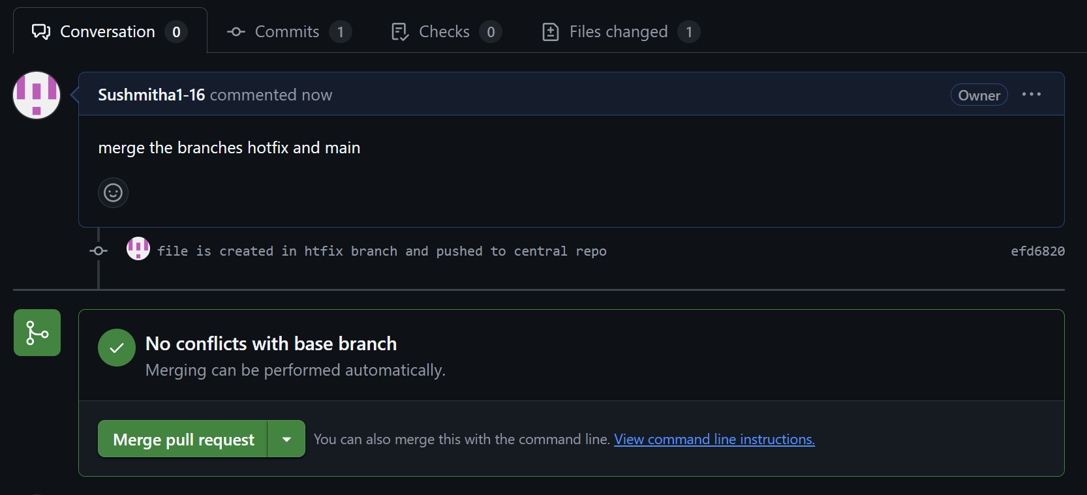

10)create a file in local and send that to branch in github.

* Created a file htfxfile.yml
* Then **git add .**
* **Git commit**
* Then push the file to central by **git push origin hotfix**

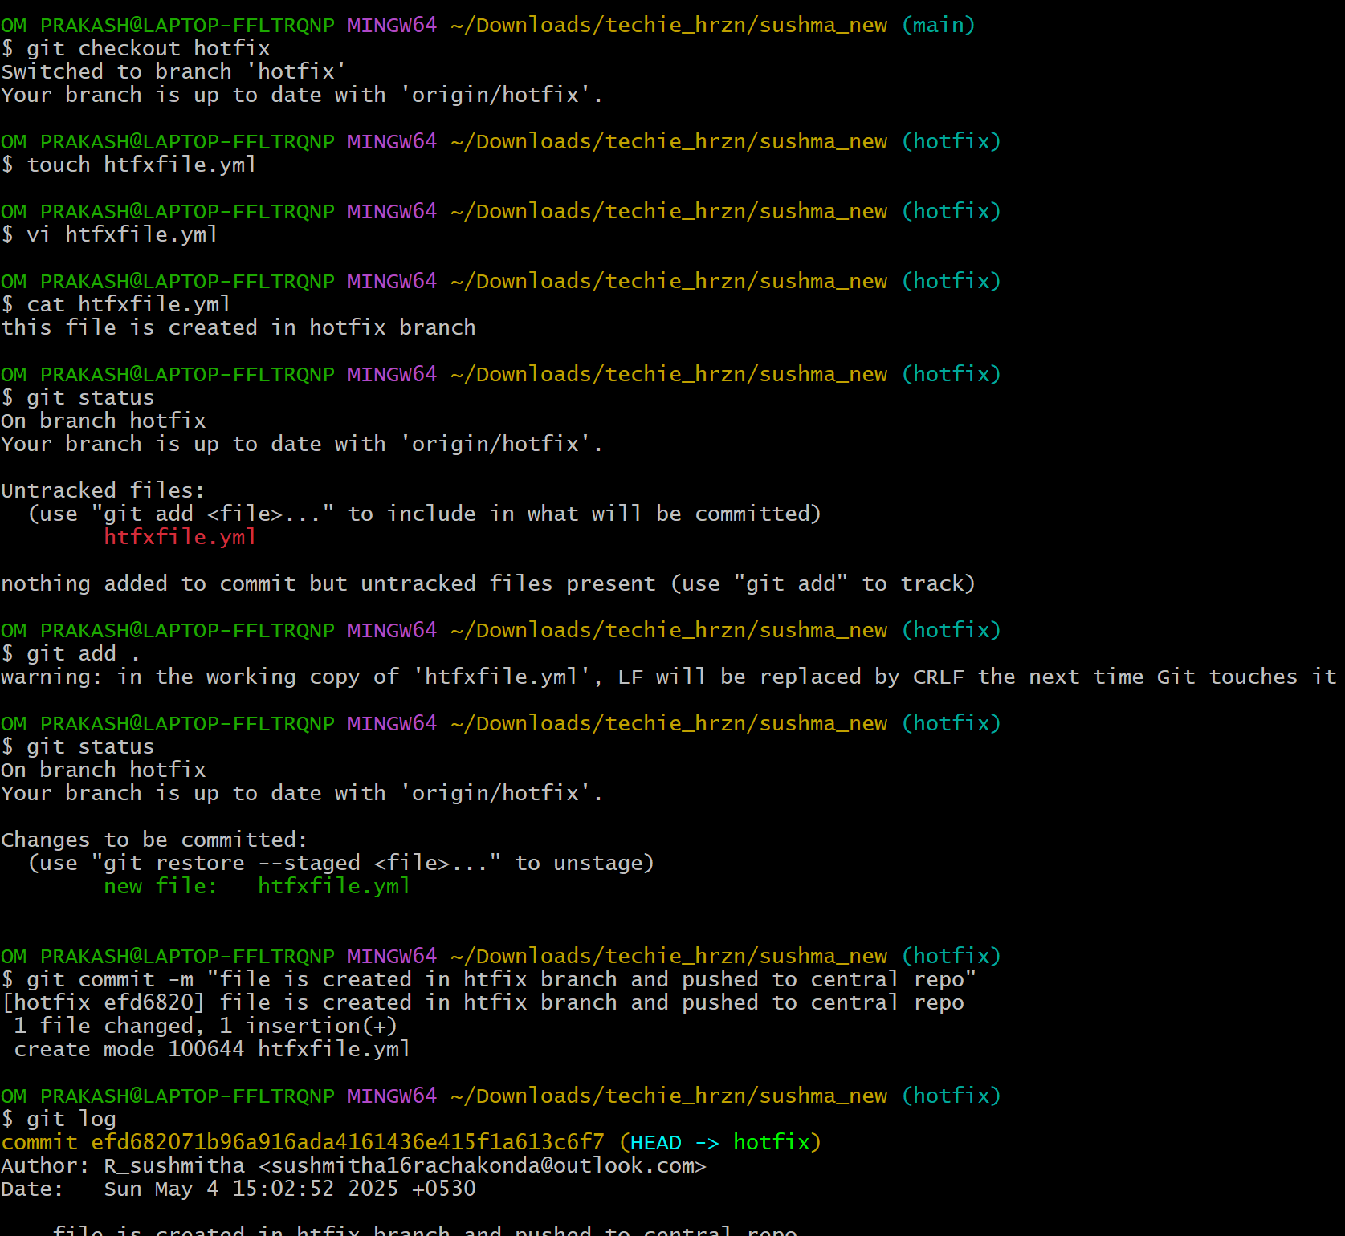  
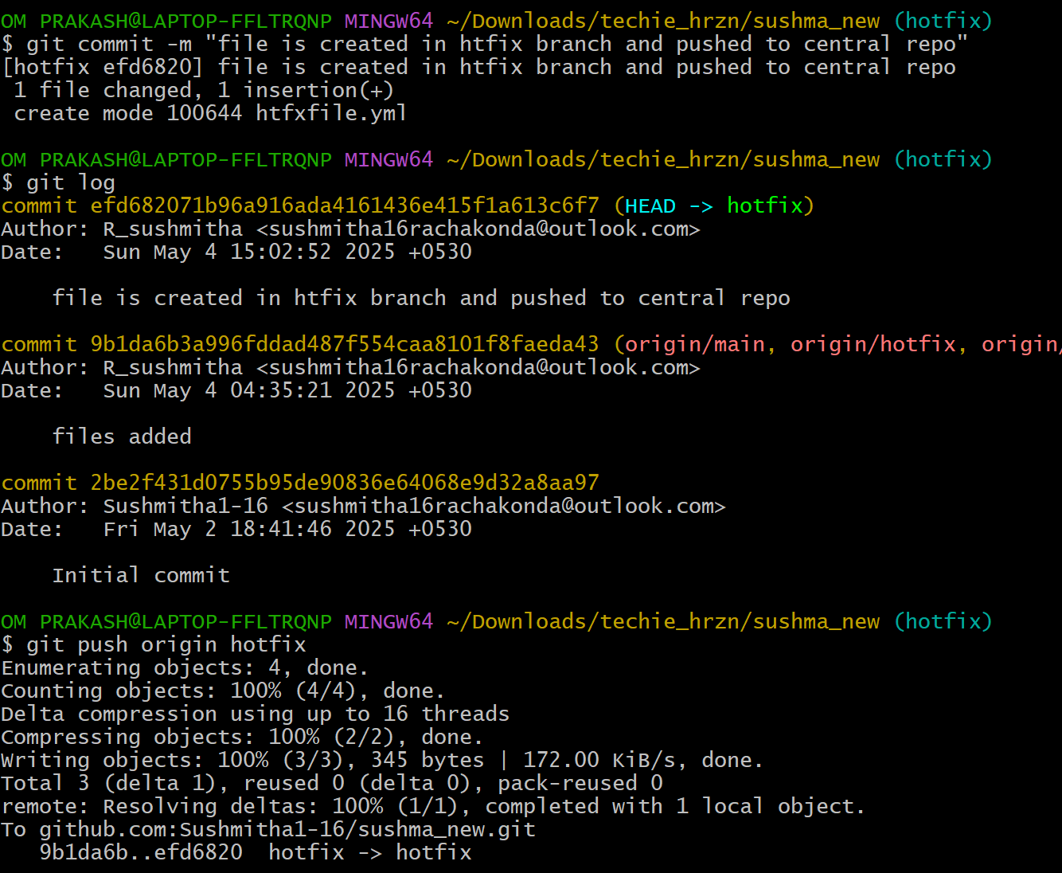

11)clone only a branch from github to local.

* Use command **git clone –branch branchname –single-branch centralrepo url**

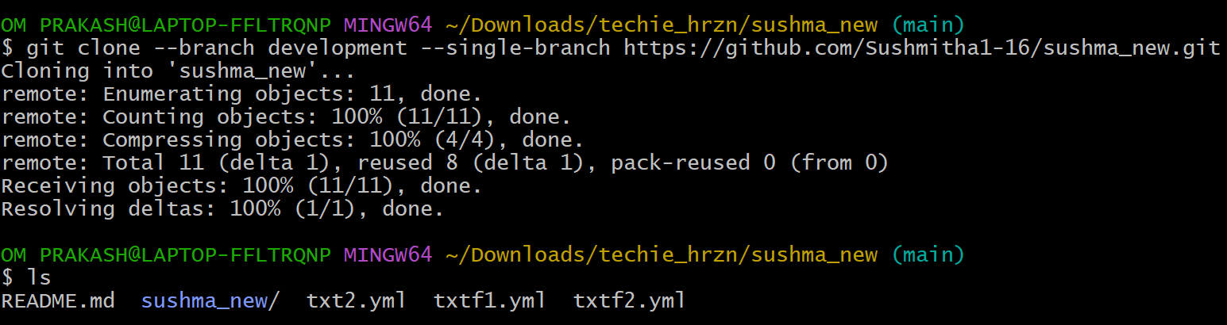

12)create a file with all passwords and make that untrackable with git.

* Created a file called paswrd.yml which contains passwords
* Then add the file to ignore file by  **vi .gitignore**
* Then commit
* Check the status by  **git status –ignored**

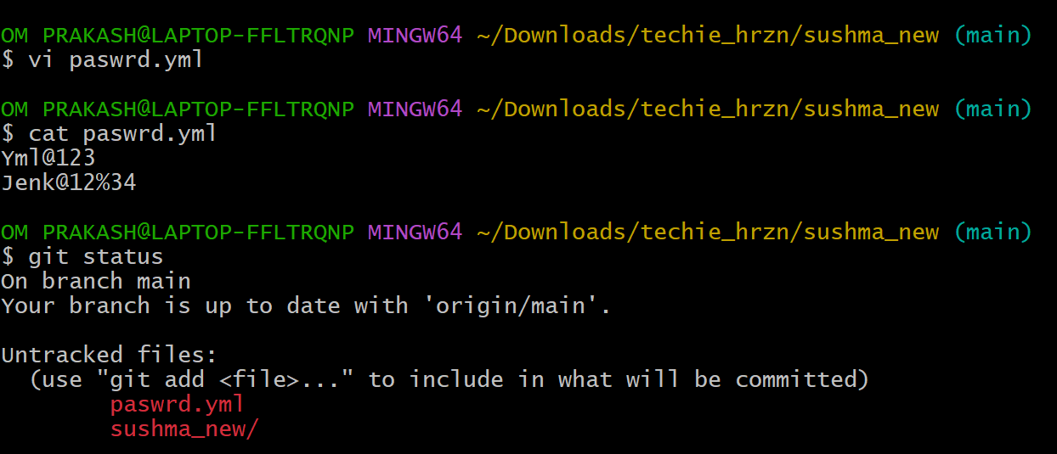

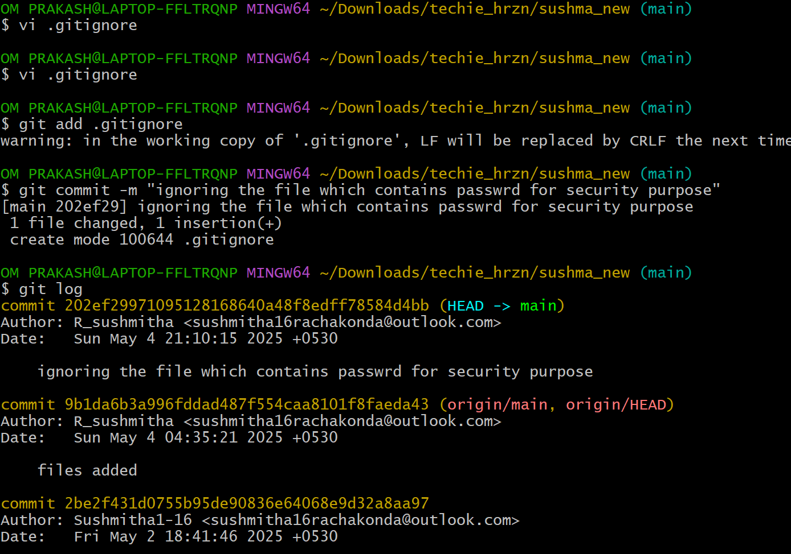

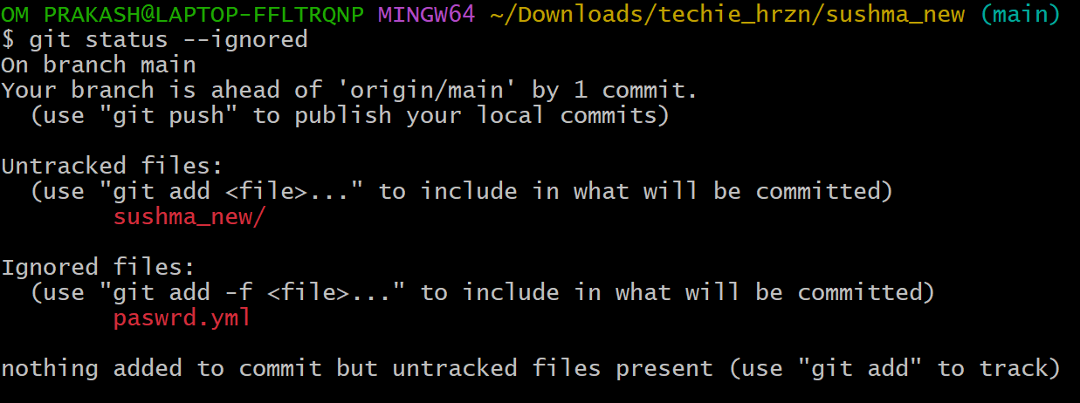

13)make a commit and make that commit reset without savings changes.

* Created file temp.jsn
* Then **commit**
* To reset the commit **git reset --hard HEAD~1**

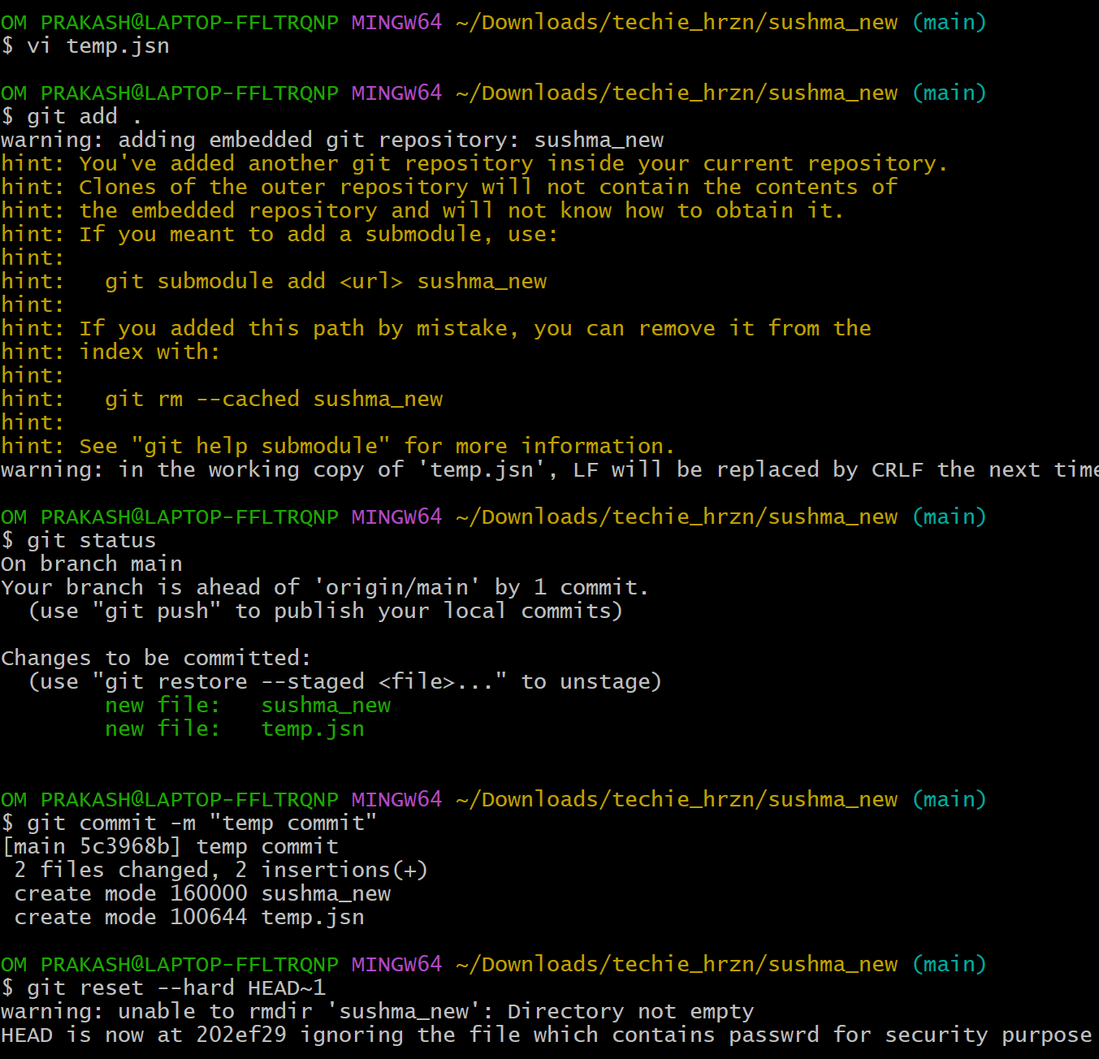  
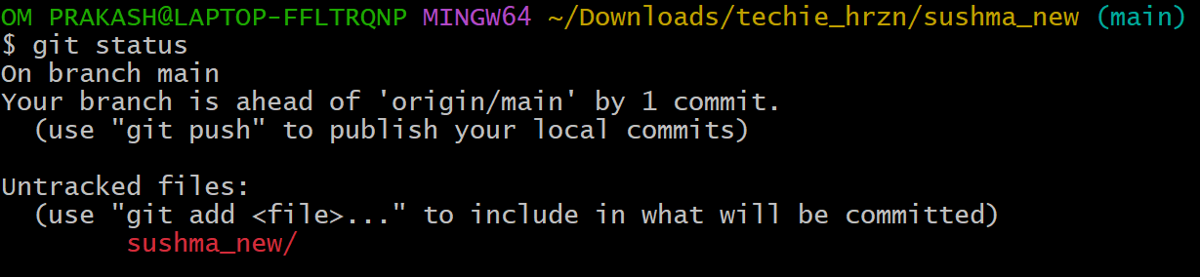

14)Revert a commited commit to the older version.

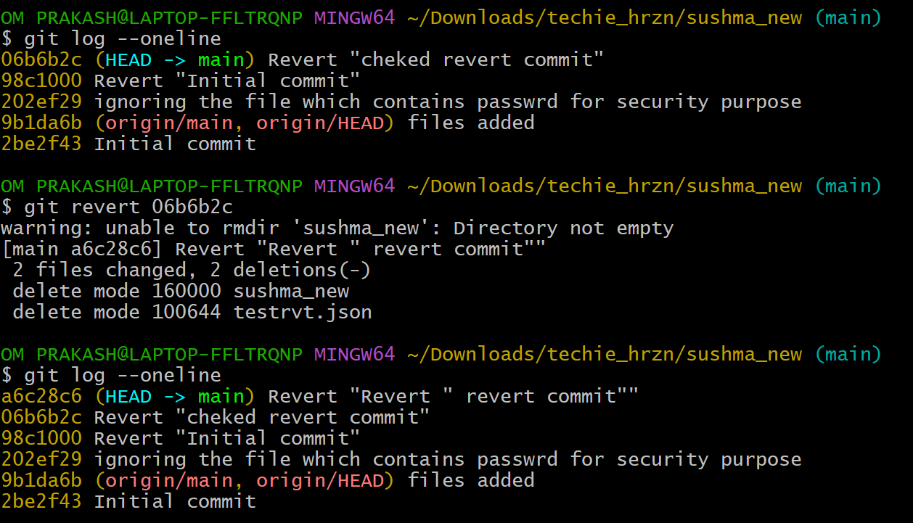

15)push a file to stash without savings the changes and work on another file.

* Created a file stest.json which is not commited
* Then **git add stest.json**
* To stash untracked file run **git stash push -m “message” --include-untracked**
* Created a new file and tracked
* The check the list by **git stash list**

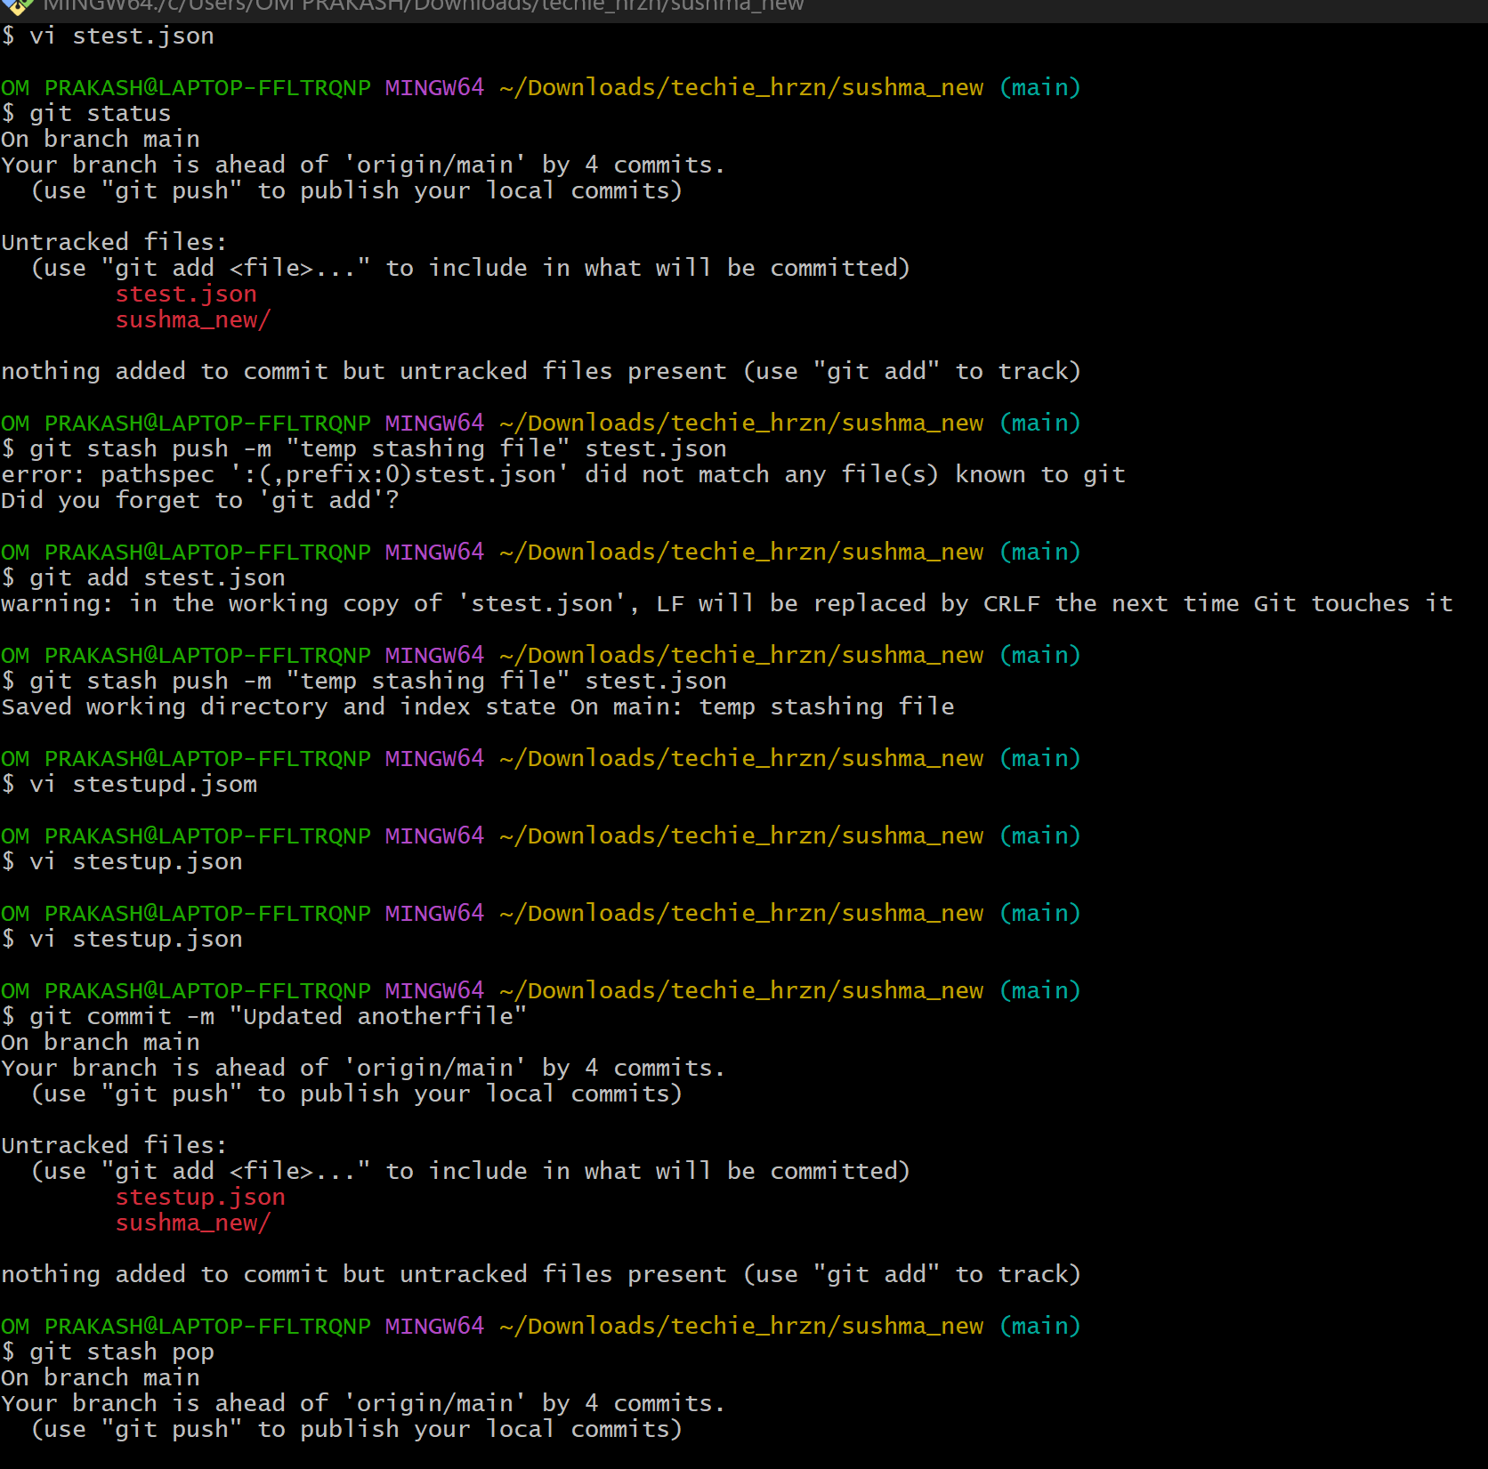

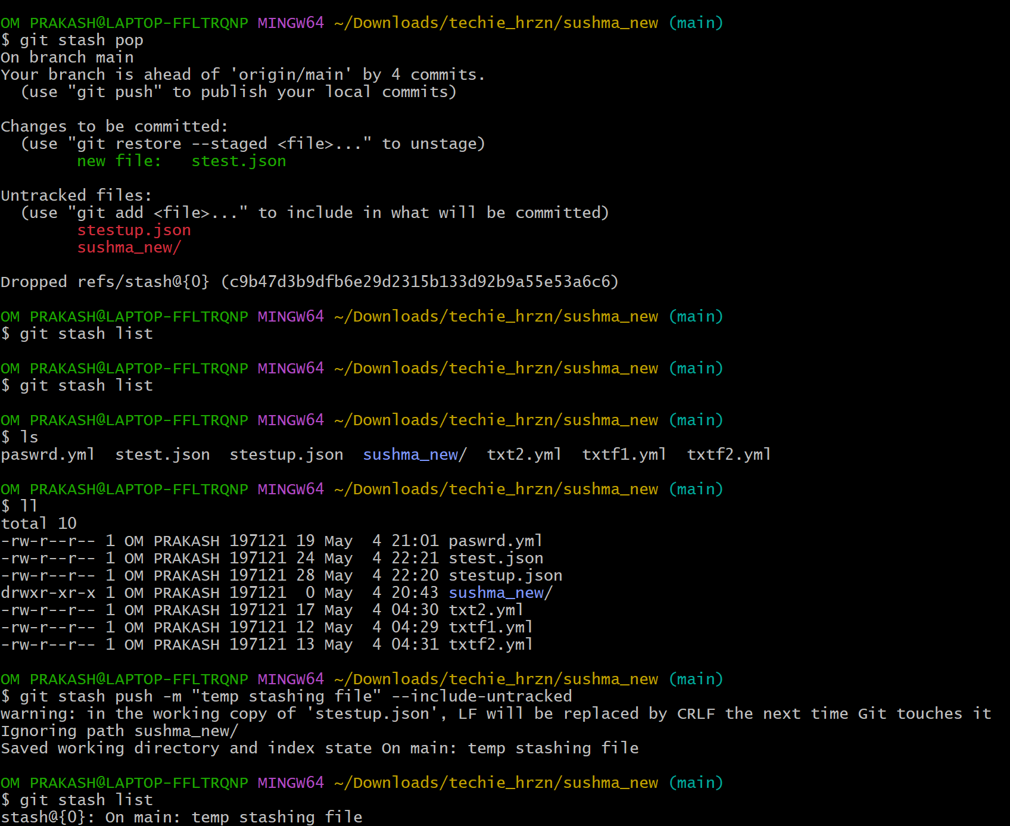

16)undo the stash file and start working on that again.

* Check the stash list by **git stash list**
* Then remove the file from stash by **git stash pop**

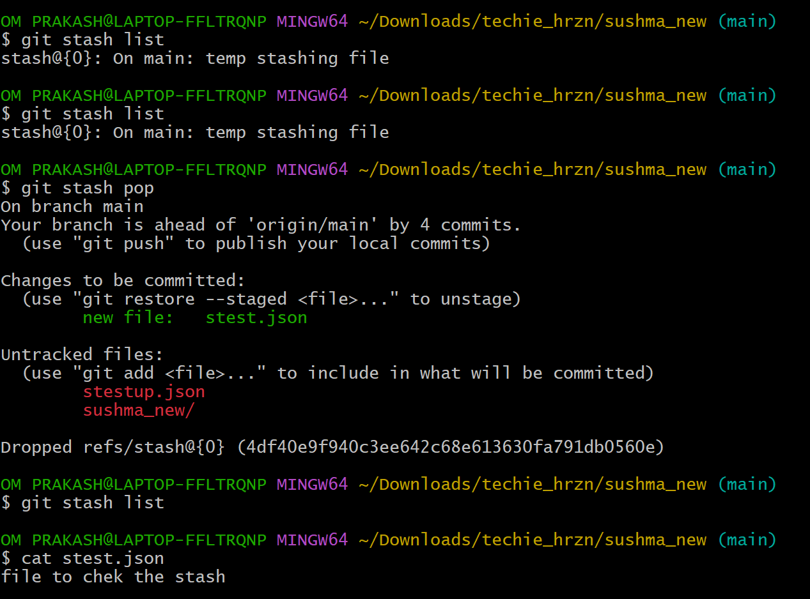

17)generate a ssh-keygen and configure into github.

* Run **ssh-Keygen**
* Copy the url **/c/Users/OM PRAKASH/.ssh/id_rsa.pub**
* Cat “**/c/Users/OM PRAKASH/.ssh/id_rsa.pub”**
* Then copy
* Goto github 🡪 **settings🡪ssh and gps key 🡪newssh🡪paste 🡪addssh**

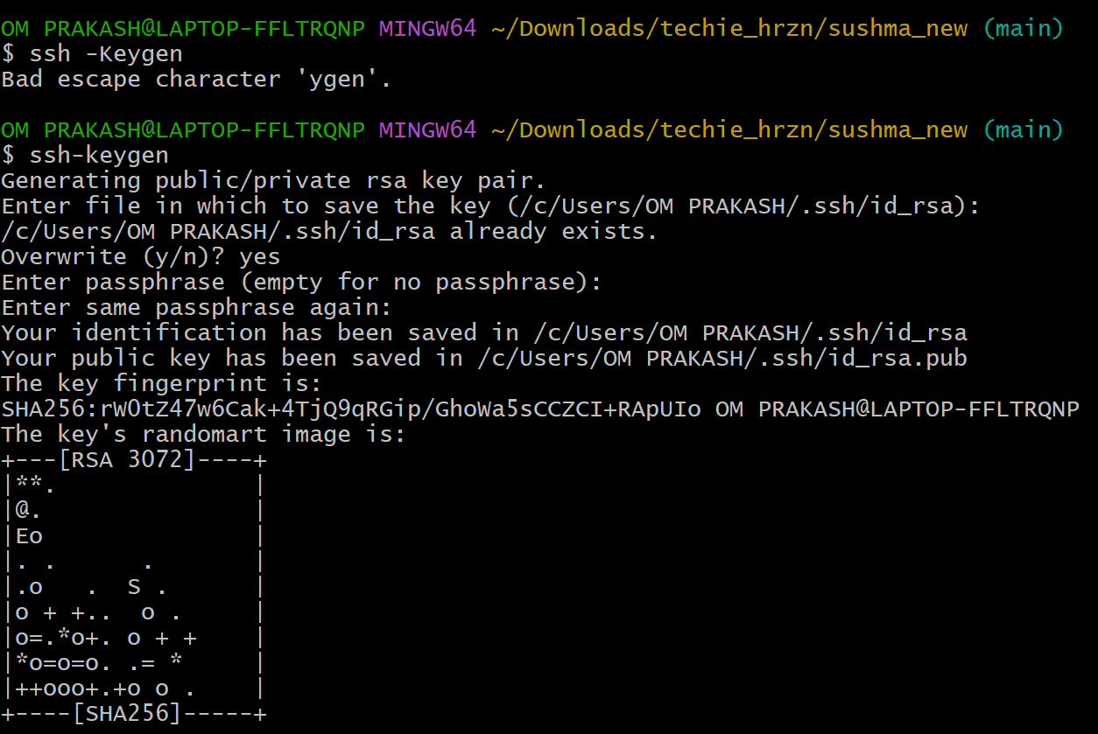



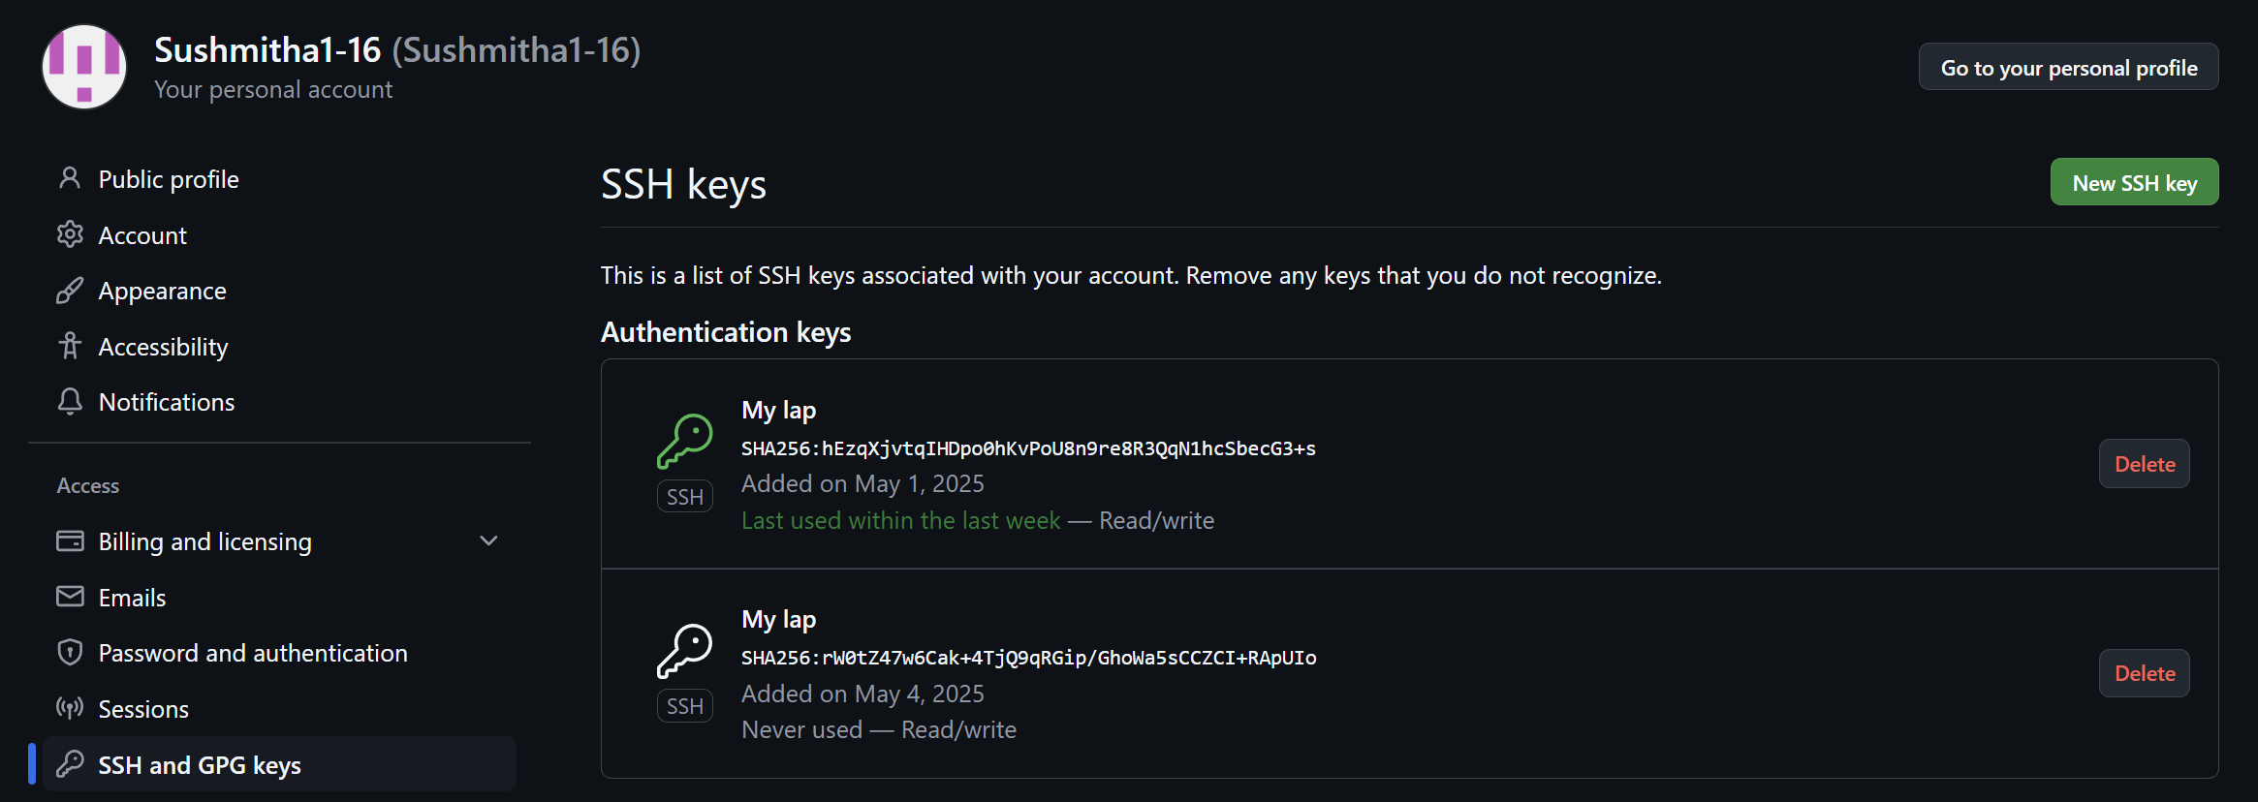

20)Check all the logs of git.

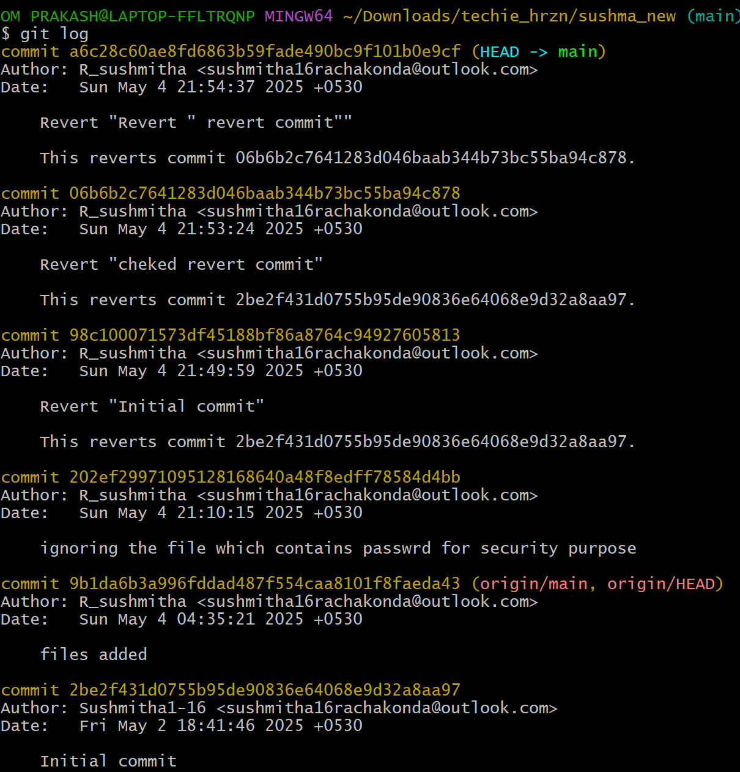

* For oneline run **git log --oneline**

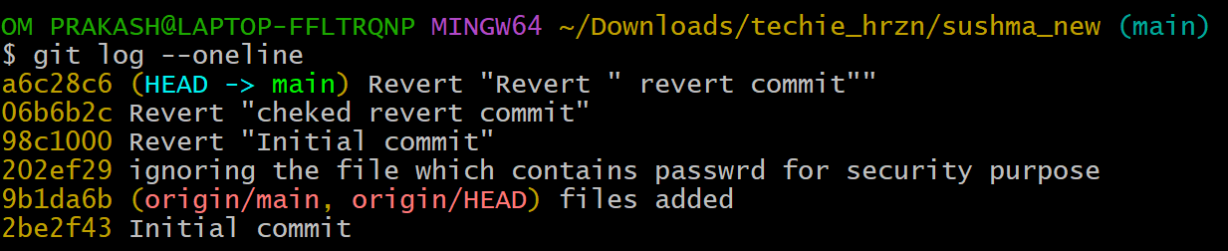

* For graph run  **git log –oneline --graph --all**

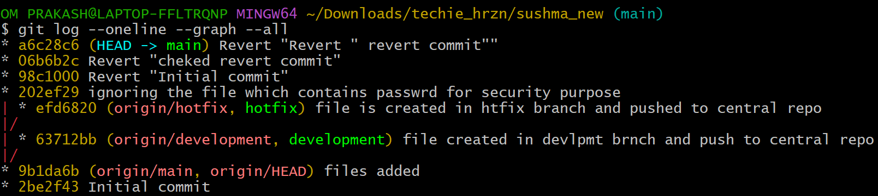

21)Rename the commit message.

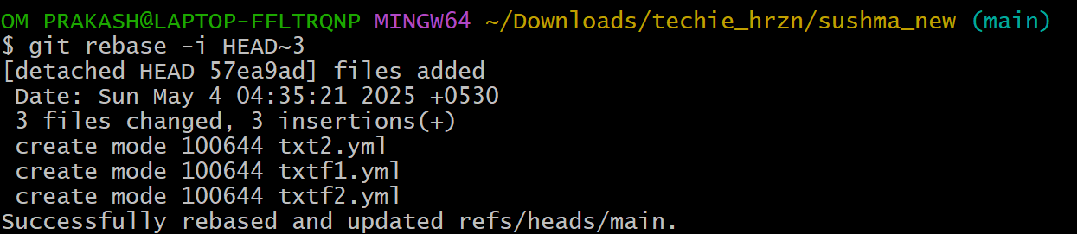

* Then change the pick as **reword** for the commit which we need to rename

22)Merge multiple commits into single commit.

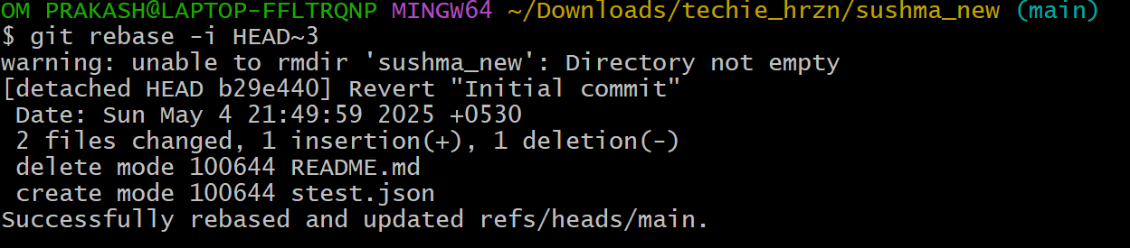

* Then change the pick as **squash** for the commits which we need to merge