PROJECT DOCUMENTATION
CareerForge
AI Interview Career Support System
Architecture · Block diagrams · Sequence · Usage
Web application for company-specific mock interviews
with keyword scoring, camera behavior analysis, voice fluency and accent ML,
SkillBridge maps, and a 10-course / 10-company practice catalog
React · Express · MySQL · Flask · OpenCV · scikit-learn

Contents
1. Introduction
2. System architecture
2.1 Architecture diagram
2.2 Product block diagram
2.3 Scoring block diagram
2.4 Components and page flow
2.5 ML modules
3. Sequence flows
4. Usage (run on another computer)
4.1 Software to install
4.2 What to copy
4.3 Windows commands
4.4 macOS / Linux commands
4.5 Optional MySQL
4.6 Optional Google Sign-In
4.7 Check it is running
4.8 How to use the product
4.9 API map
5. Pros and cons
6. Project structure
7. Limitations and future work
8. Summary
1. Introduction
CareerForge is a web application that helps students prepare for company-specific technical interviews. The student signs in (email/password or Google), works through a 10-course × 10-company catalog and a Practice / SkillBridge workspace, then takes a four-round mock interview. During each round the system evaluates what they say and how they present themselves.
Signal | What it measures
Answer quality | Keyword matching and pattern matching on the typed or spoken answer
Camera behavior | Confidence, nervousness, and malpractice risk from the webcam
Voice delivery | Fluency, content accuracy, and accent/clarity (ASR intelligibility)
Skill / chance | Technical, communication, problem-solving, plus chance of advancing this screen

Table 1. Evaluation signals used in the mock interview
The goal is structured practice: company-specific rounds, adaptive difficulty across four rounds, camera and voice signals, and a results pack after submit. Rubric chips are not shown live in the answer box.
1.1 Problem
Students often know the syllabus but freeze in interviews. Typical prep apps score only written answers, or only length. They miss:
- whether the answer actually contains the expected concepts
- whether the candidate looks away, leaves the frame, or appears with another person
- whether spoken answers are fluent and on-topic
1.2 Objectives
- Guide the student from login to dashboard, practice or course/company, four-round mock, and result.
- Score answers with keywords (concepts) and patterns (definition, comparison, example).
- Analyze the webcam for confidence, nervousness, and integrity flags.
- Score voice answers for fluency, accuracy, and accent/clarity (ASR intelligibility, not a linguistic accent classifier).
- Keep the ML stack in a separate Python service so models can be retrained without rewriting the UI.
- Persist accounts and sessions in MySQL when reachable, otherwise JSON files under backend/data/.
2. System architecture
CareerForge is a three-process system. The browser never talks to MySQL, JSON account files, or .pkl / ONNX models directly. Vite (and Express after a production build) proxy /api and /ml so the student uses one origin.
2.1 Architecture diagram
Figure 1 is the deployment architecture: student browser, Express API, Flask ML service, optional Google Identity, and persistence that prefers MySQL and falls back to JSON files.
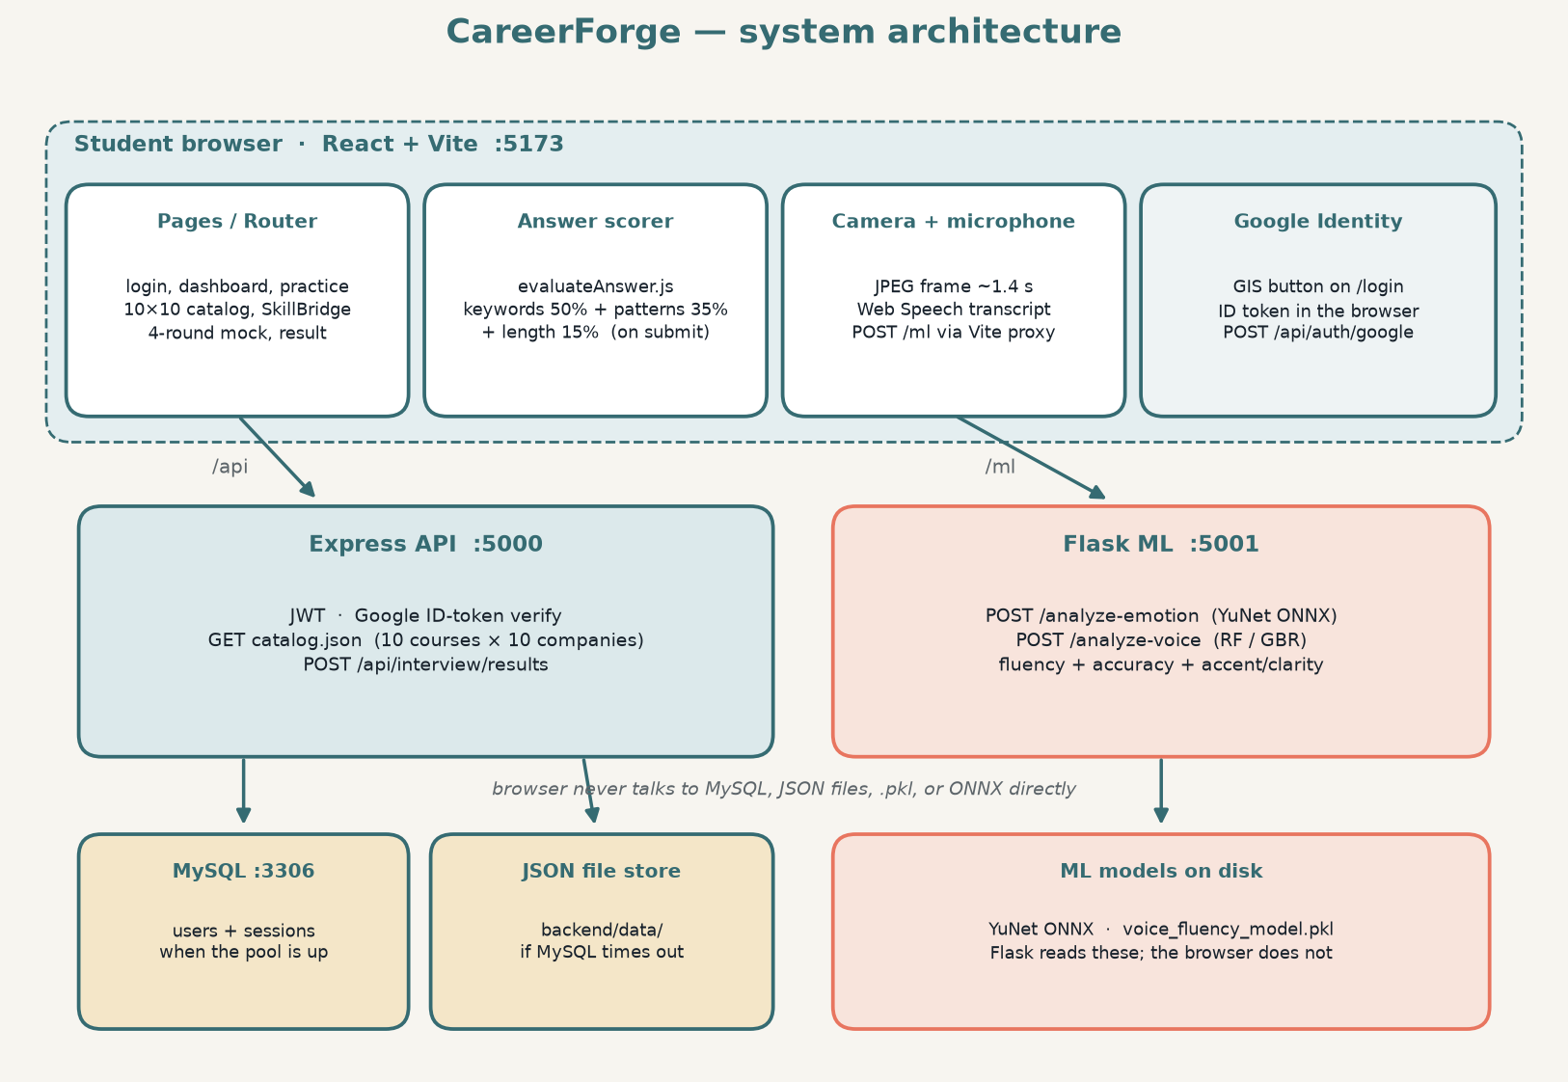
Figure 1. System architecture diagram
Block | Runs on | Talks to | Does not talk to
React SPA | Browser :5173 | Express /api, Flask /ml, Google GIS | MySQL, .pkl files, ONNX
Express | Node :5000 | MySQL or JSON files, Google tokeninfo | YuNet / sklearn directly
Flask ML | Python :5001 | ONNX + pickle models on disk | The student browser origin except via /ml proxy
Google Identity | accounts.google.com | Returns an ID token to the login page | CareerForge database

Table 2. Who may call whom
2.2 Product block diagram
Figure 2 is the product block diagram (what the student uses), not the process diagram. Prepare feeds a four-round mock. Three scoring blocks feed the result pack.
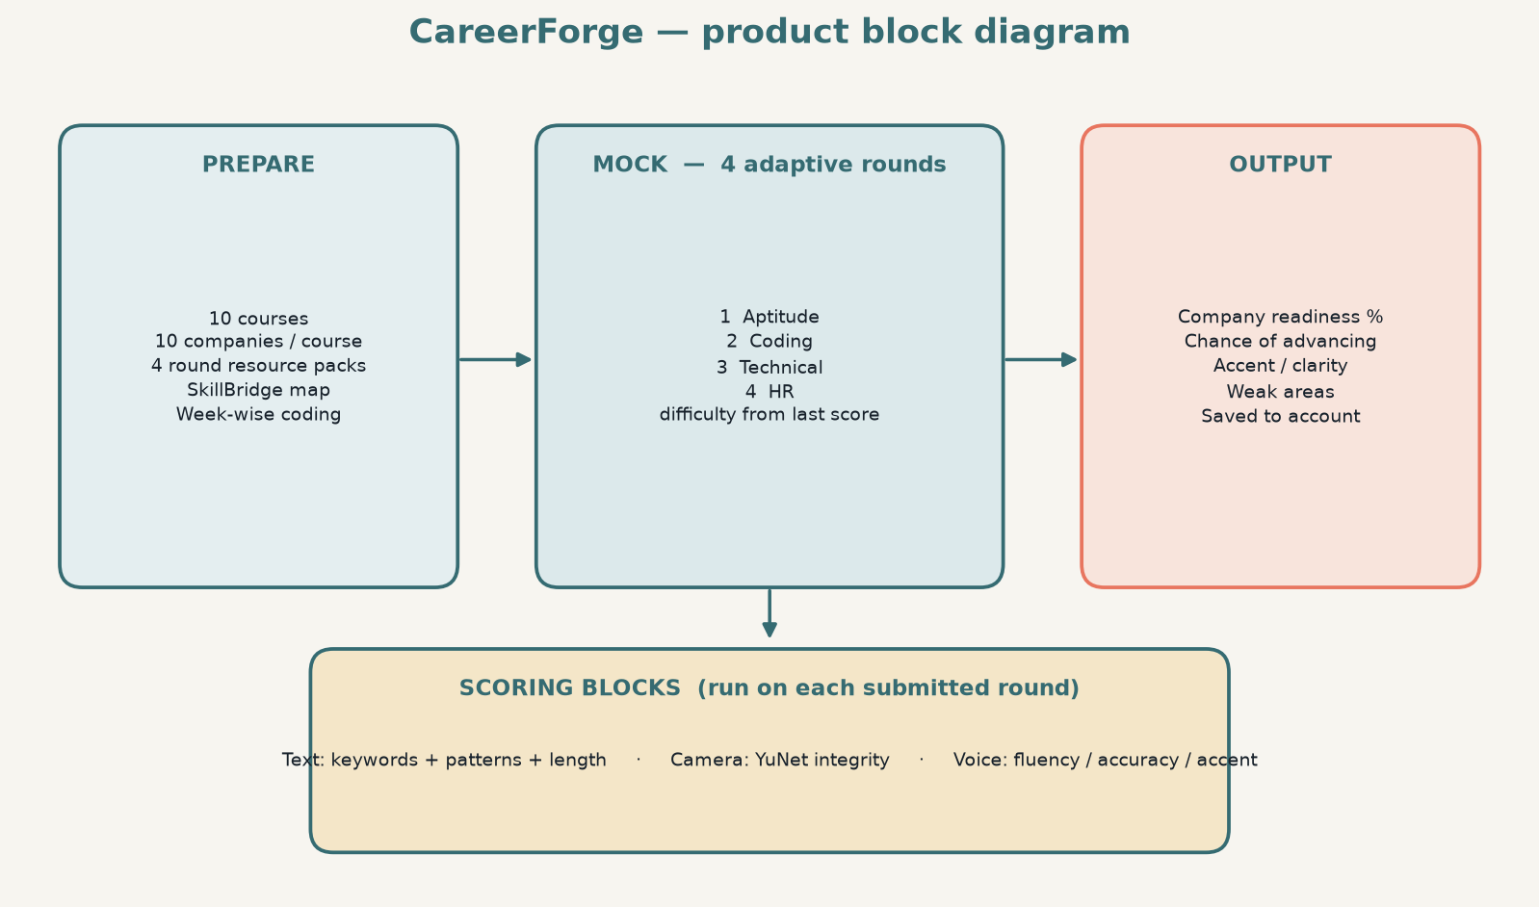
Figure 2. Product block diagram
Block | What it contains | Student sees it on
Prepare | 10x10 catalog, course-specific rounds, live practice URLs, SkillBridge, week-wise coding | /practice, /readiness, /preparation
Mock | Four adaptive rounds: aptitude, coding, technical, HR. Difficulty follows the last score. | /interview
Scoring | Keywords+patterns; YuNet camera; voice fluency, accuracy, accent/clarity | Interview meters + /result
Output | Readiness %, chance of advancing this screen, weak areas, saved session | /result, account history

Table 3. Product blocks
2.3 Scoring block diagram
Each submitted round runs three independent blocks. The live answer box does not show the rubric; scores appear after submit.
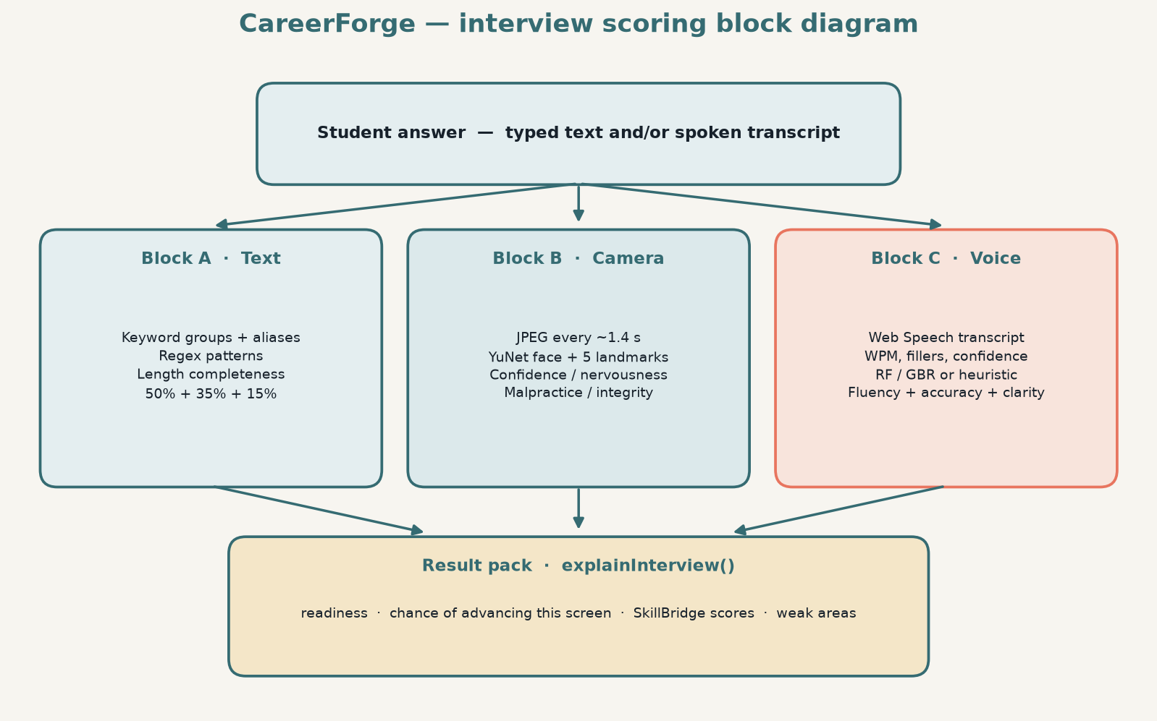
Figure 3. Interview scoring block diagram
2.4 Components and page flow
Layer | Technology | Port | Responsibility
Frontend | React + Vite + React Router | 5173 | Login, practice, catalog, mock, result, SkillBridge
Backend API | Express.js | 5000 | JWT auth, Google verify, catalog, saved interviews
Database | MySQL (optional) | 3306 | Users and interview sessions when reachable
File store | JSON in backend/data/ | — | Auth and results if MySQL times out
ML service | Flask + OpenCV + sklearn | 5001 | Camera integrity, voice fluency / accuracy / accent

Table 4. System layers
Routing is React Router in src/App.jsx.
From | To | Trigger
Login | Dashboard | Email/password or Google sign-in
Dashboard | Practice | Practice workspace
Dashboard | Courses | Mock path — choose a domain
Dashboard | SkillBridge /readiness | Maps, week-wise coding, requirement detector
Courses | Companies | Course chosen (10 companies)
Companies / Practice | Preparation or interview | Company chosen
Mock interview | Result | Four rounds complete or End interview
Result | Dashboard, retry, or SkillBridge | After scores and chance %

Figure 4. User navigation flow
2.5 ML modules
Skill model (train_model.py): RandomForestClassifier on technical_score, communication_score, problem_solving maps to skill_level (Strong / Average / Weak).
Voice model (train_voice_model.py): Generates labeled feature rows, trains Random Forest and Gradient Boosting (MultiOutputRegressor), and saves the better average R² model as voice_fluency_model.pkl. If the pickle is missing, /analyze-voice falls back to a heuristic scorer.
Camera model: OpenCV YuNet (face_detection_yunet_2023mar.onnx). Landmarks drive looking-away, looking-down, smile proxy, and fidgeting. Face count and brightness drive malpractice flags.
Module | Input | Algorithm / method | Output
Answer evaluation (browser) | Typed or spoken text + question spec | Keyword aliases + regex patterns | Score = 50% keywords + 35% patterns + 15% length
Camera analysis (Flask) | JPEG webcam frame | YuNet ONNX + landmark heuristics | Confidence, nervousness, cheating risk, integrity
Voice analysis (Flask) | Transcript, duration, confidence, keyword/pattern scores | Random Forest or Gradient Boosting regressor | fluency, accuracy, accent/clarity (0–100)

Table 5. ML and scoring modules
2.7 Training datasets and model files
CareerForge trains two sklearn models from CSV files in ml_service/. Face detection is not trained here: YuNet is a pretrained OpenCV ONNX file. There are no wav/mp3 corpora and no labeled webcam image sets. See also ml_service/TRAINING_DATA.md.
File | Rows | Kind | Used by | Output
skill_assessment_data.csv | 20 | Hand-written labels | train_model.py | skill_assessment_model.pkl, label_encoder.pkl
voice_fluency_data.csv | 480 | Synthetic features (seed 42) | train_voice_model.py | voice_fluency_model.pkl, voice_fluency_meta.pkl
face_detection_yunet_2023mar.onnx | — | Pretrained YuNet | emotion_analyzer.py | Not trained in this repo

Table 6. Training data and model artifacts
Skill data: 20 rows. Features technical_score (45–95), communication_score (50–92), problem_solving (42–96). Labels Strong 7, Average 7, Weak 6. RandomForestClassifier with 100 trees, 80/20 split.
Voice data: 480 synthetic rows from five profiles (fluent 22%, average 28%, hesitant 20%, rushed 15%, inaccurate 15%). Eleven input features plus fluency_score and accuracy_score labels from teacher functions plus noise. Random Forest and Gradient Boosting compete; the higher average R² model is saved.
Shipped pickles: skill_assessment_model.pkl, label_encoder.pkl, voice_fluency_model.pkl, voice_fluency_meta.pkl. Retrain with py -3 train_model.py and py -3 train_voice_model.py from ml_service/.
3. Sequence flows
The following tables are sequence diagrams in document form. Read each row top to bottom as a message from one participant to another.
3.1 End-to-end student journey
Step | From | To | Action
1 | Student | React app | Email/password or Google sign-in
2 | React app | Express :5000 | POST /api/auth/login or /api/auth/google
3 | Express | MySQL or JSON | Upsert / load user
4 | Express | React app | JWT + user
5 | Student | React app | Open practice, courses, or SkillBridge
6 | React app | Express | GET /api/courses
7 | Express | React app | catalog.json (10 × 10)
8 | Student | React app | Select company and start mock
9 | React / Flask | React / Flask | Four-round interview loop
10 | React app | Express | POST /api/interview/results
11 | Express | MySQL or JSON | Save session
12 | React app | React app | Show /result: readiness, chance %, weak areas

Figure 5. Sequence — student journey
The course list is served from src/data/catalog.json, not from a MySQL catalog table.
3.2 Answer scoring (keywords and patterns)
Step | From | To | Action
1 | Student | Answer textarea | Type or dictate answer
2 | Student | MockInterview UI | Submit answer
3 | MockInterview UI | evaluateAnswer.js | Send text + current question spec
4 | evaluateAnswer.js | evaluateAnswer.js | Match keyword aliases
5 | evaluateAnswer.js | evaluateAnswer.js | Test regex patterns
6 | evaluateAnswer.js | MockInterview UI | Keyword %, pattern %, length, combined score
7 | MockInterview UI | MockInterview UI | Store round; set next-round difficulty from last score
8 | MockInterview UI | MockInterview UI | Next of 4 rounds or finish

Figure 6. Sequence — keyword and pattern matching
Keyword groups allow aliases (for example mutable also matches “can be changed”). Patterns check structure: definition phrasing, comparison words, examples, and prevention methods. Difficulty of the next round is foundation / applied / corporate from the last score — not a live Easy → Medium → Hard unlock while typing.
3.3 Camera emotion and integrity
Step | From | To | Action
1 | Student | Webcam | Allow camera permission
2 | MockInterview | Webcam | getUserMedia (video)
3 | MockInterview | Canvas | Loop every ~1.4 seconds: capture JPEG
4 | MockInterview | Vite proxy /ml | POST /ml/analyze-emotion
5 | Vite proxy | Flask emotion_analyzer | POST /analyze-emotion
6 | Flask | Flask | YuNet detect faces and 5-point landmarks
7 | Flask | Flask | Score confidence, nervousness, cheating risk
8 | Flask | MockInterview | JSON + optional face bounding box
9 | MockInterview | MockInterview | Update meters and overlay
10 | MockInterview | Result state | Average samples into result.behavior

Figure 7. Sequence — camera analysis
Integrity labels:
- Clear — one frontal face, looking at the camera
- Warning — looking away, fidgeting, moderate risk
- Flagged — no face, covered camera, or multiple people
3.4 Voice fluency and accuracy
Step | From | To | Action
1 | Student | MockInterview | Start Voice Input
2 | MockInterview | Web Speech API | Start recognition
3 | Web Speech API | MockInterview | Transcript + confidence
4 | MockInterview | Keyword/pattern scorer | Score spoken text vs question
5 | MockInterview | Flask /analyze-voice | Transcript, duration, keyword/pattern scores
6 | Flask | Flask | extract_features()
7 | Flask | Flask | If model loaded: Random Forest / Gradient Boosting predict
8 | Flask | Flask | Else: heuristic_scores()
9 | Flask | MockInterview | Fluency, accuracy, accent/clarity, notes, algorithm name
10 | MockInterview | MockInterview | Show voice meters and attach scores to the answer

Figure 8. Sequence — voice fluency, accuracy, and clarity
Fluency is driven by words per minute, filler ratio, unique-word ratio, repetition, pauses, and recognition confidence. Accuracy is driven by keyword coverage, pattern coverage, and speech-recognition confidence (how clearly the words were heard). Accent/clarity is an intelligibility estimate. It is not a linguistic accent identifier (it does not label “Indian English” vs “US English”).
3.5 Persist interview session
After the four rounds (or End interview), the result page posts a session. Express writes MySQL when the pool is up; otherwise it writes backend/data/sessions.json.
Step | From | To | Action
1 | React | Express | POST /api/interview/results (JWT)
2 | Express | MySQL or JSON | Save session for this user
3 | Store | Express | id
4 | Express | React | Saved confirmation

Figure 9. Sequence — save interview session
4. Usage — run on another computer
Share the project folder (USB, zip, or git clone). The other PC must install Node.js and Python, then run the commands below. Three terminals stay open while the app is used. MySQL is optional: if it is missing, login and saved interviews still work using backend/data JSON files. Google Sign-In is optional.
4.1 Software to install first (once per computer)
- Node.js LTS (20 or 22) from https://nodejs.org — this also installs npm. Restart the terminal after install.
- Python 3.10+ from https://www.python.org/downloads/ — on Windows tick Add python.exe to PATH.
- Google Chrome or Microsoft Edge (needed for Voice Input).
- Optional: MySQL Server if you want a real database instead of JSON files.
Check that the tools work:
node -v
npm -v
py -3 --version
On macOS / Linux use python3 --version instead of py -3 --version. If node or py is not found, close the terminal and open a new one, or reinstall with PATH enabled.
4.2 What to copy (and what to leave out)
Copy the whole ai_careerforge folder, including src/, backend/ (except secrets), ml_service/, and ml_service/models/face_detection_yunet_2023mar.onnx.
Leave out | Why
node_modules/ and backend/node_modules/ | Too large; run npm install instead
backend/.env | Contains passwords; create a new file from .env.example
backend/data/ | Local user accounts on the original machine
dist/ | Production build output
__pycache__/ | Python cache

Table 6. Files not to copy to the other computer
4.3 Windows — all commands (PowerShell)
Open PowerShell. Replace the first cd with the real folder path on that PC.
A. Install libraries (once)
cd "C:\Users\YOUR_NAME\Desktop\ai_careerforge"
node -v
npm -v
py -3 --version
npm install
cd backend
npm install
Copy-Item .env.example .env
cd ..
cd ml_service
py -3 -m pip install --upgrade pip
py -3 -m pip install -r requirements.txt
py -3 train_model.py
py -3 train_voice_model.py
cd ..
Edit backend\.env in Notepad if MySQL is installed (set DB_PASSWORD). If MySQL is not installed, leave .env as copied — the API will print Accounts: file store and still work.
B. Start the app (every time) — three windows. Keep all three running.
Terminal 1 — Flask ML (http://127.0.0.1:5001):
cd "C:\Users\YOUR_NAME\Desktop\ai_careerforge\ml_service"
py -3 app.py
Terminal 2 — Express API (http://127.0.0.1:5000):
cd "C:\Users\YOUR_NAME\Desktop\ai_careerforge\backend"
node server.js
Terminal 3 — React UI (http://127.0.0.1:5173):
cd "C:\Users\YOUR_NAME\Desktop\ai_careerforge"
npm run dev
C. Open the app in Chrome
http://127.0.0.1:5173
Use 127.0.0.1, not localhost, if you later add Google Sign-In (Google treats them as different sites).
4.4 macOS / Linux — all commands
A. Install libraries (once)
cd ~/Desktop/ai_careerforge
node -v
npm -v
python3 --version
npm install
cd backend
npm install
cp .env.example .env
cd ..
cd ml_service
python3 -m pip install --upgrade pip
python3 -m pip install -r requirements.txt
python3 train_model.py
python3 train_voice_model.py
cd ..
B. Start the app (every time) — three terminals
Terminal 1:
cd ~/Desktop/ai_careerforge/ml_service
python3 app.py
Terminal 2:
cd ~/Desktop/ai_careerforge/backend
node server.js
Terminal 3:
cd ~/Desktop/ai_careerforge
npm run dev
Open http://127.0.0.1:5173
4.5 Optional MySQL
Only if you want accounts in MySQL instead of JSON files.
CREATE DATABASE ai_interview_career_support_db;
Then set these in backend/.env (never share this file):
DB_HOST=localhost
DB_USER=root
DB_PASSWORD=YOUR_MYSQL_PASSWORD
DB_NAME=ai_interview_career_support_db
JWT_SECRET=any-long-random-string
PORT=5000
ML_ORIGIN=http://127.0.0.1:5001
GOOGLE_CLIENT_ID=
Tables are created automatically on API start. Restart node server.js after editing .env.
4.6 Optional Google Sign-In
- Google Cloud Console → APIs & Services → Credentials → Create OAuth client ID → Web application.
- Authorized JavaScript origins: http://127.0.0.1:5173 and http://localhost:5173 and http://127.0.0.1:5000.
- Paste the client ID into GOOGLE_CLIENT_ID= in backend/.env.
- Restart node server.js.
Leave GOOGLE_CLIENT_ID empty to use email/password only.
4.7 Check it is running
With the three terminals open, run in a fourth window:
curl http://127.0.0.1:5001/health
curl http://127.0.0.1:5000/api/health
You should see JSON with ok: true. Then open http://127.0.0.1:5173 and register a new account.
Problem | Fix
node is not recognized | Reinstall Node.js LTS; close and reopen the terminal
py / python is not recognized | Reinstall Python with Add to PATH; use py -3 on Windows
Port 5173 / 5000 / 5001 already in use | Close the old CareerForge windows and start again
Camera or voice offline | Terminal 1 (py -3 app.py) must be running; allow camera/mic in Chrome
Accounts: file store in the API window | Normal when MySQL is off — login still works
Page loads but login fails | Confirm Terminal 2 is running; use http://127.0.0.1:5173

Table 7. Common setup problems
4.8 How to use the product
- Register or sign in with email/password, or Google if GOOGLE_CLIENT_ID is set.
- Dashboard: Practice, course path, Explore, Guide, or SkillBridge (/readiness).
- Practice: pick course → company → open round resources → start mock; or Courses → company → preparation → mock.
- Complete four adaptive rounds (aptitude, coding, technical, HR — names follow the course track).
- Answer box: type a full answer. Scoring runs on submit (keywords 50% + patterns 35% + length 15%).
- Camera: allow access. Watch confidence, nervousness, and malpractice risk. Sit in a bright room, one person in frame, facing the camera.
- Voice: use Voice Input in Chrome. Flask scores fluency, accuracy, and accent/clarity when the ML service is up.
- Next-round difficulty follows the last round’s score (foundation / applied / corporate).
- Result page: company readiness, chance of advancing this screen, accent/clarity, weak areas. Session is saved to the signed-in account.
4.9 Main API map
Method | Path | Purpose
GET | /api/health | API health
GET | /api/auth/config | Public Google client id (may be empty)
POST | /api/auth/register | Email/password register
POST | /api/auth/login | Email/password login
POST | /api/auth/google | Google ID-token login
GET | /api/auth/me | Current user (JWT)
GET | /api/courses | 10 courses from catalog.json
GET | /api/courses/:id/companies | 10 companies for a course
GET | /api/companies/:id/requirements | Company requirements
GET | /api/requirements/detect | Hiring-cycle detector (static snapshots)
POST | /api/interview/results | Save interview session (JWT)
GET | /api/me/results | Saved sessions for the signed-in user
GET | http://127.0.0.1:5001/ | ML health
POST | http://127.0.0.1:5001/predict | Skill level from three scores
POST | http://127.0.0.1:5001/analyze-emotion | Camera frame
POST | http://127.0.0.1:5001/analyze-voice | Fluency, accuracy, accent/clarity

Table 8. HTTP endpoints
5. Pros and cons
5.1 Pros
- End-to-end loop — from Practice / SkillBridge to a four-round scored result, not a single quiz page.
- Explainable answer scoring — keyword and pattern rules are documented; scores appear after submit.
- Adaptive rounds — next-round difficulty follows the last score (foundation / applied / corporate).
- Separate ML service — OpenCV and sklearn stay in Python; the UI stays in React.
- Integrity signals — extra faces, empty frame, covered camera, looking down.
- Voice model is trainable — Random Forest vs Gradient Boosting, heuristic fallback if the pickle is absent.
- Auth with fallback storage — JWT, optional Google Sign-In, MySQL or JSON files.
- Dev-friendly proxy — one origin for the browser via Vite /api and /ml.
5.2 Cons
- Not a substitute for a human interviewer. Keyword lists can miss a valid unusual answer; camera heuristics can flag looking at notes when the student is only thinking.
- YuNet cues are approximate. Confidence and nervousness are behavioral estimates, not clinical emotion recognition.
- Voice accuracy depends on the browser transcript. Accents, noise, and Chrome-only Speech API limit quality.
- Accent/clarity is not an accent classifier. It is intelligibility, not a linguistic accent model.
- Voice training data is synthetic. Generated feature rows mean the regressor learns a designed scoring policy, not a large corpus of real interviews.
- Hiring-cycle detector is not live. Diffs static snapshots in companySignals.js; it does not scrape live job boards.
- Three processes must run together. If Flask is down, camera/voice analysis show offline errors while typed scoring still works.
- Google Sign-In is optional. Needs a real OAuth client ID in .env; empty id hides the Google button.
Area | Advantage | Limitation
Answer scoring | Visible keywords and patterns | Can miss valid wording not in the list
Camera | Live integrity and presence cues | Not medical emotion detection
Voice ML | Trained RF/GBR with fallback | Synthetic labels; depends on browser STT
Architecture | Clear split of UI / API / ML + block diagrams | Three services to start

Table 9. Pros and cons at a glance
6. Project structure
ai_careerforge/
src/
App.jsx # React Router
data/
catalog.json # 10 courses × 10 companies
interviewBank.js # mock questions
practiceResources.js # round resource URLs
skillMaps.js # SkillBridge chains
companySignals.js # hiring-cycle snapshots
pages/ # Login, Dashboard, Practice, interview, Result, ReadinessHub
utils/
evaluateAnswer.js # keywords + regex patterns
adaptiveInterview.js # 4 rounds, difficulty, conversionChance
explainSkills.js # result pack
accentScore.js # client fallback if Flask is down
backend/
server.js # Express REST + /ml proxy in production
auth.js / accounts.js # JWT, Google upsert
db.js # MySQL pool from .env
data/ # JSON fallback (gitignored)
ml_service/
app.py # Flask: predict, analyze-emotion, analyze-voice
emotion_analyzer.py # YuNet + integrity heuristics
voice_features.py # fluency / accuracy / accent features
train_model.py # skill Random Forest
train_voice_model.py # voice Random Forest / GBR
TRAINING_DATA.md # dataset and model inventory
skill_assessment_data.csv
voice_fluency_data.csv
skill_assessment_model.pkl / label_encoder.pkl
voice_fluency_model.pkl / voice_fluency_meta.pkl
models/ # YuNet ONNX (pretrained)
docs/figures/ # architecture and block-diagram PNGs
DOCUMENTATION.md
CareerForge_Documentation.docx
7. Limitations and future work
- Replace synthetic voice labels with recorded mock interviews and human fluency/accuracy ratings.
- Use a dedicated speech model (Whisper / wav2vec) instead of browser transcription.
- Train a real accent classifier only with labeled speech; do not treat the current score as ethnicity or region detection.
- Prefer MySQL in production and keep JSON only as a local fallback.
- Expand live job-board ingestion if the requirement detector should reflect the market, not snapshots.
- Put a reverse proxy (nginx) in front of the built SPA, Express, and Flask for a single production origin.
8. Summary
CareerForge is a three-process mock-interview system: a React SPA (Vite :5173), an Express API (:5000) with JWT/Google auth and a 10×10 catalog, and a Flask ML service (:5001) for camera and voice. Product blocks are prepare (practice, SkillBridge, resources), mock (four adaptive rounds), scoring (text, camera, voice), and output (readiness, chance of advancing, weak areas). The models are practice tools, not production proctoring or medical diagnostics.

