Alliance School of Advanced Computing

Department of Computer Science and Engineering

Class Assignment-1

Course Code: 5CS1025

Course Title: Artificial Intelligence

Semester: 04

Class: AIML-E

Name: Sushmitha.S

Roll no: 2023BCSE07AED415

Link: https://github.com/Sushmitha2375/AI-assignment.git

1. Imagine you are tasked with designing a humanoid robot to assist in a home or office environment. The robot must be capable of interacting with people by talking and listening, walking to different locations, seeing and recognizing objects, and learning from its surroundings to adapt its behaviour. What technologies, tools, and frameworks would you need to build such a robot? Give as flow chart

|  |  |  |
| --- | --- | --- |
| **Technology** | **Tool** | **Framework** |
| Speech Recognition | Google Speech API | CMU Sphinx |
| Natural Language Processing | NLTK, Rasa | SpaCy |
| Computer Vision | OpenCV, RealSense | TensorFlow |
| Machine Learning | Scikit-learn | PyTorch |
| Robotics Control | ROS, Arduino | Gazebo |
| Navigation & Mapping | LIDAR, GPS | SLAM |
| Object Recognition | YOLO, SSD | OpenCV |
| Human-Robot Interaction | Unity3D | ROS Interaction Libraries |
| Emotion Recognition | Affect Net Dataset | TensorFlow |
| Mobility Systems | Servo Motors, Stepper Motors | Arduino |

2. Calculate and interpret mean, median, mode, variance and standard deviation for a given dataset. Data =[ 15,21,29,21,15,24,32,21,15,30]

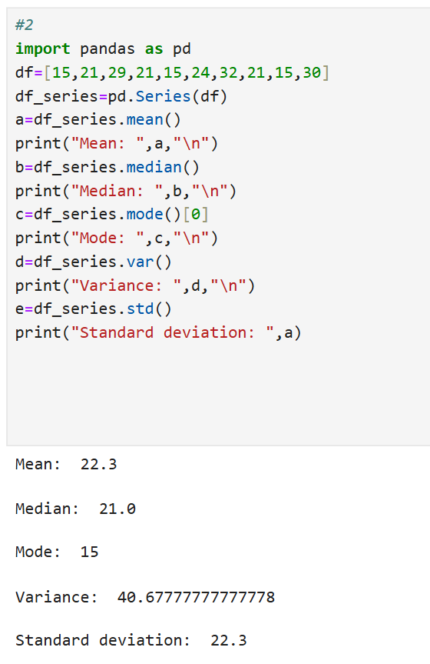

3. You are analyzing a dataset that captures the daily performance and activity of a humanoid robot in a simulated environment. The dataset link robot_dataset(robot_dataset)_1.csv includes the following attributes

|  |
| --- |
| Interaction_Count: Number of conversations the robot had daily. |
| Steps_Walked: Total steps taken each day. |
| Objects_Recognized: Number of objects successfully identified by the robot. |
| Learning_Sessions: Number of learning tasks completed. |
| Energy_Consumption (kWh): Daily energy usage of robots. |

Perform Basic Statistical Operations:

1) What is the average (mean) number of conversations the robot has daily?

2) Find the total steps walked by the robot over a given period.

3) Determine the maximum and minimum energy consumption in the dataset.

4) Calculate the correlation between the number of steps walked and energy consumption. 5) Analyze the distribution of objects recognized daily (e.g., histogram or box plot).

6) What is the variance in the number of learning sessions completed? 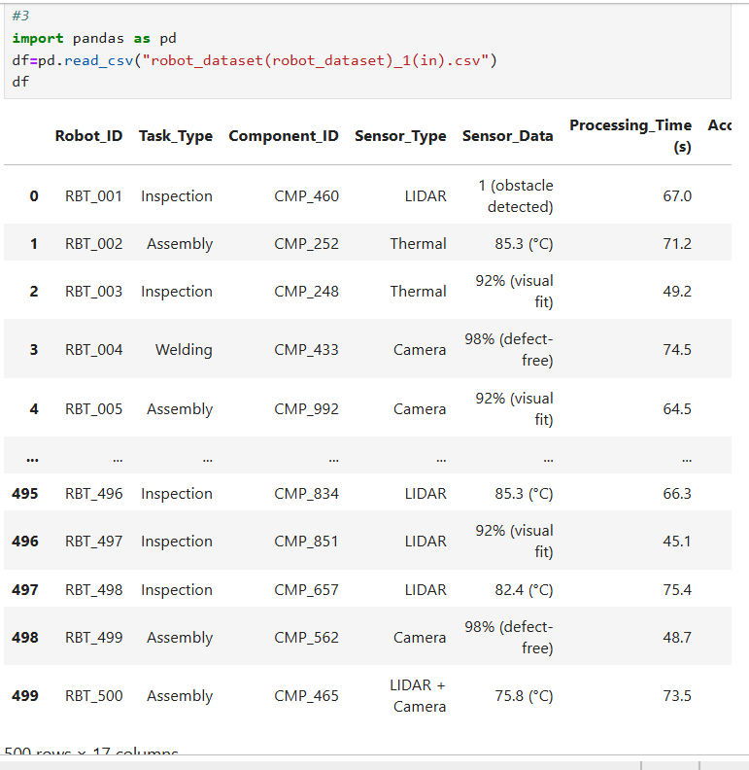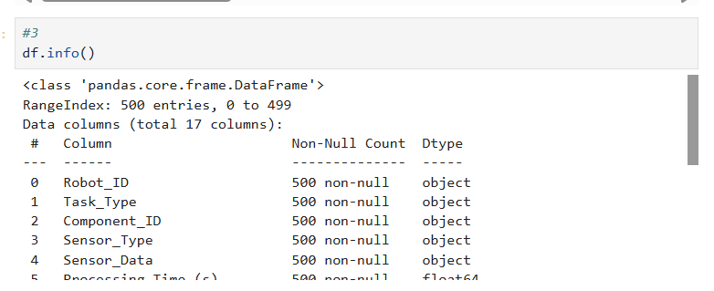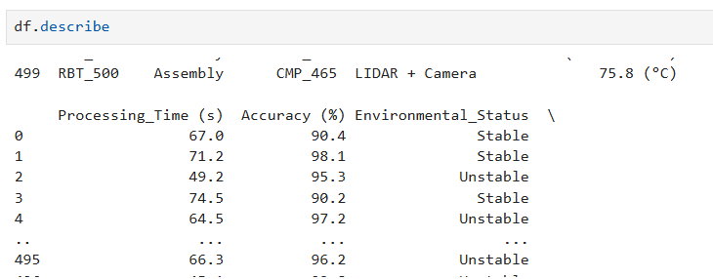



Output:

Correlation between steps and energy consumption: 0.001547813739331415

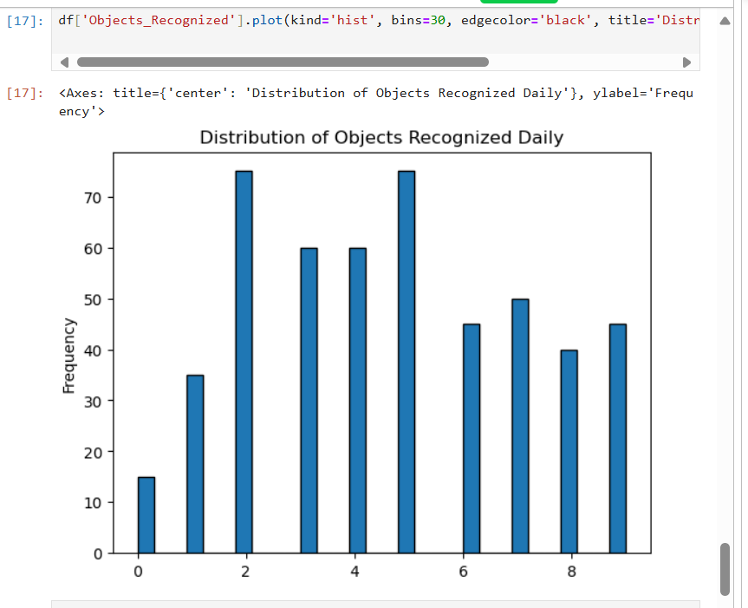 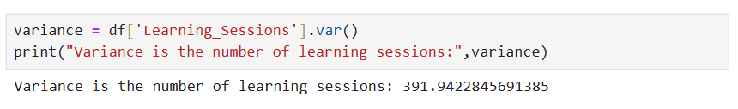

4. Write a Python program that declares variables of different data types (e.g., string, integer, float, and boolean). Output the variables in a sentence format using print() and f-strings.

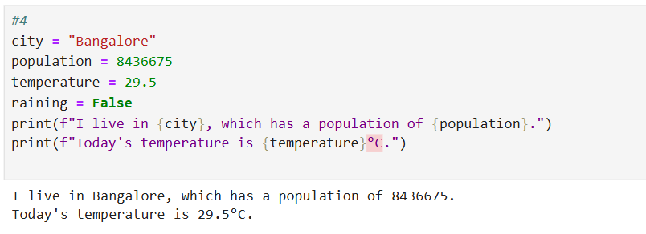

5. Write a Python program that takes an integer input and checks whether the number is positive, negative, or zero using conditional statements (if-else).

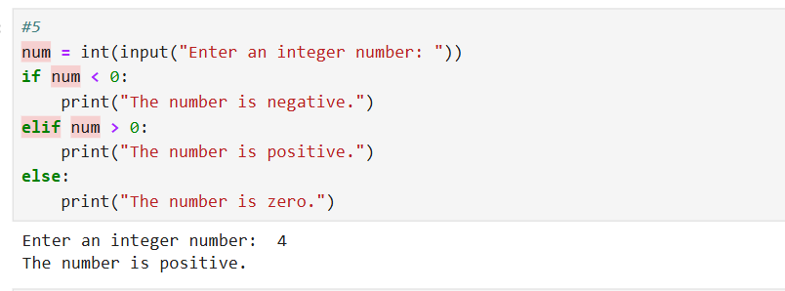

6. Write a Python program that takes a number as input and prints the multiplication table for that number (from 1 to 10).

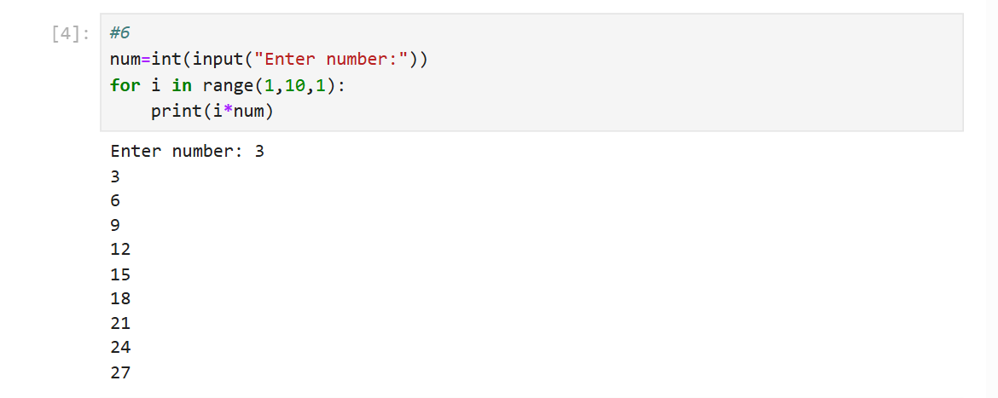

7. Create a Python list that contains the names of 5 different fruits. Perform the given operations on the list.

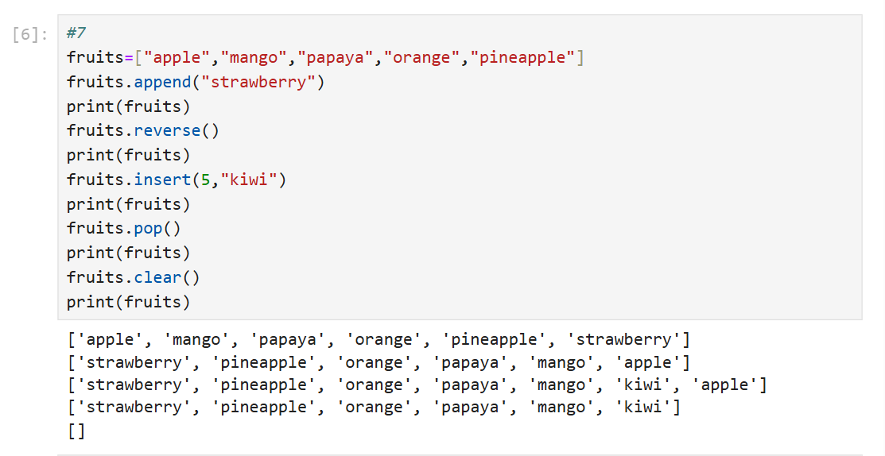

8. Write a Python program that creates a tuple containing 5 numbers. Perform the given operations on the tuple. 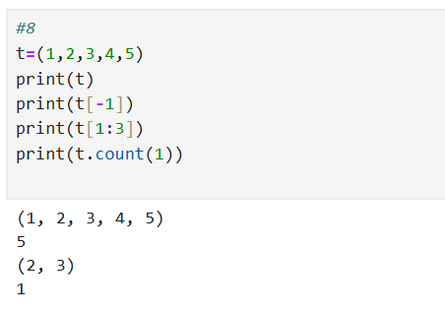

9. Create a dictionary that stores the names of 3 students as keys and their marks in mathematics as values. Perform the given operations.

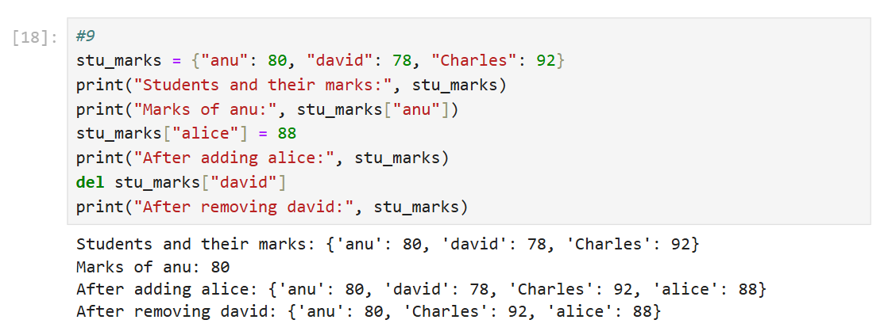

10. Create two sets of integers. Perform the given set operations.

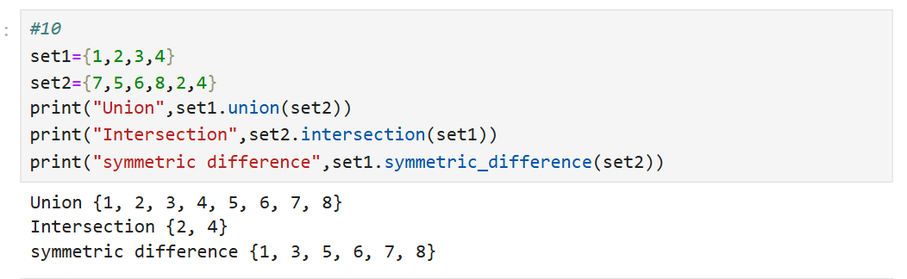

11. Write a Python function called find_largest() that takes a list of numbers as input and returns the largest number from the list. Test the function with a sample list.

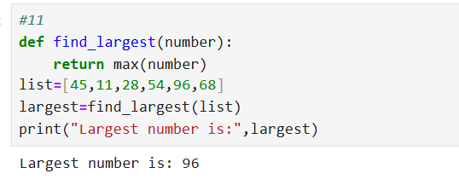

12. Use list comprehension to create a list of squares of all even numbers between 1 and 20.

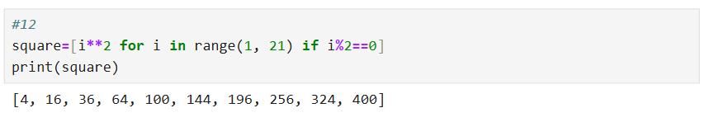13. Write a Python script that uses a lambda function to calculate the product of two numbers provided by the user. 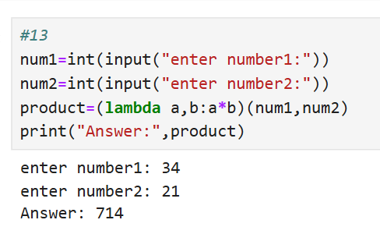

14. Write a Python program to create a one-dimensional, two-dimensional, and three-dimensional NumPy array. Print the shape and dimensions of each array. 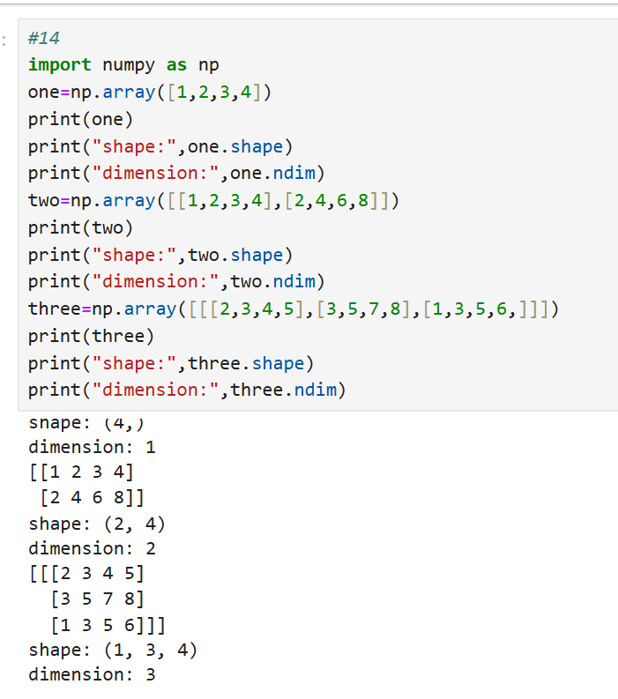

15. Write a Python program to create a 5x5 NumPy array of random integers and Perform array indexing as given. 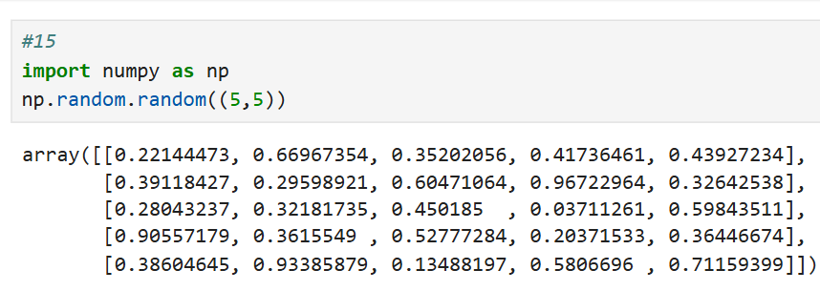

16. create a NumPy array of shape (4, 4) containing numbers from 1 to 16. Use slicing to extract for the given conditions 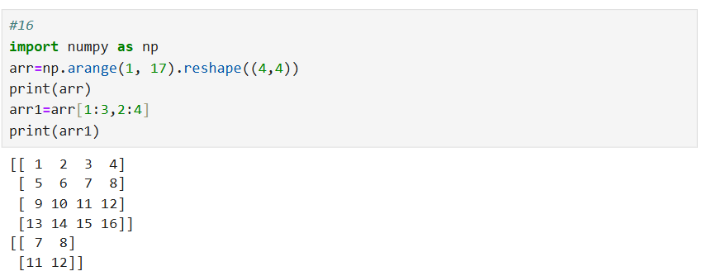

17. Write a Python program that creates a 2D array of shape (6, 2) using np.arange() and then reshapes it into a 3D array of shape (2, 3, 2). Flatten the reshaped array and print the result. 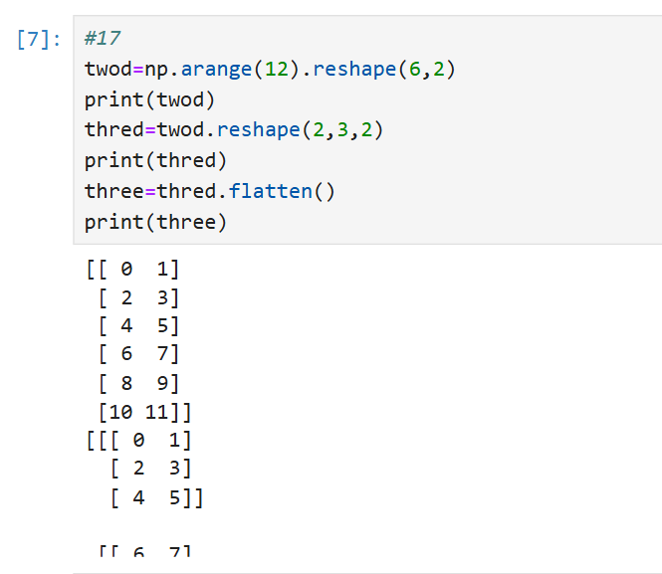

18. Write a Python program to demonstrate broadcasting. Create an array of shape (3, 3) and add a one dimensional array of shape (1, 3) to it using broadcasting. 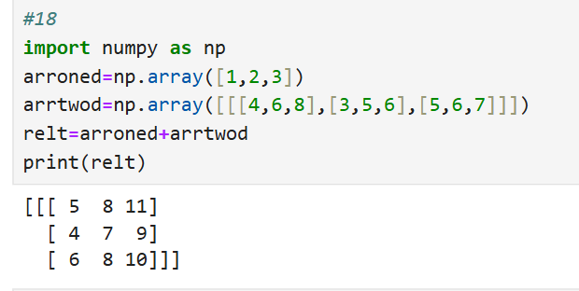

19. Create two NumPy arrays of the same shape, A and B. Perform the following arithmetic operations: Element-wise addition. Element-wise subtraction. Element-wise multiplication. Element-wise division. 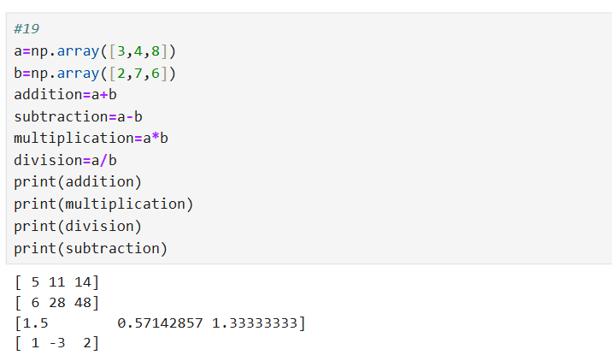

20. Create a Pandas DataFrame with the given Name and marks of 3 courses: Add a new column named 'Total' that represents the sum of all the courses. Add 'Grade' based on the values of the 'Total'. Print the updated DataFrame with the new 'Total' and 'Grade' column.

