Bengaluru, Karnataka, India

AN INTERNSHIP REPORT

ON

“Resume builder website ”

## **BACHELOR OF ENGINEERING**

In

#### **ELECTRONICS AND COMMUNICATION ENGINEERING**

##### **Submitted by: SUSHMITHA.S ( 1KS19EC093 )**



2020-2021

**K.S. INSTITUTE OF TECHNOLOGY** (Affiliated to Visvesvaraya Technological University and Approved by AICTE, New Delhi)Accredited By NAAC with ‘A’ Grade

ISO 9001-2015 and 14001-2015 certified Institute

**Kanakapura,Bangalore-560109**

**ABOUT THE COMPANY**

CST is a digital service provider that aims to provide software, designing and marketing solutions to individuals and businesses. At CST , we believe that service and quality is the key to success

We provide all kinds of technological and designing solutions from Billing Software to Web Designs or any custom demand that you may have. Experience the service like none other!

Some of our services include:

* Development - We develop responsive, functional and super-fastwebsites.
* We keep User Experience in mind while creating websites. A website should load quickly and shouldbeaccessible even on a small view-port and slow internetconnection.
* Mobile Application - We offer a wide range of professional Android, iOS&Hybrid app development services for our global clients, from a start up to a largeenterprise.
* Design - We offer professional Graphic design, Brochure design & Logo design. We are expertsin crafting visual content to convey the right message to thecustomers.
* Consultancy - We are here to provide you with expert advice on your design anddevelopment requirement.
* Videos - We create a polished professional video that impresses youraudience.

# **Table of Contents**

#### **Contents PageNo.**



**TableofContents I**

[Overview oftheproject 1](l%20)

About 2

[Toolsused 3](l%20)

[Implementation 4-25](l%20)

[Snapshots 26-27](l%20)

Biblography 28

##### **(I)**

### **OVERVIEW OF THE PROJECT**

**Project Name**: Resume builder website

**Team Members: Sushmitha S**

This project is based on Web Developmentand its Applications. The main objective of this project is to learn the implementation of HTML, CSS and JavaScript at frontend and PHP, MySQL database at backend, The webpage of this project is created using HTML and styling of the webpage is done usingCSS.

It is a web application that simplifies the task of storing a usersresults . The system is flexible to be used and reduces the need of frequently searching and accessing an individuals marks. The system is developed to provide an easy means for storing semester wise results. Individuals have to login and enter their marks in a form.TheycanthenaccesstheresultandprintitinaPDFformat.

1. **USERMODULE**

This module is mainly dedicated to the candidates who are looking to store their result. They can log in into the system, via the credentials provided to them & once they are in, they have to enter their data by filling an online form . They can download the result from the same module, in PDF fileformat.

**2. ADMINMODULE**

This module is maintained by the admin and only he/she can manage and have access to every account. Admin can add or delete the users as well. They can modify the functionalities of the system, too. Admin can alsoaddusersontheflytotheapplicationtomaketheapplicationfullofnewfunctionalities.

**Store My Results**

This online web application id designed to simplify the task of storing a usersresults . The candidates are not required to write down or maintain a physical file containing the data.The system is flexible to be used and reduces the need of frequently searching and accessing an individualsmarks.Theycan enter their details directly into a form and their results will bestored.

The system is developed to provide an easy meansfor storing semester wise results. Individuals have to loginandentertheirmarksinaform.TheycanthenaccesstheresultandprintitinaPDFformat.

In this application, a person can access the results whenever he needs it without carrying the hard copy.The system is flexible to be used and reduces the need of frequently searching and accessing an individuals marks. The system is developed to provide an easy means for storing semester wise results. The most important part of making this site is the user experience, which results in specific university websites do not focus on design as functionality outweighs design in these specific websites, which can further ruin the user experience, here the focus lies on functionality anddesign.

The Working Process is pretty simple here we ask students to create an account with us and we tend to store the data that they enter, the data might include USN, NAME and SUBJECT NAMES with their finalized marks, once that is done we keep a submit option wherein the users/Students can submit their responses, the content of the web page at the time of submission should be downloadable in PDF form for their reference, he data of the user should be completely secured and (s)he has to make an account and set their password to access their account at any point in time. This will make it easier for the students to retrieve their results or marks of any subject of any semesteranytime.

### **TOOLS USED**

**Software Requirements**

* + Visual Studio Code2019.
  + Google Chrome or Microsoft Edge of latestversion.
  + Front End: HTML, CSS,JS
  + Backend : Php, MySQL,Xampp
  + Linux 7.1 or Windows XP/7/8/10 OS or MacOS

**Hardware Requirements**

* + Pentium 200-MHz computer with a minimum of 64 MB of RAM (128 MB of RAM recommended).
  + Monitor with a refresh rate of at least 40Hz for a smoothGUI experience (optional).

# **IMPLEMENTATION**

<!DOCTYPE html>

<html lang="en">

<head>

  <meta charset="UTF-8">

  <meta http-equiv="X-UA-Compatible" content="IE=edge">

  <meta name="viewport" content="width=device-width, initial-scale=1.0">

  <title>Document</title>

  <meta name="viewport" content="width=device-width, initial-scale=1">

  <link rel="stylesheet" href="https://maxcdn.bootstrapcdn.com/bootstrap/4.5.2/css/bootstrap.min.css">

</head>

<body>

  <nav class="navbar navbar-expand-lg navbar-dark bg-dark">

    <a class="navbar-brand" href="index.html"><h2>Resumebuilder</h2></a>

    <button class="navbar-toggler" type="button" data-toggle="collapse" data-target="#navbarSupportedContent" aria-controls="navbarSupportedContent" aria-expanded="false" aria-label="Toggle navigation">

      <span class="navbar-toggler-icon"></span>

    </button>

    <div class="collapse navbar-collapse" id="navbarSupportedContent">

      <ul class="navbar-nav ml-auto">

        <li class="nav-item active">

          <a class="nav-link" href="index.html">Home <span class="sr-only">(current)</span></a>

        </li>

        <li class="nav-item">

          <a class="nav-link" href="resume.html">Resumebuilder</a>

        </li>

        <li class="nav-item">

          <a class="nav-link" href="FILE2.HTML">Login</a>

        </li>

        <li class="nav-item dropdown">

          <a class="nav-link dropdown-toggle" href="index.html" id="navbarDropdown" role="button" data-toggle="dropdown" aria-haspopup="true" aria-expanded="false">

            Dropdown

          </a>

          <div class="dropdown-menu" aria-labelledby="navbarDropdown">

            <a class="dropdown-item" href="index.html">HOME</a>

            <a class="dropdown-item" href="FILE2.HTML">LOGIN</a>

            <div class="dropdown-divider"></div>

            <a class="dropdown-item" href="resume.html">BUILDRESUME</a>

          </div>

        </li>

      </ul>

      <form class="form-inline my-2 my-lg-0">

        <input class="form-control mr-sm-2" type="search" placeholder="Search" aria-label="Search">

        <button class="btn btn-outline-success my-2 my-sm-0" type="submit">Search</button>

      </form>

    </div>

  </nav><br>

  <P style="font-weight: 600;">

    WELCOME...!!!

    Everybody knows what is a resume,A typical résumé contains a "summary" of relevant job experience and education. The résumé is usually one of the first items, along with a cover letter and sometimes an application for employment, which a potential employer sees regarding the job seeker and is typically used to screen applicants, often followed by an interview. </P><br>

  <div id="demo" class="carousel slide" data-ride="carousel">

    <ul class="carousel-indicators">

      <li data-target="#demo" data-slide-to="0" class="active"></li>

      <li data-target="#demo" data-slide-to="1"></li>

      <li data-target="#demo" data-slide-to="2"></li>

    </ul>

    <div class="carousel-inner">

      <div class="carousel-item active">

        <img src="IMG1.JPEG" alt="welcome" width="1100" height="500">

        <div class="carousel-caption">

          <h3>welcome..!!</h3>

        </div>

      </div>

      <div class="carousel-item">

        <img src="IMG2.JPEG" alt="Chicago" width="1100" height="500">

        <div class="carousel-caption">

          <h3>build your resume in no time</h3>

        </div>

      </div>

      <div class="carousel-item">

        <img src="IMG3.JPEG" alt="" width="1100" height="500">

        <div class="carousel-caption">

        </div>

      </div>

    </div>

    <a class="carousel-control-prev" href="IMG2.JPEG" data-slide="prev">

      <span class="carousel-control-prev-icon"></span>

    </a>

    <a class="carousel-control-next" href="IMG3.JPEG" data-slide="next">

      <span class="carousel-control-next-icon"></span>

    </a>

  </div><br>

  <h4>Why do we need a resume</h4>

  <ul>

    <li>Grabs the attention of employers and recruiters.</li>

      <li> Sells your strongest skills and accomplishments.</li>

        <li> Shows how you're a match for a position or project.</li>

          <li> And most importantly, gets you a job interview!

      </li> </ul>

     <ul> <h4>How does this website help you ? </h4>

      <li>Free of cost.</li>

        <li>   Easy to build; often has user-friendly process; a great option for beginners.</li>

          <li> You would be able to get a brand-new resume within five minutes.</li></ul>

  <div><br><br>

    <h2>These are some examples of our resumes...</h2>    <img src="exp1.jpeg" alt="exp1" width="300" height="350">

    <img src="exp2.jpeg" alt="exp2" width="300" height="350">

  </div><br><br>

  <q style="font-weight: 800; font-style: italic; font: size 50px; ;">BUILD YOUR RESUME IN NO TIME</q><br><br>

    <h3>Follow these steps to build your resume</h3>

    <div style="display: grid ; grid-template-columns: 200px 200px 200px;">

    <div class="card" style="width:200px height: 350px">

      <img class="card-img-top" src="CARD1.JPEG" alt="Card image">

      <div class="card-body">

        <h4 class="card-title">Step 1</h4>

        <a href="FILE2.HTML" class="btn btn-primary">login to our website</a>

      </div>&nbsp;&nbsp;

    </div>

    <div class="card" style="width:200px height: 350px" >

      <img class="card-img-top" src="CARD2.JPEG" alt="Card image">

      <div class="card-body">

        <h4 class="card-title">Step 2</h4>

        <a href="resume.html" class="btn btn-primary">fill the resume</a>

      </div>

    </div>

    <div class="card" style="width:200px; height: 350px;">

      <img class="card-img-top" src="CARD3.JPEG" alt="Card image">

      <div class="card-body">

        <h4 class="card-title">Step 3</h4>

        <a href="#" class="btn btn-primary">Download PDF</a>

    </div><br><br></div></div>

    <h2 class="ahead">About us</h2>

    <div style="font-weight: 600;">

      I used to struggle alot to write my resume,it was a headache for me.

      i guess there are alot of people like me who will be struggling out there.Its just a try to help some people to build their resume easily.

      Do use the website and build your resume in no time...

      This is my first website...!!!

  </div>

  <script src="https://ajax.googleapis.com/ajax/libs/jquery/3.5.1/jquery.min.js"></script>

  <script src="https://cdnjs.cloudflare.com/ajax/libs/popper.js/1.16.0/umd/popper.min.js"></script>

  <script src="https://maxcdn.bootstrapcdn.com/bootstrap/4.5.2/js/bootstrap.min.js"></script>

  <footer class="p-3 text-white bg-dark mr-auto" >

    <a href="contact us">contact us</a>&nbsp;&nbsp;

    <a href="about us">about us us</a>&nbsp;&nbsp;

    <a href="#">Privacy policy</a>&nbsp;&nbsp;

    <a href="#">Copyright&copy;</a>

  </footer>

</body>

</html>

<!DOCTYPE html>

<html lang="en">

<head>

    <meta charset="UTF-8">

    <meta http-equiv="X-UA-Compatible" content="IE=edge">

    <meta name="viewport" content="width=device-width, initial-scale=1.0">

    <title>login form</title>

    <link rel="stylesheet" href="style1.css">

</head>

<body><div>

    <form  action="userinfodata.php" method="post" class="container" >

    <h1 class="heading">

        REGISTER FORM

    </h1><hr>

    <label for="name">NAME  :   </label>

    <input type="text" name="name">

    <P><label for="PHONE NO.">PHONE NO. : </label>

     <input type="number" name="phone"></P>

    <p>EMAIL ID : <input type="email" placeholder="ghfvyercb@gmail.com"></p>

    <p>PASSWORD : <input type="password" name="password"></p>

    <p>CONFIRM PASSWORD : <input type="password" name="conpass"></p>

    <input type="submit" value="SIGN UP " id="submit">

</form></div>

</body>

</html>

<!DOCTYPE html>

<html lang="en">

<head>

    <meta charset="UTF-8">

    <meta http-equiv="X-UA-Compatible" content="IE=edge">

    <meta name="viewport" content="width=device-width, initial-scale=1.0">

    <title>LOGIN </title>

    <link rel="stylesheet" href="styl2.css">

</head>

<body>

    <form  class="container1" action="">

   <H1 id="HEADING1">LOGIN</H1><hr>

   <p>Username: <input type="text"></p>

   <p>Password: <input type="password"></p>

   <p id="fp">forgot password?</p>

   <input type="submit" value="LOGIN" id="login">

   <p>haven't signed up?</p>

   <a class="signup" href="file1.html">SIGN UP</a>

</form>

</body>

</html>

<!DOCTYPE html>

<html lang="en">

<head>

    <meta charset="UTF-8">

    <meta http-equiv="X-UA-Compatible" content="IE=edge">

    <meta name="viewport" content="width=device-width, initial-scale=1.0">

    <title>resume</title>

    <link rel="stylesheet" href="res.css">

</head>

<body>

    <form id="container2" action="">

    <h1 id="h1"> Resume details</h1><hr><br><br>

    <h2 id="h2">Personal details</h2>

    <p id="name">NAME : <input type="text"></p>

    <p id="date "> DOB : <input type="date" placeholder="dd/mm/yyyy"></p>

    <p id="phn"> Phone no. : <input type=" number"></p>

    <p id="email"> Email ID : <input type="email" placeholder="example@gmail.com"></p>

    <P id="address"> Address: <textarea name="Address"  cols="30" rows="4"></textarea></P><br><br>

    <h2 id="eq"> Educational Qualifications</h2><hr>

    <table>

        <tr>

            <td> <label class="head"><input type="text" name="education" placeholder="SSLC"></label></td>

           <td><input placeholder="board"></td>

           <td><input placeholder="year of passing"></td>

           <td><input placeholder=" passing percentage"></td>

        </tr><br>

        <tr>

            <td> <label class="head"><input type="text" name="education" placeholder="puc/diploma"></label></td>

           <td><input placeholder="board"></td>

           <td><input placeholder="year of passing"></td>

           <td><input placeholder="stream"></td>

           <td><input placeholder=" passing percentage"></td>

        </tr><br>

        <tr>

            <td> <label class="head"><input type="text" name="education" placeholder="bachelor degree"></label></td>

           <td><input placeholder="university name"></td>

           <td><input placeholder="year of passing"></td>

           <td><input placeholder="branch"></td>

           <td><input placeholder=" passing percentage"></td>

        </tr><br>

        <tr>

            <td> <label class="head"><input type="text" name="education" placeholder="master degree"></label></td>

           <td><input placeholder="university name"></td>

           <td><input placeholder="year of passing"></td>

           <td><input placeholder="branch"></td>

           <td><input placeholder=" passing percentage"></td>

        </tr>

    </table><hr><hr>

    <h2 id="skills"> Skills</h2><hr>

        <ul>

            <li><input type="text"></li>

            <li><input type="text"></li>

            <li><input type="text"></li>

            <li> <input type="text"></li>

            <li> <input type="text"></li>

        </ul><br><br>

<h2 id="hobb"> Hobbies</h2><hr>

        <ul>

            <li><input type="text"></li>

            <li><input type="text"></li>

            <li><input type="text"></li>

            <li> <input type="text"></li>

            <li> <input type="text"></li>

        </ul><br><br>

<H2>

    Languages known

</H2><hr>

   <p> <input type="checkbox"  > english</p>

    <p><input type="checkbox">hindi</p>

<p><input type="checkbox" >kannada</p>

<p><input type="checkbox" > french</p>

<p> <input type="checkbox" > japanese</p><br><br>

<h2>

    Upload your photo

</h2><hr>

<p ><input type="file"></p><br>

<h2 id="about">

    About me

</h2>

  <p><textarea name="about me" id="" cols="70" rows="3"></textarea></p><br>

  <p><input class="FINALBTN" type="submit" value="Submit and Download pdf"></p>

</form>

</body>

</html>

<?php

$con = mysqli_connect('localhost','root');

if($con){

    echo "conection succesful";

}

else{

    echo"no connection";

}

mysqli_select_db($con,'myresume2website');

$name = $_POST['name'];

$phone = $_POST['phone'];

$email = $_POST['email'];

$password = $_POST['password'];

$conpass = $_POST['confirm password'];

$query= insert into 'myresume2website'('id','name','phone','email','password','confirm password')

values('$name', '$phone', '$email' ,'$password','$conpass');

?>

<h2 class="ahead">About us</h2>

    <div>

        I used to struggle alot to write my resume,it was a headache for me.

        i guess there are alot of people like me who will be struggling out there.Its just a try to help some people to build their resume easily.

        Do use the website and build your resume in no time...

        This is my first website...!!!

    </div>

<!DOCTYPE html>

<html lang="en">

<head>

    <meta charset="UTF-8">

    <meta http-equiv="X-UA-Compatible" content="IE=edge">

    <meta name="viewport" content="width=device-width, initial-scale=1.0">

    <title>Document</title>

    <link rel="stylesheet" href="style.css">

</head>

<body>

    <p id="tcall">Telephone : 080-111111111<br><br>  Phone no. : 0989087655</P>

</body>

</html>

.container{

    font-family: 'Josefin Sans', sans-serif;

    font-style: normal;

    background-image: url(signup.jpeg);

    border: black 0.25cm;

    padding: 20px;

    margin: 20px;

    border-radius: 1cm;

    line-height: 1cm;

    text-align: center;

}

#submit{

    background-color:rgba(122, 75, 75, 0.308) ;

}

.container1{

    font-family: 'Josefin Sans', sans-serif;

    font-family: 'Josefin Sans', sans-serif;

    font-style: normal;

    background-image: url(login.jpeg);

    border: black 0.25cm;

    padding: 20px;

    margin: 20px;

    border-radius: 1cm;

    line-height: 1cm;

    text-align: center;

    color:white;

}

#login{

    background-color: rgba(70, 39, 39, 0.363);

}

.signup{

    color: white;

}

#container2{

    font-family: 'Josefin Sans', sans-serif;

    font-style: normal;

    width: 100%;

    box-sizing: border-box;

    border: black;

    background-color: whitesmoke;

    padding: 20px;

    margin: 20px;

    border-radius: 0.5cm;

    line-height: 1cm;

}

.FINALBTN{

    background-color: rgba(51, 69, 233, 0.904);

    padding: 00.25cm;

}



### **SNAPSHOTS**

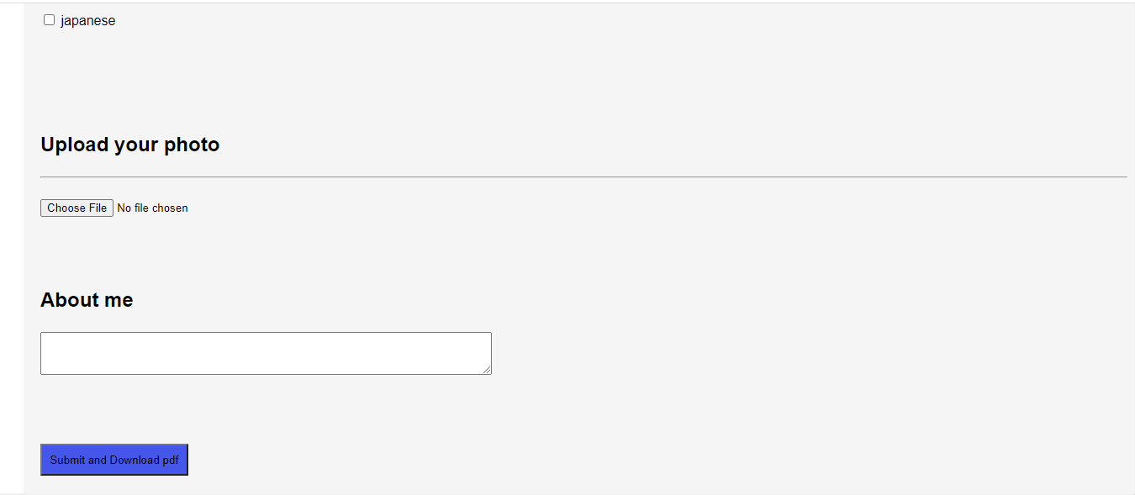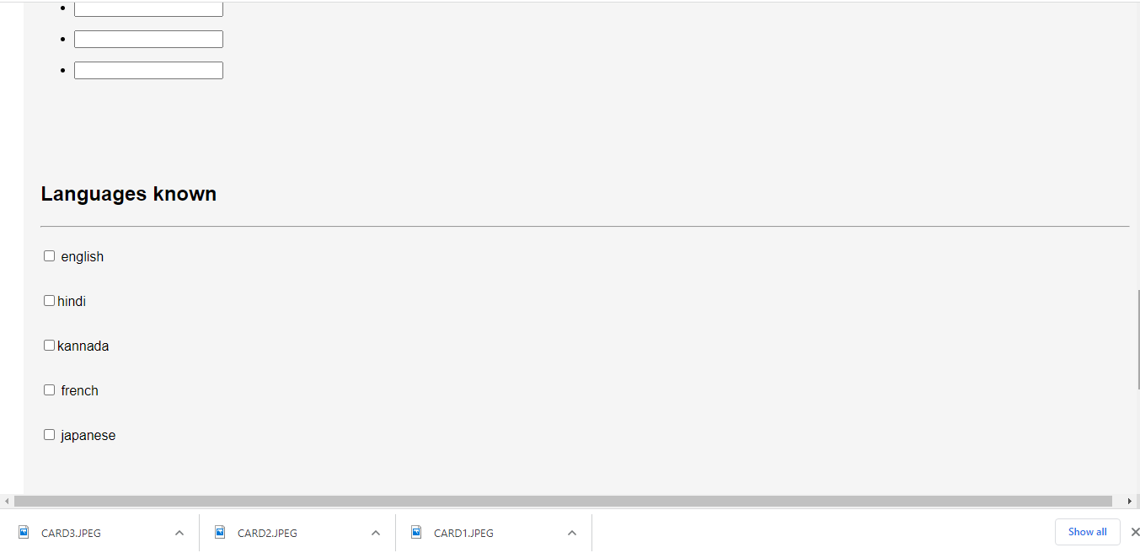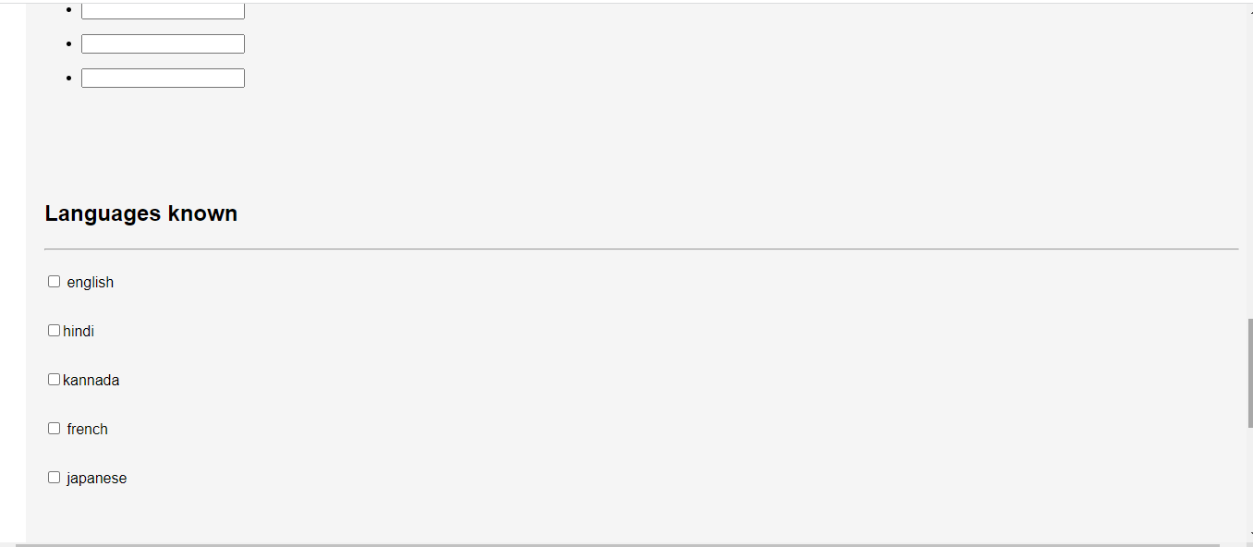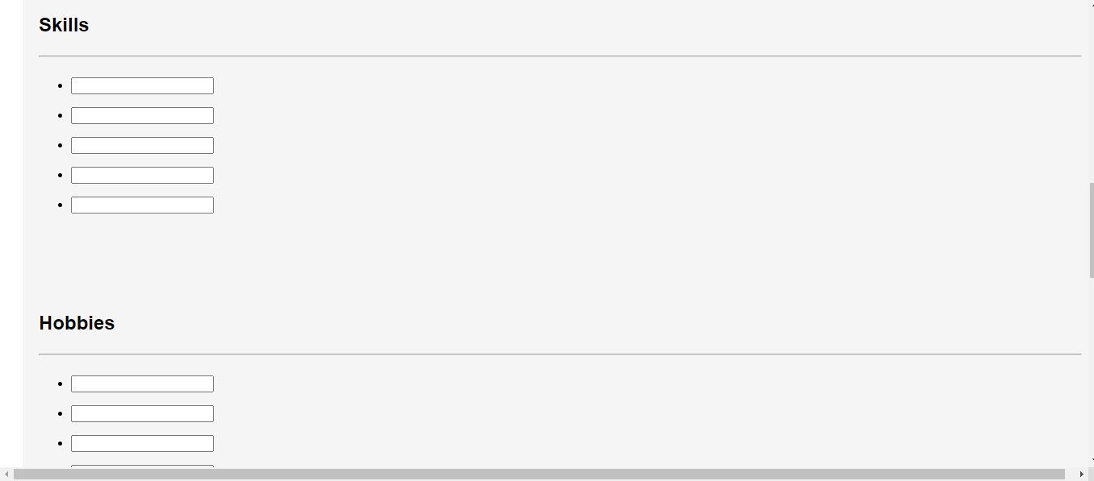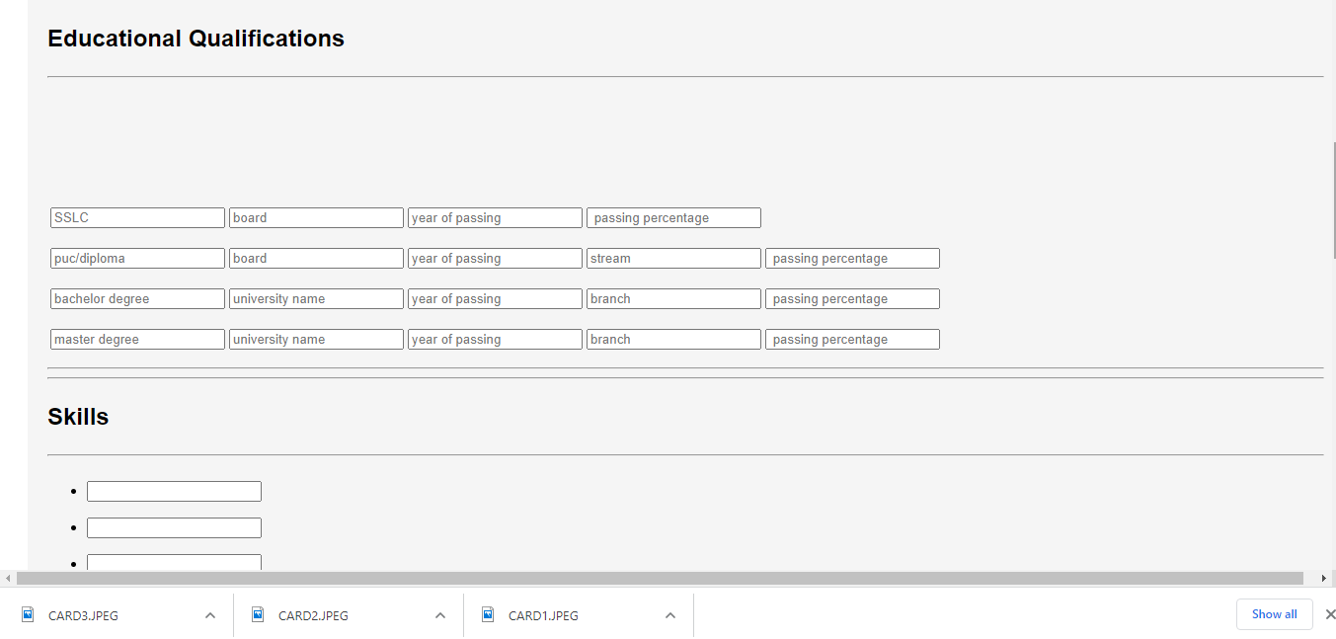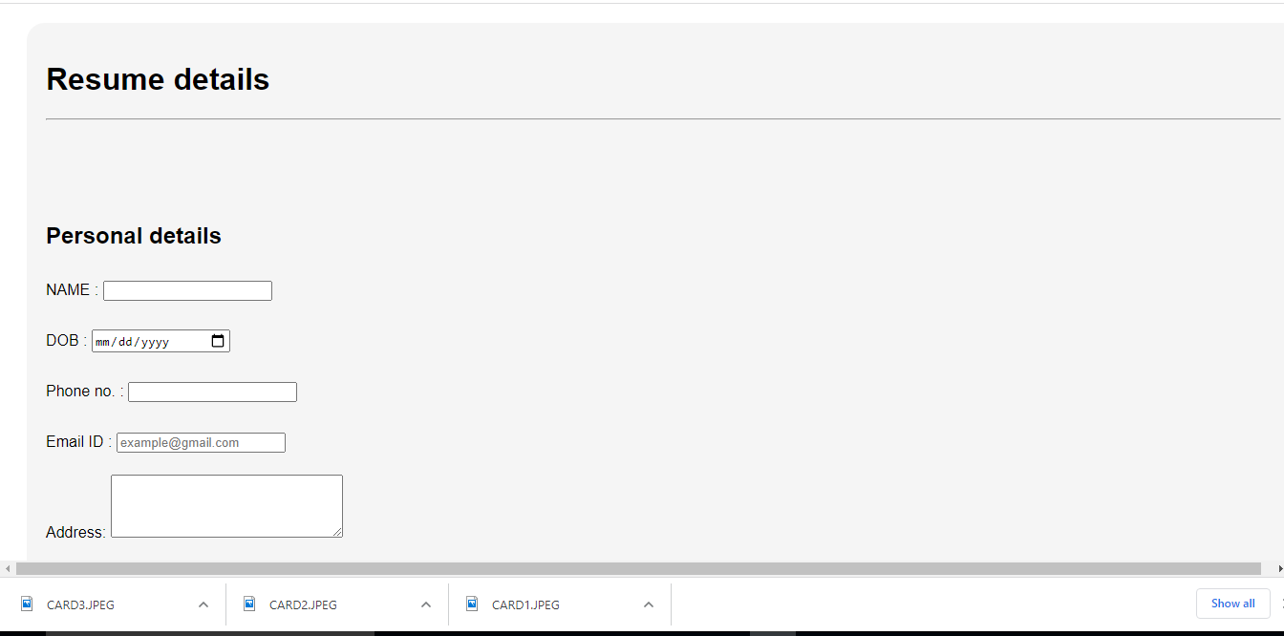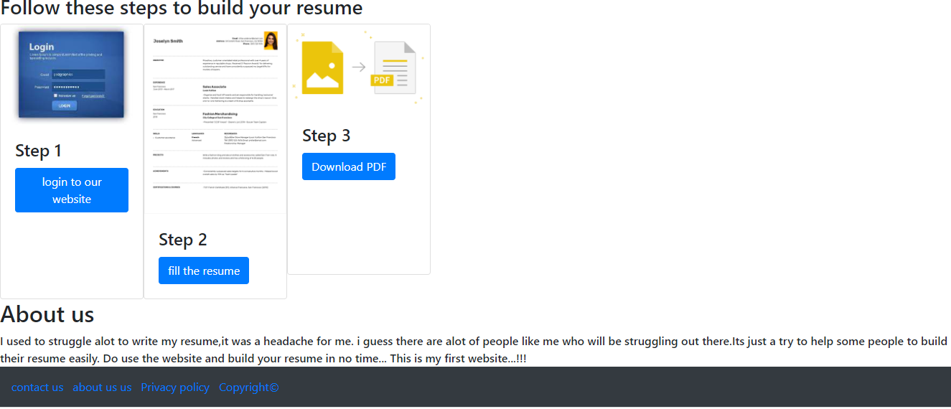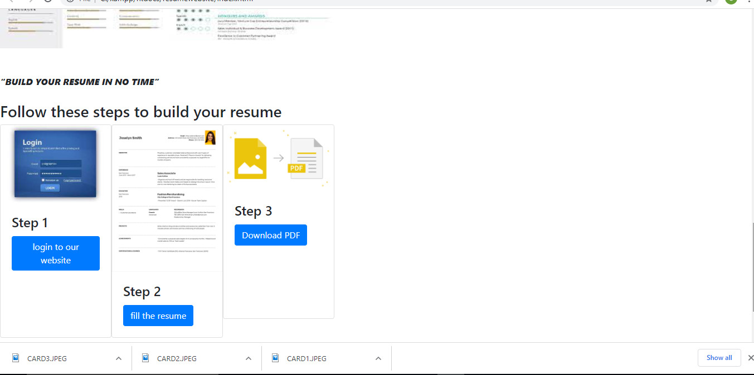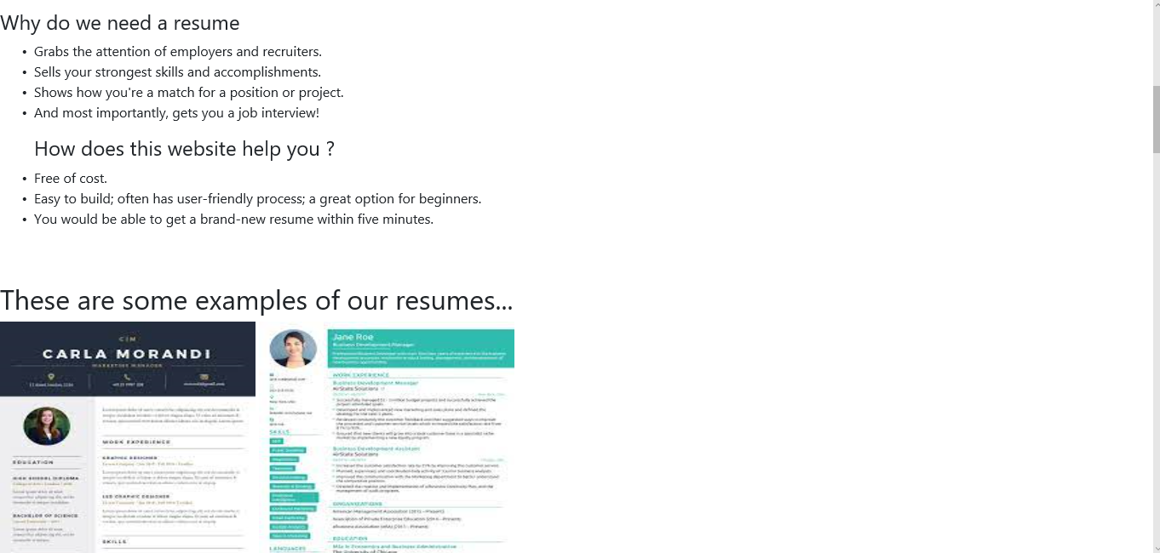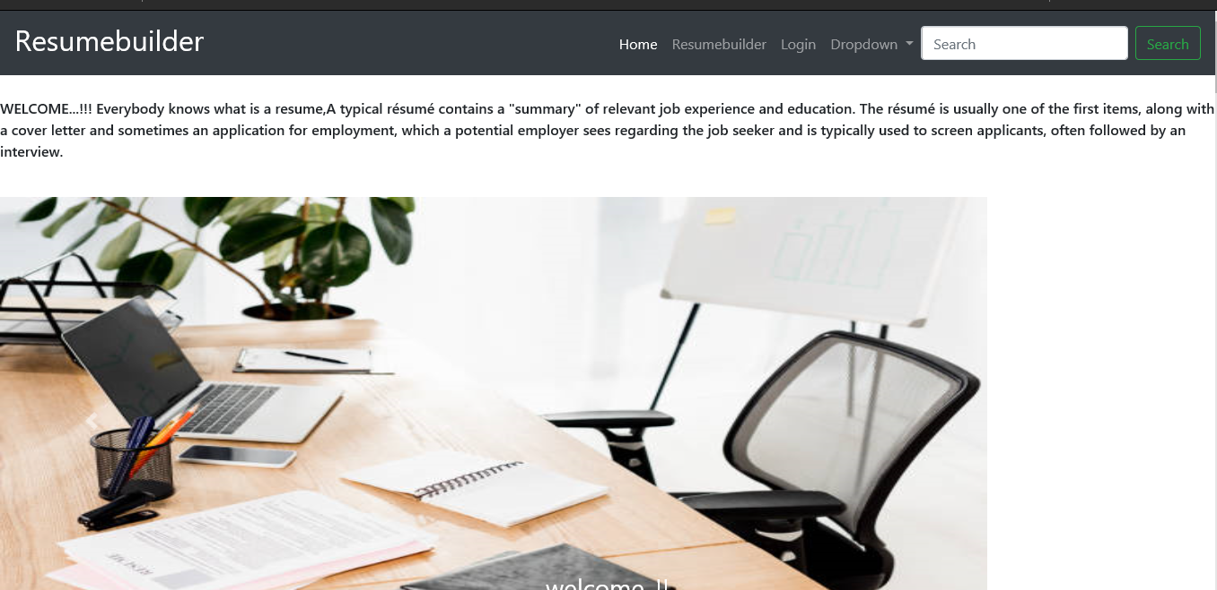

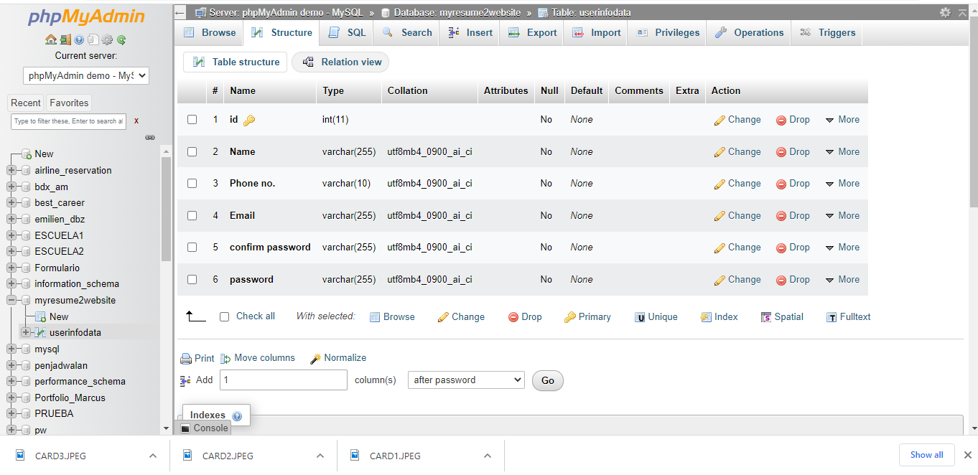

### **BIBLIOGRAPHY**

* [https://](NULL)[www.w3schools.com](http://www.w3schools.com/)
* [**https://www.geeksforgeeksorg**](https://www.geeksforgeeksorg)
* [**https://freefrontend.com**](https://freefrontend.com)
* [**https://css-tricks.com/**](https://css-tricks.com/)
* [**https://www.takeiteasyengineers.com**](https://www.takeiteasyengineers.com)
* [**https://dev.to/mychi_darko/php-tips-and-tricks-4kpn**](https://dev.to/mychi_darko/php-tips-and-tricks-4kpn)