1) HARDWARE SETTING
Create a clean, detailed top-view wiring diagram showing the full hardware setup of an STM32F103C8T6 Blue Pill board on a breadboard. Draw clearly labeled colored jumper wires.

Include the following connections:

1. OLED Display (I2C SSD1306):
- OLED GND → Blue Pill GND
- OLED VCC → Blue Pill 3.3V pin
- OLED SCL → PB6
- OLED SDA → PB7

2. 4×3 Keypad:
Row pins:
- R1 → PA0
- R2 → PA1
- R3 → PA2
- R4 → PA3

Column pins:
- C1 → PA4
- C2 → PA5
- C3 → PA6

3. LED With Resistor:
- LED Anode (+) → PB0
- LED Cathode (–) → one end of 220Ω resistor
- Other end of resistor → GND rail

4. Debugger (ST-LINK or J-Link) connections:
- SWCLK → Blue Pill CLK pin
- SWDIO → Blue Pill Data IO pin
- GND → GND
- 3.3V → 3.3V

labels for each component: “STM32 Blue Pill”, “OLED I2C”, “4x3 Keypad”, “LED + Resistor”, and “ST-LINK Debugger”. 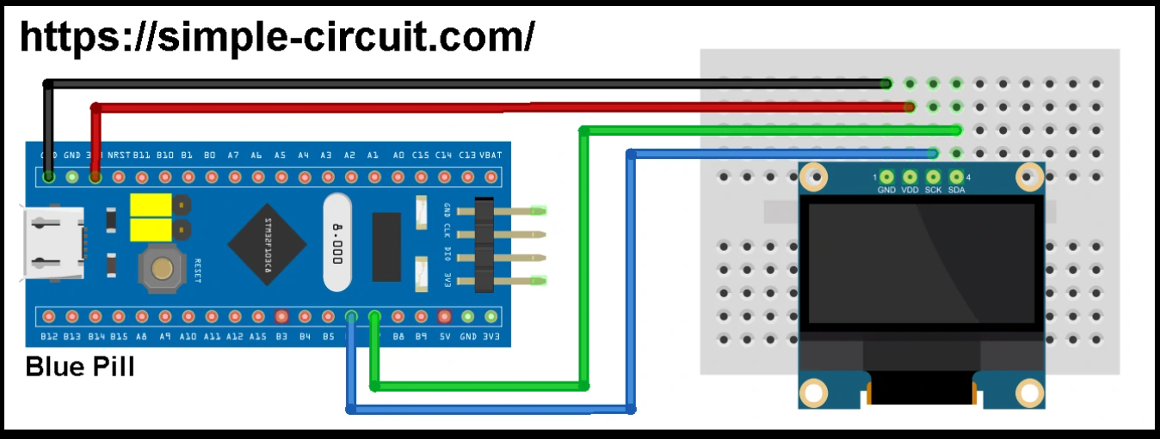

2) Simple breadboard diagram (ASCII, top view)
Place MCU (Blue-Pill) across the middle gap, OLED at one side, keypad at another, ST-LINK cable to debug pins.
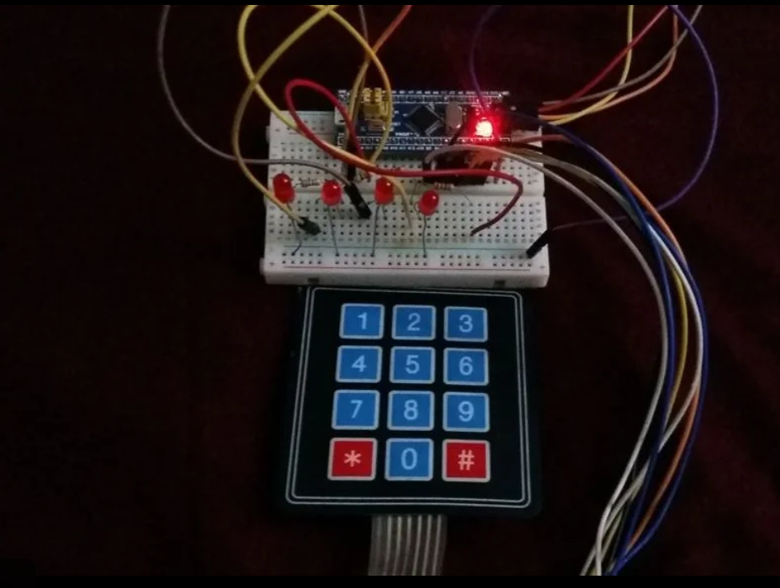 ST-LINK: SWCLK->PA14, SWDIO->PA13, 3.3V->3.3V, GND->GND

3) Wiring checklist (step-by-step)
- Power & ground
  - Connect STM32 3.3V to the breadboard 3.3V rail.
  - Connect STM32 GND to breadboard GND rail.
- OLED
  - OLED VCC → 3.3V (Important: many SSD1306 modules are 3.3V, not 5V)
  - OLED GND → GND
  - OLED SCL → PB6
  - OLED SDA → PB7
- Keypad
  - Keypad Row pins → PA0, PA1, PA2, PA3
  - Keypad Col pins → PA4, PA5, PA6
  - If keypad has ground pin, connect to GND.
- LED
  - PB0 → (wire) → LED anode (+) → LED cathode (−) → 220Ω → GND
  - Verify LED orientation (long leg = +).
- ST-LINK
  - SWCLK → PA14
  - SWDIO → PA13
  - GND → GND
  - 3.3V → 3.3V (only if you want ST-LINK to power the board)
  - Optional: NRST → RESET on board (for some ST-LINKs helps to program reliably)
- I2C pullups
  - Usually SSD1306 module already has pull-ups. If not, add two 4.7k resistors from SDA and SCL lines to 3.3V.

4) Quick software checks (if OLED shows just a dot or nothing)
- I2C address — Many modules are 0x3C (7-bit) or 0x3D. In HAL, you use 8-bit address 0x78 for 0x3C << 1. Confirm your #define SSD1306_I2C_ADDR 0x78 matches the module.
- I2C pins configured — Make sure I2C1 is configured for PB6= SCL, PB7= SDA, and the GPIO alternate function is set to I2C (open-drain) in CubeMX or code.
- I2C clock enable — Ensure __HAL_RCC_I2C1_CLK_ENABLE(); is called before HAL_I2C_Init() (you added this — good).
- Power — OLED VCC must be 3.3V. If you use 5V, you may damage it or it may behave oddly.
- Contrast/Command sequence — Use init sequence for 128×64 (must send 0x3F as multiplex). Your code uses 0x3F — correct.
- Buffer & update — After writing characters to buffer you must call ssd1306_UpdateScreen();.
- Test pattern — Upload this simple loop to verify hardware:
- HAL_Delay(500);
- ssd1306_Init();
- while(1) {
- ssd1306_Fill(0); // blank
- ssd1306_SetCursor(0,0);
- ssd1306_WriteString("OK");
- ssd1306_UpdateScreen();
- HAL_Delay(1000);

- ssd1306_Fill(1); // all pixels on
- ssd1306_UpdateScreen();
- HAL_Delay(1000);
- }
If you see alternating “OK” and a filled screen, wiring & I2C are OK.

5) Troubleshooting (single dot or dash)
- Single dot usually means the display is powered and receiving some data but either:
  - Wrong addressing (device ACKs some but you write bad data),
  - Wrong page/column pointers (you are updating only one byte),
  - Buffer content is wrong (your ssd1306_WriteChar writes at wrong offset).
- Use an I2C scanner on the STM32 (quick code) — confirm the OLED address shows up (0x3C). If not found, wiring or I2C init problem.
- Scope / Logic probe: if available, check SDA/SCL toggling when ssd1306_UpdateScreen() runs.

6) Wiring color suggestion (optional)
If you want to match photos and make debugging easier:
- Red → 3.3V (OLED VCC)
- Black → GND
- Green → PB6 (SCL)
- White → PB7 (SDA)
- Blue/Yellow → Keypad rows/cols to PAx
- Orange → PB0 to LED (with resistor)

7) Final sanity checklist — run in this order
- Power OFF hardware. Rewire per the table above and secure connections.
- Power ON. Confirm OLED VCC = 3.3V with multimeter, GND common.
- Flash the simple test program (OK + fill) above.
- If nothing, run an I2C scanner on the MCU to confirm address.
- If address present but still blank, add/verify pull-ups on SDA/SCL (4.7k).
- If still stuck, post a short video/photo showing your wiring and your ssd1306.c + ssd1306.h and I will point out the exact wire to change.

