**Technologies:** React JS, Spring Boot, H2, Maven, Junit

**Please follow the below steps .**

**For unit test :**

1. You can run “RetailerRewardsTest.java” to run unit testcases

**For application** :

1. Do maven clean install
2. Start the application
3. Type below url in browser, this will calculate the reward points and create dataset information in H2 DB.

<http://localhost:8080/sampleData>

1. Do npm install on rewards-web
2. Do npm start on rewards-web
3. Type below url in browser

<http://localhost:3000/>

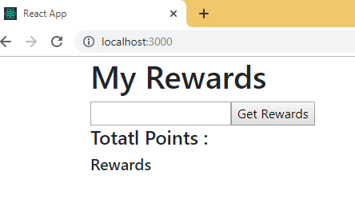

Enter cust1 and click on “Get Rewards” button.

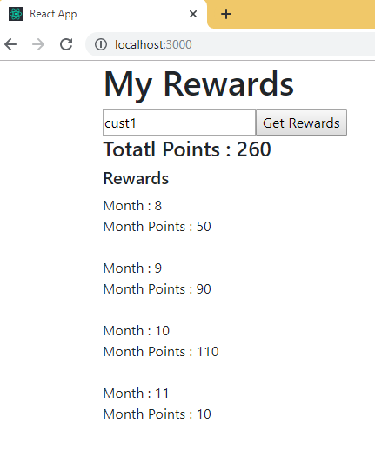

Enter cust2 and click on “Get Rewards” button.

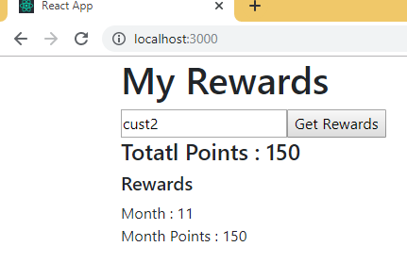

Enter any other value and click on “Get Rewards” button.

