VISVESVARAYA TECHNOLOGICAL UNIVERSITY
“JnanaSangama”, Belgaum -590014, Karnataka.

LAB REPORT
on

Artificial Intelligence (23CS5PCAIN)

Submitted by

SUSHMITHA K.L (1WA23CS003)

in partial fulfillment for the award of the degree of
BACHELOR OF ENGINEERING
in
COMPUTER SCIENCE AND ENGINEERING


B.M.S. COLLEGE OF ENGINEERING
(Autonomous Institution under VTU)
BENGALURU-560019
Aug 2025 to Dec 2025

B.M.S. College of Engineering,
Bull Temple Road, Bangalore 560019
(Affiliated To Visvesvaraya Technological University, Belgaum)
Department of Computer Science and Engineering


CERTIFICATE

This is to certify that the Lab work entitled “Artificial Intelligence (23CS5PCAIN)” carried out by SUSHMITHA K.L(1WA23CS003), who is bonafide student of B.M.S. College of Engineering. It is in partial fulfillment for the award of Bachelor of Engineering in Computer Science and Engineering of the Visvesvaraya Technological University, Belgaum. The Lab report has been approved as it satisfies the academic requirements in respect of an Artificial Intelligence (23CS5PCAIN) work prescribed for the said degree.

Lab faculty Incharge Name Assistant Professor Department of CSE, BMSCE | Dr. Kavitha Sooda Professor & HOD  Department of CSE, BMSCE

Index
Sl.  No. | Date | Experiment Title | Page No.
1 | 18-08-2025 | Implement Tic –Tac –Toe Game Implement vacuum cleaner agent | 4
2 | 25-08-2025 | Implement 8 puzzle problems using Depth First Search (DFS)  Implement Iterative deepening search algorithm | 11
3 | 08-09-2025 | Implement A* search algorithm | 30
4 | 15-09-2025 | Implement Hill Climbing search algorithm to solve N-Queens problem | 39
5 | 15-09-2025 | Simulated Annealing to Solve 8-Queens problem | 45
6 | 22-09-2025 | Create a knowledge base using propositional logic and show that the given query entails the knowledge base or not. | 48
7 | 30-09-2025 | Implement unification in first order logic | 50
8 | 13-10-2025 | Create a knowledge base consisting of first order logic statements and prove the given query using forward reasoning. | 54
9 | 27-10-2025 | Create a knowledge base consisting of first order logic statements and prove the given query using Resolution | 57
10 | 27-10-2025 | Implement Alpha-Beta Pruning. | 65

Github Link:
https://github.com/SushmithaKL01/artificial_intelligence-lab

Program 1
Implement Tic –Tac –Toe Game Algorithm:
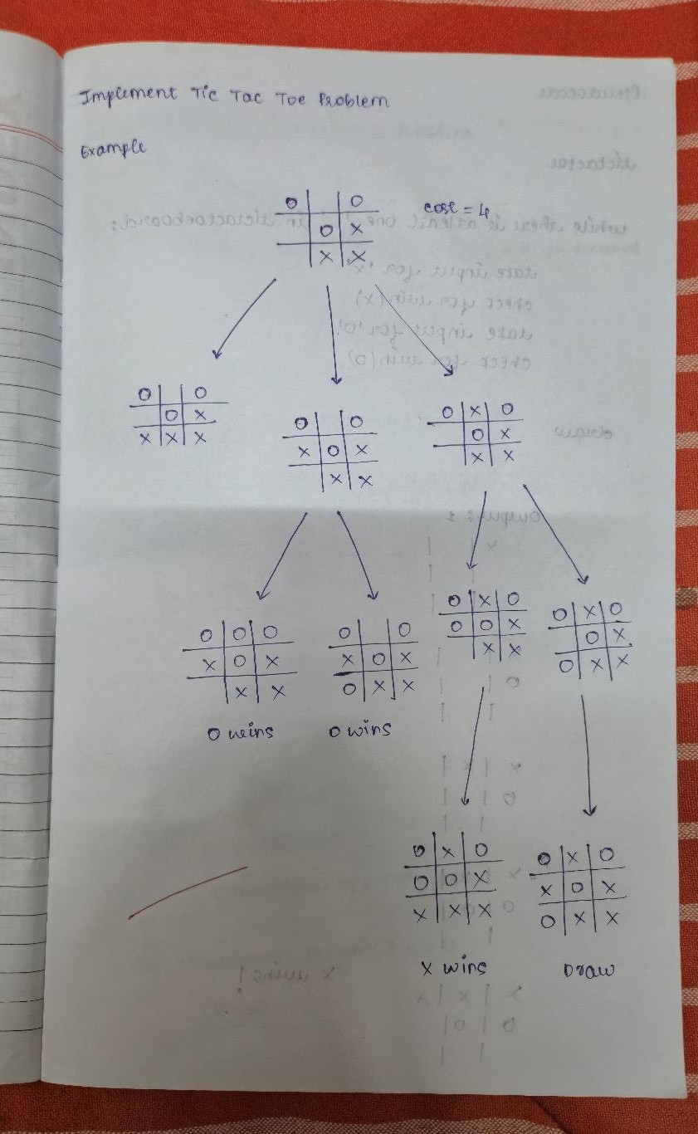

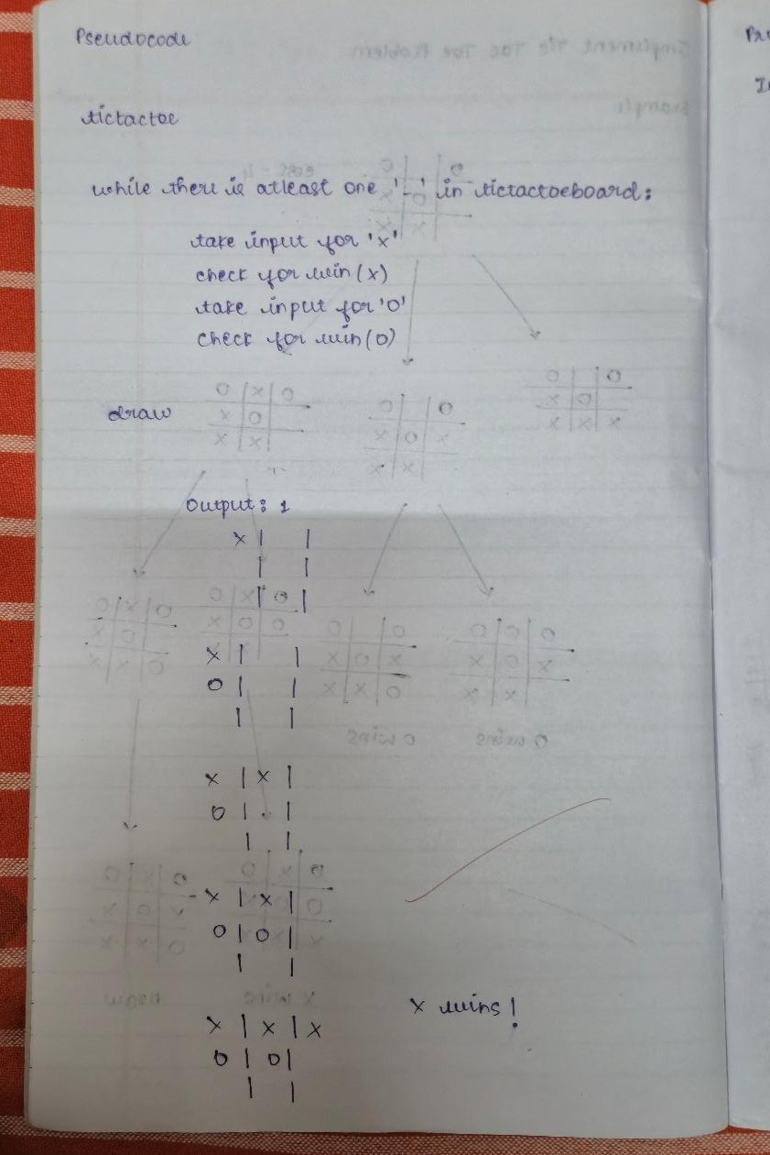
Code:
def print_board(board):
print("\n")
for i in range(3):
print(" | ".join(board[i*3:(i+1)*3])) if i < 2:
print("-" * 10)
print("\n")

def check_winner(board, player): win_conditions = [
[0, 1, 2], [3, 4, 5], [6, 7, 8],
[0, 3, 6], [1, 4, 7], [2, 5, 8],
[0, 4, 8], [2, 4, 6]
]

for combo in win_conditions: count=0
for pos in combo:
if board[pos]==player: count+=1
if count==3: return True
return False

board = [" "] * 9 current_player = "X" print_board(board)

while True: while True:
pos = int(input(f"Player {current_player}, enter your move (1-9): ")) - 1 if 0 <= pos <= 8 and board[pos] == " ":
board[pos] = current_player break
else:
print("Invalid move. Try again.") print_board(board)
if check_winner(board, current_player): print(f"Player {current_player} wins!") break
if " " not in board: print("It's a draw!") break

# Switch players
current_player = "O" if current_player == "X" else "X"

Output:

| |

| |

| |

Player X, enter your move (1-9): 1

X | |

| |

| |
Player O, enter your move (1-9): 2 X | O |

| |

| |
Player X, enter your move (1-9): 3 X | O | X

| |

| |
Player O, enter your move (1-9): 4 X | O | X

O | |

| |
Player X, enter your move (1-9): 5 X | O | X

O | X |

| |

Player O, enter your move (1-9): 6 X | O | X

O | X | O

| |
Player X, enter your move (1-9): 9
X | O | X

O | X | O

| | X

Player X wins!
Implement vacuum cleaner agent
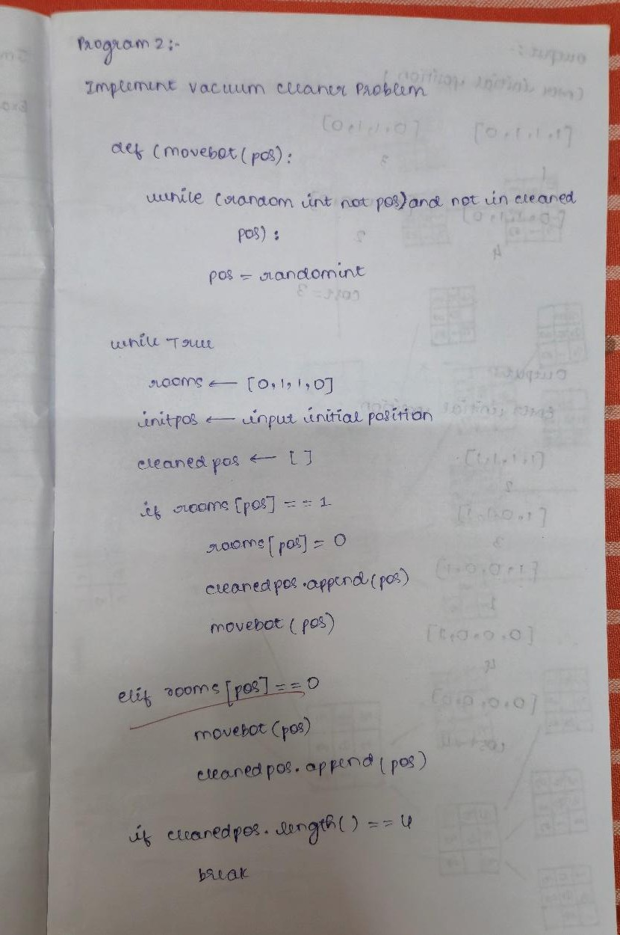

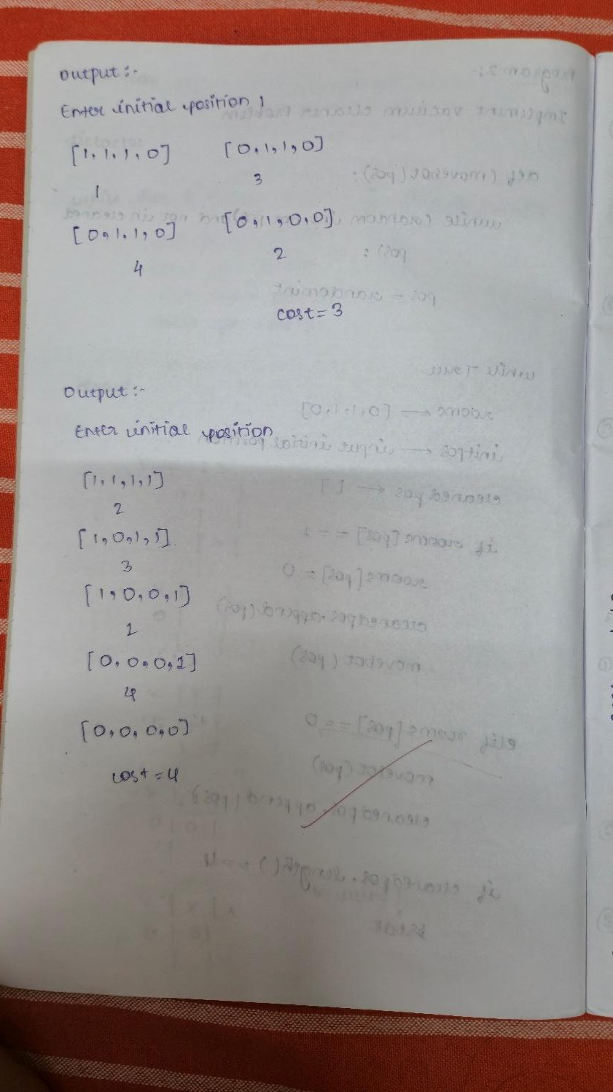

Code:
# Initial setup
rooms = [1, 1, 1, 1] # 1 = dirty, 0 = clean
botpos = int(input("Enter Initial Position (1-4): ")) - 1 cost = 0
moves = 0

# Function to clean current room

def clean_room(pos): global cost
if rooms[pos] == 1: rooms[pos] = 0
cost += 1
print(f"Cleaned room {pos+1}") else:
print(f"Room {pos+1} already clean")

# Function to move bot
def move_bot(pos, direction): global moves
# move right if direction=1 else left
newpos = pos + direction moves += 1
return newpos

# Main loop
direction = 1 # start moving right
while 1 in rooms: # loop until all rooms are clean print("Rooms:", rooms, " Bot at:", botpos+1) clean_room(botpos)

if 1 not in rooms: break

# change direction if at edges
if botpos == len(rooms)-1: direction = -1
elif botpos == 0: direction = 1

botpos = move_bot(botpos, direction)

print("\n All rooms cleaned!") print("Cleaning Cost =", cost) print("Total Moves =", moves)

Output:
Enter Initial Position (1-4): 2
Rooms: [1, 1, 1, 1] Bot at: 2
Cleaned room 2
Rooms: [1, 0, 1, 1] Bot at: 3
Cleaned room 3

Rooms: [1, 0, 0, 1] Bot at: 4
Cleaned room 4
Rooms: [1, 0, 0, 0] Bot at: 3 Room 3 already clean Rooms: [1, 0, 0, 0] Bot at: 2 Room 2 already clean Rooms: [1, 0, 0, 0] Bot at: 1
Cleaned room 1

All rooms cleaned! Cleaning Cost = 4 Total Moves = 5

Program 2
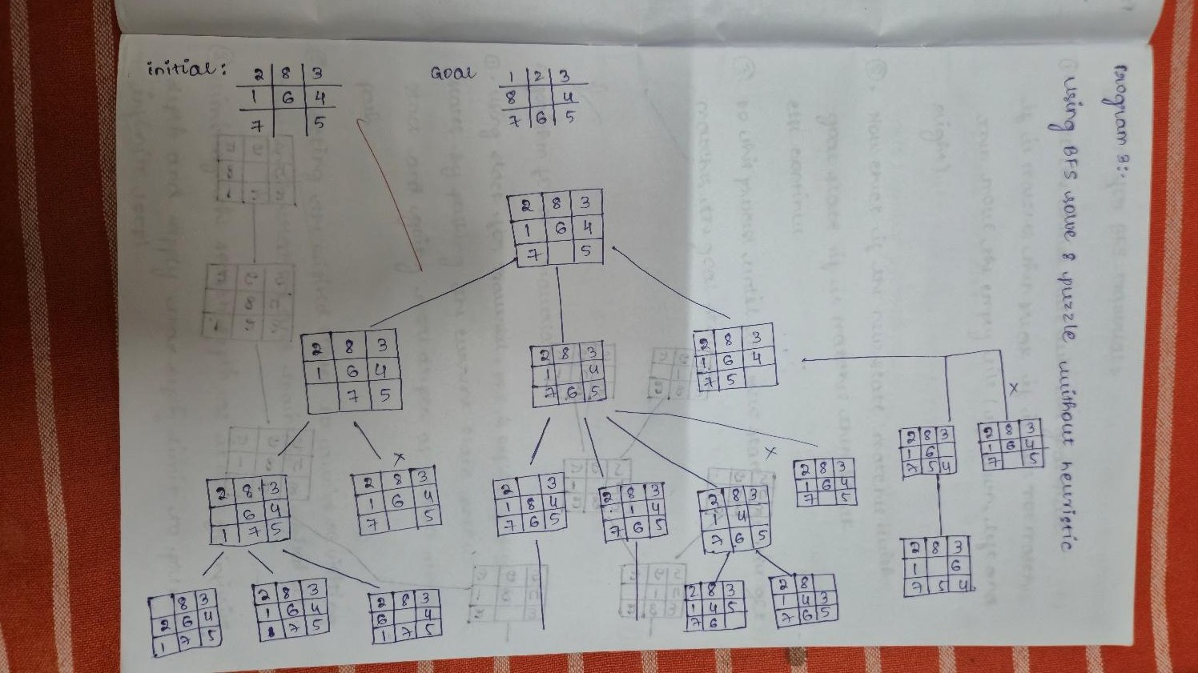
Implement 8 puzzle problems using Depth First Search (DFS) Algorithm:

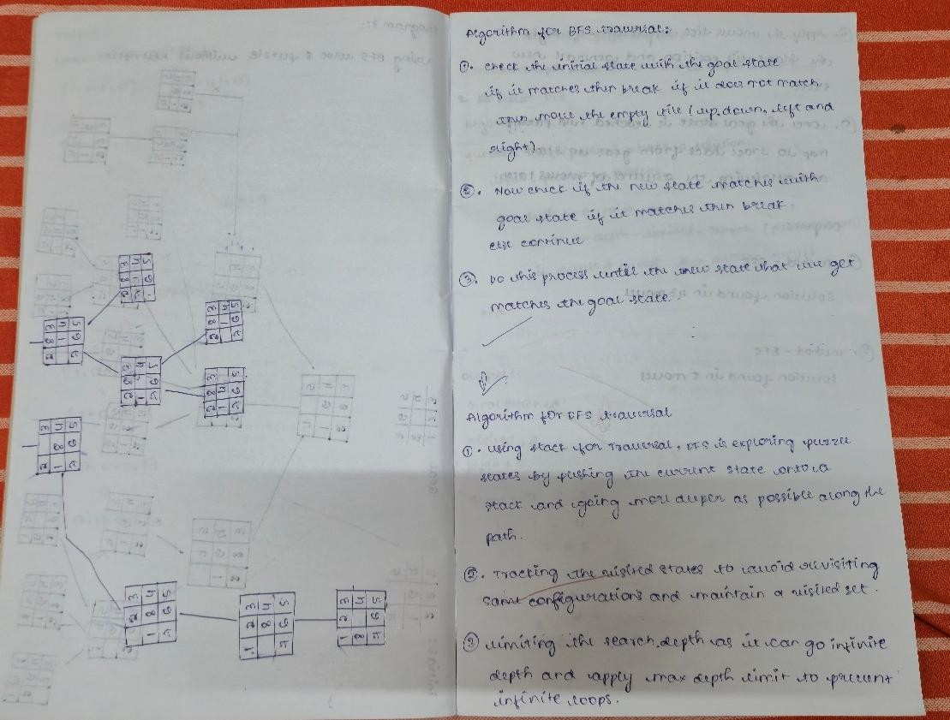
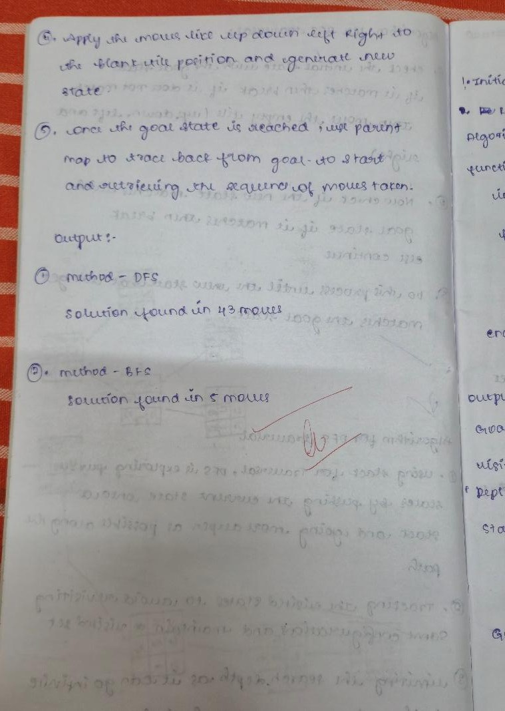

Code:
from collections import deque
# Define possible moves
MOVES = { 'Up': -3,
'Down': 3,
'Left': -1,
'Right': 1
}

def is_valid_move(zero_index, move):
if move == 'Left' and zero_index % 3 == 0: return False
if move == 'Right' and zero_index % 3 == 2: return False
if move == 'Up' and zero_index < 3: return False
if move == 'Down' and zero_index > 5: return False
return True

def move_tile(state, move): zero_index = state.index('0')
if not is_valid_move(zero_index, move): return None
new_index = zero_index + MOVES[move] state_list = list(state)
state_list[zero_index], state_list[new_index] = state_list[new_index], state_list[zero_index] return ''.join(state_list)

def reconstruct_path(parent, move_record, end_state): path = []
current = end_state
while parent[current] is not None: path.append((move_record[current], current)) current = parent[current]
path.reverse() return path

# BFS implementation
def bfs(start_state, goal_state): queue = deque()
visited = set() parent = {} move_record = {}

queue.append(start_state) visited.add(start_state) parent[start_state] = None move_record[start_state] = None

while queue:
current = queue.popleft()

if current == goal_state:
return reconstruct_path(parent, move_record, current)

for move in MOVES:
new_state = move_tile(current, move)
if new_state and new_state not in visited: visited.add(new_state) queue.append(new_state) parent[new_state] = current move_record[new_state] = move

return None

# DFS implementation
def dfs(start_state, goal_state, max_depth=50): stack = [(start_state, 0)]
visited = set() parent = {} move_record = {}

parent[start_state] = None move_record[start_state] = None

while stack:
current, depth = stack.pop()

if current == goal_state:
return reconstruct_path(parent, move_record, current)

if depth >= max_depth: continue

visited.add(current)

for move in reversed(list(MOVES)): # Reverse for consistent DFS order
new_state = move_tile(current, move)
if new_state and new_state not in visited: stack.append((new_state, depth + 1)) parent[new_state] = current

move_record[new_state] = move return None
def print_puzzle(state): for i in range(0, 9, 3):
row = state[i:i+3]
print(' '.join(c if c != '0' else '_' for c in row)) print()

def print_solution(start_state, goal_state, method='bfs'): print(f"\nStart State ({method.upper()}):") print_puzzle(start_state)
print("Goal State:") print_puzzle(goal_state)

if method == 'bfs':
path = bfs(start_state, goal_state) elif method == 'dfs':
path = dfs(start_state, goal_state) else:
raise ValueError("Method must be 'bfs' or 'dfs'")

if path is None:
print("No solution found.") return

print(f"\nSolution found in {len(path)} moves:") current = start_state
for move, state in path: print(f"Move: {move}") print_puzzle(state)

def get_state_input(prompt): while True:
raw = input(prompt).replace(" ", "").replace("_", "0")
if len(raw) != 9 or not all(c in "0123456789" for c in raw): print("Invalid input. Enter 9 digits from 0-8 (0 for blank).") continue
if sorted(raw) != list("012345678"):
print("Invalid puzzle: must contain digits 0 through 8 exactly once.") continue
return raw

# Main program
if name == " main ":
print("8-Puzzle Solver (BFS and DFS)")

print("Enter the puzzle state as 9 digits (0 = blank). Example: 123405678")

start = get_state_input("Enter the initial state: ") goal = get_state_input("Enter the goal state: ")

method = ''
while method not in ['bfs', 'dfs']:
method = input("Choose search method (bfs/dfs): ").strip().lower() print_solution(start, goal, method)

Output:
8-Puzzle Solver (BFS and DFS)
Enter the puzzle state as 9 digits (0 = blank). Example: 123405678 Enter the initial state: 283164705
Enter the goal state: 123804765 Choose search method (bfs/dfs): dfs

Start State (DFS):
2 8 3
1 6 4
7 _ 5

Goal State:
1 2 3
8 _ 4
7 6 5

Solution found in 43 moves: Move: Up
2 8 3
1 _ 4
7 6 5

Move: Up 2 _ 3
1 8 4
7 6 5

Move: Left
_ 2 3
1 8 4
7 6 5

Move: Down

1 2 3
_ 8 4
7 6 5

Move: Down 1 2 3
7 8 4
_ 6 5

Move: Right 1 2 3
7 8 4
6 _ 5

Move: Up 1 2 3
7 _ 4
6 8 5

Move: Up 1 _ 3
7 2 4
6 8 5

Move: Left
_ 1 3
7 2 4
6 8 5

Move: Down 7 1 3
_ 2 4
6 8 5

Move: Down 7 1 3
6 2 4
_ 8 5

Move: Right 7 1 3
6 2 4
8 _ 5

Move: Up 7 1 3
6 _ 4

8 2 5

Move: Up 7 _ 3
6 1 4
8 2 5

Move: Left
_ 7 3
6 1 4
8 2 5

Move: Down 6 7 3
_ 1 4
8 2 5

Move: Down 6 7 3
8 1 4
_ 2 5

Move: Right 6 7 3
8 1 4
2 _ 5

Move: Up 6 7 3
8 _ 4
2 1 5

Move: Up 6 _ 3
8 7 4
2 1 5

Move: Left
_ 6 3
8 7 4
2 1 5

Move: Down 8 6 3
_ 7 4
2 1 5

Move: Down 8 6 3
2 7 4
_ 1 5

Move: Right 8 6 3
2 7 4
1 _ 5

Move: Up 8 6 3
2 _ 4
1 7 5

Move: Up 8 _ 3
2 6 4
1 7 5

Move: Left
_ 8 3
2 6 4
1 7 5

Move: Down 2 8 3
_ 6 4
1 7 5

Move: Right 2 8 3
6 _ 4
1 7 5

Move: Down 2 8 3
6 7 4
1 _ 5

Move: Left 2 8 3
6 7 4
_ 1 5

Move: Up 2 8 3

_ 7 4
6 1 5

Move: Right 2 8 3
7 _ 4
6 1 5

Move: Down 2 8 3
7 1 4
6 _ 5

Move: Left 2 8 3
7 1 4
_ 6 5

Move: Up 2 8 3
_ 1 4
7 6 5

Move: Up
_ 8 3
2 1 4
7 6 5

Move: Right 8 _ 3
2 1 4
7 6 5

Move: Down 8 1 3
2 _ 4
7 6 5

Move: Left 8 1 3
_ 2 4
7 6 5

Move: Up
_ 1 3
8 2 4
7 6 5

Move: Right 1 _ 3
8 2 4
7 6 5

Move: Down 1 2 3
8 _ 4
7 6 5

Implement Iterative deepening search algorithm Algorithm:
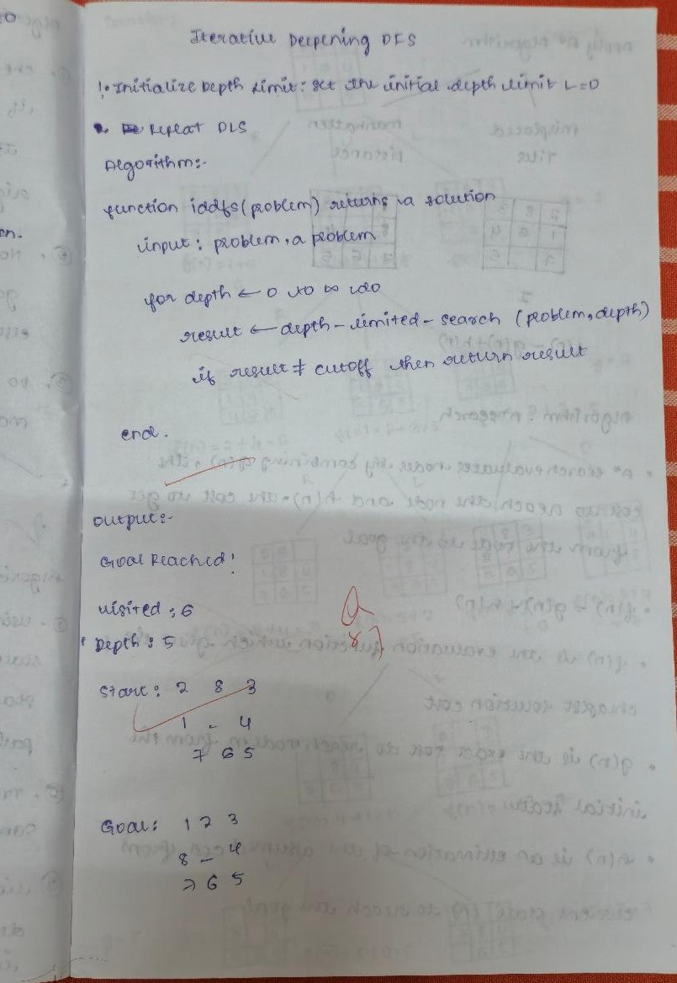

Code:

import copy

# Goal state
goal_state = [[1, 2, 3],
[8, 0, 4],
[7, 6, 5]]

# Moves: Up, Down, Left, Right
moves = [(-1, 0), (1, 0), (0, -1), (0, 1)]

# Find the position of the blank tile (0)
def find_blank(state): for i in range(3):
for j in range(3):
if state[i][j] == 0: return i, j

# Check if the current state is the goal state
def is_goal(state):
return state == goal_state

# Get all possible neighbors (states) by moving the blank tile
def get_neighbors(state): neighbors = []
x, y = find_blank(state) for dx, dy in moves:
nx, ny = x + dx, y + dy
if 0 <= nx < 3 and 0 <= ny < 3: new_state = copy.deepcopy(state)
new_state[x][y], new_state[nx][ny] = new_state[nx][ny], new_state[x][y] neighbors.append(new_state)
return neighbors

# Convert the state into a tuple for hashing in the visited set
def state_to_tuple(state):
return tuple(tuple(row) for row in state)

# Print the current state in a readable format
def print_state(state): for row in state:
print(" ".join(str(num) if num != 0 else "_" for num in row)) print(" ")

# Depth-limited DFS
def dfs_limited(state, path, depth, limit, visited):
if depth == limit: # If we reached the depth limit, stop exploring
return None

# Print the current state (optional, can be commented out for cleaner output)
print_state(state)

if is_goal(state):
return path + [state] # Return the solution path if goal is found

visited.add(state_to_tuple(state)) # Mark current state as visited

for neighbor in get_neighbors(state): key = state_to_tuple(neighbor)
if key not in visited:
result = dfs_limited(neighbor, path + [state], depth + 1, limit, visited) if result:
return result # If a valid solution is found, return it
return None # No solution found at this depth # Iterative Deepening DFS
def iddfs(start_state, max_depth=50): for limit in range(max_depth + 1):
print(f"=== Iteration with depth limit {limit} ===") visited = set() # Set to track visited states
path = dfs_limited(start_state, [], 0, limit, visited) # Start DFS with depth 0
if path:
print("Goal reached!") print("Visited:", len(visited)) print("Solution depth:", len(path) - 1) print("Steps:")
for step in path:
print_state(step) # Print the path from start to goal
return # Solution found, exit the function
print("No solution found within depth limit.") # No solution found after max_depth

# Example usage
start_state = [[2, 8, 3],
[1, 6, 4],
[7, 0, 5]]

iddfs(start_state, max_depth=20) # Start the search with a max depth of 20

Output:

=== Iteration with depth limit 0 ===
=== Iteration with depth limit 1 === 2 8 3
1 6 4
7 _ 5

=== Iteration with depth limit 2 === 2 8 3
1 6 4
7 _ 5

2 8 3
1 _ 4
7 6 5

2 8 3
1 6 4
_ 7 5

2 8 3
1 6 4
7 5 _

=== Iteration with depth limit 3 === 2 8 3
1 6 4
7 _ 5

2 8 3
1 _ 4
7 6 5

2 _ 3
1 8 4
7 6 5

2 8 3
_ 1 4
7 6 5

2 8 3
1 4 _
7 6 5

2 8 3
1 6 4

_ 7 5

2 8 3
_ 6 4
1 7 5

2 8 3
1 6 4
7 5 _

2 8 3
1 6 _
7 5 4

=== Iteration with depth limit 4 === 2 8 3
1 6 4
7 _ 5

2 8 3
1 _ 4
7 6 5

2 _ 3
1 8 4
7 6 5

_ 2 3
1 8 4
7 6 5

2 3 _
1 8 4
7 6 5

2 8 3
_ 1 4
7 6 5

_ 8 3
2 1 4
7 6 5

2 8 3
7 1 4
_ 6 5

2 8 3
1 4 _
7 6 5

2 8 _
1 4 3
7 6 5

2 8 3
1 4 5
7 6 _

2 8 3
1 6 4
_ 7 5

2 8 3
_ 6 4
1 7 5

_ 8 3
2 6 4
1 7 5

2 8 3
6 _ 4
1 7 5

2 8 3
1 6 4
7 5 _

2 8 3
1 6 _
7 5 4

2 8 _
1 6 3
7 5 4

2 8 3
1 _ 6
7 5 4

=== Iteration with depth limit 5 === 2 8 3
1 6 4

7 _ 5

2 8 3
1 _ 4
7 6 5

2 _ 3
1 8 4
7 6 5

_ 2 3
1 8 4
7 6 5

1 2 3
_ 8 4
7 6 5

2 3 _
1 8 4
7 6 5

2 3 4
1 8 _
7 6 5

2 8 3
_ 1 4
7 6 5

_ 8 3
2 1 4
7 6 5

8 _ 3
2 1 4
7 6 5

2 8 3
7 1 4
_ 6 5

2 8 3
7 1 4
6 _ 5

2 8 3

1 4 _
7 6 5

2 8 _
1 4 3
7 6 5

2 _ 8
1 4 3
7 6 5

2 8 3
1 4 5
7 6 _

2 8 3
1 4 5
7 _ 6

2 8 3
1 6 4
_ 7 5

2 8 3
_ 6 4
1 7 5

_ 8 3
2 6 4
1 7 5

8 _ 3
2 6 4
1 7 5

2 8 3
6 _ 4
1 7 5

2 _ 3
6 8 4
1 7 5

2 8 3
6 7 4
1 _ 5

2 8 3
6 4 _
1 7 5

2 8 3
1 6 4
7 5 _

2 8 3
1 6 _
7 5 4

2 8 _
1 6 3
7 5 4

2 _ 8
1 6 3
7 5 4

2 8 3
1 _ 6
7 5 4

2 _ 3
1 8 6
7 5 4

2 8 3
1 5 6
7 _ 4

2 8 3
_ 1 6
7 5 4

=== Iteration with depth limit 6 === 2 8 3
1 6 4
7 _ 5

2 8 3
1 _ 4
7 6 5

2 _ 3
1 8 4

7 6 5

_ 2 3
1 8 4
7 6 5

1 2 3
_ 8 4
7 6 5

1 2 3
7 8 4
_ 6 5

1 2 3
8 _ 4
7 6 5

Goal reached! Visited: 6
Solution depth: 5 Steps:
2 8 3
1 6 4
7 _ 5

2 8 3
1 _ 4
7 6 5

2 _ 3
1 8 4
7 6 5

_ 2 3
1 8 4
7 6 5

1 2 3
_ 8 4
7 6 5

1 2 3
8 _ 4
7 6 5

Program 3

Implement A* search algorithm Algorithm:
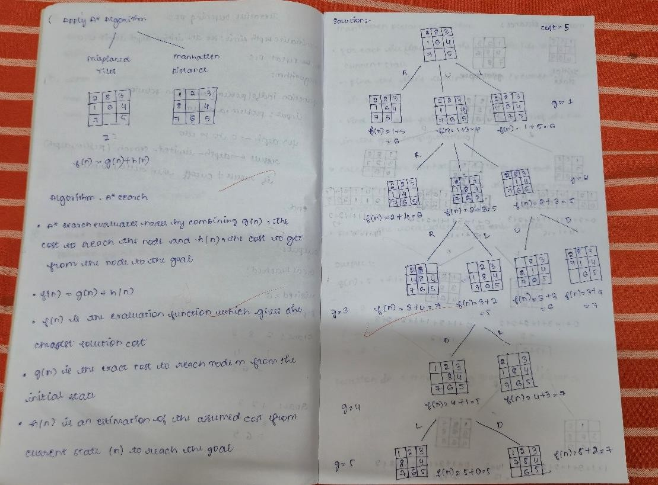
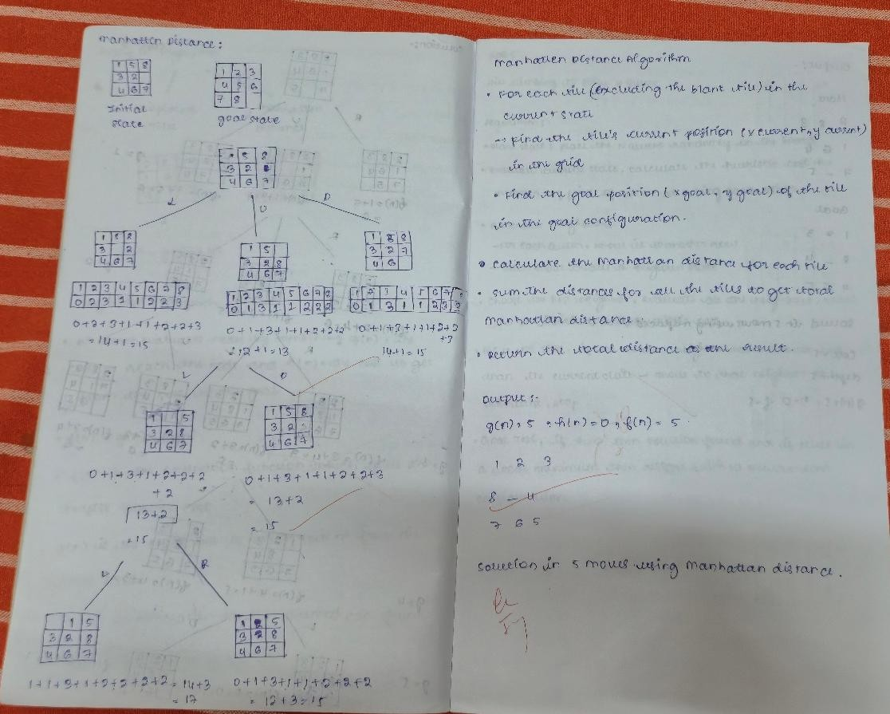

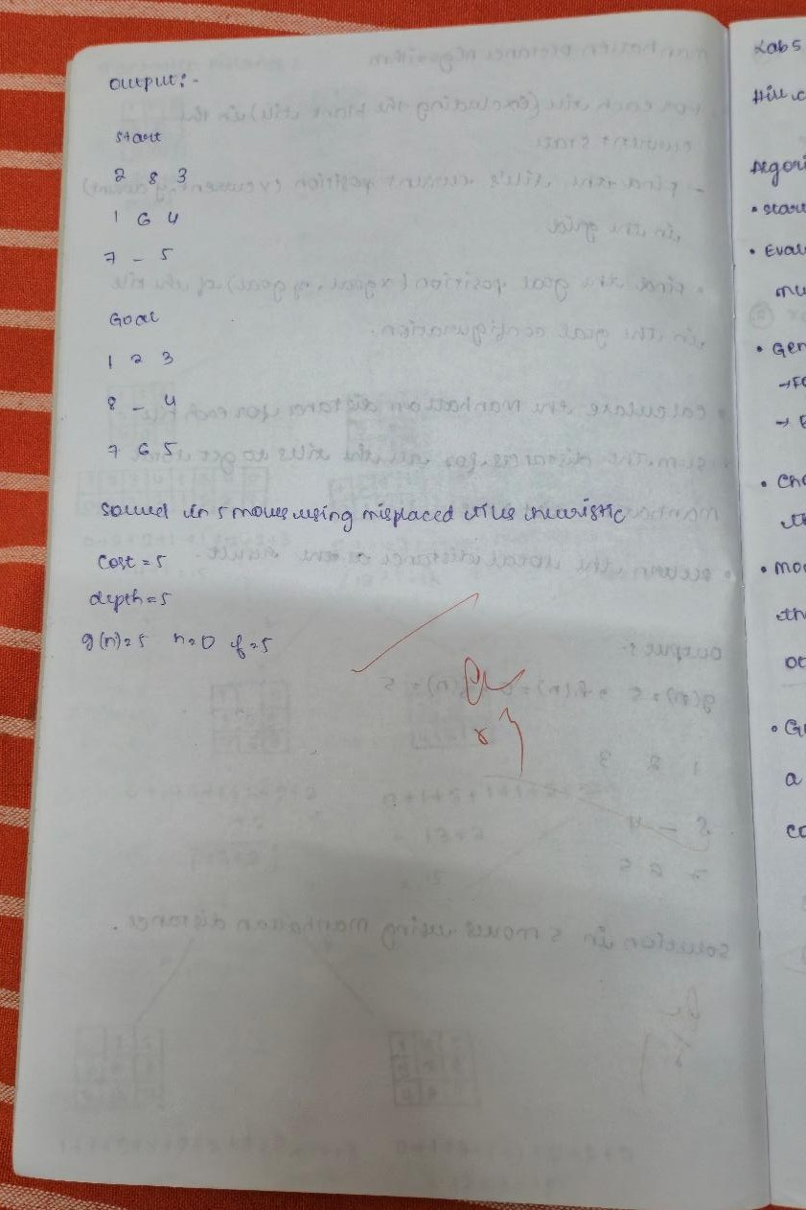
Code:
from heapq import heappush, heappop
GOAL = (1, 2, 3,
8, 0, 4,
7, 6, 5) # 0 = blank
GOAL_POS = {v: (i // 3, i % 3) for i, v in enumerate(GOAL)} def manhattan_distance(state):
dist = 0
for i, v in enumerate(state): if v != 0: # skip blank
r, c = divmod(i, 3) # current position (row, col)

gr, gc = GOAL_POS[v] # goal position (row, col)
dist += abs(r - gr) + abs(c - gc) return dist

# Inversion parity (checking solvability)
def inversion_parity(state):
arr = [v for v in state if v != 0] inv = 0
for i in range(len(arr)):
for j in range(i + 1, len(arr)): if arr[i] > arr[j]:
inv += 1 return inv % 2

def is_solvable(start, goal):
"""General solvability: start and goal must have same inversion parity.""" return inversion_parity(start) == inversion_parity(goal)

# Moves: (name, row_delta, col_delta)
MOVES = [ ("up", -1, 0),
("down", 1, 0),
("left", 0, -1),
("right", 0, 1),
]

def neighbors(state):
"""Generate (next_state, action) pairs by sliding a tile into the blank.""" zero = state.index(0)
zr, zc = divmod(zero, 3)

for name, dr, dc in MOVES: nr, nc = zr + dr, zc + dc
if 0 <= nr < 3 and 0 <= nc < 3: nidx = nr * 3 + nc new_state = list(state)
new_state[zero], new_state[nidx] = new_state[nidx], new_state[zero] yield tuple(new_state), name

# A* search
def a_star(start):
if not is_solvable(start, GOAL):
raise ValueError("This puzzle configuration is not solvable.")

counter = 0
h0 = manhattan_distance(start) frontier = []

heappush(frontier, (h0, counter, start))

g = {start: 0} # g(n): cost to reach the current state from the start
parent = {start: None} action_to = {start: None}

while frontier:
f, _, s = heappop(frontier)

if s == GOAL:
# Reconstruct path actions, states = [], [] cur = s
while cur is not None: states.append(cur) actions.append(action_to[cur]) cur = parent[cur]
actions = actions[-2::-1] # drop None, reverse
states = states[::-1] return actions, states, g

for ns, act in neighbors(s):
tentative_g = g[s] + 1 # g(n) = g(parent) + 1
if ns not in g or tentative_g < g[ns]: g[ns] = tentative_g
parent[ns] = s action_to[ns] = act counter += 1
heappush(frontier, (tentative_g + manhattan_distance(ns), counter, ns)) raise ValueError("No path found (should not happen for solvable states).")
def print_state(state): for r in range(3):
row = state[3*r:3*r+3]
print(" ".join(str(x) if x != 0 else "·" for x in row)) print()

if name == " main ": start = (2, 8, 3,
1, 6, 4,
7, 0, 5)

print("Start:") print_state(start) print("Goal:") print_state(GOAL)

try:
actions, states, g = a_star(start)
print(f"Solved in {len(actions)} moves using Manhattan distance heuristic.\n")

# Printing the costs during the search path
for i, (a, st) in enumerate(zip(actions, states[1:]), start=1): g_cost = g[st] # g(n): cost to reach this state from the start
h_cost = manhattan_distance(st) # h(n): Manhattan distance heuristic
f_cost = g_cost + h_cost # f(n) = g(n) + h(n)
print(f"Move {i}: {a}")
print(f"g(n) = {g_cost}, h(n) = {h_cost}, f(n) = {f_cost}") print_state(st)
except ValueError as e: print(e)

from heapq import heappush, heappop

# ---------- Problem setup ----------
GOAL = (1, 2, 3,
8, 0, 4,
7, 6, 5) # 0 = blank

# Heuristic: misplaced tiles
def misplaced_tiles(state):
return sum(1 for i, v in enumerate(state) if v != 0 and v != GOAL[i])

# Inversion count
def inversion_parity(state):
arr = [v for v in state if v != 0] inv = 0
for i in range(len(arr)):
for j in range(i + 1, len(arr)): if arr[i] > arr[j]:
inv += 1 return inv % 2

def is_solvable(start, goal):
"""General solvability: start and goal must have same inversion parity.""" return inversion_parity(start) == inversion_parity(goal)

# Moves: (name, row_delta, col_delta)
MOVES = [ ("up", -1, 0),
("down", 1, 0),
("left", 0, -1),

("right", 0, 1),
]

def neighbors(state):
"""Generate (next_state, action) pairs by sliding a tile into the blank.""" zero = state.index(0)
zr, zc = divmod(zero, 3)

for name, dr, dc in MOVES: nr, nc = zr + dr, zc + dc
if 0 <= nr < 3 and 0 <= nc < 3: nidx = nr * 3 + nc new_state = list(state)
new_state[zero], new_state[nidx] = new_state[nidx], new_state[zero] yield tuple(new_state), name

# A* search
def a_star(start):
if not is_solvable(start, GOAL):
raise ValueError("This puzzle configuration is not solvable.")

counter = 0
h0 = misplaced_tiles(start) frontier = []
heappush(frontier, (h0, counter, start))

g = {start: 0}
parent = {start: None} action_to = {start: None}

while frontier:
f, _, s = heappop(frontier)

if s == GOAL:
# Reconstruct path actions, states = [], [] cur = s
while cur is not None: states.append(cur) actions.append(action_to[cur]) cur = parent[cur]
actions = actions[-2::-1] # drop None, reverse
states = states[::-1] return actions, states, g

for ns, act in neighbors(s): tentative_g = g[s] + 1

if ns not in g or tentative_g < g[ns]: g[ns] = tentative_g
parent[ns] = s action_to[ns] = act counter += 1
heappush(frontier, (tentative_g + misplaced_tiles(ns), counter, ns)) raise ValueError("No path found (should not happen for solvable states).")
# ---------- Pretty printing ----------
def print_state(state): for r in range(3):
row = state[3*r:3*r+3]
print(" ".join(str(x) if x != 0 else "·" for x in row)) print()

# Example
if name == " main ": start = (2, 8, 3,
1, 6, 4,
7, 0, 5)

print("Start:") print_state(start) print("Goal:") print_state(GOAL)

try:
actions, states, g = a_star(start)
print(f"Solved in {len(actions)} moves using misplaced-tiles heuristic.\n") for i, (a, st) in enumerate(zip(actions, states[1:]), start=1):
g_cost = g[st]
h_cost = misplaced_tiles(st) f_cost = g_cost + h_cost print(f"Move {i}: {a}")
print(f"g={g_cost}, h={h_cost}, f={f_cost}") print_state(st)
except ValueError as e: print(e)

Output:
Start:
2 8 3
1 6 4
7 · 5

Goal:
1 2 3
8 · 4
7 6 5

Solved in 5 moves using Manhattan distance heuristic.

Move 1: up
g(n) = 1, h(n) = 4, f(n) = 5
2 8 3
1 · 4
7 6 5

Move 2: up
g(n) = 2, h(n) = 3, f(n) = 5
2 · 3
1 8 4
7 6 5

Move 3: left
g(n) = 3, h(n) = 2, f(n) = 5
· 2 3
1 8 4
7 6 5

Move 4: down
g(n) = 4, h(n) = 1, f(n) = 5
1 2 3
· 8 4
7 6 5

Move 5: right
g(n) = 5, h(n) = 0, f(n) = 5
1 2 3
8 · 4
7 6 5
Start:
2 8 3
1 6 4
7 · 5

Goal:
1 2 3
8 · 4

7 6 5

Solved in 5 moves using misplaced-tiles heuristic.

Move 1: up g=1, h=3, f=4 2 8 3
1 · 4
7 6 5

Move 2: up g=2, h=3, f=5
2 · 3
1 8 4
7 6 5

Move 3: left g=3, h=2, f=5
· 2 3
1 8 4
7 6 5

Move 4: down g=4, h=1, f=5 1 2 3
· 8 4
7 6 5

Move 5: right g=5, h=0, f=5 1 2 3
8 · 4
7 6 5

Program 4
Implement Hill Climbing search algorithm to solve N-Queens problem Algorithm:

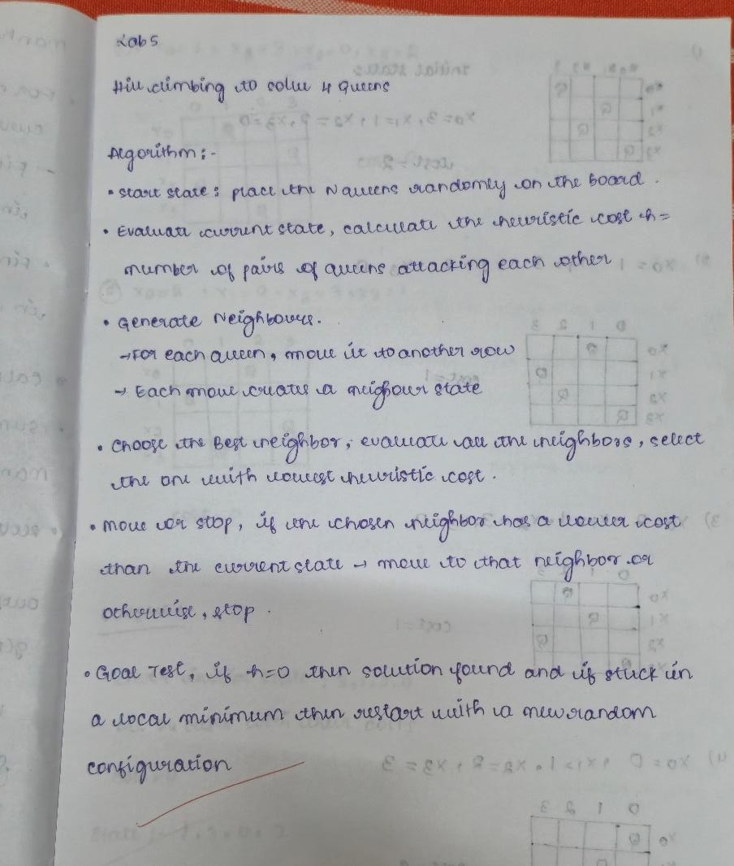
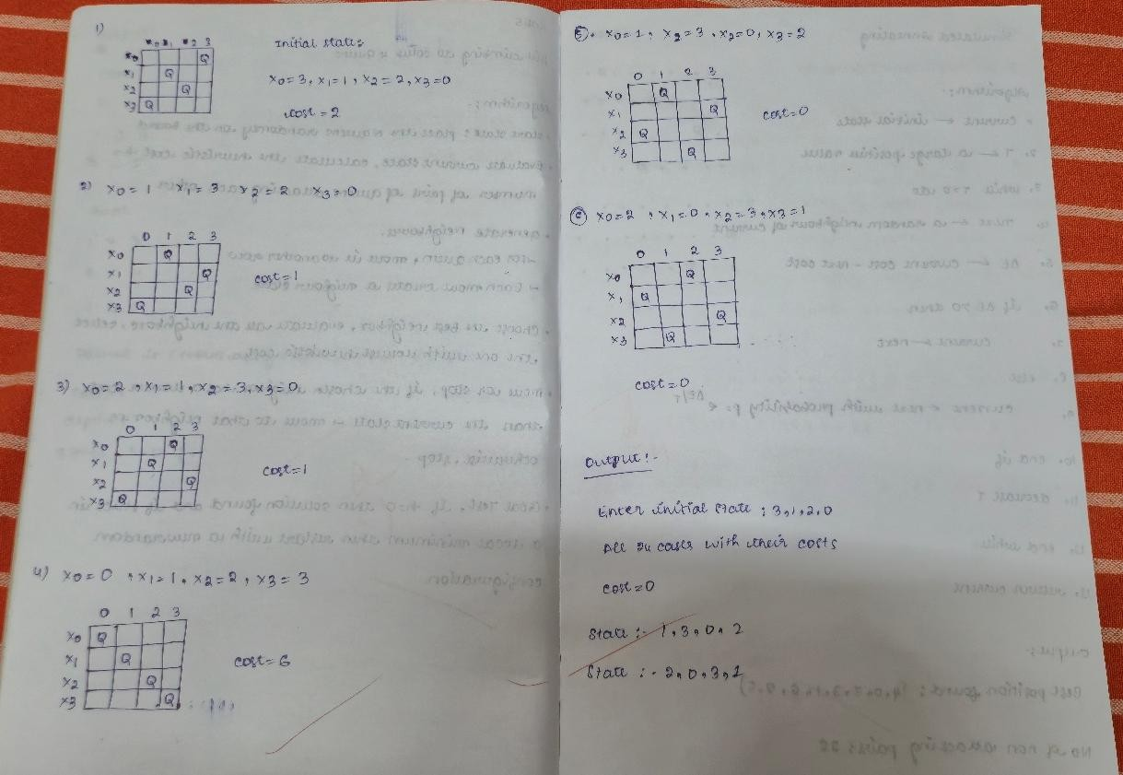

Code:
from itertools import permutations
def compute_cost(state):
conflicts = 0 n = len(state)
for i in range(n):
for j in range(i + 1, n):
if abs(state[i] - state[j]) == abs(i - j): conflicts += 1
return conflicts

def format_board(state): n = len(state) board_lines = []
for row in range(n):
row_str = " ".join("Q" if state[col] == row else "-" for col in range(n)) board_lines.append(row_str)
return "\n".join(board_lines)

def is_valid_permutation(state):
return sorted(state) == list(range(len(state)))

def main(): n = 4
all_states = list(permutations(range(n))) costs = []

print(f"Total possible permutations: {len(all_states)}\n")

# Calculate costs for all states
for state in all_states:
cost = compute_cost(state) costs.append((state, cost))

# Find minimum cost
min_cost = min(costs, key=lambda x: x[1])[1]
best_solutions = [state for state, cost in costs if cost == min_cost]

# Print all states with their costs
print("All permutations with their costs:\n") for idx, (state, cost) in enumerate(costs, 1):
print(f"Case {idx}: {state} | Conflicts = {cost}") print(format_board(state))
print("-" * 40)

# Print best solution(s)

print(f"\nLowest cost = {min_cost}") print("Best solution(s):\n")
for state in best_solutions:
print(f"State: {state} | Conflicts = {min_cost}") print(format_board(state))
print("-" * 40)

if name == " main ": main()

Output:
Total possible permutations: 24 All permutations with their costs:
Case 1: (0, 1, 2, 3) | Conflicts = 6 Q - - -
- Q - -
- - Q -
- - - Q

Case 2: (0, 1, 3, 2) | Conflicts = 2 Q - - -
- Q - -
- - - Q
- - Q -

Case 3: (0, 2, 1, 3) | Conflicts = 2 Q - - -
- - Q -
- Q - -
- - - Q

Case 4: (0, 2, 3, 1) | Conflicts = 1 Q - - -
- - - Q
- Q - -
- - Q -

Case 5: (0, 3, 1, 2) | Conflicts = 1 Q - - -
- - Q -
- - - Q
- Q - -

Case 6: (0, 3, 2, 1) | Conflicts = 4 Q - - -
- - - Q
- - Q -
- Q - -

Case 7: (1, 0, 2, 3) | Conflicts = 2
- Q - -
Q - - -
- - Q -
- - - Q

Case 8: (1, 0, 3, 2) | Conflicts = 4
- Q - -
Q - - -
- - - Q
- - Q -

Case 9: (1, 2, 0, 3) | Conflicts = 1
- - Q -
Q - - -
- Q - -
- - - Q

Case 10: (1, 2, 3, 0) | Conflicts = 4
- - - Q
Q - - -
- Q - -
- - Q -

Case 11: (1, 3, 0, 2) | Conflicts = 0
- - Q -
Q - - -
- - - Q
- Q - -

Case 12: (1, 3, 2, 0) | Conflicts = 1
- - - Q
Q - - -
- - Q -
- Q - -

Case 13: (2, 0, 1, 3) | Conflicts = 1
- Q - -
- - Q -
Q - - -
- - - Q

Case 14: (2, 0, 3, 1) | Conflicts = 0
- Q - -
- - - Q
Q - - -
- - Q -

Case 15: (2, 1, 0, 3) | Conflicts = 4
- - Q -
- Q - -
Q - - -
- - - Q

Case 16: (2, 1, 3, 0) | Conflicts = 1
- - - Q
- Q - -
Q - - -
- - Q -

Case 17: (2, 3, 0, 1) | Conflicts = 4
- - Q -
- - - Q
Q - - -
- Q - -

Case 18: (2, 3, 1, 0) | Conflicts = 2
- - - Q
- - Q -
Q - - -
- Q - -

Case 19: (3, 0, 1, 2) | Conflicts = 4
- Q - -
- - Q -
- - - Q
Q - - -

Case 20: (3, 0, 2, 1) | Conflicts = 1
- Q - -
- - - Q
- - Q -
Q - - -

Case 21: (3, 1, 0, 2) | Conflicts = 1
- - Q -
- Q - -
- - - Q

Q - - -

Case 22: (3, 1, 2, 0) | Conflicts = 2
- - - Q
- Q - -
- - Q -
Q - - -

Case 23: (3, 2, 0, 1) | Conflicts = 2
- - Q -
- - - Q
- Q - -
Q - - -

Case 24: (3, 2, 1, 0) | Conflicts = 6
- - - Q
- - Q -
- Q - -
Q - - -

Lowest cost = 0 Best solution(s):
State: (1, 3, 0, 2) | Conflicts = 0
- - Q -
Q - - -
- - - Q
- Q - -

State: (2, 0, 3, 1) | Conflicts = 0
- Q - -
- - - Q
Q - - -
- - Q -

Program 5
Simulated Annealing to Solve 8-Queens problem Algorithm:

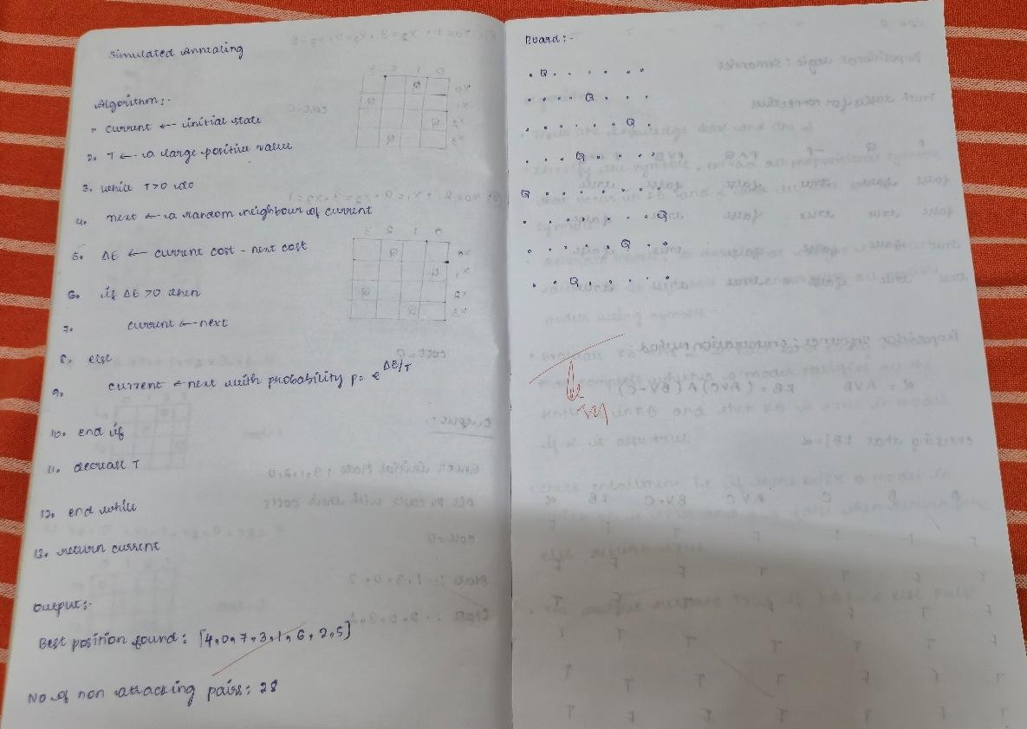
Code:
import random
import math

def cost(state):
"""Calculate number of attacking pairs in the state.""" attacks = 0
n = len(state) for i in range(n):
for j in range(i + 1, n):
if state[i] == state[j] or abs(state[i] - state[j]) == abs(i - j): attacks += 1
return attacks
def get_neighbor(state):
"""Generate a neighbor by swapping two random positions.""" neighbor = state[:]
i, j = random.sample(range(len(state)), 2) neighbor[i], neighbor[j] = neighbor[j], neighbor[i] return neighbor

def simulated_annealing(n=8, max_iter=10000, temp=100.0, cooling=0.95): """Perform simulated annealing to solve N-Queens."""
current = list(range(n)) random.shuffle(current)

current_cost = cost(current)

temperature = temp cooling_rate = cooling

best = current[:] best_cost = current_cost

for _ in range(max_iter):
if temperature <= 0 or best_cost == 0: break

neighbor = get_neighbor(current) neighbor_cost = cost(neighbor) delta = current_cost - neighbor_cost

if delta > 0 or random.random() < math.exp(delta / temperature): current, current_cost = neighbor, neighbor_cost
if neighbor_cost < best_cost:
best, best_cost = neighbor[:], neighbor_cost temperature *= cooling_rate
return best, best_cost

def print_board(state):
"""Print the board in a readable format.""" n = len(state)
for row in range(n):
line = " ".join("Q" if state[col] == row else "." for col in range(n)) print(line)
print()

if name == " main ": n = 8
solution, cost_val = simulated_annealing(n, max_iter=20000)

print("Best position found:", solution)
print(f"Number of non-attacking pairs: {n*(n-1)//2 - cost_val}") print("\nBoard:")
print_board(solution)

Output:

Best position found: [4, 0, 7, 3, 1, 6, 2, 5] Number of non-attacking pairs: 28

Board:
. Q . . . . . .
. . . . Q . . .
. Q .
. . . Q . . . .
Q . . . . . . .
. Q
. . . . . Q . .
. . Q . . . . .

Program 6
Create a knowledge base using propositional logic and show that the given query entails the knowledge base or not.

Algorithm:

Code:
from itertools import product

# --- Utility to parse logical expressions safely ---
def eval_formula(expr, model):
# Replace propositional symbols with model values
for sym, val in model.items():
expr = expr.replace(sym, str(val))

# Replace logical operators with Python equivalents
expr = expr.replace("¬", " not ") expr = expr.replace("∧", " and ") expr = expr.replace("∨", " or ")
expr = expr.replace("→", " <= ") # A → B ≡ (not A) or B
expr = expr.replace("↔", " == ") # A ↔ B ≡ (A == B)

return eval(expr)

# --- Main program ---
print("Available logical operators you can use in input formulas:") print(" Negation (NOT): ¬")
print(" Conjunction (AND): ∧") print(" Disjunction (OR): ∨") print(" Implication (IMPLIES): →") print(" Biconditional (IFF): ↔") print("-" * 50)

symbols = input("Enter symbols separated by space (e.g., P Q R): ").split()

kb_expr = input("Enter Knowledge Base formula (e.g., (P ∧ Q) → R): ") query_expr = input("Enter Query formula α (e.g., R): ")
print("\nKnowledge Base (KB):", kb_expr) print("Query (α):", query_expr, "\n")

# Function to print truth table
def print_truth_table(kb_expr, query_expr, symbols): header = symbols + ["KB", "α"]
print(" | ".join(f"{h:^5}" for h in header))
print("-" * (7 * len(header)))

for values in product([False, True], repeat=len(symbols)): model = dict(zip(symbols, values))
kb_val = eval_formula(kb_expr, model) q_val = eval_formula(query_expr, model)
row = [model[s] for s in symbols] + [kb_val, q_val] print(" | ".join(f"{str(r):^5}" for r in row))
# Entailment check
def entails(kb_expr, query_expr, symbols):
for values in product([True, False], repeat=len(symbols)): model = dict(zip(symbols, values))
if eval_formula(kb_expr, model): # KB true
if not eval_formula(query_expr, model): # Query false → not entailed
return False return True

# Run
print_truth_table(kb_expr, query_expr, symbols) result = entails(kb_expr, query_expr, symbols) print("\nDoes KB entail Query (α)? :", result)

Output:
Available logical operators you can use in input formulas: Negation (NOT): ¬
Conjunction (AND): ∧ Disjunction (OR): ∨ Implication (IMPLIES): → Biconditional (IFF): ↔

Enter symbols separated by space (e.g., P Q R): A B C
Enter Knowledge Base formula (e.g., (P ∧ Q) → R): (A∨C) ∧ (B∨¬C)
Enter Query formula α (e.g., R): A ∨ B
Knowledge Base (KB): (A∨C) ∧ (B∨¬C)

Query (α): A ∨ B
A | B | C | KB | α

False | False | False | False | False False | False | True | False | False False | True | False | False | True False | True | True | True | True True | False | False | True | True True | False | True | False | True True | True | False | True | True True | True | True | True | True

Does KB entail Query (α)? : True

Program 7
Implement unification in first order logic Algorithm:
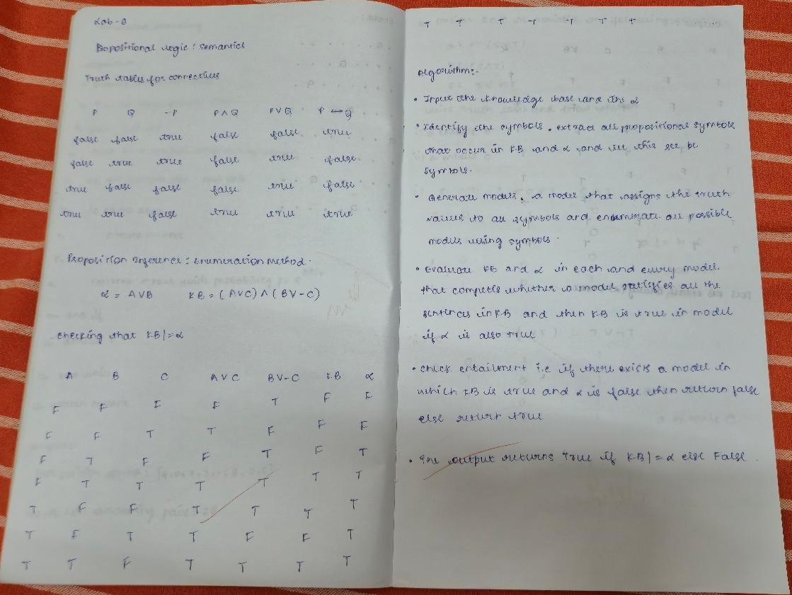

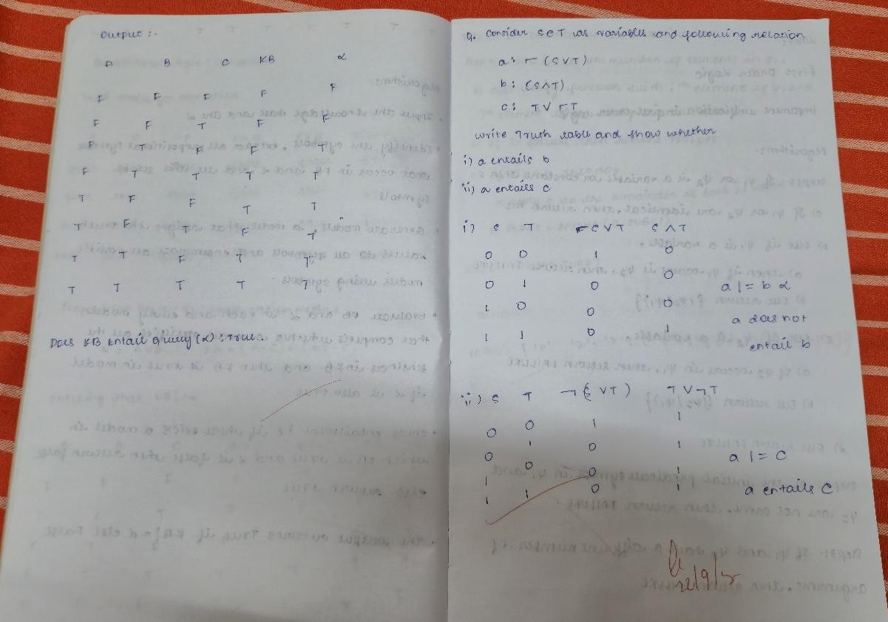
Code:

def unify(x, y, substitutions=None):
if substitutions is None: substitutions = {}

if x == y:
return substitutions

# If x is a variable
if is_variable(x):
return unify_var(x, y, substitutions)
# If y is a variable
if is_variable(y):
return unify_var(y, x, substitutions)

# If both are compound terms (like f(a), g(X), etc.)
if isinstance(x, tuple) and isinstance(y, tuple): if x[0] != y[0] or len(x[1]) != len(y[1]):
return None
for xi, yi in zip(x[1], y[1]):
substitutions = unify(apply(substitutions, xi), apply(substitutions, yi), substitutions) if substitutions is None:
return None

return substitutions return None

def unify_var(var, x, substitutions): if var in substitutions:
return unify(substitutions[var], x, substitutions) elif occurs_check(var, x, substitutions):
return None else:
substitutions[var] = x return substitutions

def occurs_check(var, x, substitutions): if var == x:
return True
elif isinstance(x, tuple):
return any(occurs_check(var, xi, substitutions) for xi in x[1]) elif isinstance(x, str) and x in substitutions:
return occurs_check(var, substitutions[x], substitutions) return False

def apply(substitutions, expr): if isinstance(expr, str):
return substitutions.get(expr, expr) elif isinstance(expr, tuple):
return (expr[0], [apply(substitutions, e) for e in expr[1]]) else:
return expr

def is_variable(x):
# A variable is a single lowercase letter (e.g., x, y, z)
return isinstance(x, str) and len(x) == 1 and x.islower()

def parse(expr):
expr = expr.replace(" ", "") if '(' not in expr:
return expr
functor = expr.split('(')[0]
args = expr[len(functor) + 1:-1] parts, depth, start = [], 0, 0
for i, c in enumerate(args): if c == ',' and depth == 0:

parts.append(args[start:i]) start = i + 1
elif c == '(': depth += 1
elif c == ')': depth -= 1
parts.append(args[start:])
return (functor, [parse(p) for p in parts])

# -------- TEST CASES --------
tests = [
("p(b,x,f(g(z)))", "p(z,f(y),f(y))"), # fixed the extra parenthesis
("Q(a,g(x,a),f(y))", "Q(a,g(f(b),a),x)"), ("p(f(a),g(Y))", "p(X,X)"),
("prime(11)", "prime(y)"),
("knows(John,x)", "knows(y,mother(y))"),
("knows(John,x)", "knows(y,Bill)")
]

print(" UNIFICATION RESULTS \n")
for i, (a, b) in enumerate(tests, start=1): e1 = parse(a)
e2 = parse(b)
result = unify(e1, e2) print(f"Q{i}: {a} AND {b}") if result is None:
print("MGU = FAIL\n") else:
print("MGU =", result, "\n")

Output:

UNIFICATION RESULTS

Q1: p(b,x,f(g(z))) AND p(z,f(y),f(y)) MGU = {'b': 'z', 'x': ('f', ['y']), 'y': ('g', ['z'])}

Q2: Q(a,g(x,a),f(y)) AND Q(a,g(f(b),a),x)
MGU = {'x': ('f', ['b']), 'y': 'b'}

Q3: p(f(a),g(Y)) AND p(X,X) MGU = FAIL

Q4: prime(11) AND prime(y) MGU = {'y': '11'}

Q5: knows(John,x) AND knows(y,mother(y)) MGU = {'y': 'John', 'x': ('mother', ['John'])}

Q6: knows(John,x) AND knows(y,Bill) MGU = {'y': 'John', 'x': 'Bill'}

Program 8
Create a knowledge base consisting of first order logic statements and prove the given query using forward reasoning.

Algorithm:
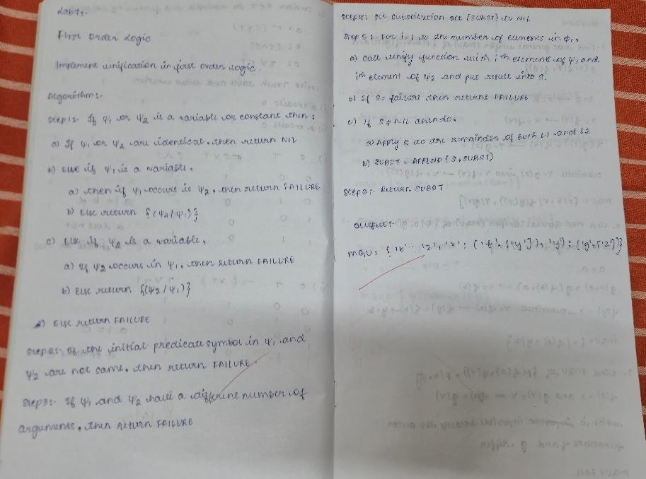
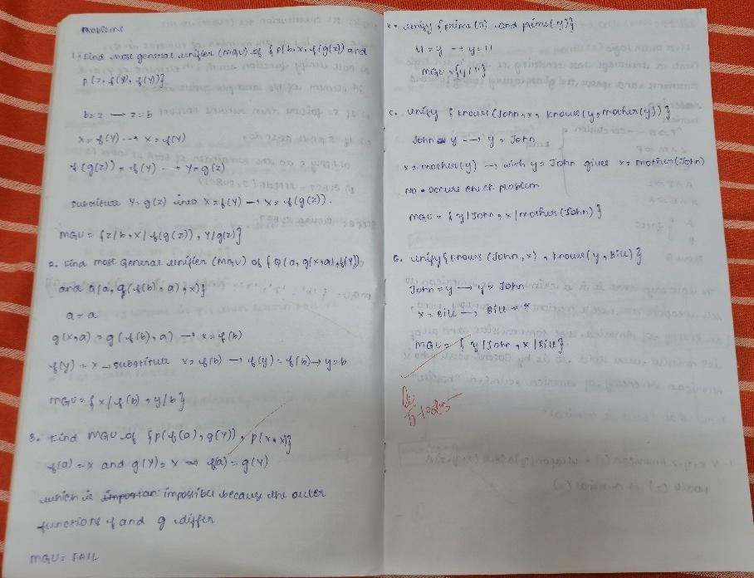

Code:
import re

def match_pattern(pattern, fact):
pat_pred, pat_args = re.match(r'(\w+)', pattern).groups() fact_pred, fact_args = re.match(r'(\w+)', fact).groups()

# Predicate names must match
if pat_pred != fact_pred: return None

pat_args = [a.strip() for a in pat_args.split(",")] fact_args = [a.strip() for a in fact_args.split(",")]

if len(pat_args) != len(fact_args): return None

subst = {}
for p_arg, f_arg in zip(pat_args, fact_args):
# Variables are lowercase identifiers (e.g., p, x, y)
if re.fullmatch(r'[a-z]\w*', p_arg): subst[p_arg] = f_arg
elif p_arg != f_arg: return None
return subst

def apply_substitution(expr, subst): for var, val in subst.items():
expr = re.sub(rf'\b{var}\b', val, expr) return expr

rules = [
(["American(p)", "Weapon(q)", "Sells(p,q,r)", "Hostile(r)"], "Criminal(p)"), (["Missile(x)"], "Weapon(x)"),
(["Enemy(x, America)"], "Hostile(x)"),
(["Missile(x)", "Owns(A, x)"], "Sells(Robert, x, A)")
]

facts = { "American(Robert)", "Enemy(A, America)",
"Owns(A, T1)",
"Missile(T1)"

}

goal = "Criminal(Robert)"

def forward_chain(rules, facts, goal): added = True
while added: added = False
for premises, conclusion in rules: possible_substs = []

# Check each premise of the rule
for p in premises: matched = False for f in facts:
subst = match_pattern(p, f) if subst:
possible_substs.append(subst) matched = True
break
if not matched:
break # one premise fails → skip rule
else:
# Combine substitutions into one dictionary
combined = {}
for s in possible_substs: combined.update(s)
new_fact = apply_substitution(conclusion, combined) if new_fact not in facts:
facts.add(new_fact) print(f"Inferred: {new_fact}") added = True
if new_fact == goal: return True
return goal in facts

print("Goal achieved:", forward_chain(rules, facts, goal))

Output:
Inferred: Weapon(T1)
Inferred: Hostile(A)
Inferred: Sells(Robert, T1, A) Inferred: Criminal(Robert)

Goal achieved: True

Program 9
Create a knowledge base consisting of first order logic statements and prove the given query using Resolution

Algorithm:
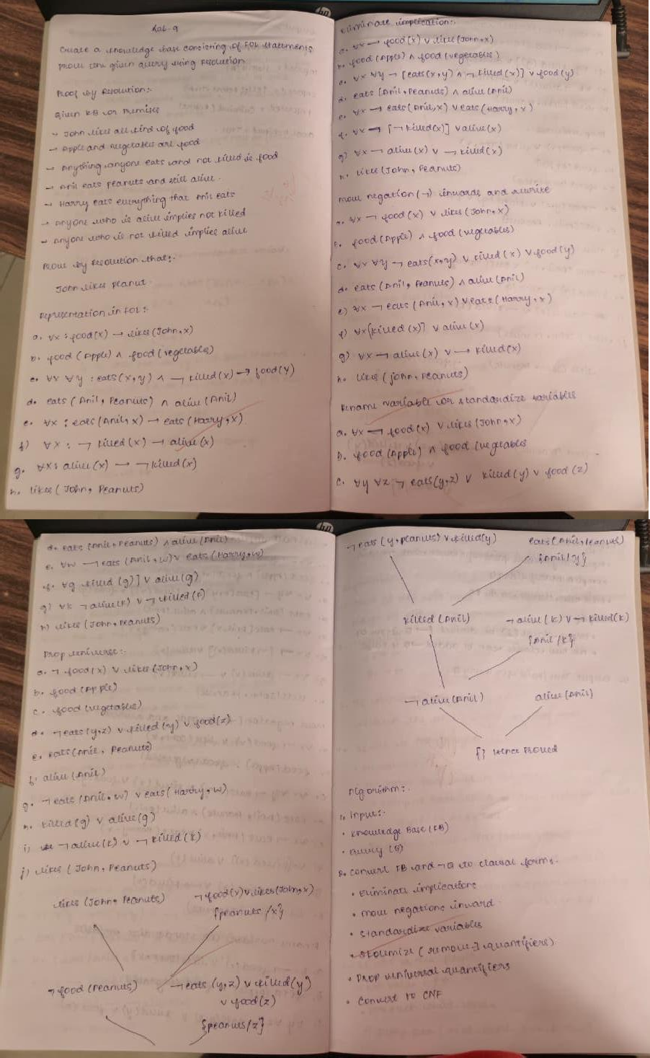

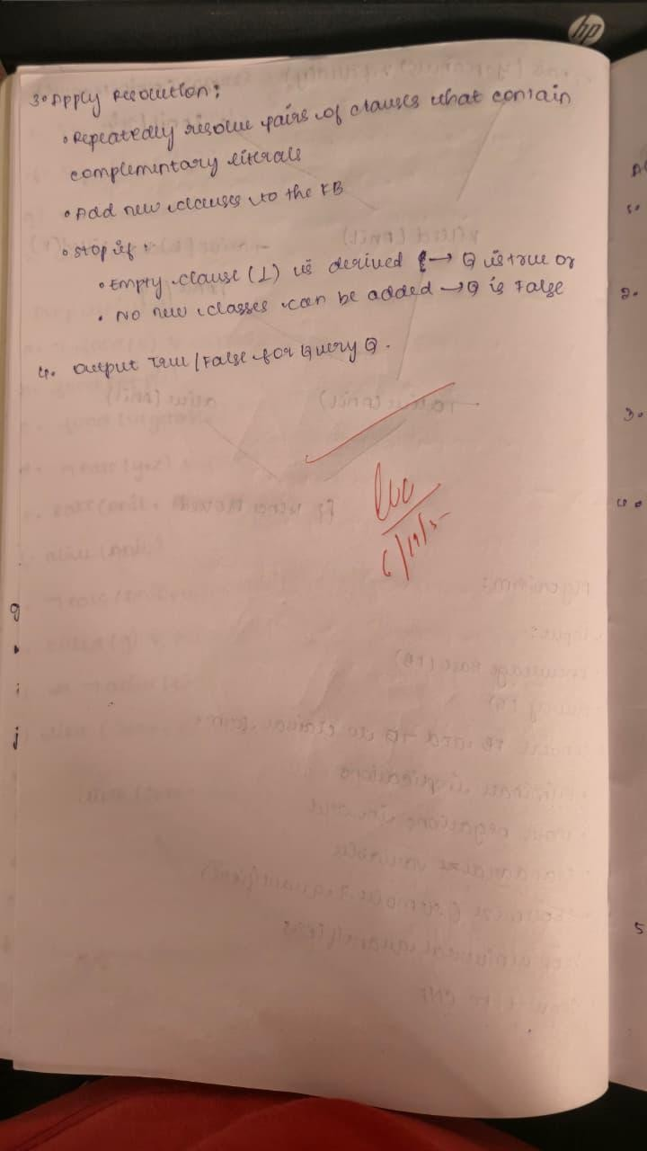

Code:
import re
import copy

def init (self, predicate_string): self.predicate_string = predicate_string.strip()
self.name, self.arguments, self.negative = self.parse_predicate(self.predicate_string) def parse_predicate(self, predicate_string):
s = predicate_string.strip() neg = False
while s.startswith('~'): neg = not neg
s = s[1:].strip()
m = re.match(r"^([A-Za-z_][A-Za-z0-9_]*)$", s) if not m:
raise ValueError(f"Invalid predicate: {predicate_string}") name, args = m.groups()
args = [a.strip() for a in args.split(",") if a.strip() != ""] return name, args, neg

def negate(self):
self.negative = not self.negative
self.predicate_string = ("~" if self.negative else "") + self.name + "(" + ",".join(self.arguments) +
")"

def unify_with_predicate(self, other):
if self.name != other.name or len(self.arguments) != len(other.arguments): return False
subs = {}

def is_var(x):
return len(x) > 0 and x[0].islower()

for a, b in zip(self.arguments, other.arguments): if a == b:
continue
if is_var(a) and is_var(b):
if a in subs and subs[a] != b: return False
if b in subs and subs[b] != a: return False
subs[a] = b

elif is_var(a):
if a in subs and subs[a] != b: return False
subs[a] = b elif is_var(b):
if b in subs and subs[b] != a: return False
subs[b] = a else:
return False return subs

def substitute(self, subs):
self.arguments = [subs.get(a, a) for a in self.arguments]
self.predicate_string = ("~" if self.negative else "") + self.name + "(" + ",".join(self.arguments) +
")"

def repr (self):
return self.predicate_string

def eq (self, other):
return isinstance(other, Predicate) and self.name == other.name and self.arguments == other.arguments and self.negative == other.negative

def hash (self):
return hash((self.name, tuple(self.arguments), self.negative))

class Statement:
def init (self, statement_string): self.statement_string = statement_string.strip()
self.predicate_set = self.parse_statement(self.statement_string)

def parse_statement(self, statement_string):
parts = [p.strip() for p in statement_string.split('|') if p.strip() != ''] predicates = [Predicate(p) for p in parts]
return frozenset(predicates)

def add_statement_to_KB(self, KB, KB_HASH): if self in KB:
return KB.add(self)
for predicate in self.predicate_set: key = predicate.name
if key not in KB_HASH: KB_HASH[key] = set()
KB_HASH[key].add(self)

def get_resolving_clauses(self, KB_HASH): resolving_clauses = set()
for predicate in self.predicate_set: key = predicate.name
if key in KB_HASH:
resolving_clauses |= KB_HASH[key] return resolving_clauses

def resolve(self, other): new_statements = set()
for p1 in self.predicate_set:
for p2 in other.predicate_set:
if p1.name == p2.name and p1.negative != p2.negative: subs = p1.unify_with_predicate(p2)
if subs is False: continue
new_pred_set = set()
for pred in (set(self.predicate_set) | set(other.predicate_set)): if pred == p1 or pred == p2:
continue
pred_copy = copy.deepcopy(pred) pred_copy.substitute(subs) new_pred_set.add(pred_copy)
if not new_pred_set:
return False # contradiction (empty clause) sorted_preds = sorted([str(p) for p in new_pred_set]) new_stmt = Statement('|'.join(sorted_preds)) new_statements.add(new_stmt)
return new_statements

def repr (self):
sorted_preds = sorted([str(p) for p in self.predicate_set]) return '|'.join(sorted_preds)

def eq (self, other):
return isinstance(other, Statement) and self.predicate_set == other.predicate_set

def hash (self):
return hash(self.predicate_set) def fol_to_cnf_clauses(sentence):
sentence = sentence.replace(' ', '') if '=>' in sentence:
lhs, rhs = sentence.split('=>')
parts = [p for p in lhs.split('&') if p != ''] negated_lhs = []

for p in parts:
if p.startswith('~'): negated_lhs.append(p[1:])
else:
negated_lhs.append('~' + p) disjunction = '|'.join(negated_lhs + [rhs]) return [disjunction]
if '&' in sentence:
return [c for c in sentence.split('&') if c != ''] return [sentence]

KILL_LIMIT = 8000

def prepare_knowledgebase(fol_sentences): KB = set()
KB_HASH = {}
for sentence in fol_sentences:
clauses = fol_to_cnf_clauses(sentence) for clause in clauses:
stmt = Statement(clause) stmt.add_statement_to_KB(KB, KB_HASH)
return KB, KB_HASH

def FOL_Resolution(KB, KB_HASH, query, verbose=True): KB = set(KB)
KB_HASH = {k: set(v) for k, v in KB_HASH.items()}

query.add_statement_to_KB(KB, KB_HASH) if verbose:
print("\nInitial KB clauses (including negated query):") for s in KB:
print(" ", s)

iterations = 0 while True:
iterations += 1
if len(KB) > KILL_LIMIT:
if verbose:
print("Reached KILL_LIMIT, stopping.") return False
new_statements = set() kb_list = list(KB)
for s1 in kb_list:
for s2 in s1.get_resolving_clauses(KB_HASH): if s1 == s2:
continue
resolvents = s1.resolve(s2)

if resolvents is False: if verbose:
print(f"\nCONTRADICTION derived by resolving:\n {s1}\n {s2}\n=> empty clause (proof found).")
return True new_statements |= resolvents
if new_statements.issubset(KB): if verbose:
print("\nNo new clauses derived. Resolution failed (query not proved).") return False
added = new_statements - KB if verbose and added:
print(f"\nIteration {iterations}: Derived {len(added)} new clause(s):") for st in sorted(added, key=lambda x: str(x)):
print(" ", st) for st in added:
st.add_statement_to_KB(KB, KB_HASH)

def main(): fol_sentences = [
"Food(x) => Likes(John,x)", "Food(Apple)", "Food(Vegetables)", "Eats(p,y)&~Killed(y) => Food(y)", "Eats(Anil,Peanuts)", "Alive(Anil)",
"Eats(Anil,y) => Eats(Harry,y)", "Alive(x) => ~Killed(x)", "~Killed(x) => Alive(x)"
]

goal = "Likes(John,Peanuts)"
KB, KB_HASH = prepare_knowledgebase(fol_sentences) neg_goal_pred = Predicate(goal)
neg_goal_pred.negate()
neg_goal_stmt = Statement(str(neg_goal_pred))
proved = FOL_Resolution(KB, KB_HASH, neg_goal_stmt, verbose=True)
print("\nResult: Query 'John likes peanuts' is", "TRUE (proved)" if proved else "FALSE (not proved)")

if name == " main ": main()

Output:

Initial KB clauses (including negated query): Alive(x)|Killed(x)
~Alive(x)|~Killed(x)
~Likes(John,Peanuts) Food(Apple) Alive(Anil) Eats(Anil,Peanuts) Food(Vegetables) Likes(John,x)|~Food(x)
Eats(Harry,y)|~Eats(Anil,y) Food(y)|Killed(y)|~Eats(p,y)

Iteration 1: Derived 13 new clause(s): Alive(x)|~Alive(x) Eats(Harry,Peanuts) Food(Peanuts)|Killed(Peanuts) Food(x)|~Alive(x)|~Eats(p,x) Food(y)|Killed(y)|~Eats(Anil,y) Food(y)|~Alive(y)|~Eats(p,y) Killed(x)|Likes(John,x)|~Eats(p,x) Killed(x)|~Killed(x) Killed(y)|Likes(John,y)|~Eats(p,y) Likes(John,Apple) Likes(John,Vegetables)
~Food(Peanuts)
~Killed(Anil)

Iteration 2: Derived 23 new clause(s): Alive(x) Food(Anil)|~Eats(Anil,Anil) Food(Anil)|~Eats(p,Anil) Food(Peanuts)|~Alive(Peanuts) Food(x)|Killed(x)|~Eats(Anil,x) Food(x)|Killed(x)|~Eats(p,x) Food(x)|~Alive(x)|~Eats(Anil,x) Food(x)|~Eats(p,x) Food(y)|~Alive(y)|~Eats(Anil,y) Killed(Peanuts) Killed(Peanuts)|Likes(John,Peanuts) Killed(Peanuts)|~Eats(Anil,Peanuts) Killed(Peanuts)|~Eats(p,Peanuts) Killed(x) Killed(x)|Likes(John,x)|~Eats(Anil,x) Killed(y)|Likes(John,y)|~Eats(Anil,y)

Likes(John,Anil)|~Eats(p,Anil) Likes(John,x)|~Alive(x)|~Eats(p,x) Likes(John,x)|~Eats(p,x) Likes(John,y)|~Alive(y)|~Eats(p,y)
~Alive(Peanuts)|~Eats(p,Peanuts)
~Alive(x)
~Killed(x)

CONTRADICTION derived by resolving: Killed(x)
Killed(x)|~Killed(x)
=> empty clause (proof found).

Result: Query 'John likes peanuts' is TRUE (proved)

Program 10
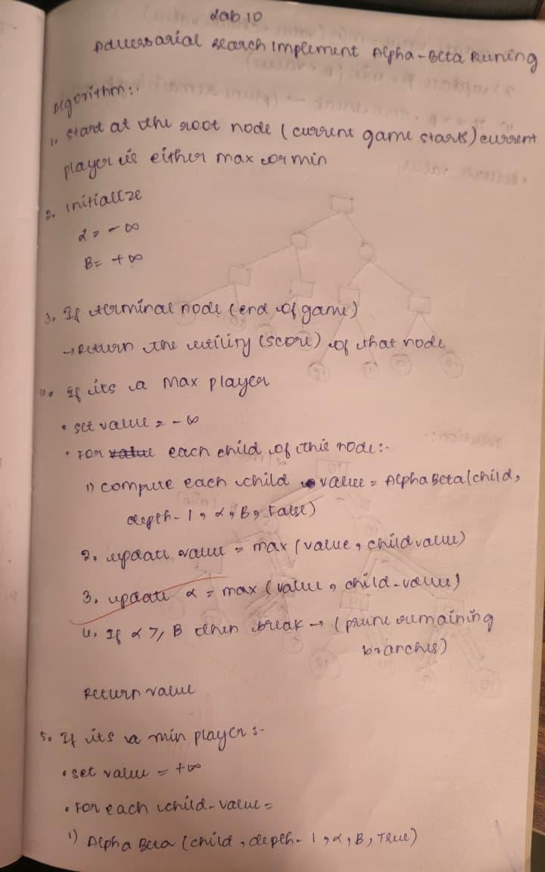
Implement Alpha-Beta Pruning. Algorithm:

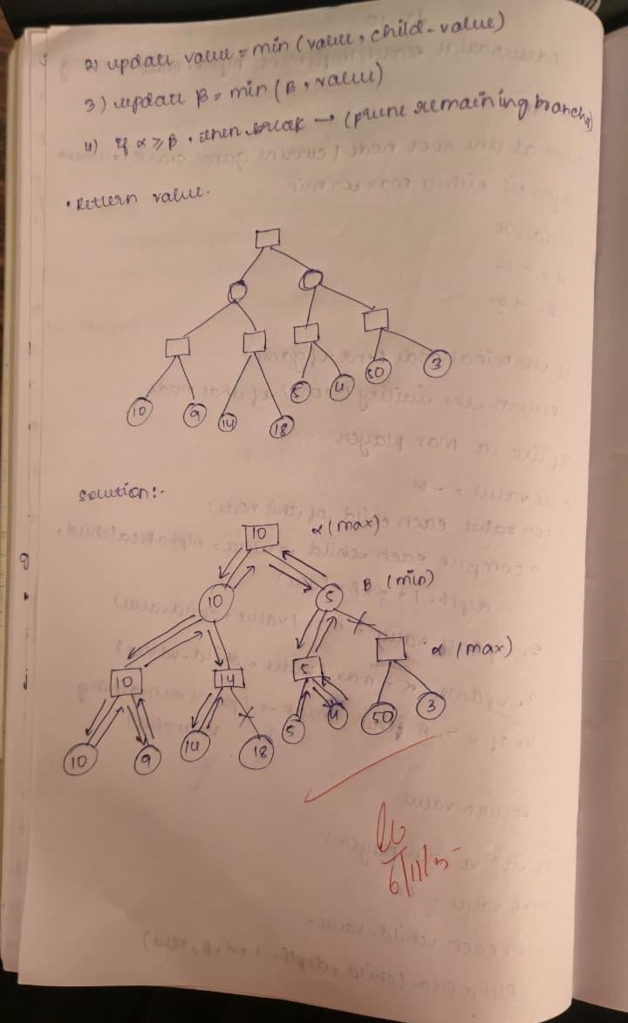

Code:
from typing import List, Optional, Tuple import math

class Node:
def init (self, name: str, children: Optional[List["Node"]] = None, value: Optional[int] = None): self.name = name
self.children = children or [] self.value = value

def is_leaf(self):
return self.value is not None

def repr (self): if self.is_leaf():
return f"{self.name}({self.value})" return f"{self.name}"
EXPANSION_ORDER: List[str] = []
PRUNED_SUBTREES: List[Tuple[str, List[str]]] = []

def alpha_beta(node: Node,
alpha: float, beta: float,
maximizing_player: bool,
path: Optional[List[str]] = None) -> Tuple[float, List[str]]: if path is None:
path = []
path = path + [node.name] if node.is_leaf():
EXPANSION_ORDER.append(node.name) return node.value, path
EXPANSION_ORDER.append(node.name) if maximizing_player:
value = -math.inf best_path: List[str] = [] for child in node.children:
if value >= beta:
PRUNED_SUBTREES.append((child.name, path + [child.name])) continue

child_val, child_path = alpha_beta(child, alpha, beta, False, path) if child_val > value:
value = child_val best_path = child_path

alpha = max(alpha, value) return value, best_path
else:
value = math.inf best_path: List[str] = [] for child in node.children:
if value <= alpha:
PRUNED_SUBTREES.append((child.name, path + [child.name])) continue

child_val, child_path = alpha_beta(child, alpha, beta, True, path) if child_val < value:
value = child_val best_path = child_path
beta = min(beta, value) return value, best_path
def build_example_tree() -> Node: L_D1 = Node("D1", value=3) L_D2 = Node("D2", value=5) L_E1 = Node("E1", value=6) L_E2 = Node("E2", value=9)

L_F1 = Node("F1", value=1) L_F2 = Node("F2", value=2) L_G1 = Node("G1", value=0) L_G2 = Node("G2", value=-1)

L_I1 = Node("I1", value=4) L_I2 = Node("I2", value=7) L_J1 = Node("J1", value=8) L_J2 = Node("J2", value=-2)

D = Node("D", children=[L_D1, L_D2]) # 5
E = Node("E", children=[L_E1, L_E2]) # 9

F = Node("F", children=[L_F1, L_F2]) # 2
G = Node("G", children=[L_G1, L_G2]) # 0

I = Node("I", children=[L_I1, L_I2]) # 7
J = Node("J", children=[L_J1, L_J2]) # 8

B = Node("B", children=[D, E]) # min(5,9)=5
C = Node("C", children=[F, G]) # min(2,0)=0
H = Node("H", children=[I, J]) # min(7,8)=7

A = Node("A", children=[B, C, H]) # MAX root
return A

def evaluate_child_without_polluting_trace(child: Node, root_name: str) -> float:

global EXPANSION_ORDER, PRUNED_SUBTREES
saved_exp = EXPANSION_ORDER.copy() saved_pruned = PRUNED_SUBTREES.copy()

# Clear globals for a clean evaluation EXPANSION_ORDER.clear() PRUNED_SUBTREES.clear()
val, _ = alpha_beta(child, alpha=-math.inf, beta=math.inf, maximizing_player=False, path=[root_name])
EXPANSION_ORDER.clear()
EXPANSION_ORDER.extend(saved_exp) PRUNED_SUBTREES.clear()
PRUNED_SUBTREES.extend(saved_pruned)

return val
def run_demo():
global EXPANSION_ORDER, PRUNED_SUBTREES EXPANSION_ORDER = []
PRUNED_SUBTREES = []

root = build_example_tree() child_values = []
for child in root.children:
val = evaluate_child_without_polluting_trace(child, root.name) child_values.append((child.name, val))
best_child_name, best_child_val = max(child_values, key=lambda x: x[1]) print(f"Best move for MAX: {best_child_name} (value = {best_child_val})\n") EXPANSION_ORDER = []
PRUNED_SUBTREES = []
root_value, best_path = alpha_beta(root, alpha=-math.inf, beta=math.inf, maximizing_player=True)

print("Alpha-Beta Pruning Demo (root is MAX):\n") print(f"Root value computed: {root_value}")
print(f"Best path from root to leaf (names): {' -> '.join(best_path)}")

print("\nNodes expanded in visit order:") print(" ", " , ".join(EXPANSION_ORDER))

if PRUNED_SUBTREES:
print("\nPruned subtrees (roots and their path from root):") for name, path in PRUNED_SUBTREES:
print(f" Pruned subtree root: {name}, path: {' -> '.join(path)}")
else:
print("\nNo pruning occurred for this ordering.")

# Also display per-child values (useful to see why that child was chosen)
print("\nImmediate child values at root (MIN nodes evaluated):") for name, val in child_values:
print(f" Child {name}: {val}")

if name == " main ": run_demo()

Output:
