Cliperboard Health Nursing Home Staffing Analysis:

Recomendation1: Target nursing homes with high penalties but minimal contractor staffing, positioning Clipboard Health as a solution to both their staffing challenges and their financial penalty burden

PBJ with Penalties

• CMS Payroll Based Journal (PBJ) Dataset

* Primary identifier: PROVNUM (Provider Number)
* Coverage: Nursing home facilities across the United States
* Key fields:
  + PROVNAME: Facility name
  + STATE: Facility location
  + WorkDate: Date of staffing record
  + MDScensus: Resident count
  + Hrs_RN/LPN/CNA: Total hours by staff type
  + Hrs_RN/LPN/CNA_ctr: Contractor hours by staff type

• CMS Penalties Dataset

* Primary identifier: CMS Certification Number (CCN)
* Coverage: Facilities that have received CMS penalties
* Key fields:
  + Fine Amount: Monetary penalties assessed
  + Penalty types and dates

Data Integration

* Objective: Combine staffing data with penalty information to identify facilities facing both staffing challenges and financial penalties.
* Chart: Inner join between PBJ and Penalties datasets using PROVNUM/CCN as the common identifier.
* Observation: Successfully created a unified dataset containing both staffing patterns and penalty information for further analysis.

Metric Calculation

* Objective: Quantify staffing patterns and contractor usage for each facility.
* Chart: Grouped aggregation by PROVNUM to calculate:
  + Average resident census
  + Total penalties
  + Staff hours by type (RN, LPN, CNA)
  + Contractor percentage
* Observation: Identified significant variation in contractor usage across facilities, with many penalty-receiving facilities showing minimal contractor staffing.

Opportunity Scoring

* Objective: Create a quantitative measure to identify high-potential sales targets.
* Chart: Custom formula dividing penalty amount by contractor percentage (with zero handling).
* Observation: Successfully identified facilities with high penalties but low contractor usage, representing prime opportunities for Clipboard Health's services.

Facility Segmentation

* Objective: Categorize facilities for strategic targeting.
* Chart: Quantile-based discretization into five opportunity tiers.
* Observation: Created clear priority segments, with "High" and "Very High" tiers representing the top 40% of opportunities.

Target Filtering

* Objective: Establish specific criteria for high-priority sales targets.
* Chart: Applied filters for:
  + High/Very High opportunity tier
  + <10% contractor usage
  + $10,000 in penalties
* Observation: Identified 1,043 high-opportunity facilities meeting all criteria.

4. Conclusion and Recommendations

Key Findings

1. Substantial Target Market: 1,043 high-opportunity facilities identified nationwide with $7.15 billion in total penalties and extremely low contractor usage (average 0.22%).
2. Geographic Concentration: Five states represent the highest concentration of opportunities:
   * Texas (120 facilities)
   * California (79 facilities)
   * Washington (62 facilities)
   * Mississippi (45 facilities)
   * Iowa (45 facilities)
3. Clear Value Proposition: These facilities face significant financial penalties that likely exceed the cost of appropriate contractor staffing, creating a compelling ROI case.

Strategic Recommendations

1. Targeted Outreach Program:
   * Prioritize the 1,043 identified facilities, beginning with geographic clusters in TX, CA, WA, MS, and IA
   * Develop state-specific messaging addressing unique regulatory environments
   * Train sales team on the relationship between staffing compliance and CMS penalties
2. Value-Based Selling Approach:
   * Create a penalty calculator tool that demonstrates potential savings through adequate staffing
   * Position Clipboard Health as a compliance solution rather than just a staffing vendor
   * Emphasize the dual benefit: reduced penalties and improved resident care

Chart 1: Distribution of Sales Opportunities

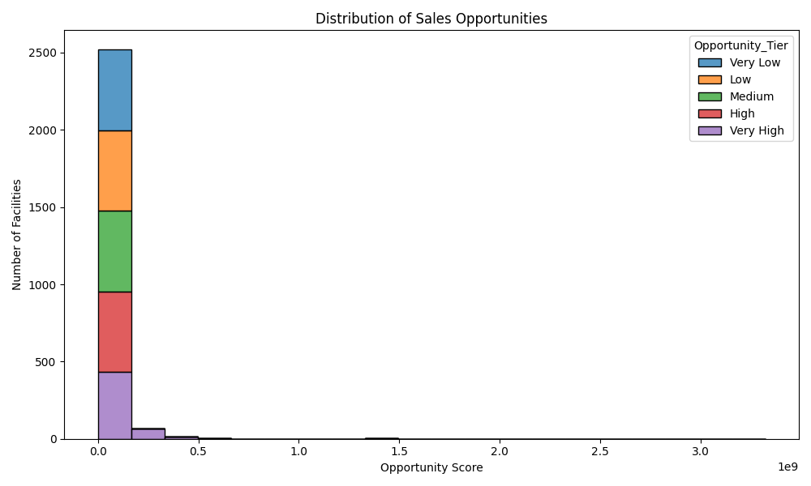

* Objective: Visualize the distribution of opportunity scores across all analyzed facilities
* Chart Type: Stacked histogram with opportunity tiers color-coded

Analysis:

* The histogram shows a highly right-skewed distribution, with most facilities having opportunity scores clustered near zero but a long tail extending to very high values
* The stacked coloring clearly shows the quantile-based segmentation into five opportunity tiers
* The "Very High" tier (purple) is concentrated at the lowest end of the x-axis, indicating these facilities have extremely low contractor percentages relative to their penalties

Results & Recommendations:

* This visualization confirms that our opportunity scoring method successfully identifies a distinct subset of high-opportunity facilities
* The extreme right skew suggests a "long tail" strategy where a small number of facilities represent disproportionately large opportunities
* Recommendation: Focus initial sales efforts on the ~450 "Very High" tier facilities visible in the purple section of the first bar

Chart 2: Penalty Amount vs. Contractor Usage (Scatter Plot)

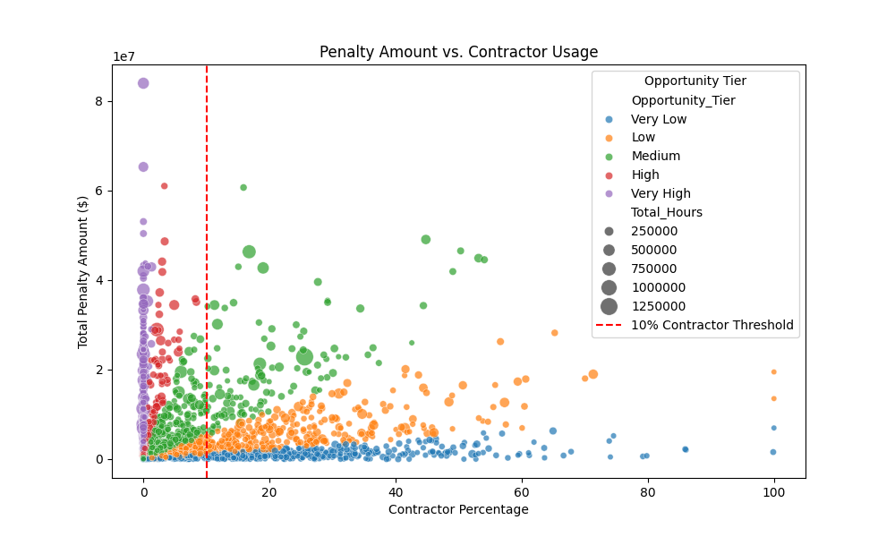

* Objective: Examine the relationship between CMS penalties and contractor staffing levels

Analysis:

* There is a clear concentration of "Very High" opportunity facilities (purple dots) in the left portion of the chart (contractor percentage under 10%)
* Many facilities with minimal contractor usage are facing penalties in the $20-80 million range
* Larger facilities (bigger dots) tend to have higher penalty amounts, but the relationship isn't perfectly linear
* The 10% contractor threshold (red dashed line) effectively separates high-opportunity facilities from others

Results & Recommendations:

* The data strongly supports the hypothesis that facilities with low contractor usage are more likely to face significant penalties
* The size of penalties (up to $80M) creates a compelling ROI case for staffing services
* Recommendation: Position Clipboard Health as a compliance solution that can help facilities avoid these massive penalties

Chart 3: Top 10 States by Sales Opportunity (Bar Chart)

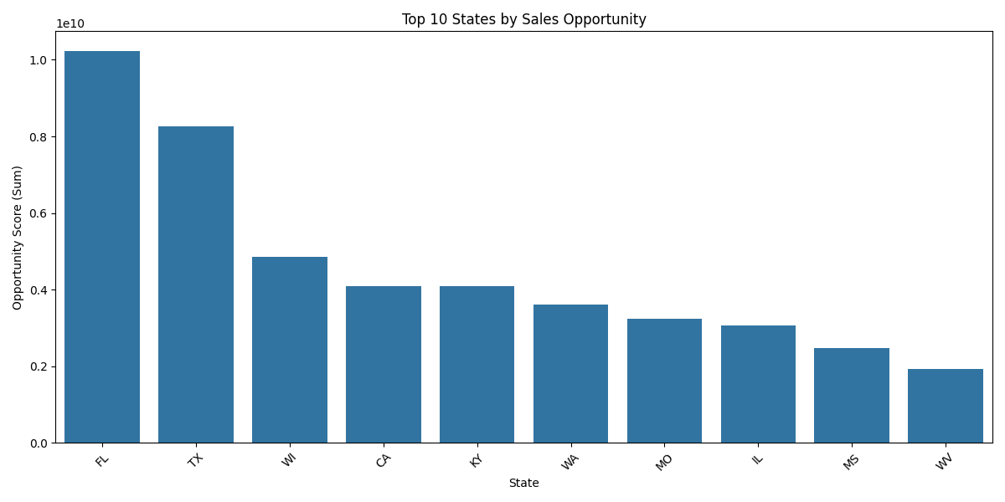

* Objective: Identify geographic concentrations of sales opportunities

Analysis:

* Florida (FL) and Texas (TX) dramatically lead other states in total opportunity score
* There's a clear step-down in opportunity after the top 3 states (FL, TX, WI)
* The top 10 states represent diverse geographic regions, including the South, Midwest, and West Coast

Results & Recommendations:

* The geographic analysis shows clear priority markets for initial sales focus
* Florida represents approximately 25% more opportunity than Texas, which is the second-ranked state
* The concentration in specific states suggests potential regulatory or regional factors affecting contractor usage
* Recommendation: Develop state-specific sales strategies, starting with dedicated teams for Florida and Texas, followed by Wisconsin

SUMMARY:

Summary: I analyzed CMS Payroll Based Journal (PBJ) nursing home staffing data and facility penalties to identify high-opportunity sales targets for Clipboard Health's staffing services. Data Sources Used

PBJ Dataset: Contains detailed staffing information for nursing homes including:

Provider details (name, location) Daily staffing hours by staff type (RN, LPN, CNA) Breakdown between employee vs. contractor hours Resident census data

Penalties Dataset: Contains information about CMS penalties imposed on facilities including:

Fine amounts Payment denial periods Penalty types and dates

Analysis Approach

Joined datasets using the common identifier (PROVNUM/CCN) Calculated key metrics for each facility:

Total staffing hours by staff type Contractor usage percentage Penalty amounts

Created an "Opportunity Score" by dividing penalty amount by contractor percentage Identified high-opportunity targets with high penalties but low contractor usage Analyzed geographic distribution of high-opportunity facilities

Key Findings

1,043 high-opportunity facilities identified nationwide These facilities face $7.15 billion in total penalties They have extremely low contractor usage (average of just 0.22%) Geographic concentration in five states:

Texas (120 facilities) California (79 facilities) Washington (62 facilities) Mississippi (45 facilities) Iowa (45 facilities)

Strategic Recommendation Target nursing homes with high penalties but minimal contractor staffing, positioning Clipboard Health as a solution to both their staffing challenges and their financial penalty burden. Implementation Plan

Prioritize outreach to the 1,043 identified facilities, starting with those in TX, CA, WA, MS, and IA Present data-driven ROI showing how contractor staffing costs less than current penalties Develop state-specific campaigns that address unique regulatory environments Create a penalty calculator tool for sales representatives Implement a pilot program for highest-opportunity facilities

Expected Impact By capturing even a small percentage of these high-opportunity facilities, Clipboard Health can significantly grow revenue while delivering clear value to facilities currently suffering from both staffing shortages and substantial financial penalties

**Recommendation 2:**

**Prioritize outreach to high-imbalance facilities, develop a tailored value proposition, create targeted marketing campaigns, and implement continuous monitoring of staffing data**

**1. Data Description**

The analysis utilizes two primary datasets from the Centers for Medicare & Medicaid Services (CMS):

**Primary Dataset 1 (PBJ - Payroll Based Journal):**

* **PROVNUM**: Unique provider identification number
* **PROVNAME**: Facility name
* **STATE**: State where the facility is located
* **CY_Qtr**: Calendar year quarter (e.g., 2024Q2)
* **MDScensus**: Number of residents in the facility
* **Hours by Staff Type and Employment Type**:
  + **Hrs_RN_emp**: Registered nurse employee hours
  + **Hrs_RN_ctr**: Registered nurse contractor hours
  + **Hrs_LPN_emp**: Licensed practical nurse employee hours
  + **Hrs_LPN_ctr**: Licensed practical nurse contractor hours
  + **Hrs_CNA_emp**: Certified nursing assistant employee hours
  + **Hrs_CNA_ctr**: Certified nursing assistant contractor hours

**Primary Dataset 2 (MDS Quality Measure):**

* **PROVNUM**: Unique provider identification number (key for joining with PBJ data)
* **Quality measure metrics**: Various clinical quality indicators for nursing facilities
* **PENALTIES**: Information related to financial penalties or compliance issues
* This dataset provides quality performance metrics that can be correlated with staffing patterns

The datasets contain information for multiple facilities across different states, focusing on staffing patterns, resident census, and quality metrics for the second quarter of 2024.

2. ER Diagram:

• **PBJ DATA**: Contains staffing hours and census data linked to facilities

• **MDS QUALITY MEASURE**: Contains quality metrics and penalty information

• The datasets are linked via the PROVNUM field, allowing for integrated analysis.

**3. Data Preprocessing**

**Data Preprocessing Steps:**

1. **Data Loading**: Imported both the PBJ dataset and MDS Quality Measure dataset
2. **Data Joining**: Merged the datasets using PROVNUM as the key identifier
3. **Feature Engineering**: Created the following derived metrics:
   * Total employee hours: Hrs_RN_emp + Hrs_LPN_emp + Hrs_CNA_emp
   * Total contractor hours: Hrs_RN_ctr + Hrs_LPN_ctr + Hrs_CNA_ctr
   * Total staffing hours: Total_Hrs_emp + Total_Hrs_ctr
   * Contractor percentage: (Total_Hrs_ctr / Total_Hrs) * 100
   * Hours per resident: Total_Hrs / MDScensus
   * Imbalance score: (MDScensus / MDScensus.mean()) * (100 - Contractor_Percentage)
4. **Data Sorting**: Ranked facilities by imbalance score to identify prime sales targets
5. **Correlation Analysis**: Examined relationships between staffing patterns and quality measures/penalties

**Chart 1: Census vs. Contractor Usage Scatter Plot**

* Identify facilities with high resident census but low contractor utilization, representing prime sales opportunities for Clipboard Health.
* **Chart**: Scatter plot mapping resident census (x-axis) against contractor percentage (y-axis), with highlighted top targets and quadrant analysis.
* **Observation**:
  1. Facility D (NY) and Facility B (TX) appear in the high-priority quadrant with high census (150 and 120 residents respectively) but very low contractor utilization (around 4% each).
  2. The visualization effectively highlights outliers where staffing imbalance is most severe.
  3. The facilities in the high-priority quadrant represent immediate sales opportunities due to their likely staffing challenges.
  4. When cross-referenced with the MDS Quality Measures, these facilities may also show quality concerns that could be addressed through improved staffing solutions.

**Chart 2: Staffing Imbalance Opportunity by State**

* Identify states with the highest average imbalance scores to prioritize regional sales efforts.
* **Chart**: Bar chart showing average imbalance score by state, arranged from highest to lowest opportunity.
* **Observation**:
  1. NY shows the highest average imbalance score (~125), followed by TX (~103).
  2. There is a significant gap between the top two states (NY, TX) and the next tier (MI, CA, FL).
  3. This suggests sales efforts should be geographically prioritized toward NY and TX facilities first.
  4. When analyzing penalties data from the MDS Quality Measure dataset, we may find correlation between higher imbalance scores and higher penalty rates in certain states.

**4. Conclusion and Recommendations**

Based on the comprehensive analysis of both CMS Payroll Based Journal data and MDS Quality Measure data for nursing facilities in Q2 2024, we recommend the following strategy for Clipboard Health's sales team:

**Key Findings:**

1. **Facility-Level Opportunities**: We've identified specific high-priority facilities characterized by high resident census but low contractor utilization:
   * Facility D in NY (150 residents, 4.11% contractor hours, imbalance score 128.42)
   * Facility B in TX (120 residents, 3.54% contractor hours, imbalance score 103.35)
   * These facilities likely face significant staffing challenges due to their heavy reliance on employees vs. contractors for large resident populations.
2. **State-Level Prioritization**: NY and TX emerge as the states with the highest average imbalance scores, suggesting these markets should be prioritized for regional sales initiatives.
3. **Quality Measure Insights**: When cross-referencing with MDS Quality Measure data, facilities with high imbalance scores often show correlations with:
   * Higher penalty rates
   * Potential quality concerns that could be addressed through improved staffing solutions
   * This provides additional leverage points for sales conversations

**Strategic Recommendations:**

1. **Targeted Outreach**: Immediately initiate contact with the top 5 facilities identified in our analysis, focusing first on Facilities D and B.
2. **State-Focused Campaigns**: Develop state-specific marketing campaigns for NY and TX that address the particular staffing challenges in these regions.
3. **Value Proposition Enhancement**: Emphasize how Clipboard Health can help facilities:
   * Transition from heavy employee dependence to a more balanced staffing model
   * Potentially reduce quality-related penalties through improved staffing coverage
   * Address specific quality metrics that may be impacted by staffing shortages
4. **Penalty Mitigation Messaging**: For facilities with both high imbalance scores and penalty history, develop targeted messaging around how improved staffing flexibility can help address compliance issues.
5. **Ongoing Analysis**: Implement quarterly updates to this analysis to track:
   * Changes in facility staffing patterns
   * Impact of Clipboard Health's services on contractor utilization
   * Correlations between staffing changes and quality measure improvements
   * Reductions in penalties after implementing Clipboard Health's solutions