**Chapter 1**

**INTRODUCTION**

This chapter provides an overview of the mobile based smart cashless system. This system can be used by a student in a college for his/her day to day transactions in the college where money is involved.

* 1. **Preamble**

With the current generation of mobile devices like smart phones, Personal Digital Assistants (PDAs) and other consumer devices, the wireless market is expanding very fast. People are using these mobile phones and devices for wide range of applications like mobile banking, location based services, e-learning and others. The situation also brings out a large scope and demand for software applications for such high-end mobile devices. As the power and flexibility of mobile devices increases, there are more architectural options for developing mobile applications, and user’s expectations also increase.

There are various operating systems for the mobiles such as Symbian, BREW, Windows and Android etc. Our aim is to concentrate more on the Android operating system as the aim is to develop an application for android phones. The android operating system was earlier launched in the year 2008. It is a mobile Operating System (OS) based on the Linux kernel and currently developed by Google. With a user interface based on direct manipulation, Android is designed primarily for touch screen mobile devices such as smart phone sand tablet computers, with specialized user interfaces for televisions (Android TV), cars (Android Auto), and wrist watches (Android Wear). The OS uses touch inputs that loosely correspond to real-world actions, like swiping, tapping, pinching, and reverse pinching to manipulate on-screen objects, and a virtual keyboard. Despite being primarily designed for touch screen input, it has also been used in game consoles, digital cameras, regular PCs, and other electronics.

Student have cash involvements in many areas in college. He/She has to pay money in Canteen, Exam section, Library, Society and Hostel. The use of cash presents problems such as waiting for a student to find cash for payment, and time spent by the clerk to count out the exact amount of change to be returned to the student. When the clerk doesn’t have the exact change to render to the customer, then everyone in line must wait while change is being given. These and other problems are created when cash is used and slows down the pace of the business. Few other drawbacks of bringing cash to college are,

* Potential for losing the wallet or having it stolen.
* One may have an emergency and need to make a payment and not have enough cash to do so.
* Potential inconvenience of going and getting to an Automated Teller Machine(ATM).
* May invite theft if you start flashing your money in public.
* Pickpockets and mugging is another issue.

Standing in queues is extremely frustrating for both students and the staff members at peak times of the year. If students are spending their valuable time waiting in queues they might lose their precious opportunities.

Staff must take steps to ensure that when a student pays with a cheque that the cheque is valid. This can be a time consuming process. Many areas of specify cheque by the computer. Sometimes the staff must manually check the name of the student presenting the cheque against a list of students who have passed bad cheques in the past. The staff must verify the identity of the person presenting the cheque, along with their phone number and address. All of these steps that must be taken to ensure that the cheque is valid not only cost the college money, but also inconveniences other students who must wait in line while the staffs makes certain that the check is valid.

* 1. **Literature Survey**

There are a few works reported in the literature on mobile wallete services. Some of them are discussed next:

**1.2.1 Cashless Transaction**

The literature relating to the concept of money is vast and complex. According to Snelders et al. (1992) money is a typical polymorphous concept, i.e. a concept whose definition and boundaries cannot be specified precisely. An outcome of this is that discussion and research is found in numerous disciplines and across numerous perspectives. Underlying the concept of money is the notion that it is a medium of exchange, measure of account, and means of storing and transporting abstract value (Keynes, 1930; Grierson, 1977; Hicks, 1989; Hoover, 1996). As a medium of exchange, it is considered superior to barter in terms of reducing transaction cost. Barter requires an improbable coincidence of wants or events and balancing value. Overcoming this without money requires some system of in-kind credit or gift exchange, restricting trade to those who know one another. Money based transactions differ from barter in that the burden of trust is removed from the participants in the actual transaction and placed on a third party - the issuer of money- usually in the form of a transferable token. In this sense, coins and notes embodied a store of value within a conveniently portable medium of exchange and acceptable means of payments

According to the normative principle of fungiblity- at the point of purchase, a mental accounting is opened and decision to purchase is based on evaluation of perceived benefit and cost of purchases rather than the payment form used (Prelec and Lowenstein, 1998).

People place a material value on cash is evident in hording behaviour and in numismatics. In addition, the commodity theory of money, sees money as a ‘good’ linked to a precious metal (or alternate physical objects) or its convertible paper symbol i.e. “Money is essentially material and tangible; it could be stored and passed from hand to hand- it circulated”.

**1.2.2 Cashless Society**

The research design used in this study is the descriptive survey method. The population of this study is the entire academic community. A sample size of 100 was selected using the convenience sampling procedure. The sample includes both literate and illiterate Nigerians since they are the ones that can respond to determine the reliability of the numeracy of users knowing fully that an average Nigerians can use mobile phones. The method used to collect data for this study is structured questionnaire. A total of 100 copies of the questionnaire were personally administered out of which 87 copies were retrieved in usable form. This represents a response rate of 87%. The responses from the respondents were collated and analyzed using the simple percentage procedure.

A lot has been said about the convenience of electronic cash, the time it saves for individuals, and the ease of access resulting in money being instantly available for us without having to be carried around while currency exchange will be largely unnecessary. A cashless society will experience a high degree of control as the move from cash to electronic money (electronic credit) is a part of a well-organized attempt to unify the world and control it through its currency. It will be a big booster for bringing the economic uniformity in the world. A cashless society will further enhance the globalization that characterize our present time. The computerized systems can be used to reduce the amount of paper trail. Also replacing paper cash with cashless credits or electronic money transfers can at least minimize crime, illegal drug trade, terrorism, illegal immigration, human trafficking, and corruption. A cashless society will go a long way in making our society, and the earth a better place to live, with a reduced rate of criminal activities. Physical paper cash is non-traceable, unaccountable, easy to hide or lose, steal, counterfeit, and spend without a trace. As such, paper cash has allowed all sorts of criminal activity to thrive. However, in a cashless economy, this will change with certain crimes almost eliminated.

Violent crimes such as bank robberies, store holdups, armed robberies, employee cash theft, armour car heists, kidnap for ransom, and purse snatching would be significantly reduced, if not entirely eliminated, because carriage of Cash would be lite. The illegal drug trade and human trafficking are ‘cash’ businesses, and in a Cashless economy all illegal enterprises will be disrupted. There is also the reduced risk of transferring diseases. Citizens would be less likely to become ill due to contamination from bank notes and coins, as cash has been identified as disease carriers and medium of diseases transmission. Taking a consumer point of view, mobile payments contain some practical advantages in the form of queue avoidance, time, place independence, remote access to payment services, availability and increased spee. Judging the bank’s perspective, the cashless society implies advantages in the form of savings. Cashiers and bank assistants would become superfluous and only a few assistants would be needed to assist at self-service counters. On the part of government and society this is however not desirable, as it means a reduction in the number of jobs with its inherent challenges such as crime and insecurity especially in an environment such as Nigeria.

Another advantage to the bank is the possibility of a reduction in card production costs when customers pay with their personal mobile phone or their personal payment card, information on the paper is transferred together with the money, thus omitting the need for loyalty, bonus and member cards.

Despite the usefulness of the proposed technology, there are still some disadvantages of a Cashless Society enumerated as follows: the unstable electronic value of money will become even more volatile especially, given that people will be conducting business with imaginary money. The government would be able to monitor purchases, spending habits and businesses patronized. Under this new system, the government will have a total control of our transaction and therefore exposing the privacy of individuals. Another issue concerns the transaction involving children with the challenge of determining the age at which such children will have for such transactions as accessing their substance ‘pocket’ money since it would need a mobile phone or a payment card to use store their money. A cashless society would therefore force parents to acquire mobile phones or payment cards for their children earlier than they may wish if they would want to give their children pocket money.

The proper handling of a mobile phone or payment card therefore becomes an additional challenge given that users must be able to remember details as Personal Identification Number (PIN) and passwords. This might be a problem for elderly or illiterate people who might have to compromise privacy and divulge their personal codes in search of assistance.

Another issue is the possibility of theft. People are likely to lose mobile phones more than their wallets. In relation to this is the security issue. It is a fact that electronic systems designed by experts can be disassembled by others who have unwholesome intensions and used for bad antisocial.

**1.2.3 Softcash Count in Casino**

The soft cash is counted and verified in accordance with industry procedures. In Balance soft cash on the computerized management system. Performance criteria in the data input is carried out and verified in accordance with industry procedures. Documentation for balancing data is completed and checked, and any irregularities are addressed in accordance with industry procedures. Totals are reconciled in accordance with industry procedures. Adhere to security and emergency procedures for the count room. Security procedures for the count room are followed in accordance with industry procedures. Emergency procedures for the count room are followed in accordance with industry procedures.

People credited with this unit standard are able to, in a casino: count and collect soft cash; balance soft cash on the computerised management system; and adhere to security and emergency procedures for the count room

The risk of theft of the phone will be high and once the phone has been stolen any number of transactions could be done without the notice of any industries

**1.2.4 Staying at the top of the Wallete**

A limited number of ‘cashless transaction’ studies addressed the issue that the mode of payment affects perceptions of money and purchase behavior, the majority of the research is in the area of the credit card payment mode. Credit card based research has shown that when a credit card based payment is used, the volume, value and type of products purchased increase. Whether this is due to the credit element or to the ‘cashless or mobile’ element of the transaction is not known. The notion that the tangibility of cash influences perceptions of money is not novel, but it is untested.

Two distinct consumer segments who are interested in mobile wallets and more likely to consider alternate mobile wallet providers other than their primary bank – Techno Shoppers and Payment Optimizers – are the ones to target. Both groups are placing more value on a broader set of mobile wallet services. Techno Shoppers in particular are attracted to an enhanced shopping and social experience. Banks have a strong position with consumers for the top mobile service categories -- payment choices and management of receipts.

Yet, the Tech Titans are currently the preferred service providers in shopping and social experience services.As mobile wallets continue to integrate the shopping and payment experience, financial institutions will need to market to new and distinct consumer profiles. A new look at customer segmentation in light of valued mobile wallet services and features can help banks keep the competition at bay.

**1.3. Motivation**

The literature survey discussed in the previous section has motivated to the new work in developing the application. The main motivation to the project is to avoid students from making cash based payment for their various necessities in the college and thus saving time and tedious processes involved. The manual accounting system in colleges is time and energy consuming, students need to wait in queues for hours. Power cuts and fake notes are also the major issue.

Mobile technology has changed the way we interact with the world, with almost no activity or sphere left out. As more and more advanced solutions come by, the success is increasingly dependent on whether businesses manage to quickly adopt them. Few technologies have been seeing so much growth and evolution within the last decades as have payments. From cash to checks, to credit and debit cards, to online banking and mobile commerce.

A **College Wallette** aims to be designed as a mobile (preferably android) application that allows an individual to make cashless transactions. This can include making payments like library dues, exam fee, canteen bills, hostel bills using a smartphone. Increasingly, college wallets can be used not just for basic financial transactions but also to authenticate the students' credentials. One can approach the term college wallet not as a singular technology but as three major parts: the system (the database), the application (the software that operates on top) and the device (the smartphone)

* 1. **Problem Statement**

Manual accounting systems put pressure on people to be correct in all details of their work at all times. It can be easy to accidentally switch details and end up with inconsistency in data entry or in hand written orders. Manual system is time consuming for students since they will have to spend their precious time waiting in queues for general book bank dues, examination fee, revaluation fee, library due payments, hostel bill payments, canteen bill payments. Reporting and checking these data can be timely and expensive. *In this project, the cashless transaction system is proposed that allows for seamless transaction of all student transaction where significant money can be saved by automation.*

* 1. **Objectives**

The following are the objectives of the project – College Wallete:

* To enable the payment for various sections of the college like library, Exam, Accounts, Hostel and Canteen using smart phones
* Generation of appropriate receipts for each billing transaction
* Maintaining accurate accounting of each transactions for each section
* Allowing flexible recharging and lending facilities.
* Ensuring each transaction is secure using authentication and One Time Password (OTP) mechanisms
* Making provisions for speedy and internet free transactions
* Designing an easy to use and attractive interface for the users and providers
* Designing and development of a normalized database for the proper interaction of all the modules involved.
* Allowing location and timing constraints to be incorporated in the billing mechanism

**1.6. Organization of the Report**

This report is organized into six chapters. The second chapter discusses basic concepts of existing cash systems, Mobile Wallete, Android Mobile devices and OTP. The third chapter details on the design functional and non-functional requirements and design of the system. The implementation of various modules used in the application is discussed in Chapter 4. Chapter 5 provides results of usage of various features by both student and administrators. The report ends with conclusion and direction for future work in the last chapter.

**Chapter 2**

**THEORETICAL BACKGROUND**

In this chapter, various theoretical concepts involved in the design of mobile based cashless Wallette system are explored and discussed in depth.

**2.1 Existing cash systems**

The most common alternatives of cash are debit cards, charge cards, prepaid cards, direct debit, bank transfers, phone and mobile payments, checks, and money orders.

**2.1.1 Debit card**

A debit card also known as a bank card or check card is a plastic card that provides an alternative payment method to cash when making purchases in which the issuer and the cardholder enter into an agreement that the debt incurred on the charge account will be paid in full and by due date. Debit and charge cards are used and accepted in many countries and can be used at a point of sale location or online.

Unfortunately, debit card problems such as stolen cards or PINs, overdrafted accounts, or fraudulent charges are also common. Lost or stolen debit cards are some of the most common debit card problems. Of course, keeping track of one's card and wallet is one way to prevent a lost debit card, but that doesn't prevent the number being stolen after the card was used.

**2.1.2 Prepaid cards**

Prepaid or stored-value cards provide payment through a monetary value held on the actual card or on deposit in an account. One major difference between stored-value cards and prepaid cards is that prepaid cards are usually issued in the name of the individual account holders, while stored value cards are usually anonymous. In the United States, prepaid and stored-value cards typically can be processed on the credit card network, but this is not the case for all cards, especially those outside of the United States.

Card issuers charge all fees to handle the costs of these cards, including data processing, customer service and fraud management. high costs wipe out most of the benefits of using prepaid cards.

**2.1.3 A direct debit**

A direct debit or direct withdrawal is an instruction that a bank account holder gives to his or her bank to collect an amount directly from another account. It is similar to a direct deposit but initiated by the beneficiary. Direct debit is available in several countries including the United Kingdom, Germany, Austria and the Netherlands. It is scheduled to be available across the whole Single European Payments Area by the end of 2010. In the United States, where checks are more popular than bank transfers, a similar service is available through the Automated Clearing House network.

A major drawback of direct debit processing is a loss of control over the ability to make payments. Customers are locked in to making recurring payments directly from their bank accounts and have no flexibility as regards changing payment amounts or using alternative forms of payment (such as credit cards or other bank accounts) in response to unforeseen expenses.

**2.1.4 Credit transfer**

A bank transfer (also known as a wire transfer or credit transfer) is a method of transferring money from one person or institution (entity) to another. A wire transfer can be made from one bank account to another bank account or through a transfer of cash at a cash office. A bank wire transfer is often the most expedient method for transferring funds between bank accounts. The transfer messages are sent via a secure system (such as SWIFT or Fedwire) utilizing IBAN(International Bank Account Number) and BIC(Bank Identifier Code). Online bank transfer systems in Europe are popular alternative payment methods, where the bank transfer is authorized by the consumer who logs onto his bank website and authorizes the funds transfer for payment to a merchant.

A giro transfer is a bank transfer payment, whereby order is given by the payer to his or her bank, which transfers funds into the payee's bank account; the receiving bank then notifies the payee. Giro is often used by post offices as well. Applying for a new credit card and closing an old credit card will affect your credit score. Having one fewer card might lower your total available credit, which can have a negative impact on your credit score if you’re using a high percentage of your available credit. Opening a new account can also ding your credit score in the short run.

**2.1.5 Google Wallet**

[Google Wallet](http://www.google.com/wallet/business/) is a digital wallet (where payment details are stored electronically, replacing the need for a traditional, physical wallet) that helps merchants create an engaging shopping experience, in-store or online. Merchants can showcase savable offers or integrate a loyalty program to Google Wallet through the Wallet Objects API. Additionally, merchants can create a fast checkout experience for their mobile sites and apps with Google Wallet Instant Buy. And Google Wallet can also be linked to Google sign-in to reduce friction of registering to merchant sites.

 Security is the main issue: Although the communication range of Network Interface Card(NFC) is limited to a few centimeters, NFC alone does not ensure secure communications.  Ensuring security for NFC data will require the cooperation of multiple parties: device providers will need to safeguard NFC-enabled phones with strong cryptography and authentication protocols, customers will need to protect their personal devices and data with passwords, keypad locks, and anti-virus software, and application providers and transaction parties will need to use anti-virus and other security solutions to prevent spyware and malware from infecting systems.

**2.1.6 Paypal Payments**

[PayPal](https://www.paypal.com/) has 137 million active registered accounts and over 30 million U.S. mobile customers. Available in 193 markets and 26 currencies, PayPal is the 800-pound gorilla in alternative payment options. Merchants can quickly create and send invoices, accept PayPal payments from the vast user group, simplify PCI compliance, or even go mobile with its new plug-in card reader.

Paypal is a private company and not ruled by any federal banking regulations, therefore have no need of permission or approval for freezing the account. if they feel that a user has committed a fraud or violated their policy they might freeze his/her account and hold funds till further notice . When the account is frozen It might take a while till PayPal decides to release funds and might leave the user with very limited options and without proper explanation.

**2.2 Mobile Wallete**

In an age where smartphones are everywhere and there seems to be an app for everything, mobile wallet technology is becoming more popular every day. Mobile wallets are essentially digital versions of traditional wallets that someone would carry in their pocket. While there are many variations, usually they can hold digital information about credit and debit cards for making payments, store coupons and loyalty programs, specific information about personal identity and more.

Many companies are jumping into the mobile payments space on both the paying and receiving sides of the transaction and new innovators are continuously changing the industry. In the United States., they include companies such as Google, Amazon, PayPal, Square, and Apple.

A customer can utilize all of their stored information simply by opening an app on their phone, entering in a Personal Identification Number, password or fingerprint and then selecting the information they need to access. The app then utilizes information transfer technology such as [Near Field Communications](https://www.chasepaymentech.com/nfc_payments.html) (NFC) to interact with a mobile wallet ready payment terminals.

* Mobile wallets store your credit or debit card securely
* They may also store your loyalty cards, coupons, tickets, etc.
* They communicate with terminals using a variety of technologies

Without a device that receives mobile wallet information, one cannot take advantage of this increasingly popular payment mechanism. E-wallet is an online prepaid account where one can stock money, to be used when required. As it is a pre-loaded facility, consumers can buy a range of products from airline tickets to grocery without swiping a debit or credit card.

**2.3 Android Phone Architecture**

Android operating system is a stack of software components which is roughly divided into five sections and four main layers as shown in Fig. 2.1.

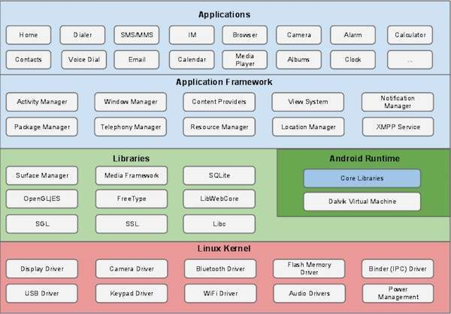

**Fig. 2.1: Android Phone Architecture**

* **Linux server**

At the bottom of the layers is Linux - Linux 3.6 with approximately 115 patches. This provides a level of abstraction between the device hardware and it contains all the essential hardware drivers like camera, keypad, display etc., the kernel also handles all the things that Linux is really good at such as networking and a vast array of device drivers, which take the pain out of interfacing to peripheral hardware.

## Libraries

On top of Linux kernel there is a set of libraries including open-source Web browser engine WebKit, well known library libc, SQLite database which is a useful repository for storage and sharing of application data, libraries to play and record audio and video, SSL libraries responsible for Internet security etc.

## Android Libraries

This category encompasses those Java-based libraries that are specific to Android development. Examples of libraries in this category include the application framework libraries in addition to those that facilitate user interface building, graphics drawing and database access. A summary of some key core Android libraries available to the Android developer is as follows −

* **android.app** − Provides access to the application model and is the cornerstone of all Android applications.
* **android.content** − Facilitates content acc
* ess, publishing and messaging between applications and application components.
* **android.database** − Used to access data published by content providers and includes SQLite database management classes.
* **android.opengl** − A Java interface to the OpenGL ES 3D graphics rendering API.
* **android.os** − Provides applications with access to standard operating system services including messages, system services and inter-process communication.
* **android.text** − Used to render and manipulate text on a device display.
* **android.view** − The fundamental building blocks of application user interfaces.
* **android.widget** − A rich collection of pre-built user interface components such as buttons, labels, list views, layout managers, radio buttons etc.
* **android.webkit** − A set of classes intended to allow web-browsing capabilities to be built into applications.

## Android Runtime

This is the third section of the architecture and available on the second layer from the bottom. This section provides a key component called **Dalvik Virtual Machine** which is a kind of Java Virtual Machine specially designed and optimized for Android. The Dalvik VM makes use of Linux core features like memory management and multi-threading, which is intrinsic in the Java language. The Dalvik VM enables every Android application to run in its own process, with its own instance of the Dalvik virtual machine. The Android runtime also provides a set of core libraries which enable Android application developers to write Android applications using standard Java programming language.

## Application Framework

The Application Framework layer provides many higher-level services to applications in the form of Java classes. Application developers are allowed to make use of these services in their applications.

The Android framework includes the following key services −

* **Activity Manager** − Controls all aspects of the application lifecycle and activity stack.
* **Content Providers** − Allows applications to publish and share data with other applications.
* **Resource Manager** − Provides access to non-code embedded resources such as strings, color settings and user interface layouts.
* **Notifications Manager** − Allows applications to display alerts and notifications to the user.
* **View System** − An extensible set of views used to create application user interfaces.

## Applications

All the Android application at the top layer can be found here. Application to be installed is written on this layer only. Examples of such applications are Contacts Books, Browser, Games etc.

* **Android Studio**

Android Studio is the official IDE for Android app development, based on [IntelliJ IDEA](https://www.jetbrains.com/idea/). On top of IntelliJ's powerful code editor and developer tools, Android Studio offers even more features that enhance your productivity when building Android apps, such as:

* A flexible Gradle-based build system
* Build variants and multiple APK file generation
* Code templates to help you build common app features
* A rich layout editor with support for drag and drop theme editing
* Lint tools to catch performance, usability, version compatibility, and other problems
* Code shrinking with ProGuard and resource shrinking with Gradle
* Built-in support for [Google Cloud Platform](http://developers.google.com/cloud/devtools/android_studio_templates/), making it easy to integrate Google Cloud Messaging and App Engine

**2.4 Location-based services** (**LBS**)

Location based services are a general class of computer program-level services that use location data to control features. As such LBS is an information service and has a number of uses in social networking today as an entertainment service, which is accessible with mobile devices through the network and which uses information on the geographical position of the mobile device. This has become more and more important with the expansion of the smartphone and tablet markets as well.

LBS are used in a variety of contexts, such as health, indoor object search, entertainment, work, personal life, etc. LBS is critical to many businesses as well as government organizations to drive real insight from data tied to a specific location where activities take place. The spatial patterns that location-related data and services can provide is one on its most powerful and useful aspect where location is a common denominator in all of these activities and can be leveraged to better understand patterns and relationships.

LBS include services to identify a location of a person or object, such as discovering the nearest banking cash machine Automated Teller Machine(ATM) or the whereabouts of a friend or employee. LBS include parcel tracking and vehicle tracking services. LBS can include mobile commerce when taking the form of coupons or advertising directed at customers based on their current location. They include personalized weather services and even location-based games. They are an example of telecommunication convergence

This concept of location based systems is not compliant with the standardized concept of Real-Time Locating Systems (RTLS) and related local services, as noted in ISO/IEC 19762-5[ and ISO/IEC 24730-1While networked computing devices generally do very well to inform consumers of days old data, the computing devices themselves can also be tracked, even in real-time.

**2.5 GPS- Global Positioning System**

Global Positioning System[8] was developed by the United States' Department of Defense. It uses between 24 and 32 Medium Earth Orbit satellites that transmit precise microwave signals. This enables GPS receivers to determine their current location, time and velocity. The GPS satellites are maintained by the United States Air Force.

GPS is often used by civilians as a navigation system. On the ground, any GPS receiver contains a computer that triangulates its own position by getting bearings from at least three satellites. The result is provided in the form of a geographic position - longitude and latitude - to, for most receivers, within an accuracy of 10 to 100 meters. Software applications can then use those coordinates to provide driving or walking instructions.

Getting a lock on by the GPS receivers on the ground usually takes some time especially where the receiver is in a moving vehicle or in dense urban areas. The initial time needed for a GPS lock is usually dependent on how the GPS receiver starts. There are three types of start

* Hot
* Warm
* Cold.

The hot start is when the GPS device remembers its last calculated position and the satellites in view, the almanac used (information about all the satellites in the constellation), the UTC Time and makes an attempt to lock onto the same satellites and calculate a new position based upon the previous information. This is the quickest GPS lock but it only works if you are generally in the same location as you were when the GPS was last turned off.

The warm start is when the GPS device remembers its last calculated position, almanac used, and Universal Time Coordinated (UTC) Time, but not which satellites were in view. It then performs a reset and attempts to obtain the satellite signals and calculates a new position. The receiver has a general idea of which satellites to look for because it knows its last position and the almanac data helps identify which satellites are visible in the sky. This takes longer than a hot start but not as long as a cold start.

The cold start is when the GPS device dumps all the information, attempts to locate satellites and then calculates a GPS lock. This takes the longest because there is no known information. The GPS receiver has to attempt to lock onto a satellite signal from any available satellites, basically like polling, which takes a lot longer than knowing which satellites to look for. This GPS lock takes the longest.

In an attempt to improve lock times, cellphone manufacturers and operators have introduced the Assisted GPS technology, which downloads the current ephemeris for a few days ahead via the wireless networks and helps triangulate the general user’s position with the cell towers thus allowing the GPS receiver to get a faster lock at the expense of several (kilo)bytes.

**2.6 SMS Services**

Short Message Service (SMS) is a text messaging service component of phone, Web, or mobile communication systems. It uses standardized communications protocols to allow fixed line or mobile phone devices to exchange short text messages.

SMS was the most widely used data application, with an estimated 3.5 billion active users, or about 80% of all mobile phone subscribers at the end of 2010. The term "SMS" is used for both the user activity and all types of short text messaging in many parts of the world. SMS is also employed in direct marketing known as SMS marketing As of September 2014, global SMS messaging business is said to be worth over USD 100 billion, and SMS accounts for almost 50 percent of all the revenue generated by mobile messaging. SMS does not need the user to be online .it is an offline service available for all the mobile phone users.

**2.7 One Time Passwords (OTP)**

A one-time password is a password that is valid for only one login session or transaction, on a computer system or other digital device. OTPs avoid a number of shortcomings that are associated with traditional (static) password-based authentication; a number of implementations also incorporate two factor authentication by ensuring that the one-time password requires access to something a person has (such as a small keyring fob device with the OTP calculator built into it, or a smartcard or specific cellphone) as well as something a person knows (such as a PIN).

The most important advantage that is addressed by OTPs is that, in contrast to static passwords, they are not vulnerable to replay attacks. This means that a potential intruder who manages to record an OTP that was already used to log in to a service or to conduct a transaction will not be able to abuse it, since it will no longer be valid. A second major advantage is that a user who uses the same (or similar) password for multiple systems, is not made vulnerable on all of them, if the password for one of these is gained by an attacker. A number of OTP systems also aim to ensure that a session cannot easily be intercepted or impersonated without knowledge of unpredictable data created during the previous session, thus reducing the attack surface further.

**2.8 Summary**

This chapter gave basic introduction about LBS, GPS, and SMS services. It also presented the working and basic principles of the GPS. The next chapter discusses about the design requirements to propose an efficient mobile based cashless Wallette system primarily focused for college students.

**Chapter 3**

**THE REQUIREMENT ANALYSIS AND DESIGN OF MOBILE WALLETTE SYSTEM**

This chapter discusses the requirements of project, followed by design issues and overall system architecture.

**3.1 Requirements**

The requirement analysis explains the basic requirements that the project must incorporate. The following mobile wallette system has different features that need to be implemented on student/admin side. Requirements can be broadly classified into functional and non-functional requirements. The functional and non-functional requirements of this project are discussed in the following subsections:

* + 1. **Functional Requirements**

A functional requirement defines functions of the software system or its components. A function is described as a set of inputs, the behavior, and outputs. The College Wallet services for a student must have two major functionalities.

They are:

1. Register
2. Login
3. Exam section
4. Canteen
5. Society

Student Register must have the options to enroll himself to the application by providing the appropriate details like name , usn, password, mobile number, semester, branch , email. Once the student enrolls his name by providing the appropriate details he must have the option to select the desired section where he wants to make payment.

Registered students can access the application by providing their appropriate usn and password.

In Exam section there are two functional requirements: Exam fee and RV fee. In Exam fee, the student can pay the exam fee for the current semester subjects which he is appearing in that semester and if there are any backlogs in previous semesters, those subjects will also be displayed where the student can opt for the subjects for which he wants to apply. After the payment is done, receipt for exam fee will be generated which shows subjects applies by student. This receipt can be saved in mobile by the student for later use.

In RV fee, the student can pay the rv fee for those subjects which he has appeared previously and all the previous backlog subjects.After the payment is done, receipt for exam fee will be generated which shows subjects applies by student. This receipt can be saved in mobile by the student for later use.

In Canteen module there are three options: Type, item and quantity. In types there are three sub-types: Breakfast, Meals and snacks. When the student selects one of these, available items will be displayed and quantity of necessary items has to be given. After that the ordered items can be disabled at the check-out time. The items ordered can be viewed in that Token-number, Short-form, Quantity will be displayed. History of the entire transaction can be viewed. Both ordered item and cancelled item can be viewed. After ordering the items token number will be issued. Later amount will be deducted and message will be sent to parent as well as student.

**3.1.2 Non-Functional Requirements**

A non-functional requirement is a requirement that specifies criteria that can be used to judge the operation of a system, rather than specific behaviors. Some of the requirements are needed to adapt for existing environment, for look and feel and faster data access. OTP concept for every transaction should be in real time. SMS should be sent to both parent and student which checks proper intimation. This checks accuracy, liability and non-corruptions.

There are a number of constraints that need to be satisfied. A few of them may be stated as follows:

* The phone should have internet connection.
* The platform used must need to be Android only.
* The balance has to be checked before every transaction. .
* The application must be user friendly for the user to understand it.
* The application must be updated with the addition of new items in the canteen.
* The Android versions must support the application.
* The user’s phone should be GPS connected.

**3.2 Design Issues**

The following are the issues involved in the instructional design of the system:

* **Mobility:**

The term mobility refers to the concept of ‘anytime, anywhere’ capability of the application. The application developed must be available in all the places of the city and must be made available for every person travelling to the college. The mobility must be very high so that the application can reach each and every person.

* **Technical challenges:**

Includes different screen sizes, operating system, mobile device capabilities, minimum storage capacity, minimum bandwidth, language runtime- Java Virtual Machine(JVM) etc. the application has to be developed in such a way that it is compatible with all the phones.

* **Affordability:**

Cost is always a very important criteria that has to be concentrated while developing any of the applications. The application has to be developed such that it is made developed with a very low cost and is made available for the user with a very less cost. Care must be taken to develop an application that works for almost all the phones irrespective of cost of the cell phones.

* **Acceptability:**

This is another consideration that determines the success of the application. The application must be developed keeping in mind the various requirements of the different users.

**3.3 System Architecture**

**The overall system architecture for mobile based smart cashless assistant is shown in Fig. 3.1. The various modules that are being used are student, database, maintenance personnel, server and network.**

* **Student is the user of the application. Submodules of student are library, canteen, account section, hostel section.**
* **Database contains overall information about the student like(USN, Admission number, General book bank number). It is a centralized database that contains various information regarding library, canteen, account section, hostel section.**
* **Maintenance personnel is the database administrator who is responsible for creation, updation and maintenance of database.**
* **Rather than storing all the information manually or in a single computer, we store it in on a server for fast and better retrieval of information effectively.**
* **Network is an interface that connects student and the server. Student can access the server either through the internet or through sms.**

This project is proposed to be implemented using a modular architecture with the following modules:

1. **User Interface :** This module is intended to develop easy to use and attractive UI for both students and server side operators/administrators
2. **Business Logic:** This module implements all the cashless payment functionalities interacting with client and server side components. It includes provisioning both wallet amount deductions and recharging facilities

**3. Security:** Most of the transactions exchanged in this project are sensitive and this module implements security functionalities using encryption, digest and One Time Passwords (OTP) schemes

**4. Database:** This module is intended to develop a core database to store all billing, auditing, and each service modules data like Exam, Library, Canteen and others

**Receipts/Reports:** The module that performs post processing of various transactions and allows generation of frequently needed report by organizations/institutions for auditing purpose.

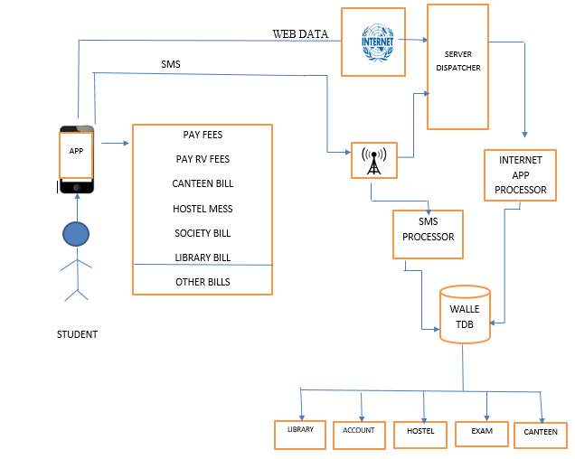

**Fig. 3.1 System architecture**

**3.4 Summary**

This chapter includes details on functional and non-functional requirements of the design issues. Theoverall system architecture of the college wallet application is also presented. The next chapter throws light sight on implementation details of college wallet

**Chapter 4**

**IMPLEMENTATION**

This chapter explains the implementation of different modules involved in the project. The different modules includes Student Registration, Student login Canteen (Order, Check history, View transaction, Cancel, Proximity), Society(Order, Check history, View transaction, Cancel, Proximity) Library, Exam Fees and RV application and Recipts. Admin module is also implemented that includes login, Canteen Order and Items processing, Society Order and Items processing, Top-Up Recharge, and application of Exam and RV fees.

**4.1 Student Registration**

Registration function receives input in the form of usn, name, password, phone no, email, branch, sem from the student. The validity of the data of each field is checked. Also the duplication of USN and phone number is validated. The entire process flow is depicted in Fig. 4.1. In case of invalid data, a failure message is sent and process terminates. In case of success, the student information is inserted into the registration table and sends a success SMS to the user.

**4.2 Student login**

The login procedure of the student is shown in Fig. 4.2. The process eceives usn and Password from user mobile devices and checks the authenticity of the student. If authentication fails, it sends a failure message. If USN exists in database, and password is correct, user will be logged in. An option to change password is also provided.

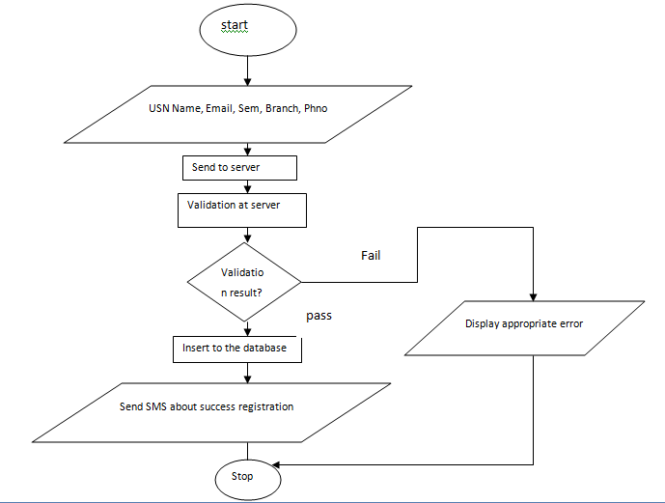

**Fig. 4.1 Flow-chart of student registration process**

**4.3 Canteen Process Implementation**

The Canteen facility provided to the student is implemented as different functions like Ordering of items, Cancellation of ordered items, checking orders, and Checking history of all canteen transactions. The overall flow chart of Canteen process of the student side is shown in Fig. 4.3. The Ordering script checks the location of the user, if he is within the proximity range it allows him to enter the input (usn, item, quantity), calculates the total amount, and asks confirmation before processing. Appropriate amount from Wallette is deducted and message is sent to both student and the ward and a token number is allotted to the order. Cancellation of existing order receives the token of the items to be cancelled as input. Cancellation involves deducting 30% of the amount and if user agrees amount will be credited back to his wallet, message will be sent to both student and the parent. The Society Module is similar to Library module where instead of food items one will have products like pen, blue books, bag and other things to purchase. Each of the products also have product categories like item categories for canteen. Hence similar flow chart of the canteen can be used to implement Society module at the Student side.

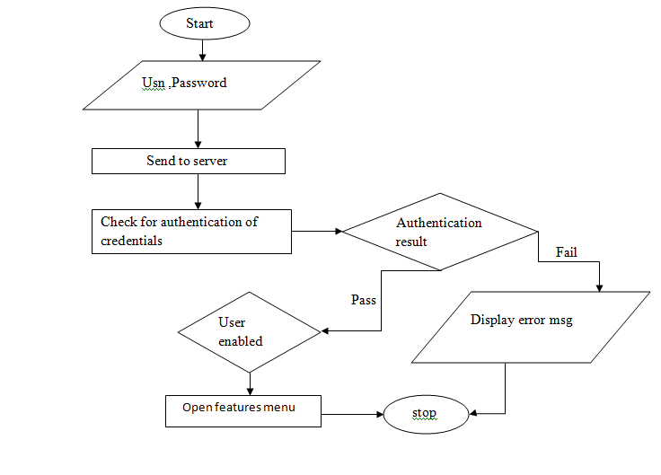

**Fig. 4.2 Process flow of student login**

.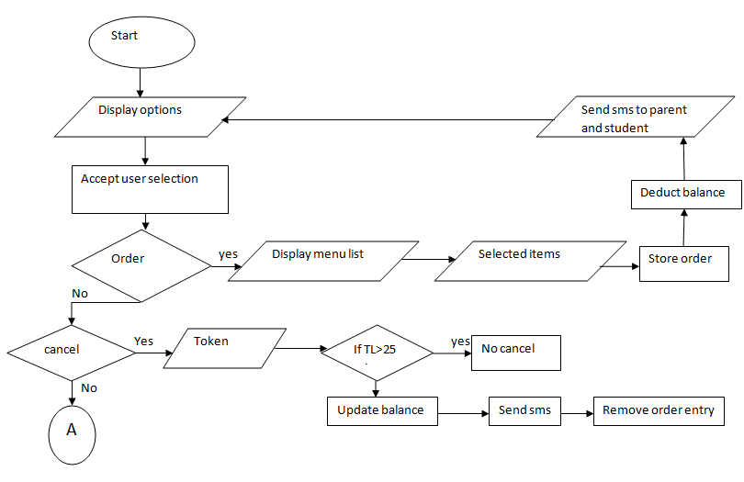

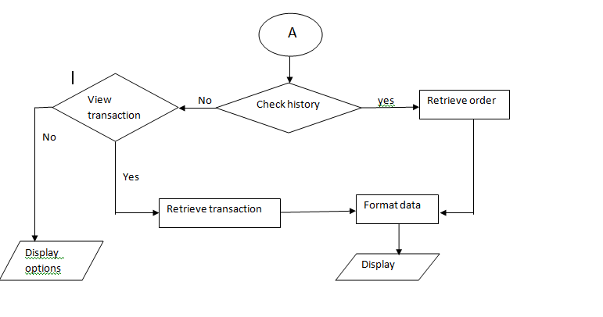

**Fig. 4.3 Implementation of Canteen process at the Student side**

**4.4 Library Module**

The flowchart of Library Module at the student side is shown in Fig. 4.5. The library module provides the user to select General Book Bank Scheme (GBB) or Lending. The script fetch the number of books issued in GBB and calculates the total amount, which is sum of 10% of the price of each book. In case of lending, amount will be calculated based on the number of days delayed. The process then asks for confirmation, and if user confirms student balance is deducted and messages about the transaction and updated balance is sent to both parent and the student.

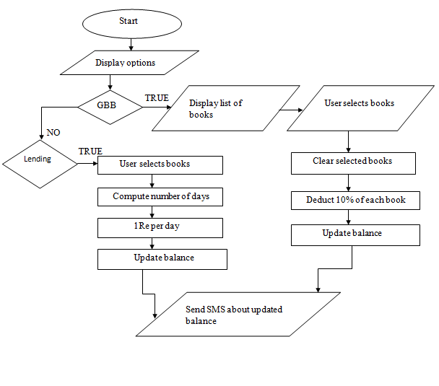

**Fig. 4.5 Flowchart of Library module**

**4.5 Exam and RV application module**

The students are provided option to use their mobile Wallette to apply exam fees. The application of exam fees is time bound. Only subjects of the current semester and subjects which he/she has backlogs are listed by retrieving from subject and result databases. The student can opt for the subjects he/she wants to apply. Subsequently appropriate amount as per the university rules is deducted and balance is updated. SMS is sent to both student and parent regarding the exam fees transaction. This process flow is depicted in Fig. 4.6. Once applied, he/she can download the receipts. The implementation of receipt generation is shown in Fig. 4.7. The procedure adopted for Exam fees can be reused for Revaluation (RV). The subject list in this case will be all the subjects for which student has applied exams.

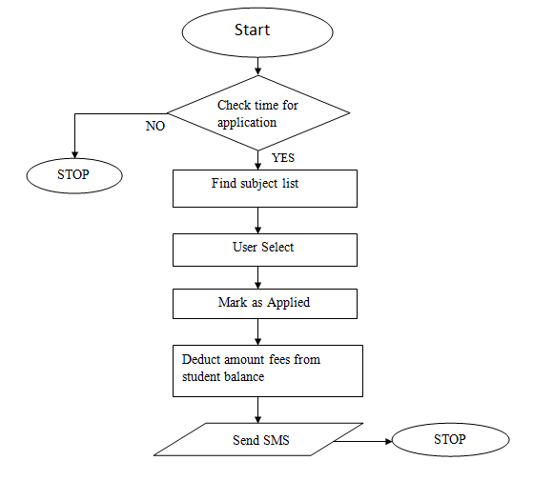

**Fig. 4.6. Implementation of Exam fees function of the student**

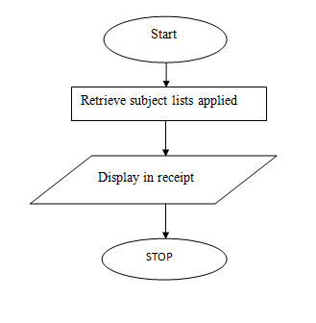

**Fig. 4.7 Process Flow of exam fee receipt generation**

**4.6 Admin canteen**

The administrator has privileges to operate on canteen. He has options to process the items ordered. Once the item is delivered, suitable fields are updated in the database. A message is sent to student regarding successful order processing. The flowchart in Fig. 4.8 explains canteen order processing of the administrator. The flowchart also explains the implementation details of how an admin can add items, increase the quantity and price of the existing items, add new items and categories**.**

**4.7 Admin Exam forms and RV application**

Fig. 4.9 gives the implementation details of the admin clearing all the exam form and RV applications. The list of the forms is retrieved one by one, recipt is generated. The admin applies candidate application in the university website and clears the application. An SMS regarding exam/RV form processing is sent to the student.

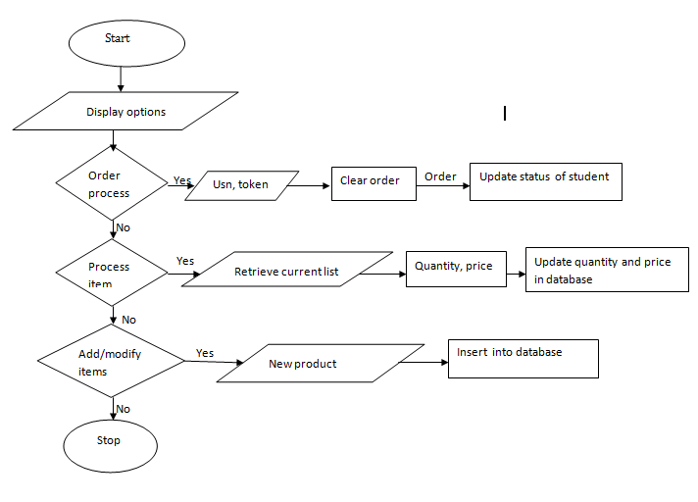

**Fig. 4.8. Implementation of canteen module of the admin**

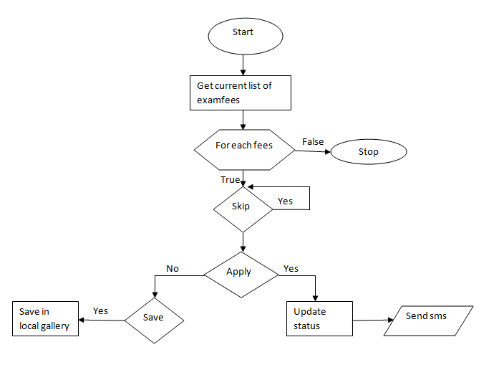

**Fig. 4.9. Implementation of processing of exam forms and RV applications by admin**

**4.8 Back End design**

This project requires an exhaustive relational database for storing data of the different entities like student, admin, canteen, society, subjects, Exam Fees and others. A database to store different tables for all these entities is created in MYSQL relational DBMS. MYSQL is chosen because of it is open source freely downloadable and has all the features of any sophisticated relational DBMS. The different tables, their fields, structures and constraints used in the project is shown next:

**STUDENT TABLE to record Student information**

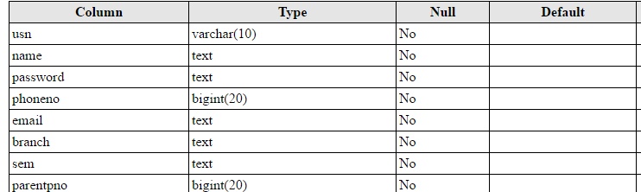

**STUDENT_BALANCE – to store balance of the registered student**

**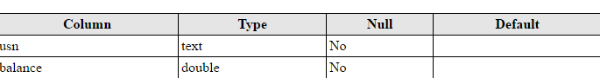  
SUBJECT TABLE – to store all the available subjects**

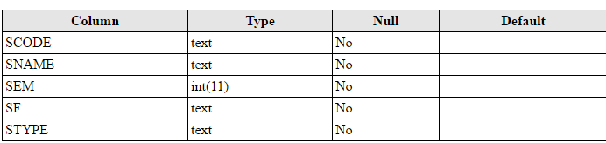

**RESULTS TABLE – to store results of the students**

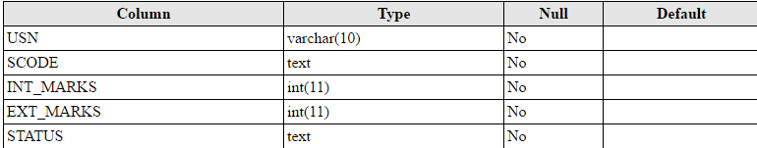

**Exam Fees - list of students paying exam fees**

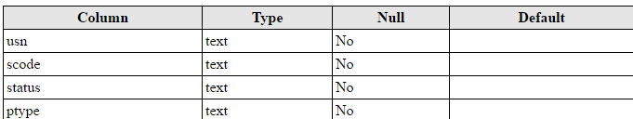

**RV Fees – list of students applied for RV**

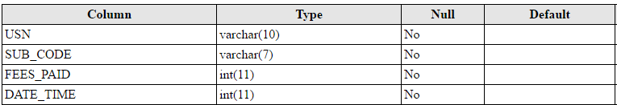

**Canteen – details of food items in the canteen**

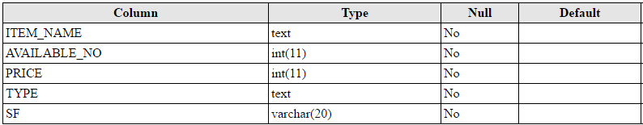

**Society – details of the products available in the society**

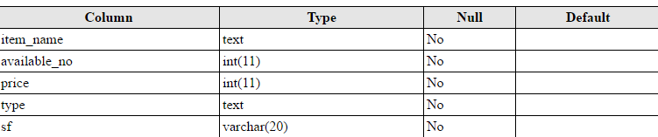

**Transactions – all the transactions are recorded in this table**

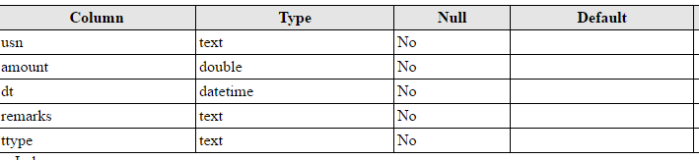

**4.9 Android APIs used in the project**

Various prototypes of the in-built functions that have been used at the student side and admin side. They are listed and briefly explained in the following:

**onCreate(Bundle)**

**{** This is where the activity is initialized. Most importantly, here a call is made to setContentView(int) with a layout resource defining your UI, and using findViewById(int) to retrieve the widgets in that UI that we need to interact with programmatically.

**}**

**voidsetContentView(intLayoutResId)**

**{** Set the activity content from a layout resource. The resource will be inflated, adding all top-level views to the activity.

**}**

**View findViewById(int id)**

**{** Finds a view that was identified by the id attribute from the XML that was processed in onCreate(Bundle). This returns the view if found or null otherwise.

**}**

**onClickListener(View v)**

**{** This class implements the public method – abstract void onClick(View v)This is called when a view has been clicked. The input taken is ‘v’ which is the view that was clicked.

**}**

**Toast.makeText(Context context, intresld, int duration)**

**{** This makes a standard toast that just contains a text view with the text from a resource.

**}**

**protected void onPostExecute(Result result)**

**{** Runs on the UI thread after doInBackground(Params…). The specified result is the value returned by doInBackground(Params…). This method won’t be invoked if the task was cancelled.

**}**

**public void onCreateOptionsMenu(Menu menu, MenuInflaterinflater)**

**{** Initialize the contents of the Activity’s standard options menu. The items must be placed in the menu.

**}**

**public Boolean onOptionsItemSelected(MenuItem menu)**

**{** This is called whenever an item in the options menu is selected. The default implementation simply returns false to have the normal processing happen. The derived classes should call through the base class for it to perform default menu handling.

**}**

**InputStreamReader(InputStream In)**

**{** InputStreamReader is a class for turning a byte stream into a character stream. Data read from the source input stream is converted into characters by either a default or a provided character converter. This method constructs a new InputStreamReader on the InputStream in.

**}**

**OutputStreamReader(OutputStream out)**

**{** OutputStreamReader is a class for turning a character stream into a byte stream. OutputStreamWriter contains a buffer of bytes to be written to target stream and converts these into characters as needed. The buffer size is 8K. This method constructs a new OutputStreamWriter using out as the target stream to write converted characters to.

**}**

**startActivityForResult(Intent, int)**

**{** startActivity(Intent) is used to start a new activity. But sometimes, to get back results from the activity, startActivityForResult() is used.

**}**

**StringBuilder()**

**{** It constructs an instance with an initial capacity of 16 when no parameter is passed. Else, it takes an integer value as the parameter and constructs an instance with specified capacity.

**}**

**voidsetDoOutput(Boolean new value)**

**{** This is a method of class URLConnection. This sets the flag indicating whether this URLConnection allows output.outputStreamgetOutputStream() – This returns an output stream for writing data to this URLConnection.

**}**

**setText(CharSequence text, TextViewBufferType type)**

**{** Sets the text that this TextView is to display and also sets whether it is stored in a styleable/spannable buffer and whether it is editable.

**}**

**getMenuInflater()**

**{** MenuInflater is an object that is able to create menu from xml resources, that is: construct a new instance of menu given a menu resource identifier.

**}**

**mysql_query()**

sends a unique query (multiple queries are no supported) to the currently active database on the server that’s associated with the specified link_identifier.

**mysql_fetch_array()**

fetches a result row as an associative array, or both.

**mysqli_connect(host, username, password, dbname);**

this function of mysqlshoud connect to a database. But if it is rewrote as $con= mysqli_connect(host, username, password, dbname); this function also do the same as well as it saves it in a variable, ‘$con’.

**mysqli_connect_error()**

function returns the error description from the last connection error, if any. It returns a string that describes the error. NULL if no error occurred.

**mysql_select_db**

sets the current active database on the server that’s associated with link identifier. Every subsequent call to mysql_query() will be made on active database.

**Error reporting ()**

function sets error reporting() directive at runtime. PHP has many levels of errors, using this function sets that level for the duration (runtime) of your script. If the optional level is not set, error reporting() will just return the current error reporting level.

# HttpClient.GetAsync Method (String, HttpCompletionOption)

AsyncTask enables proper and easy use of the UI thread. This class allows to perform background operations and publish results on the UI thread without having to manipulate threads and/or handlers. AsyncTask is designed to be a helper class around Thread and Handler and does not constitute a generic threading framework.

**HttpsURLConnection**

Each HttpURLConnection instance is used to make a single request but the underlying network connection to the HTTP server may be transparently shared by other instances. Calling the close() methods on the InputStream or OutputStream of an HttpURLConnection after a request may free network resources associated with this instance but has no effect on any shared persistent connection. Calling the disconnect() method may close the underlying socket if a persistent connection is otherwise idle at that time.

The HTTP protocol handler has a few settings that can be accessed through System Properties. This covers Proxy settings as well as various other settings.

**4.10 Summary**

In this chapter, implementation details of the student side module of the mobile cashless Wallette is discussed with relevant flowcharts. The admin module implementation details were also provided. Android and PHP APIs used in this project was also explored. Results of this project are discussed in the next chapter.

**Chapter 5**

**RESULTS AND DISCUSSIONS**

The proposed system development of college wallet has been completed and is hosted by the domain name https://mwallete.esy.es . A PHP file containing all classes and required supporting packages have been created and uploaded in the domain. The databases have been created in MySQL of the domain. The results obtained after testing each module is discussed in this chapter. The snapshots of the previously discussed modules are presented in this chapter.

**5.1 Test Plan**

A test plan consists of listing all possible test cases in using this mobile based Wallette system. It includes module to be tested, input provided and the output expected. An exhaustive test plan is given in Table 5.1.

**Table 5.1 Test Plan of the mobile wallette system**

|  |  |  |
| --- | --- | --- |
| **Test Module** | **Input** | **Output** |
| **Registration** | Invalid usn | Invalid usn |
|  | Duplicate ph num | Number already registerd |
|  | Invalid phone number | Invalid phone n umber |
|  | Invalid email | Invalid email |
|  | All valid fields in registration | Inserted successfully |
| **Login** | Unregistered usn | Invalid credentials |
|  | Password, usn mismatch | Invalid credentials |
|  | Zero balance | Balance need to be updated |
|  | All valid fields in login | Login successful |
| **Exam and RV** | Trying to apply before or after the prescribed date | Cannot apply before or after the prescribed date |
|  | Applying for current semester subjects and previous back subjects | Applied successfully |
| **Canteen** | User is not within the proximity range | Canteen functionality will be disabled |
|  | User is within proximity range | Displays available items and types |
| **Society** | User is not within the proximity range | Society functionality will be disabled |
|  | User is within proximity range | Displays available products |
| **Library** | User tries to borrow current semester books without returning previous semester books | Books will not be displayed to the user |
|  | User borrows books of current semester after returning previous semester books | Current semester books will be displayed. |

**5.2 Student Registration and Login**

Register module is used for registering the student. This module takes several information of the student for registering, those information are name of the student, his/her university seat number(USN),email, phone number and so on**.** After the completion of registering process, a message will be displayed to the student about the successful registration and that student’s record will be inserted into the ‘student’ table created at the server.

Login module can be used by those students who are already registered. This module takes student’s usn and password and compares it with the stored data of students record at the server, if the data match is successful, user will be allowed to access the other modules of the application. If either of the two data turns out to be incorrect, the application stops the user from accessing next modules.

The results of Registration and login are shown in Fig. 5.1. The database snapshot of student record at the server is shown in Fig. 5.2.

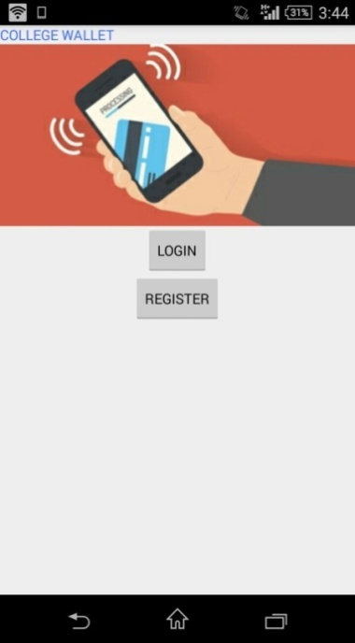 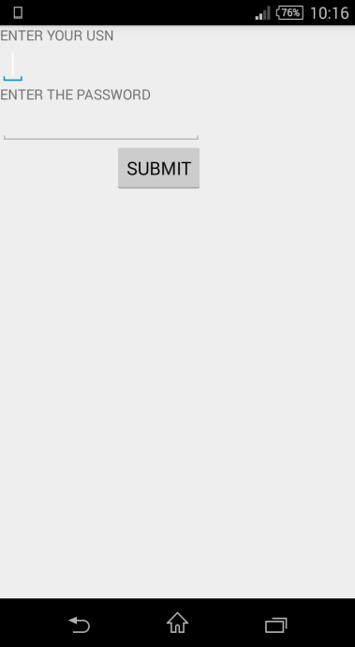 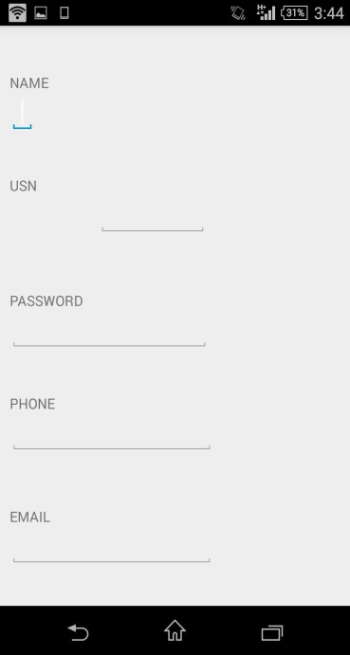

**Fig. 5.1 Registration and login screen**

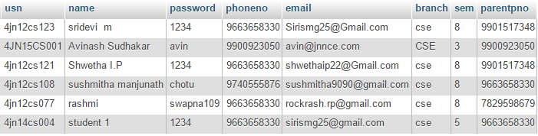

**Fig. 5.2 Database snapshot of students registered**

**5.3 Enabling access to the Students**

Registered students are allowed to access the services of the mobile Wallette only when they are enabled by the administrator. The enabling process requires phone number of the parent and initial balance to be deposited by the student. The result screen shot of administrator enabling a student is illustrated in Fig. 5.3.

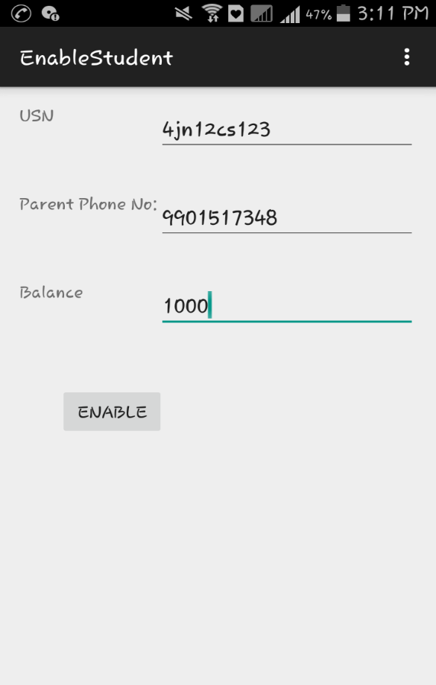 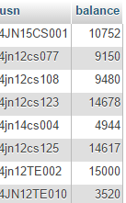

**Fig. 5.3 Enabling of student by Admin and resulting database snapshot**

**5.4 Exam and RV**

This section is used to pay exam fees and revaluation fees. This module consists of another two sub-modules, Exam fee and RV fee. In Exam fee sub-module, student’s current semester subjects and backlog subjects will be displayed. Student can then decide which subjects to select. After selecting the subjects, the application will ask for OTP to enter (which has already been sent to his/her registered phone number). After the payment exam fee receipt will be generated and the student can save that for later use.

In RV fee, the student can pay the rv fee for those subjects which he has appeared previously and all the previous backlog subjects. After the payment is done, receipt for exam fee will be generated which shows subjects applies by student. This receipt can be saved in mobile by the student for later use. The snapshots of Exam and RV fee modules are demonstrated in Fig. 5.4. The subject and results table used to support exam form and RV application processing is shown in Fig. 5.5 and 5.6 respectively. Exam fees and RV transactions of a student is shown in Fig. 5.7.

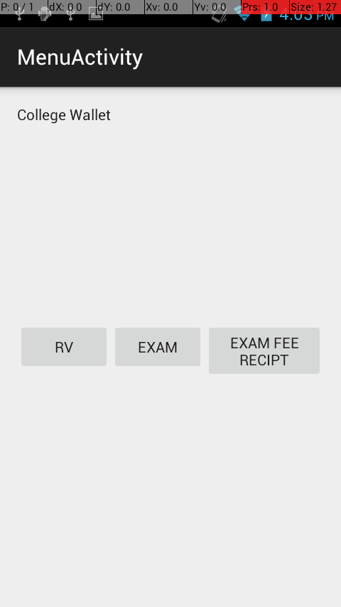 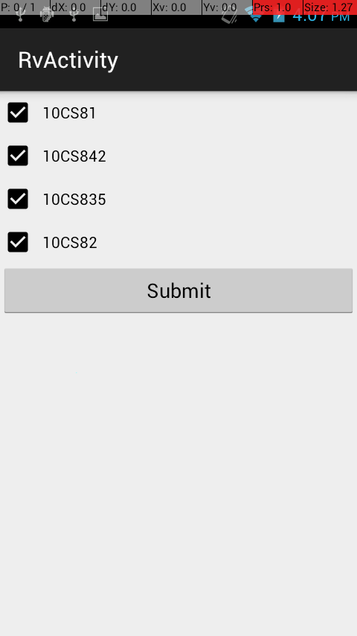 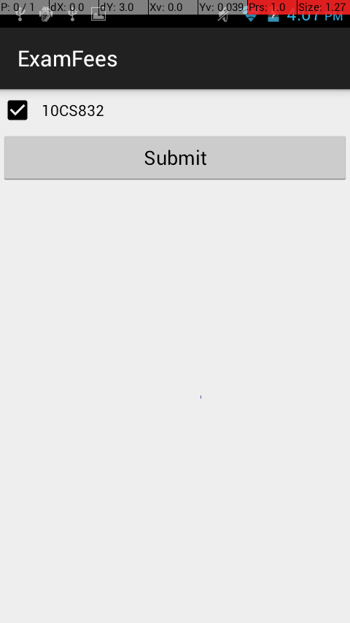

**Fig 5.4.Applying for Exam and RV subjects**

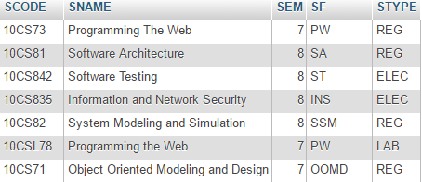

**Fig. 5.5 Subject Details**

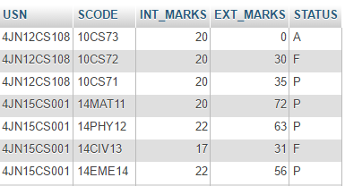

**Fig. 5.6 Result Table snapshot**

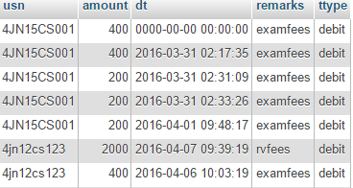

**Fig. 5.7 Exam and RV fees transactions of a student**

**5.5 Canteen Module**

In canteen module there are four sub modules. They are, order, cancel, view and check history. ‘order‘ module is be used by the student to place the order, this module can be used only when he is within college campus. ‘Cancel order’ module allows the students to cancel the order he has made by entering the respective token. ‘View order’ provides the complete list of items the student has ordered previously. ‘check history’ shows items ordered, items canceled, along with date and time of ordering/canceling. The snapshot is demonstrated in Fig. 5.8

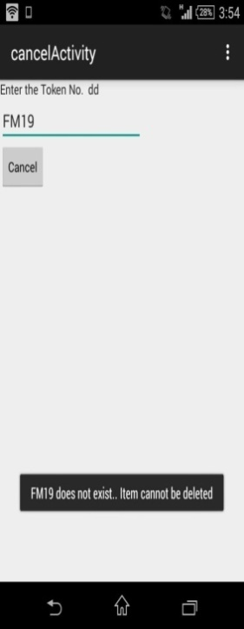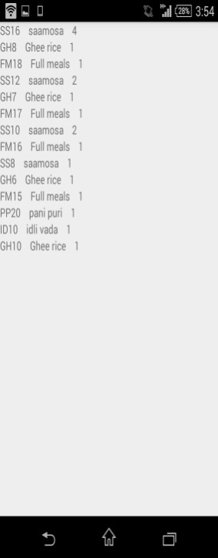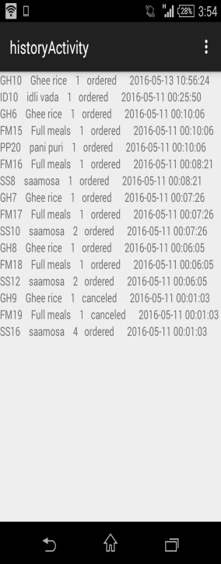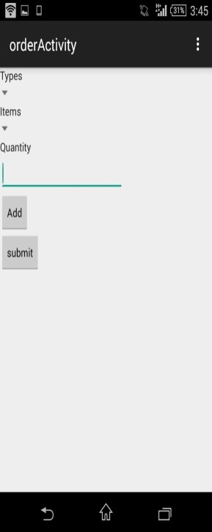

**Fig. 5.8. Results of Canteen module**

**5.6 Society Module**

In this module there are four sub modules. They are, book order, cancel booking, view and check history. ‘Book’ module is used by the student to purchase books,pen and so on. ‘Cancel order’ module allows the students to cancel the order he has made by entering the respective token. ‘View order’ provides the complete list of products the student has ordered previously. ‘check history’ shows products ordered, products canceled, along with date and time of ordering/canceling. The database snapshot of the items available in the society is depicted in Fig. 5.10. The transactions of items ordered/cancelled in the society is recorded in Fig. 5.11.

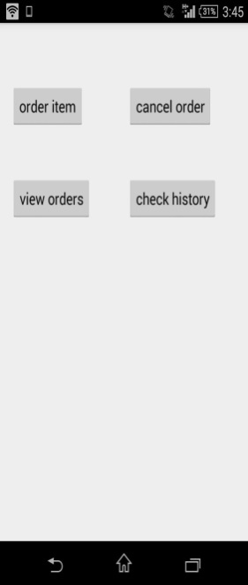 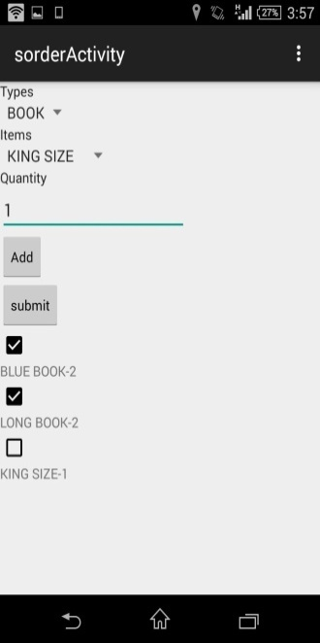

**Fig. 5.9 Results of Society module**

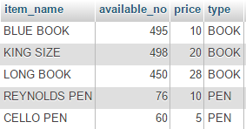

**Fig. 5.10 Database snapshot of Society**

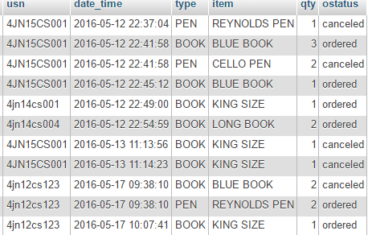

**Fig. 5.11 Society Transactions recorded in the database**

**5.7 Library Module**

This module consists of two submodules, GBB and LENDING. GBB section displays all the books that has been taken by the student. Student can later select which books to return. upon returning, calculated amount will be deducted from user account and that message will be sent to both student and the parent. Lending section shows all the current semester books available for lending to the student. Student can then choose any of the three books from the displayed list. The snapshots f GBB,Lending and message from admin to the student are all shown in Fig. 5.12.

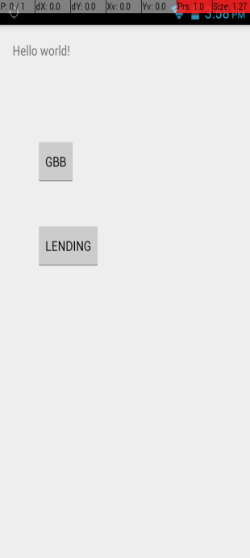 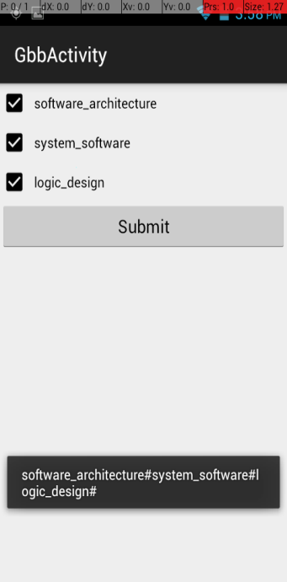 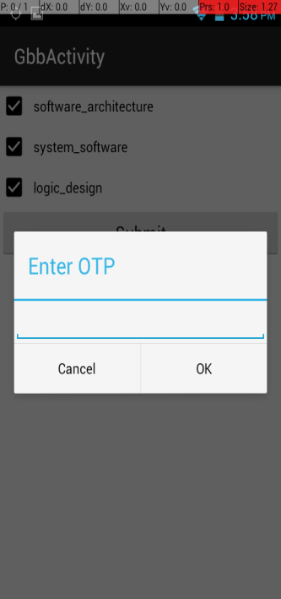

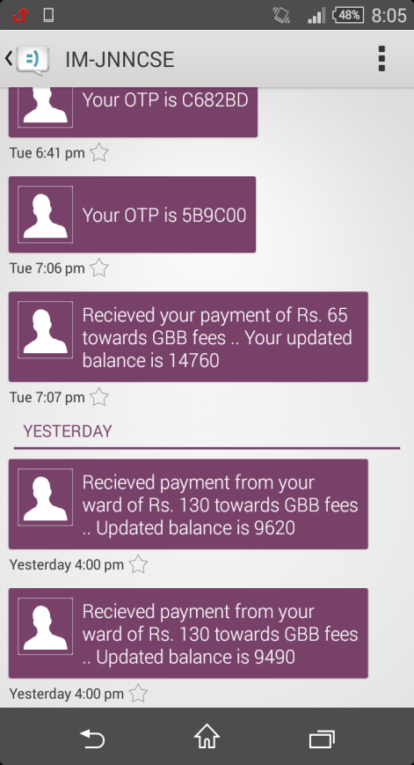

**Fig 5.12 Library Module Results**

**5.8 Amount transfer**

Students have the provision to transfer the amount from their account to their friend’s account. The result screenshots of one such amount transfer is shown in Fig. 5.13.

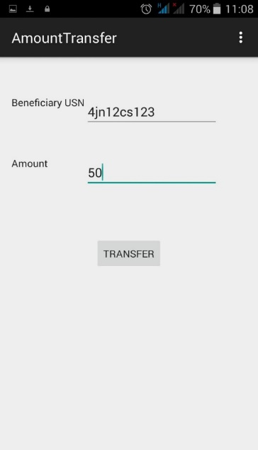 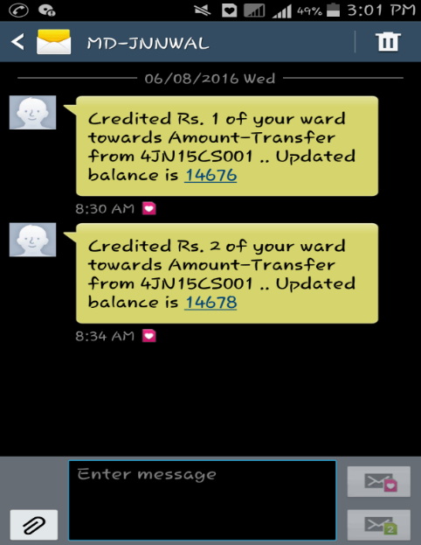

**Fig. 5.12 Amount Transfer Results**

**5.9 Admin Module Results**

The login screen for Admin is illustrated in Fig. 5.13. Canteen processing is shown in Fig. 5.14. The top-up recharge of bonafide student is demonstrated in the snapshot shown in Fig. 5.15.

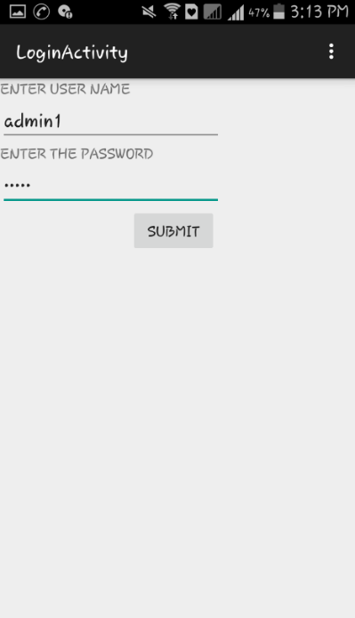

**Fig. 5.13. Admin Login Screen**

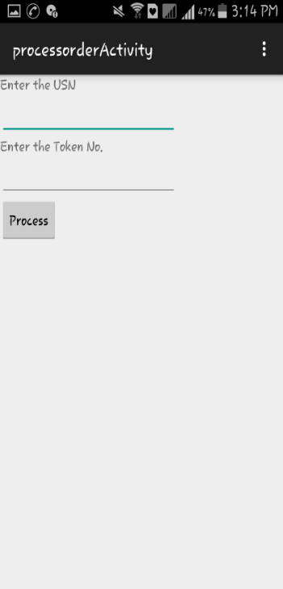 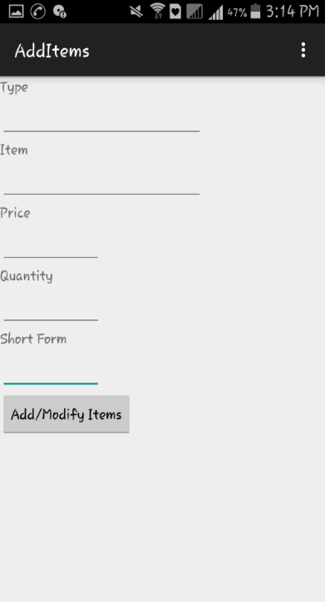

**Fig. 5.14 Canteen processing results at Admin side**

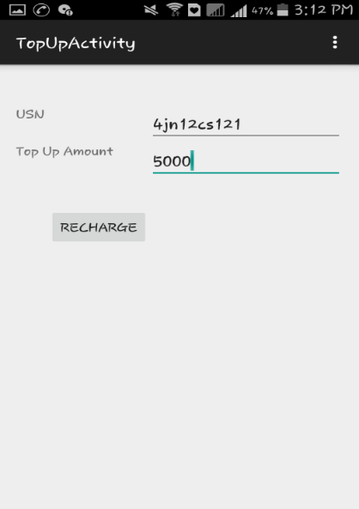

**Fig. 5.15 Top-up recharge of student by admin**

**5.10 Summary**

In this chapter, an exhaustive coverage of the results of the various modules implemented were explained with relevant snapshots. It could be seen that student can do myriad of tasks easily with his mobile and forget about the bringing of physical cash. The system is user friendly and does not require any special training for both admin and student to use it. The report is concluded in the next chapter.

**Chapter 6**

**CONCLUSION**

This project attempts to replace the physical wallets in the hands of students by digital wallets. Instead of following the traditional payment mechanism which is tedious and time consuming. All the payments like of library, hostel fee, college fee ,fees related to exam ,payment for canteen coupons could be done easily under one single application which is most appropriate for students. This project also incorporates one time password security mechanism for security of all transactions. The canteen and society services are only available if the student is in the proximity of the college. And exhaustive and easy to use Android based Application has been developed for both students and administrators.

This project can be applied in any educational institutions as well as organizations where day to day money transactions are involved. The reduction in the unwanted queues during operations of the institutions and taking care of the theft of cash is also another important application of this wallette. Digitization is an important trending factor and this project is one product that aims at complete paperless and cashless product.

**6.1 Future scope**

The developed application College Wallete may be further improved to include tuition fees, yearly college fees, hostel and bus fees. The application can be put into use for other educational institutions as well as other corporate and private organizations for cashless transaction.

**References**

[1] http://en.wikipedia.org/wiki/Android_(operating_system)

[2] M. A. HANNAN, A. M. MUSTAPHA, A. HUSSAIN and H. BASRI“Intelligent Bus Monitoring and ManagementSystem”Proceedings of the World Congress on Engineering and Computer Science 2012 Vol II WCECS 2012, October 24-26, 2012, San Francisco, USA

[3] AbhishekDilipBhonge, Deepak DattatrayKankhare, Prasad LaxmanraoTakate “GPS ENABLED ANDROID APPLICATION FOR BUSSCHEDULE SYSTEM”IJRET: International Journal of Research in Engineering and Technology eISSN: 2319-1163 | pISSN: 2321-7308

[4] WHITE PAPER – Banking on the Mobile Wallet by Anjani Kumar and Sai Prasad Seri-2015

[5] CASHLESS SOCIETY: DRIVE’S AND CHALLENGES IN NIGERIA by MaitanmiOlusola, AwodeleOludele ,OgbonnaChibueze and Osundina Samuel-2013

[6] “Cashless” transactions: perceptions of money in mobile payments by Jashim Khan and Margaret Craig-2009

[7] The Future Of Mobile Wallets Lies Beyond Payments by Thomas Husson