DFD DIAGRAMS

Context level:

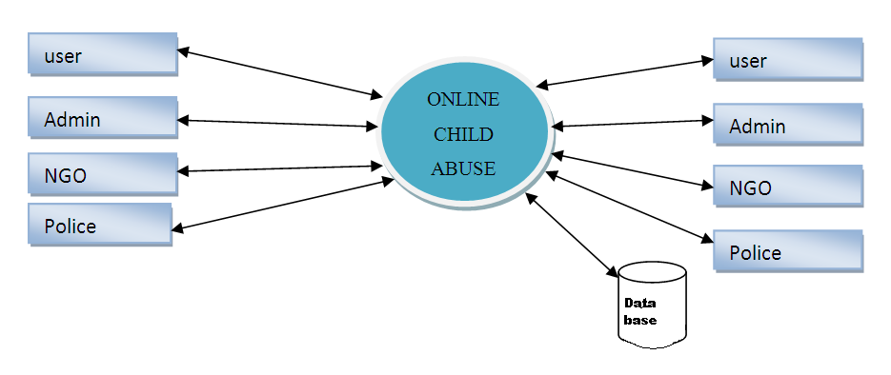

Level 1:

Registration table

start

If fail

If Success

Level 2:

Start



