**DAILY REPORT**

**Student Name :SUSHMITHA.B.POOJARY**

**Class and Sec : VI B**

**USN :4AL17CS103**

**DATE:01-07-2020**

|  |  |  |  |  |
| --- | --- | --- | --- | --- |
| **Online Test Details** | | | | |
| **Subject** | **-----------** | | | |
| **Semester** | **VI -B** | | **Duration** | **--------------** |
| **% of marks** | | **--------------** | | |

|  |  |  |  |
| --- | --- | --- | --- |
| **Certification Course Details** | | | |
| **Course** | **Introduction to cloud computing** | | |
| **Certificate Provider** | **Cognitiveclasss.ai** | **Duration** | **6hours** |

**Snapshots of the daily class acitivities.**

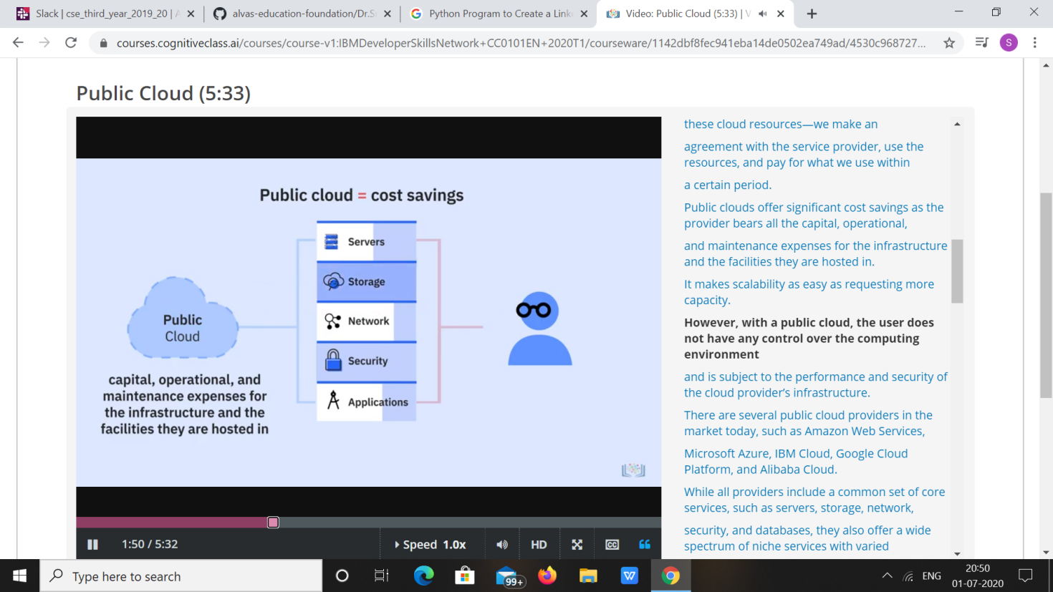

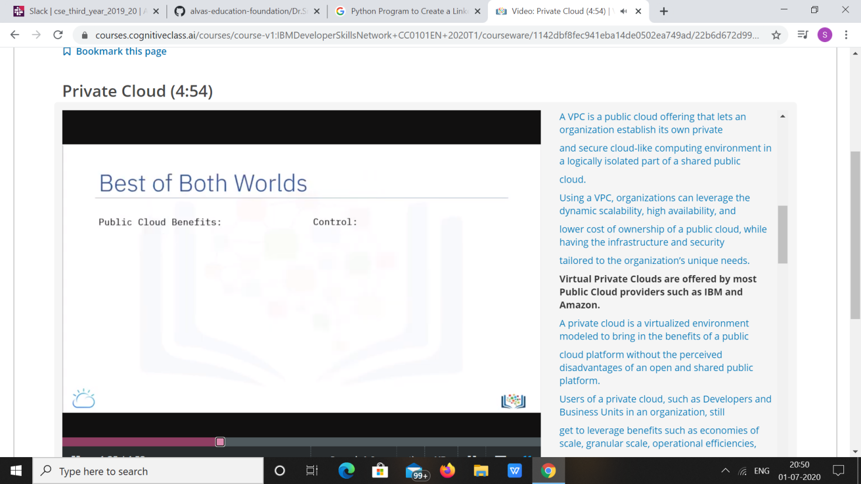

|  |  |
| --- | --- |
| **Coding Challenges** | |
| **Problem Statement: 1.Python Program to Create a Linked List & Display the Elements in the Lists.** | |
| **Status: Executed** | |
| **Uploaded the report both in Github & Slack** | **Yes** |

**Snapshots of your response to challenge.**

1. ****Python Program to Create a Linked List & Display the Elements in the Lists.****

**class Node:**

**def __init__(self, data):**

**self.data = data**

**self.next = None**

**class LinkedList:**

**def __init__(self):**

**self.head = None**

**self.last_node = None**

**def append(self, data):**

**if self.last_node is None:**

**self.head = Node(data)**

**self.last_node = self.head**

**else:**

**self.last_node.next = Node(data)**

**self.last_node = self.last_node.next**

**def display(self):**

**current = self.head**

**while current is not None:**

**print(current.data, end = ' ')**

**current = current.next**

**a_llist = LinkedList()**

**n = int(input('How many elements would you like to add? '))**

**for i in range(n):**

**data = int(input('Enter data item: '))**

**a_llist.append(data)**

**print('The linked list: ', end = '')**

**a_llist.display()**

****OUTPUT****

