**DAILY REPORT**

**Student Name :SUSHMITHA.B.POOJARY**

**Class and Sec : VI B**

**USN :4AL17CS103**

**DATE:02-07-2020**

|  |  |  |  |  |
| --- | --- | --- | --- | --- |
| **Online Test Details** | | | | |
| **Subject** | **---------------** | | | |
| **Semester** | **VI -B** | | **Duration** | **------** |
| **% of marks** | | **------------------** | | |

|  |  |  |  |
| --- | --- | --- | --- |
| **Certification Course Details** | | | |
| **Course** | **Introduction to cloud computing** | | |
| **Certificate Provider** | **Cognitiveclass.ai** | **Duration** | **6hours** |

**Snapshots of the daily class acitivities .**

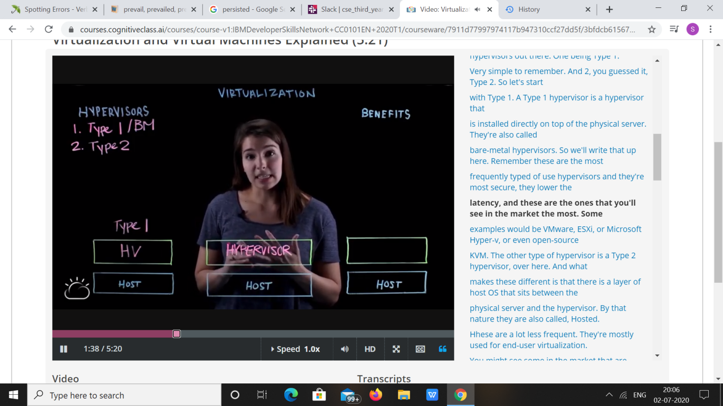

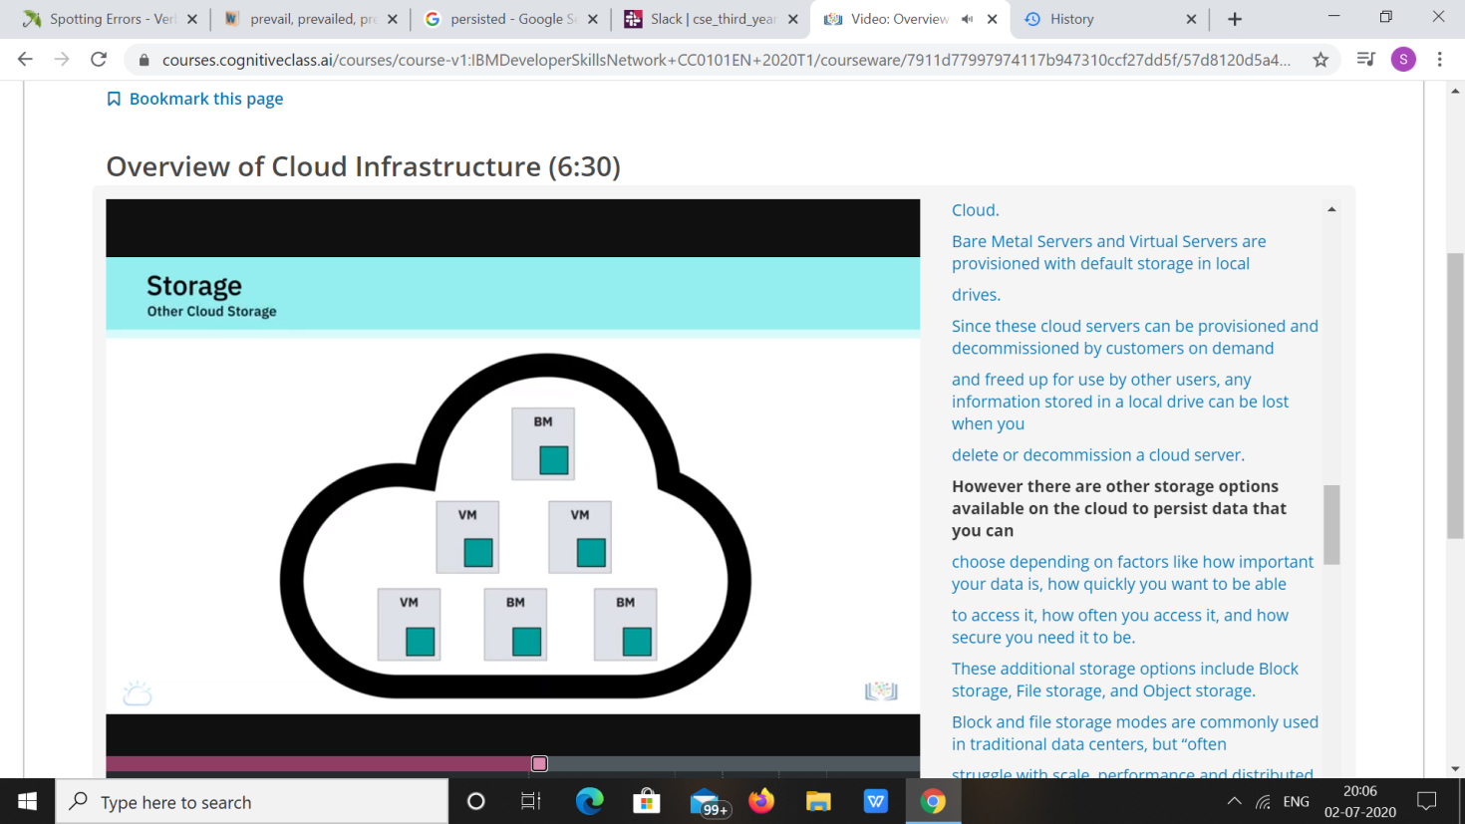

|  |  |
| --- | --- |
| **Coding Challenges** | |
| **Problem Statement: 1. Python Program to Create a Class in which One Method Accepts a String from the User and Another Prints its.** | |
| **Status: Executed** | |
| **Uploaded the report both in Github & Slack** | **Yes** |

**Snapshots of your response to challenge.**

1. ****Python Program to Create a Class in which One Method Accepts a String from the User and Another Prints its.****

**class print1():**

**def __init__(self):**

**self.string=""**

**def get(self):**

**self.string=input("Enter string: ")**

**def put(self):**

**print("String is:")**

**print(self.string)**

**obj=print1()**

**obj.get()**

**obj.put()**

****OUTPUT****

