**DAILY REPORT**

**Student Name :SUSHMITHA.B.POOJARY**

**Class and Sec : VI B**

**USN :4AL17CS103**

**DATE:03-07-2020**

|  |  |  |  |  |
| --- | --- | --- | --- | --- |
| **Online Test Details** | | | | |
| **Subject** | **--------------** | | | |
| **Semester** | **VI -B** | | **Duration** | **-----------** |
| **% of marks** | | **---------------** | | |

|  |  |  |  |
| --- | --- | --- | --- |
| **Certification Course Details** | | | |
| **Course** | **Introduction to cloud computing** | | |
| **Certificate Provider** | **Cognitiveclass.ai** | **Duration** | **6hours** |

**Snapshots of the daily class acitivities.**

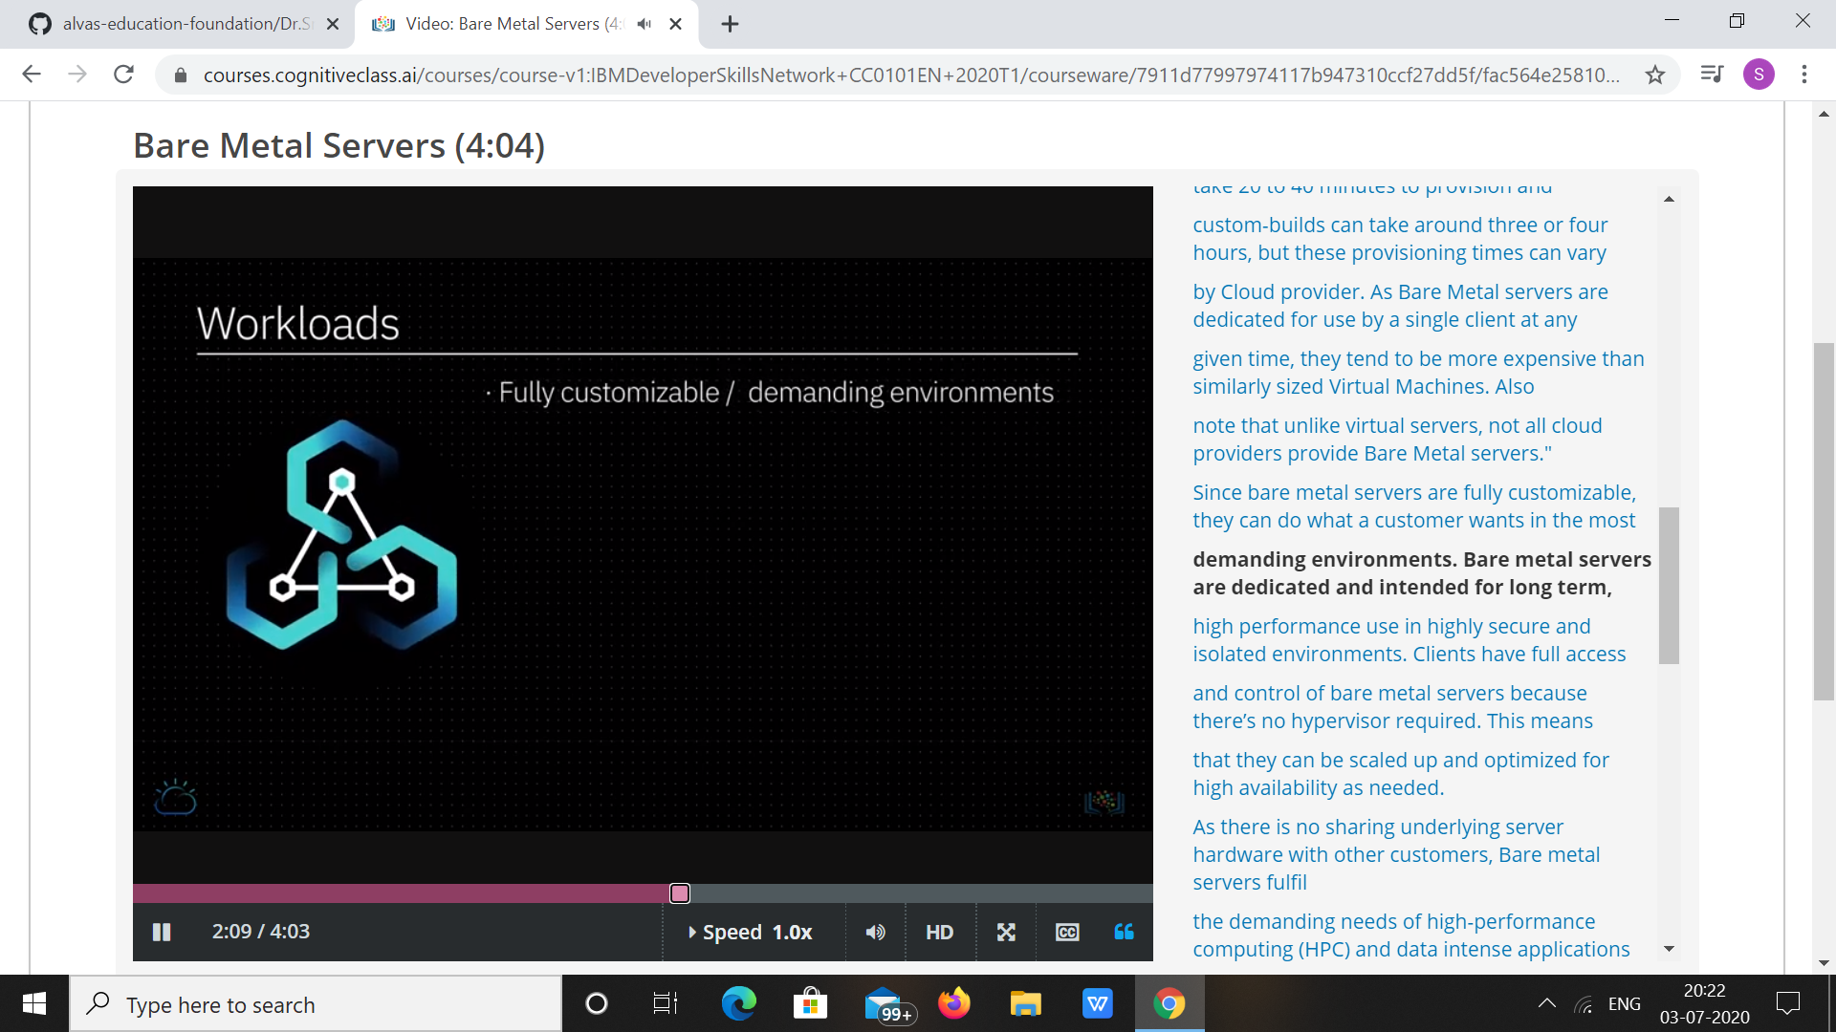

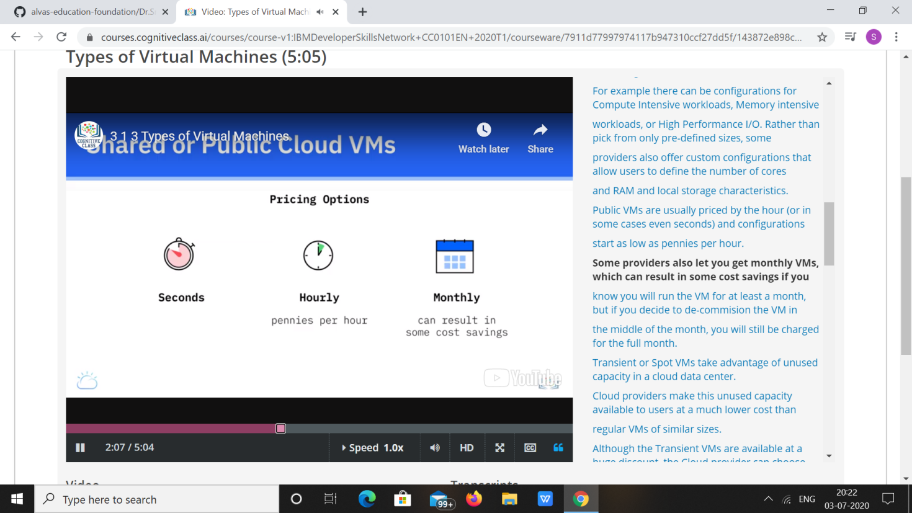

|  |  |
| --- | --- |
| **Coding Challenges** | |
| **Problem Statement: 1. Python Program to Create a Class and Get All Possible Subsets from a Set of Distinct Integerss.** | |
| **Status: Executed** | |
| **Uploaded the report both in Github & Slack** | **Yes** |

**Snapshots of your response to challenge.**

1. ****Python Program to Create a Class and Get All Possible Subsets from a Set of Distinct Integerss.****

**class sub:**

**def f1(self, s1):**

**return self.f2([], sorted(s1))**

**def f2(self, curr, s1):**

**if s1:**

**return self.f2(curr, s1[1:]) + self.f2(curr + [s1[0]], s1[1:])**

**return [curr]**

**a=[]**

**n=int(input("Enter number of elements of list: "))**

**for i in range(0,n):**

**b=int(input("Enter element: "))**

**a.append(b)**

**print("Subsets: ")**

**print(sub().f1(a))**

