**DAILY REPORT**

**Student Name :SUSHMITHA.B.POOJARY**

**Class and Sec : VI B**

**USN :4AL17CS103**

**DATE:04-07-2020**

|  |  |  |  |  |
| --- | --- | --- | --- | --- |
| **Online Test Details** | | | | |
| **Subject** | **---------** | | | |
| **Semester** | **VI -B** | | **Duration** | **----------** |
| **% of marks** | | **--------------** | | |

|  |  |  |  |
| --- | --- | --- | --- |
| **Certification Course Details** | | | |
| **Course** | **Introduction to Cloud computing** | | |
| **Certificate Provider** | **Cognitiveclass.ai** | **Duration** | **6hours** |

**Snapshots of the daily class acitivities.**

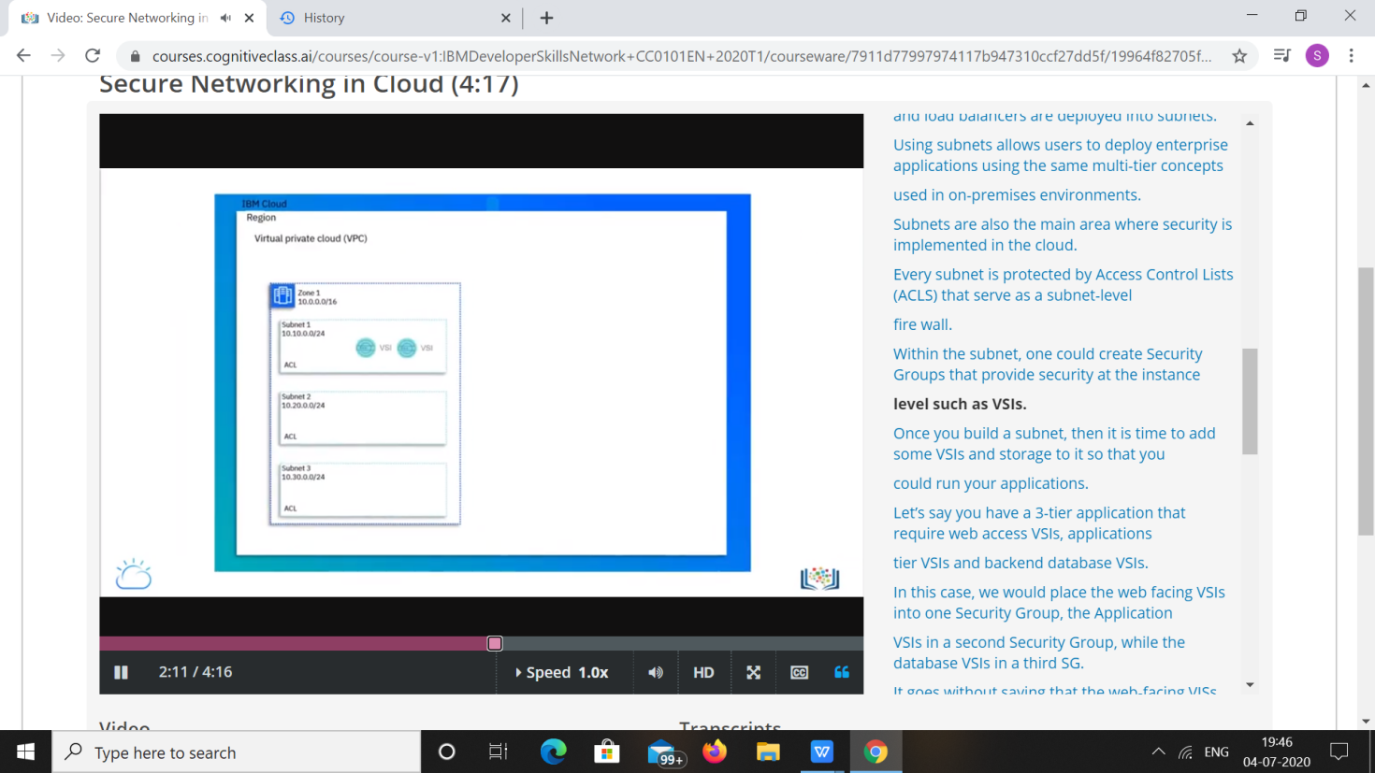

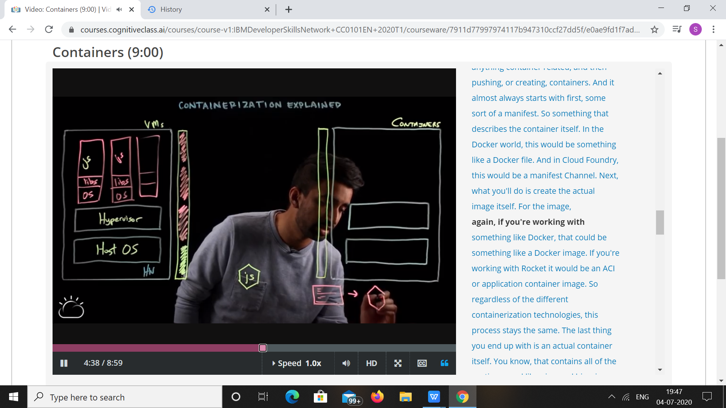

|  |  |
| --- | --- |
| **Coding Challenges** | |
| **Problem Statement: 1.Python Program to Create a Class in which One Method Accepts a String from the User and Another Prints its.**  **2.Python Program to Create a Class which Performs Basic Calculator Operationss.** | |
| **Status: Executed** | |
| **Uploaded the report both in Github & Slack** | **Yes** |

**Snapshots of your response to challenge.**

1. ****Python Program to Create a Class in which One Method Accepts a String from the User and Another Prints its.****

**class print1():**

**def __init__(self):**

**self.string=""**

**def get(self):**

**self.string=input("Enter string: ")**

**def put(self):**

**print("String is:")**

**print(self.string)**

**obj=print1()**

**obj.get()**

**obj.put()**

****OUTPUT****

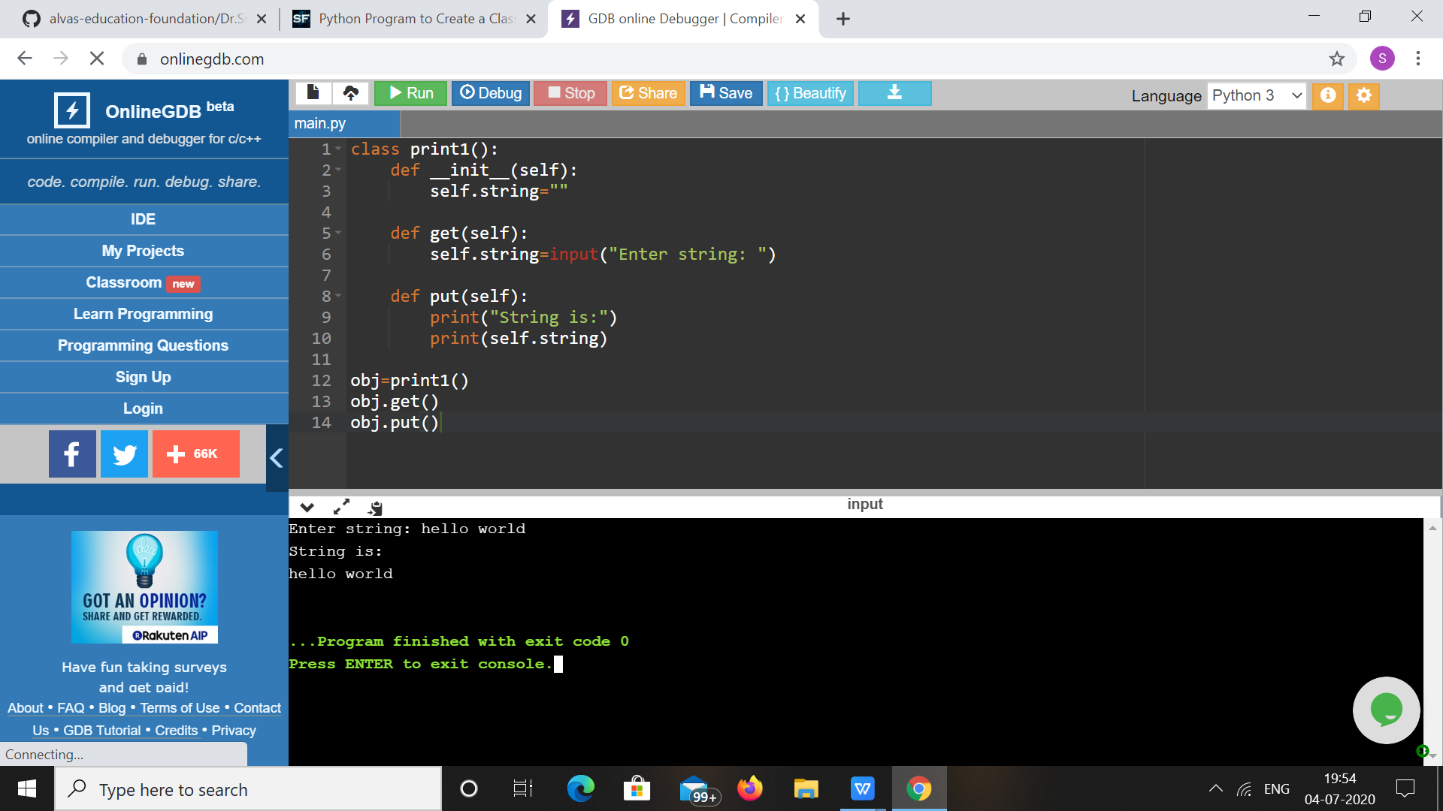

1. ****Python Program to Create a Class which Performs Basic Calculator Operationss.****

**class cal():**

**def __init__(self,a,b):**

**self.a=a**

**self.b=b**

**def add(self):**

**return self.a+self.b**

**def mul(self):**

**return self.a*self.b**

**def div(self):**

**return self.a/self.b**

**def sub(self):**

**return self.a-self.b**

**a=int(input("Enter first number: "))**

**b=int(input("Enter second number: "))**

**obj=cal(a,b)**

**choice=1**

**while choice!=0:**

**print("0. Exit")**

**print("1. Add")**

**print("2. Subtraction")**

**print("3. Multiplication")**

**print("4. Division")**

**choice=int(input("Enter choice: "))**

**if choice==1:**

**print("Result: ",obj.add())**

**elif choice==2:**

**print("Result: ",obj.sub())**

**elif choice==3:**

**print("Result: ",obj.mul())**

**elif choice==4:**

**print("Result: ",round(obj.div(),2))**

**elif choice==0:**

**print("Exiting!")**

**else:**

**print("Invalid choice!!")**

**print()**

****OUTPUT****

****