**DAILY REPORT**

**Student Name :SUSHMITHA.B.POOJARY**

**Class and Sec : VI B**

**USN :4AL17CS103**

**DATE:04-08-2020**

|  |  |  |  |  |
| --- | --- | --- | --- | --- |
| **Online Test Details** | | | | |
| **Subject** | **------** | | | |
| **Semester** | **VI -B** | | **Duration** | **----** |
| **% of marks ---** | | **-----** | | |

|  |  |  |  |
| --- | --- | --- | --- |
| **Certification Course Details** | | | |
| **Course** | **Python for Everybody** | | |
| **Certificate Provider** | **Coursera** | **Duration** | **19hours** |

**Snapshots of the daily class acitivities.**

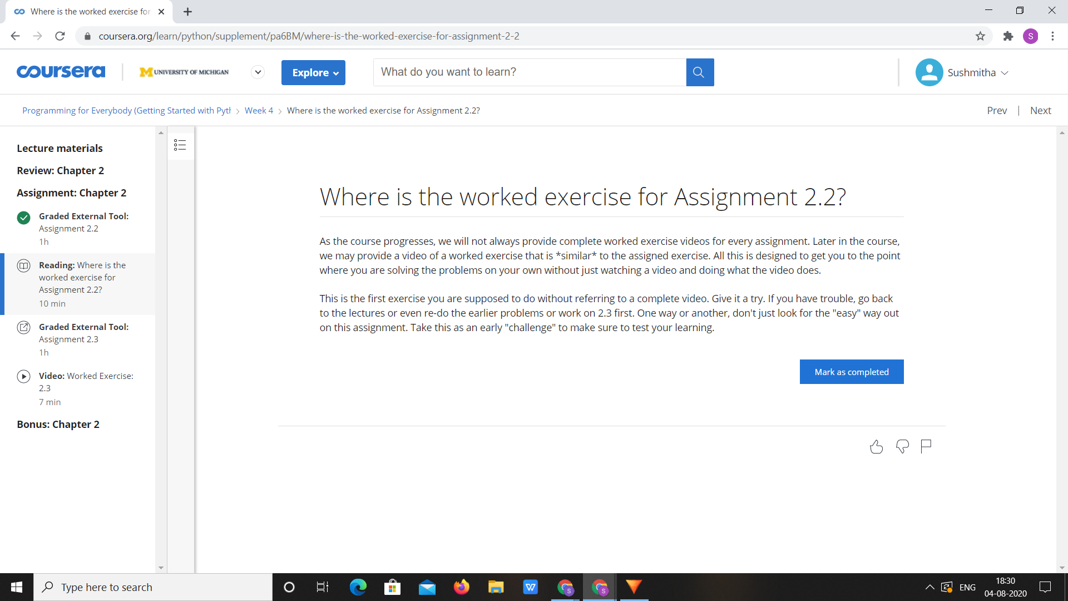

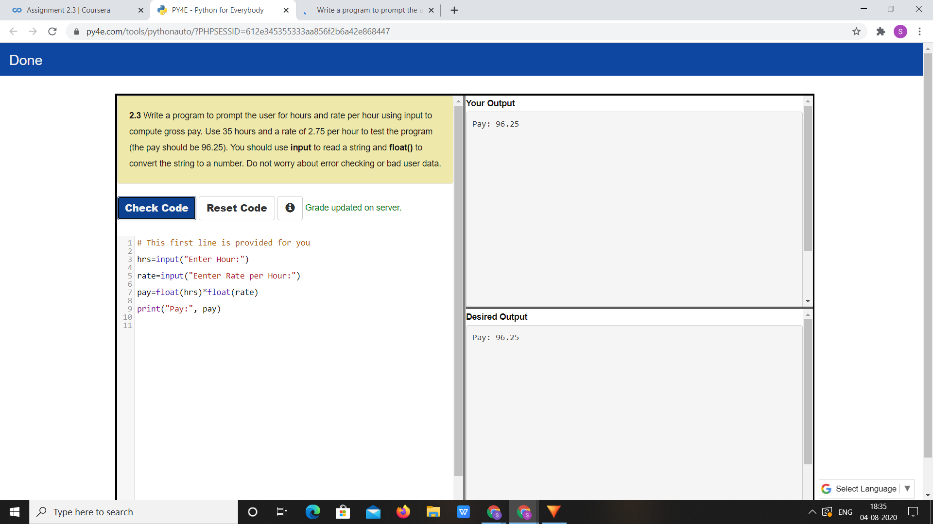

|  |  |
| --- | --- |
| **Coding Challenges** | |
| **Problem Statement:** 1.**Python Program for Finding the vertex, focus and directrix of a parabola.** | |
| **Status:** Executed | |
| **Uploaded the report both in Github & Slack** | Yes |

**Snapshots of your response to challenge.**

**1.**Python Program for Finding the vertex, focus and directrix of a parabola.****

def parabola(a, b, c):

print ("Vertex: (" , (-b / (2 * a)) , ", "

,(((4 * a * c) - (b * b)) / (4 * a)) , ")" )

print ("Focus: (" , (-b / (2 * a)) , ", "

, (((4 * a * c) - (b * b) + 1) / (4 * a)) , ")" )

print ("Directrix: y="

, (int)(c - ((b * b) + 1) * 4 * a ))

a = 5

b = 3

c = 2

parabola(a, b, c)

**OUTPUT**

