**DAILY REPORT**

**Student Name :SUSHMITHA.B.POOJARY**

**Class and Sec : VI B**

**USN :4AL17CS103**

**DATE:05-07-2020**

|  |  |  |  |  |
| --- | --- | --- | --- | --- |
| **Online Test Details** | | | | |
| **Subject** | **-----------** | | | |
| **Semester** | **VI -B** | | **Duration** | **----------** |
| **% of marks** | | **---------------** | | |

|  |  |  |  |
| --- | --- | --- | --- |
| **Certification Course Details** | | | |
| **Course** | **Introduction to Cloud Computing** | | |
| **Certificate Provider** | **Cognitiveclass.ai** | **Duration** | **6hours** |

**Snapshots of the daily class acitivities.**

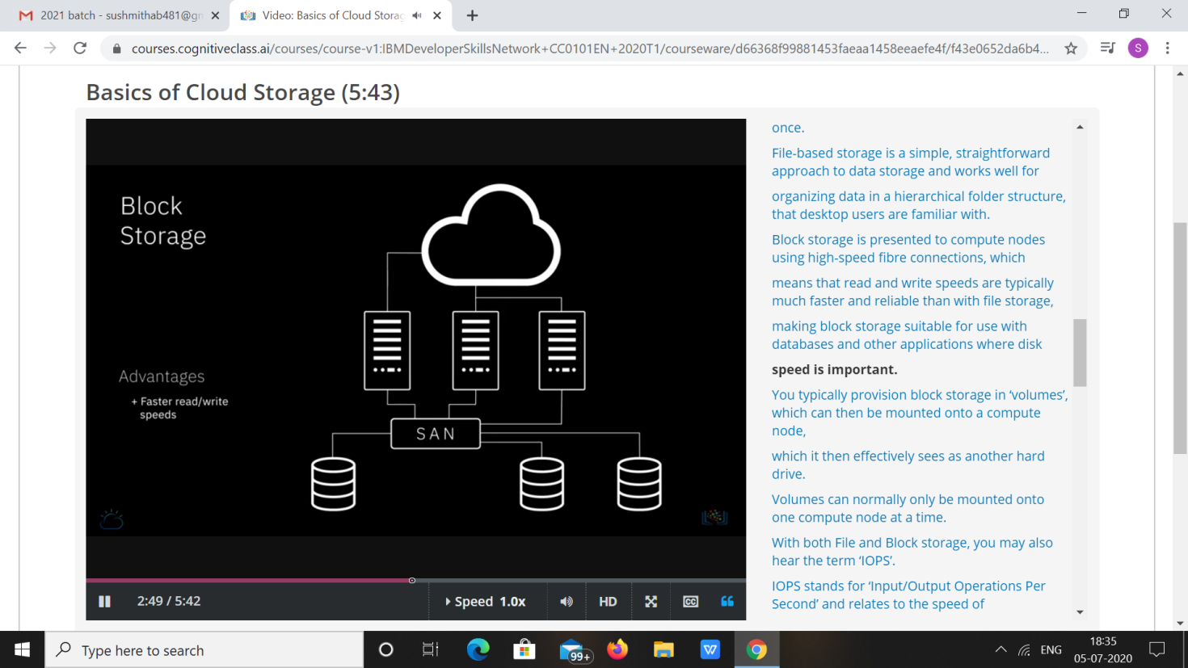

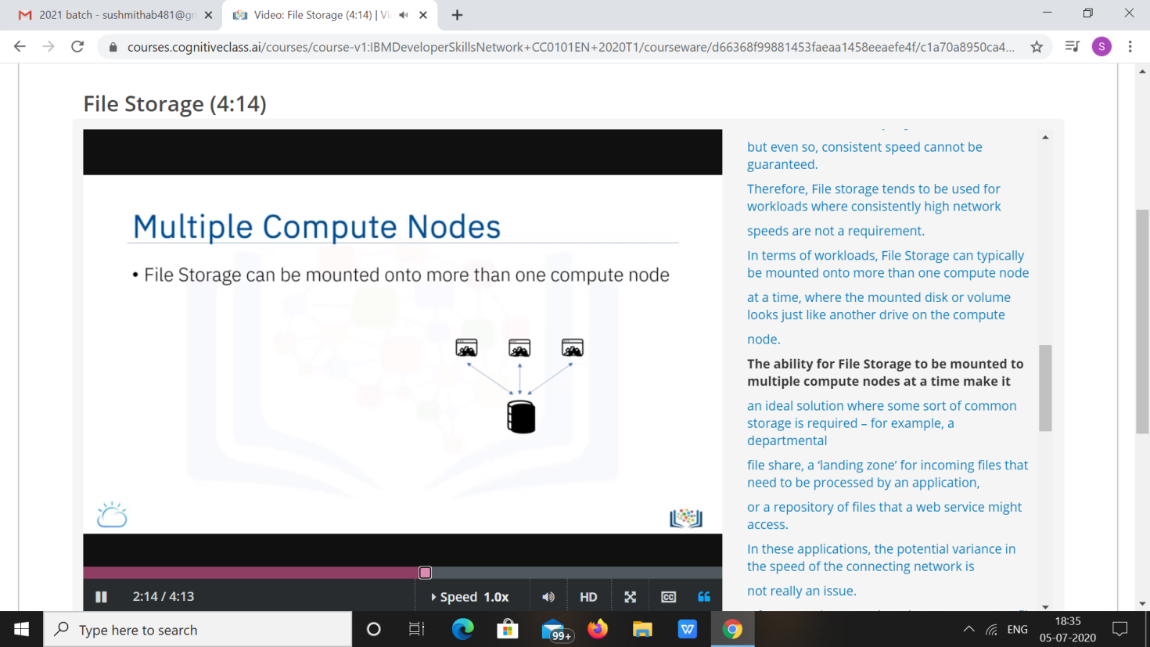

|  |  |
| --- | --- |
| **Coding Challenges** | |
| **Problem Statement: 1**.**Python Program to Append, Delete and Display Elements of a List Using Classes.** | |
| **Status: Executed** | |
| **Uploaded the report both in Github & Slack** | **Yes** |

**Snapshots of your response to challenge.**

1. ****Python Program to Append, Delete and Display Elements of a List Using Classes.****

**class check():**

**def __init__(self):**

**self.n=[]**

**def add(self,a):**

**return self.n.append(a)**

**def remove(self,b):**

**self.n.remove(b)**

**def dis(self):**

**return (self.n)**

**obj=check()**

**choice=1**

**while choice!=0:**

**print("0. Exit")**

**print("1. Add")**

**print("2. Delete")**

**print("3. Display")**

**choice=int(input("Enter choice: "))**

**if choice==1:**

**n=int(input("Enter number to append: "))**

**obj.add(n)**

**print("List: ",obj.dis())**

**elif choice==2:**

**n=int(input("Enter number to remove: "))**

**obj.remove(n)**

**print("List: ",obj.dis())**

**elif choice==3:**

**print("List: ",obj.dis())**

**elif choice==0:**

**print("Exiting!")**

**else:**

**print("Invalid choice!!")**

**print()**

****OUTPUT****

****