**DAILY REPORT**

**Student Name :SUSHMITHA.B.POOJARY**

**Class and Sec : VI B**

**USN :4AL17CS103**

**DATE:05-08-2020**

|  |  |  |  |  |
| --- | --- | --- | --- | --- |
| **Online Test Details** | | | | |
| **Subject** | **------** | | | |
| **Semester** | **VI -B** | | **Duration** | **----** |
| **% of marks ---** | | **-----** | | |

|  |  |  |  |
| --- | --- | --- | --- |
| **Certification Course Details** | | | |
| **Course** | **Python for Everybody** | | |
| **Certificate Provider** | **Coursera** | **Duration** | **19hours** |

**Snapshots of the daily class acitivities.**

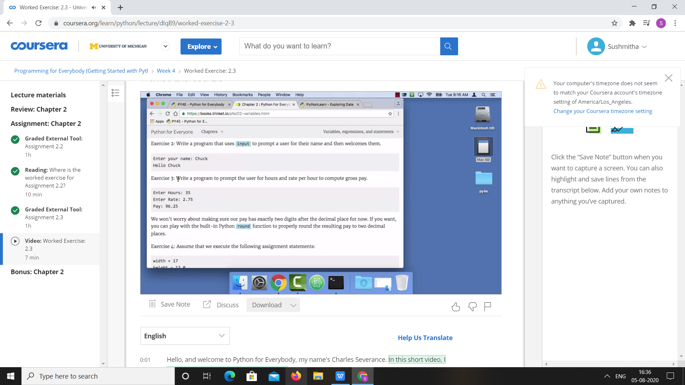



|  |  |
| --- | --- |
| **Coding Challenges** | |
| **Problem Statement:**1.**Python Program for Find sum of even factors of a number.** | |
| **Status:** Executed | |
| **Uploaded the report both in Github & Slack** | Yes |

**Snapshots of your response to challenge.**

****1. Python Program for Find sum of even factors of a number.****

import math

def sumofFactors(n) :

if (n % 2 != 0) :

return 0

res = 1

for i in range(2, (int)(math.sqrt(n)) + 1) :

count = 0

curr_sum = 1

curr_term = 1

while (n % i == 0) :

count= count + 1

n = n // i

if (i == 2 and count == 1) :

curr_sum = 0

curr_term = curr_term * i

curr_sum = curr_sum + curr_term

res = res * curr_sum

if (n >= 2) :

res = res * (1 + n)

return res

n = 18

print(sumofFactors(n))

OUTPUT

