**Snapshots of your response to challenge.**

**Coding Challenges Details:**

1. **Write a program in C to rotate an array by N positions.**

**Expected Output :**  
**The given array is :** 0 3 6 9 12 14 18 20 22 25 27  
Enter the Position N from where you want to rotate: 4  
From 4th position the values of the array are : 12 14 18 20 22 25 27  
Before 4th position the values of the array are : 0 3 6 9  
After rotating from 4th position the array is:  
12 14 18 20 22 25 27 0 3 6 9

#include <stdio.h>

void shiftArr1Pos(int *arr1, int arrSize)

{

int i, temp;

temp = arr1[0];

for(i = 0; i < arrSize-1; i++)

{

arr1[i] = arr1[i+1];

}

arr1[i] = temp;

}

void arr1Rotate(int *arr1, int arrSize, int rotFrom)

{

int i;

for(i = 0; i < rotFrom; i++)

{

shiftArr1Pos(arr1, arrSize);

}

return;

}

int main()

{

int arr1[] = {0,3,6,9,12,14,18,20,22,25,27};

int ctr = sizeof(arr1)/sizeof(arr1[0]);

int i;

printf("The given array is : ");

for(i = 0; i < ctr; i++)

{

printf("%d ", arr1[i]);

}

printf("\n");

printf("From 4th position the values of the array are : ");

for(i = 4; i < ctr; i++)

{

printf("%d ", arr1[i]);

}

printf("\n");

printf("Before 4th position the values of the array are : ");

for(i = 0; i < 4; i++)

{

printf("%d ", arr1[i]);

}

printf("\n");

arr1Rotate(arr1, ctr, 4);

printf("\nAfter rotating from 4th position the array is: \n");

for(i = 0; i<ctr; i++)

{

printf("%d ", arr1[i]);

}

return 0;

}

**Output:**

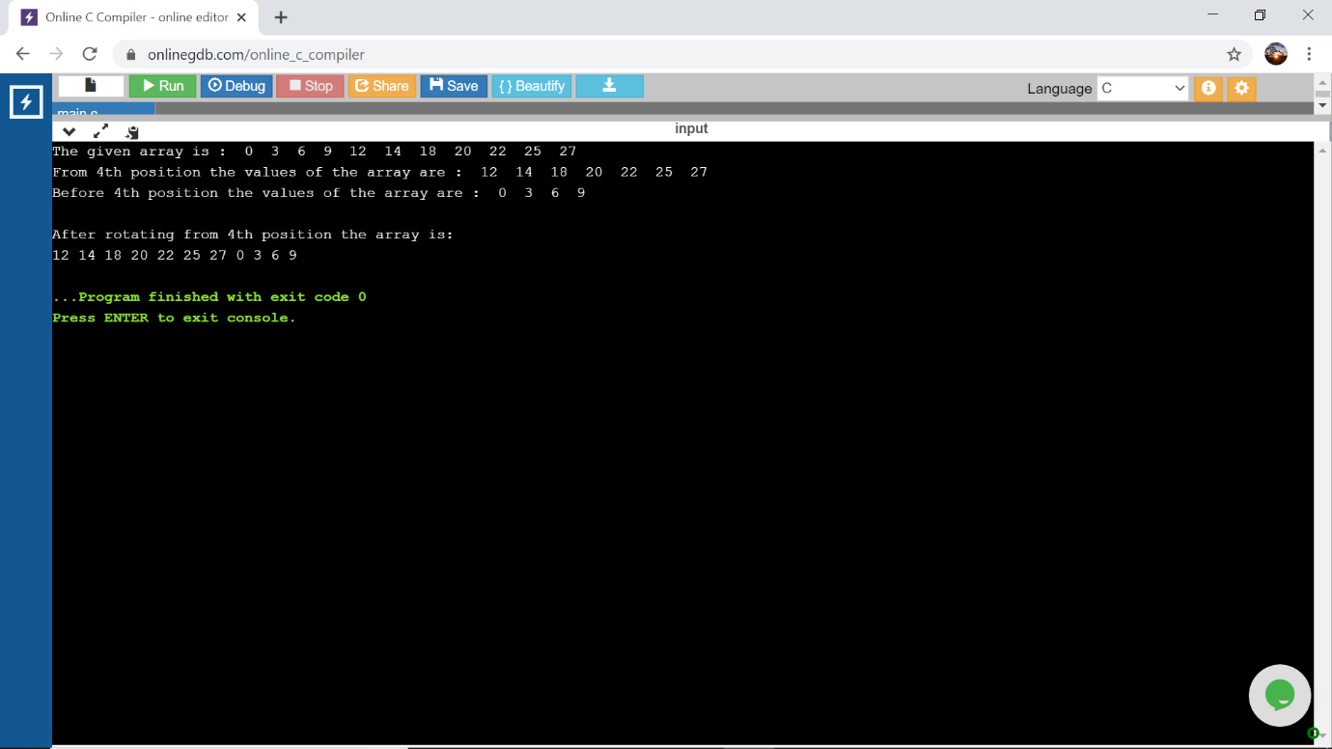

**2.Write a Python program to perform Cyclic Redundancy Check**

from math import log, ceil

def CRC(dataword, generator):

dword = int(dataword, 2)

l_gen = len(generator)

dividend = dword << (l_gen - 1)

shft = ceil(log(dividend + 1, 2)) - l_gen

generator = int(generator, 2)

while dividend >= generator or shft >= 0:

rem = (dividend >> shft) ^ generator

dividend = (dividend & ((1 << shft) - 1)) | (rem << shft)

shft = ceil(log(dividend+1, 2)) - l_gen

codeword = dword << (l_gen-1)|dividend

print("Remainder: ", bin(dividend).lstrip("-0b"))

print("Codeword : ", bin(codeword).lstrip("-0b"))

dataword = input("Enter Dataword: \n")

generator = input("Enter Key: \n")

CRC(dataword, generator)

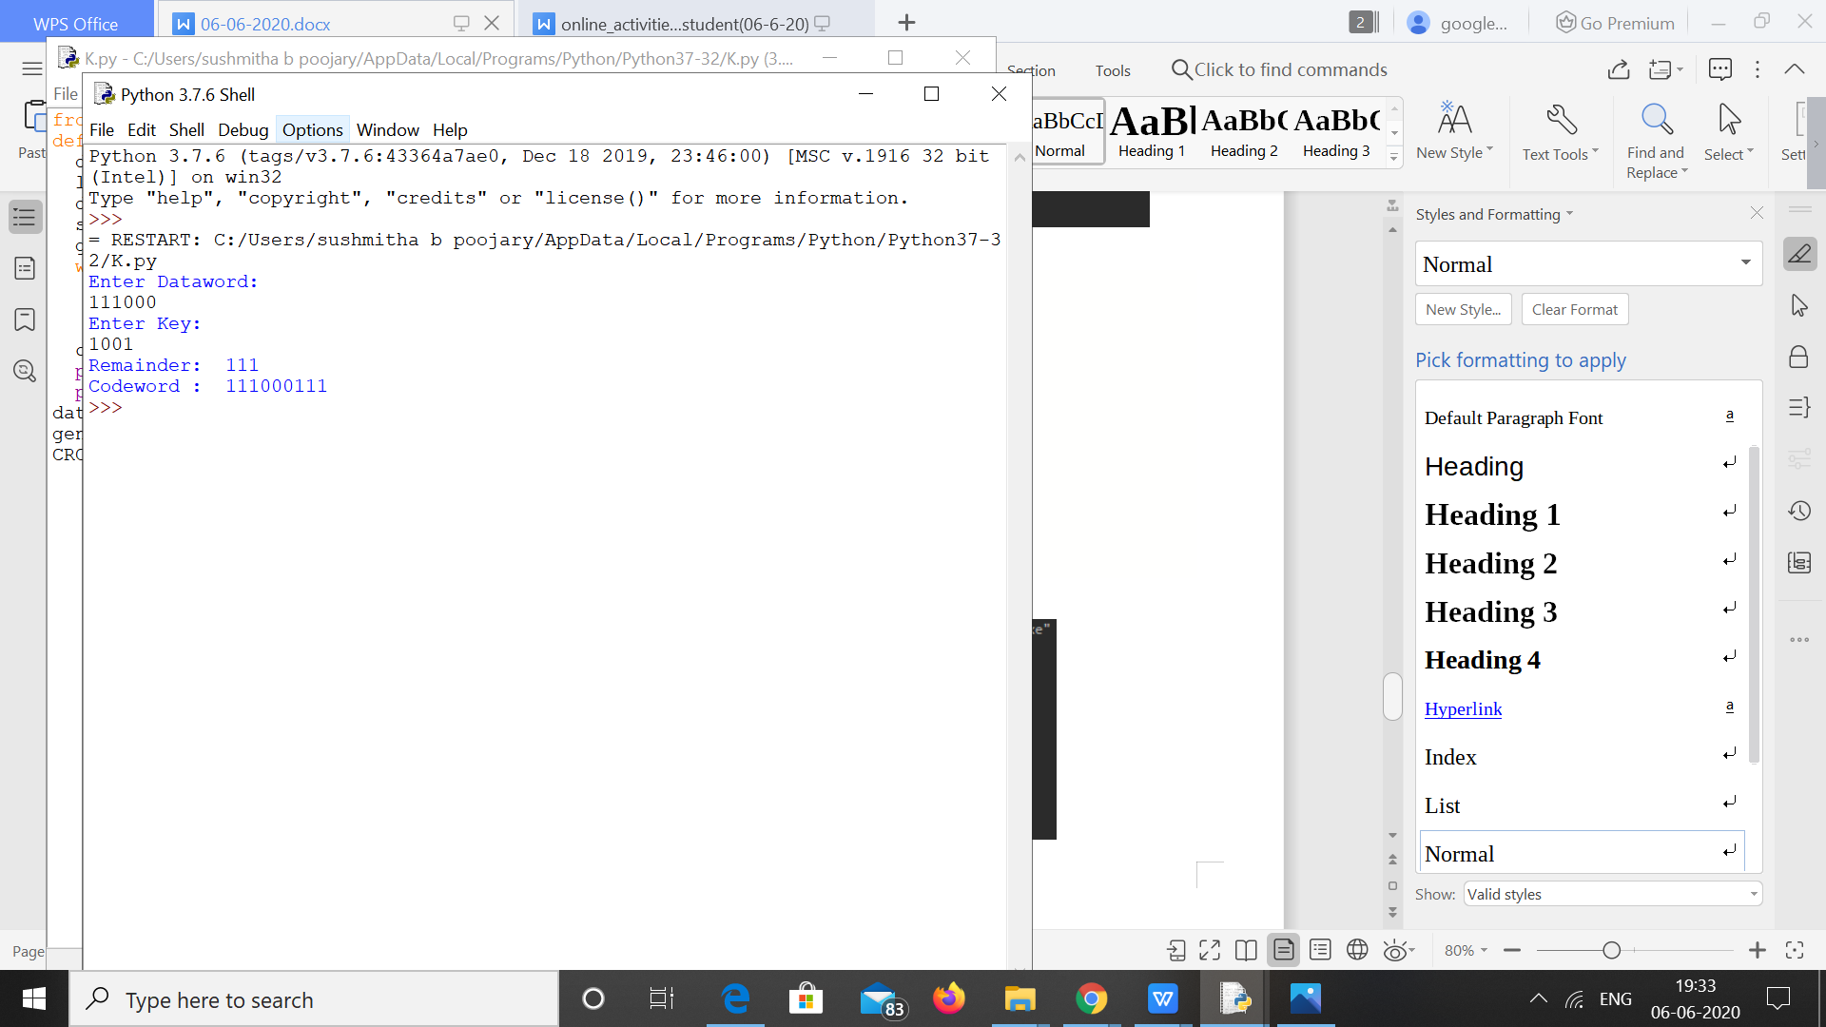

**3.Write a Python program to count the number of strings, provided string length is 2 or more and the first and last character are same from a given list of strings.**

n = int(input("Enter Number Of Strings: "))

a = []

print("Enter The Strings With Length>1: ")

for i in range(n):

a.append(input())

j=0

for i in a:

if(i[0]==i[len(i)-1]):

j+=1

print("Number Of Strings With First And Last Character Is Same: ",j)

**Output:**

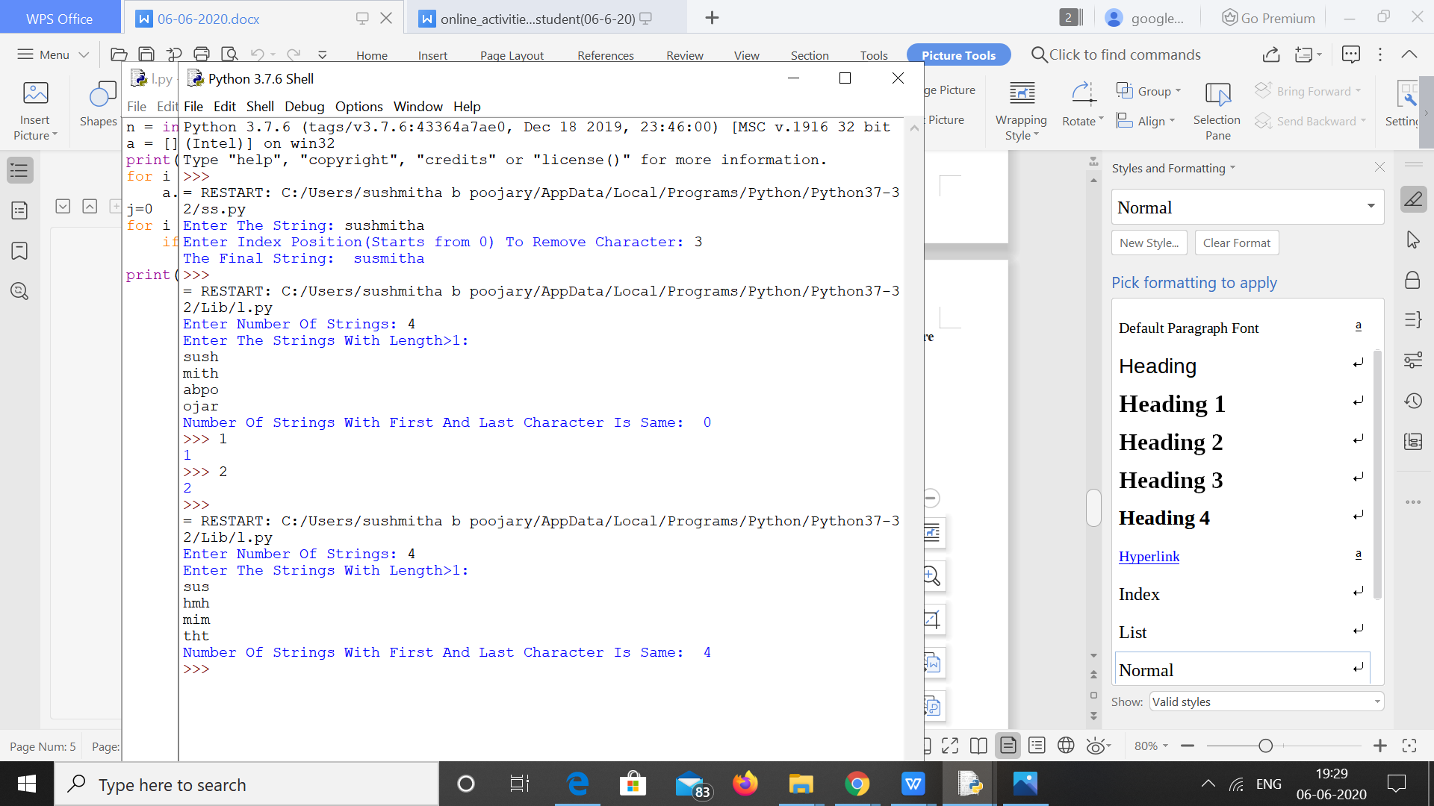

4**.Python Program to Count the Occurrences of a Word in a Text File.**

t = open("SUSHMITHA.txt","r")

d = dict()

for l in t:

a = l.strip()

b = a.lower()

words = b.split(" ")

for w in words:

if w in d:

d[w] = d[w]+1

else:

d[w] = 1

for i in list(d.keys()):

print(i, ":", d[i])

SUSHMITHA.txt

sushmitha poojary

b poojary

poojary sushmitha

suvarna b

