**DAILY REPORT**

**Student Name :SUSHMITHA.B.POOJARY**

**Class and Sec : VI B**

**USN :4AL17CS103**

**DATE:07-06-2020**

|  |  |  |  |  |
| --- | --- | --- | --- | --- |
| **Online Test Details** | | | | |
| **Subject** | **SSCD** | | | |
| **Semester** | **VI -B** | | **Duration** | **60 Minutes** |
| **% of marks 30** | | **24** | | |

**Snapshot of the test result**

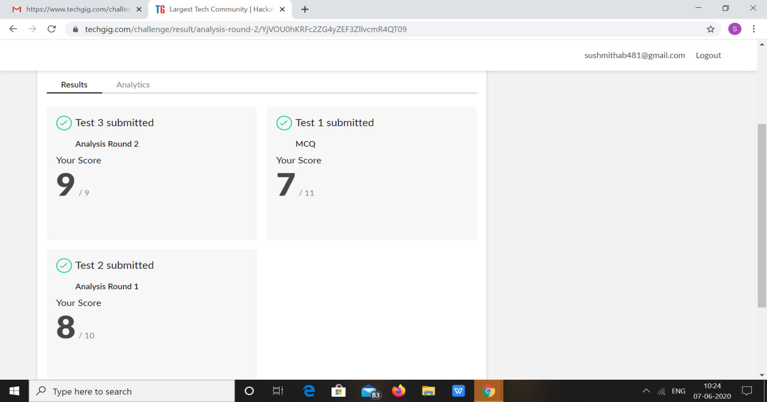

|  |  |  |  |
| --- | --- | --- | --- |
| **Certification Course Details** | | | |
| **Course** | **Introduction to cyber security** | | |
| **Certificate Provider** | **Great Learning** | **Duration** | **5.5Hours** |

**Snapshots of the daily class acitivities**



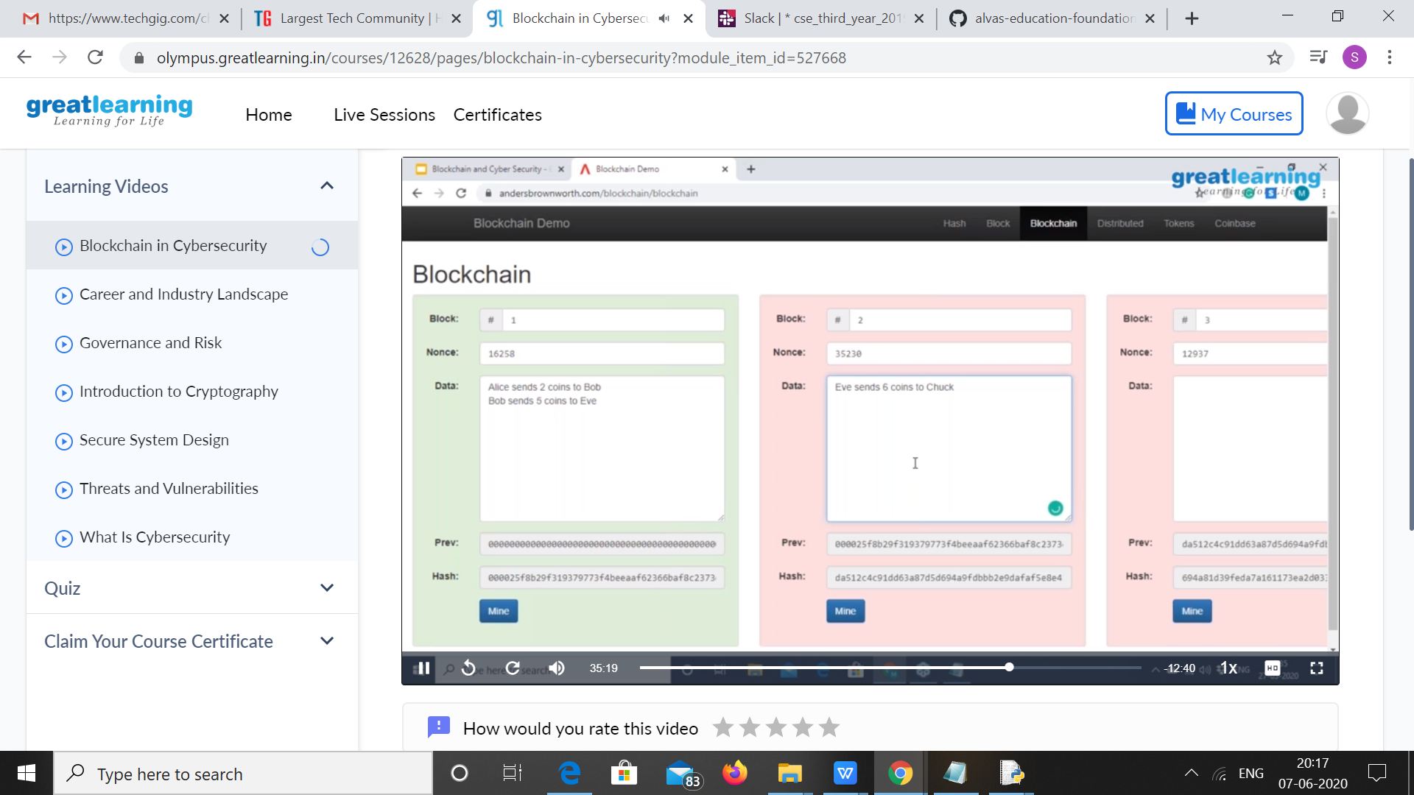

|  |  |
| --- | --- |
| **Coding Challenges** | |
| **Problem Statement:** 1.write a java Program to print smallest and biggest possible palindrome word in a given string.  2.Python program the first and last 5 elements.  3. **Python Program to Copy the Contents of One File into Another.** | |
| **Status: Executed** | |
| **Uploaded the report both in Github & Slack** | **Yes** |

**Snapshots of your response to challenge.**

**1.write a java Program to print smallest and biggest possible palindrome word in a given string**

public class Main

{

    public static boolean isPalindrome(String a){

        boolean flag = true;

        for(int i = 0; i < a.length()/2; i++){

            if(a.charAt(i) != a.charAt(a.length()-i-1)){

                flag = false;

                break;

            }

        }

        return flag;

    }

    public static void main(String[] args){

        String string = "Wow you own kayak";

        String word = "", smallPalin = "", bigPalin="";

        String[] words = new String[100];

        int temp = 0, count = 0;

        string = string.toLowerCase();

        string = string + " ";

        for(int i = 0; i < string.length(); i++){

            if(string.charAt(i) != ' '){

                word = word + string.charAt(i);

            }

            else{

                words[temp] = word;

                temp++;

                word = "";

            }

        }

        for(int i = 0; i< temp; i++){

            if(isPalindrome(words[i])){

                count++;

                if(count == 1)

                    smallPalin = bigPalin = words[i];

                else{

                    if(smallPalin.length() > words[i].length())

                        smallPalin = words[i];

                    if(bigPalin.length() < words[i].length())

                        bigPalin = words[i];

                }

            }

        }

        if(count == 0)

            System.out.println("No palindrome is present in the given string");

        else{

            System.out.println("Smallest palindromic word: " + smallPalin);

            System.out.println("Biggest palindromic word: " + bigPalin);

        }

    }

}

Output:

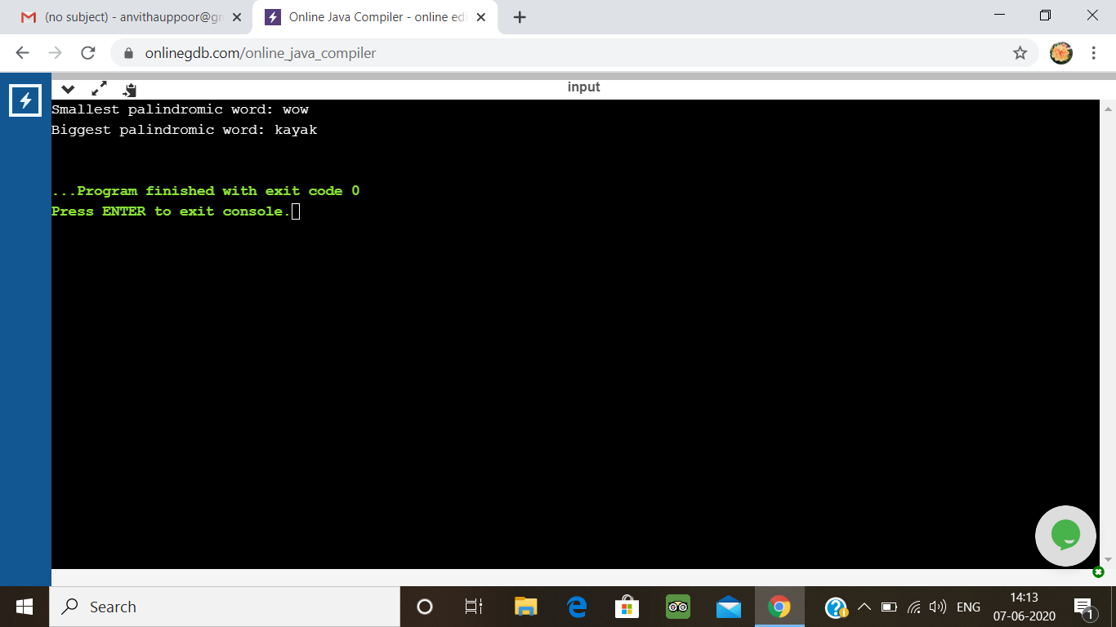

**2. Python program the first and last 5 elements**

Description:  
Print a list of first and last 5 elements where the values are square of numbers between 1 and 30 (both included)

Eg: If the range of elements is 20  
Then output is:  
[1,4,9,16,25]  
[256,289,324,361,400]  
If the elements begins from 5 to 30  
Then output is:  
[25,36,49,64,81]  
[676,729,784,841,900]

def printValues():

l = list()

for i in range(1,20):

l.append(i**2)

print(l[:5])

print(l[-5:])

printValues()

**output:**

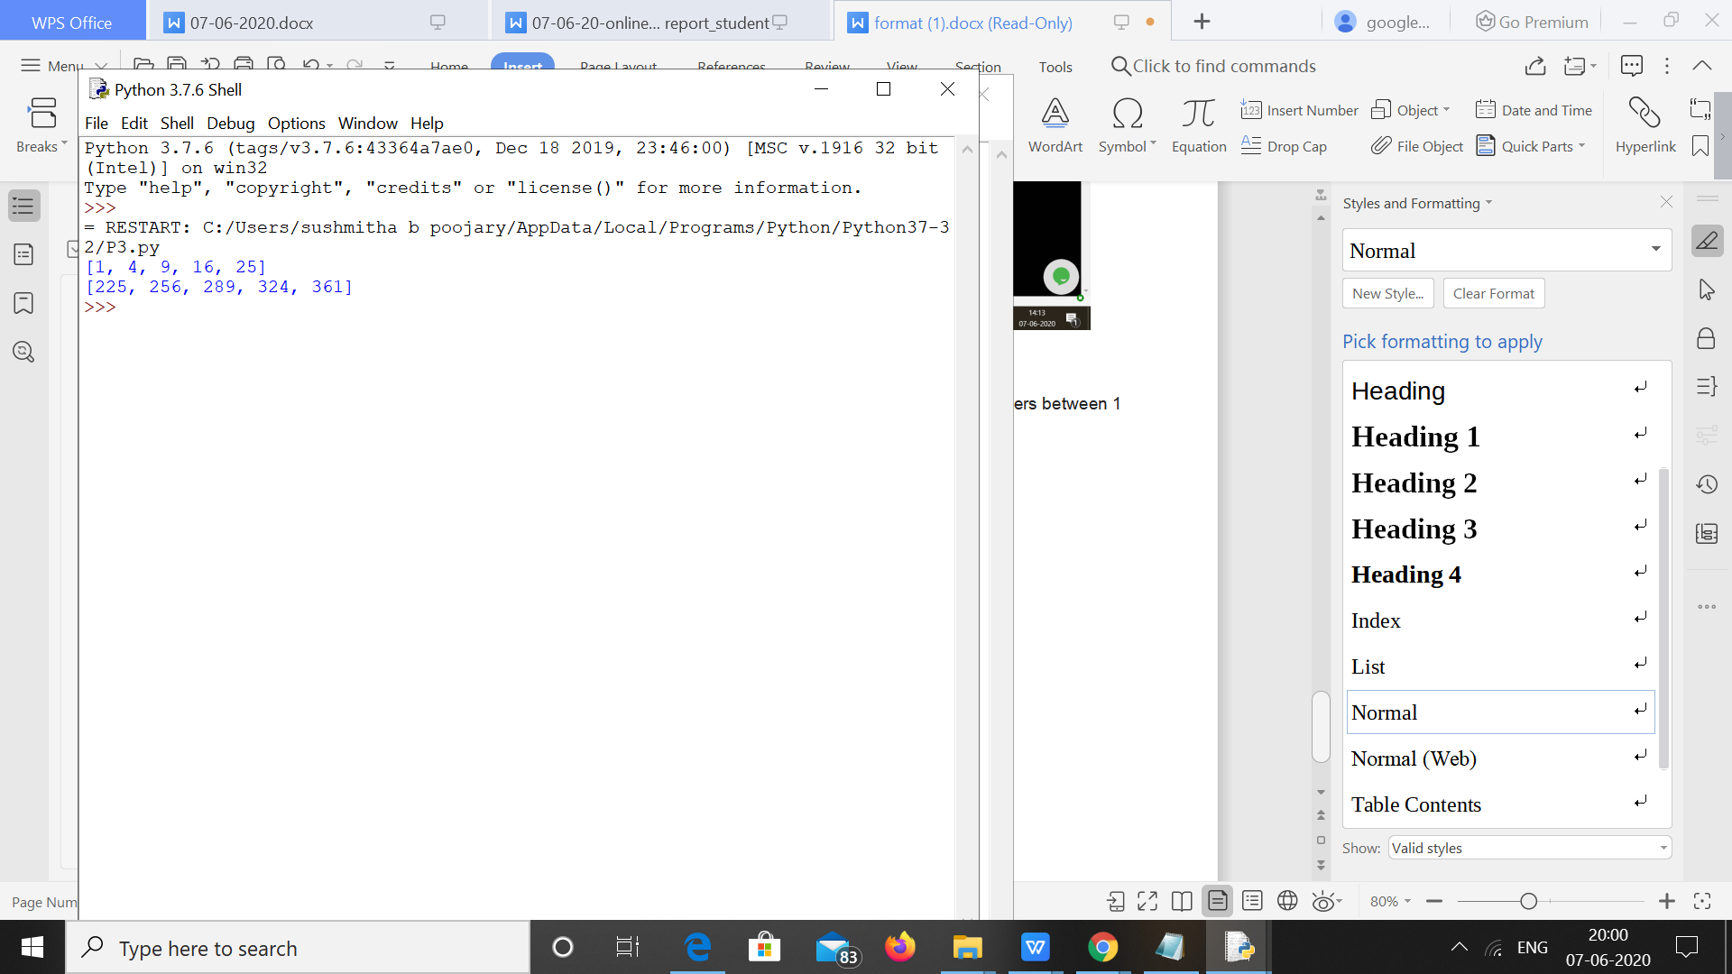

**3. Python Program to Copy the Contents of One File into Another.**

print("Contents Of File-1:\n\r",(open("SUSHMITHA.txt", "r")).read())

print("Before Coping Contents Of File-2: \n", (open("SUSH.txt", "r")).read())

f1 = open("SUSHMITHA.txt", "r")

f2 = open("SUSH.txt", "w")

for l in f1:

f2.write(l)

f2.close()

print("After Coping Contents Of File-2: \n", (open("SUSH.txt", "r")).read())

**Output:**

