**DAILY REPORT**

**Student Name :SUSHMITHA.B.POOJARY**

**Class and Sec : VI B**

**USN :4AL17CS103**

**DATE:07-07-2020**

|  |  |  |  |  |
| --- | --- | --- | --- | --- |
| **Online Test Details** | | | | |
| **Subject** | **CGV** | | | |
| **Semester** | **VI -B** | | **Duration** | **------** |
| **% of marks 30** | | **----------** | | |

|  |  |  |  |
| --- | --- | --- | --- |
| **Certification Course Details** | | | |
| **Course** | **Python for Everbody** | | |
| **Certificate Provider** | **Coursera** | **Duration** | **19hours** |

**Snapshots of the daily class acitivities**

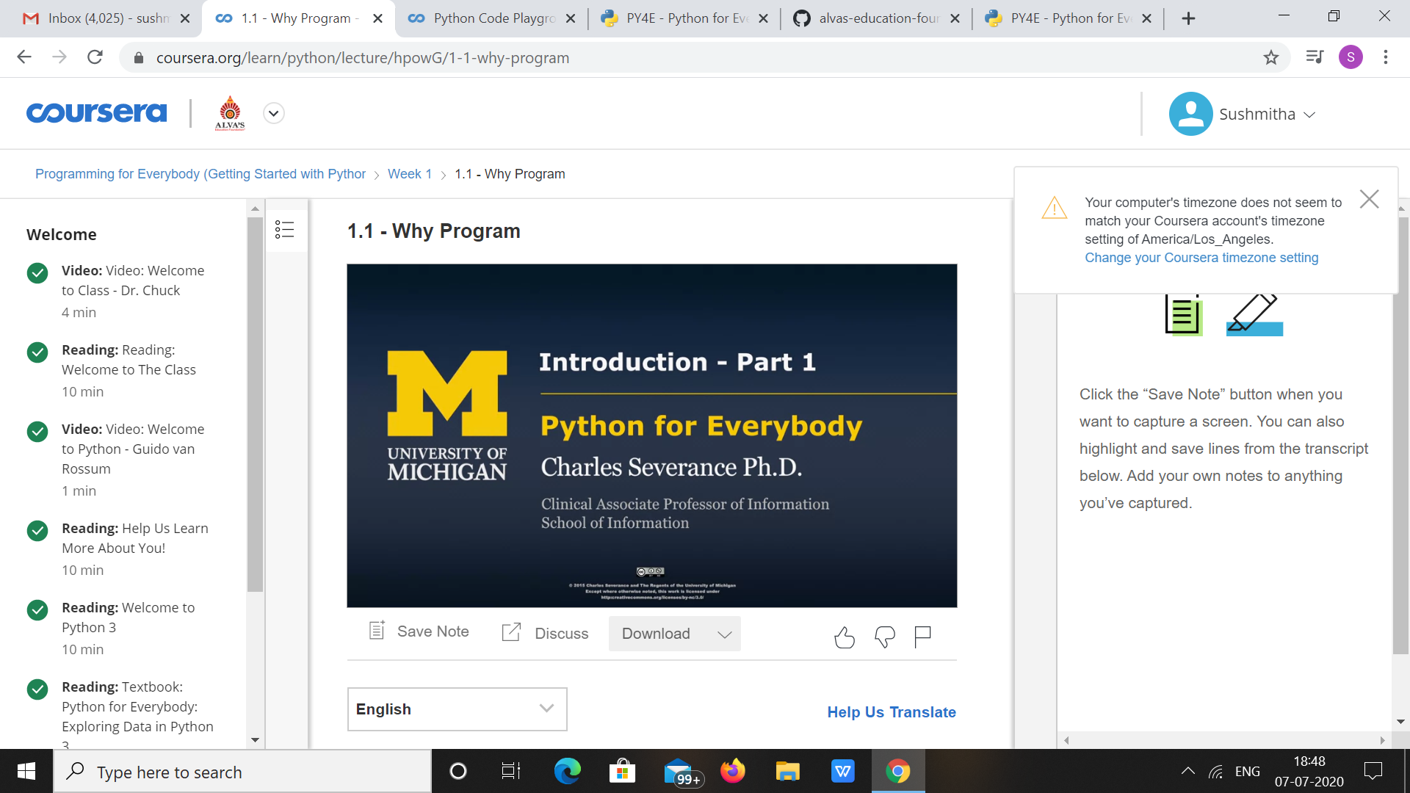

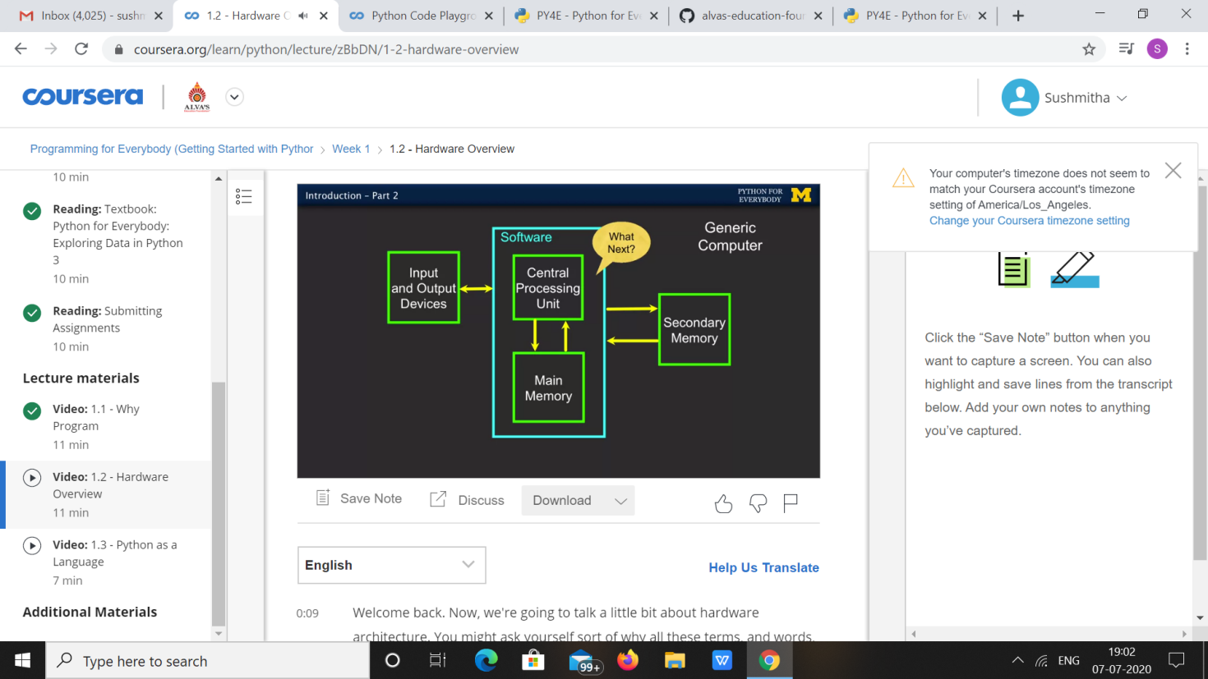

|  |  |
| --- | --- |
| **Coding Challenges** | |
| **Problem Statement: 1.**Write a C program to count number of digits. | |
| **Status: Executed** | |
| **Uploaded the report both in Github & Slack** | **Yes** |

**Snapshots of your response to challenge.**

**1.Write a C program to count number of digits**.

#include <stdio.h>

int main() {

long long n;

int count = 0;

printf("Enter an integer: ");

scanf("%lld", &n);

while (n != 0) {

n /= 10; // n = n/10

++count;

}

printf("Number of digits: %d", count);

}

**Output:**

