**DAILY REPORT**

**Student Name :SUSHMITHA.B.POOJARY**

**Class and Sec : VI B**

**USN :4AL17CS103**

**DATE:07-08-2020**

|  |  |  |  |  |
| --- | --- | --- | --- | --- |
| **Online Test Details** | | | | |
| **Subject** | **------** | | | |
| **Semester** | **VI -B** | | **Duration** | **----** |
| **% of marks ---** | | **-----** | | |

|  |  |  |  |
| --- | --- | --- | --- |
| **Certification Course Details** | | | |
| **Course** | **Python for Everybody** | | |
| **Certificate Provider** | **Coursera** | **Duration** | **19hours** |

**Snapshots of the daily class acitivities.**

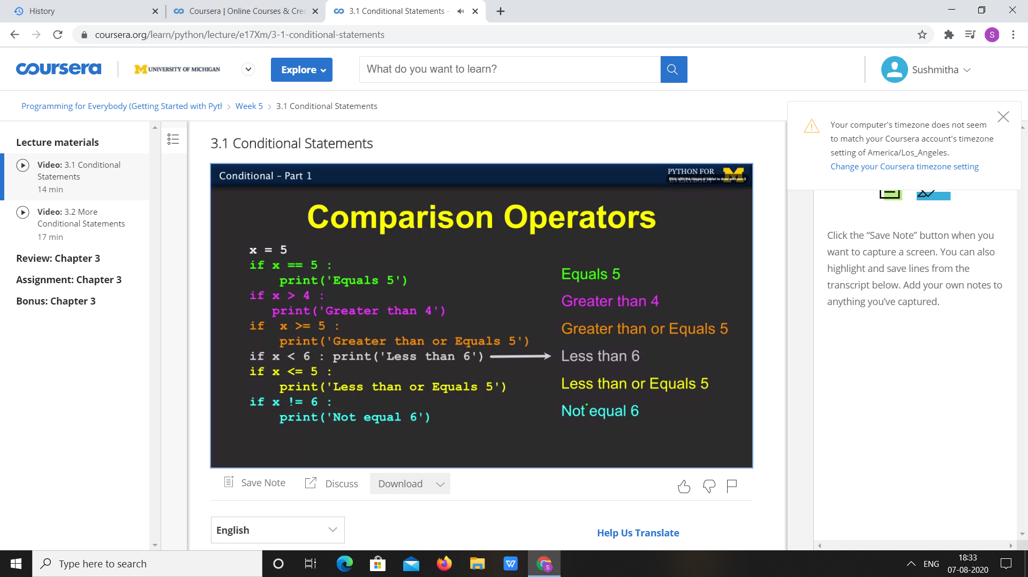

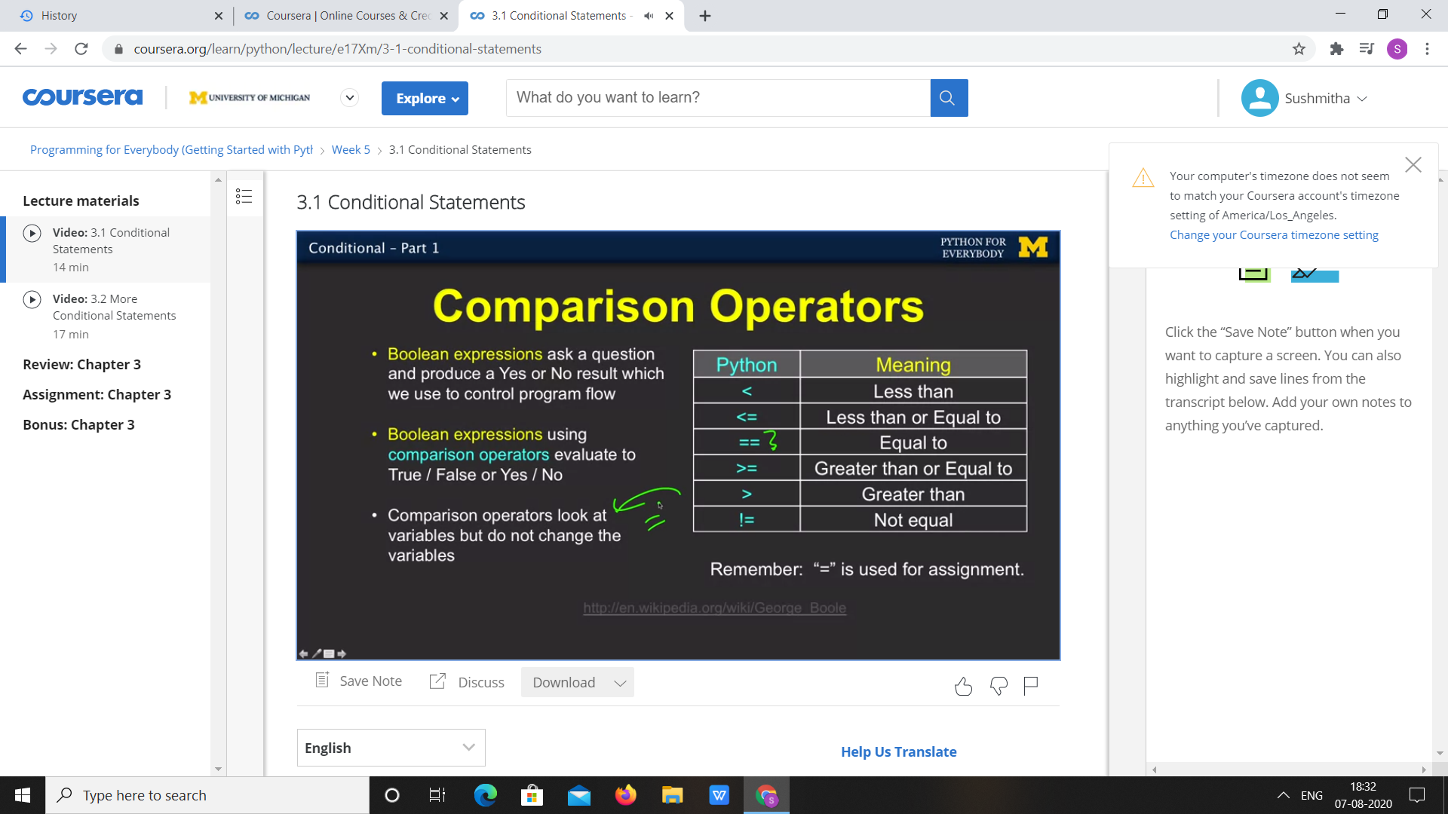

|  |  |
| --- | --- |
| **Coding Challenges** | |
| **Problem Statement:** 1.**Python Program for Check if all digits of a number divide it.** | |
| **Status:**  Executed | |
| **Uploaded the report both in Github & Slack** | Yes |

**Snapshots of your response to challenge.**

1. ****Python Program for Check if all digits of a number divide it.****

**def checkDivisibility(n, digit) :**

**return (digit != 0 and n % digit == 0)**

**def allDigitsDivide( n) :**

**temp = n**

**while (temp > 0) :**

**digit = n % 10**

**if ((checkDivisibility(n, digit)) == False) :**

**return False**

**temp = temp // 10**

**return True**

**n = 128**

**if (allDigitsDivide(n)) :**

**print("Yes")**

**else :**

**print("No" )**

****OUTPUT****

