1**.Write C++ program to Check whether a number can be represented as difference of two squares**

#include <iostream>

using namespace std;

bool checkPrime(int n);

int main()

{

int n, i;

bool flag = false;

cout << "Enter a positive integer: ";

cin >> n;

for(i = 2; i <= n/2; ++i)

{

if (checkPrime(i))

{

if (checkPrime(n - i))

{

cout << n << " = " << i << " + " << n-i << endl;

flag = true;

}

}

}

if (!flag)

cout << n << " can't be expressed as sum of two prime numbers.";

return 0;

}

// Check prime number

bool checkPrime(int n)

{

int i;

bool isPrime = true;

for(i = 2; i <= n/2; ++i)

{

if(n % i == 0)

{

isPrime = false;

break;

}

}

return isPrime;

}

**Output:**

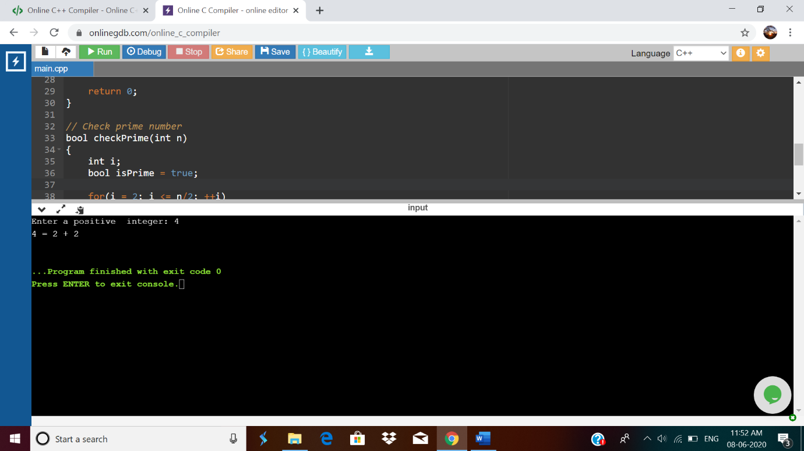

**2.C Program to Generate All the Set Partitions of n Numbers Beginning from 1 and so on**

#include <stdio.h>

#include <stdlib.h>

typedef struct {

int first;

int n;

int level;

} Call;

void print(int n, int * a) {

int i ;

for (i = 0; i <= n; i++) {

printf("%d", a[i]);

}

printf("\n");

}

void integerPartition(int n, int * a){

int first;

int i;

int top = 0;

int level = 0;

Call * stack = (Call * ) malloc (sizeof(Call) * 1000);

stack[0].first = -1;

stack[0].n = n;

stack[0].level = level;

while (top >= 0){

first = stack[top].first;

n = stack[top].n;

level = stack[top].level;

if (n >= 1) {

if (first == - 1) {

a[level] = n;

print(level, a);

first = (level == 0) ? 1 : a[level-1];

i = first;

} else {

i = first;

i++;

}

if (i <= n / 2) {

a[level] = i;

stack[top].first = i;

top++;

stack[top].first = -1;

stack[top].n = n - i;

stack[top].level = level + 1;

} else {

top--;

}

} else {

top --;

}

}

}

int main(){

int N = 1;

int * a = (int * ) malloc(sizeof(int) * N);

int i;

printf("\nEnter a number N to generate all set partition from 1 to N: ");

scanf("%d", &N);

for ( i = 1; i <= N; i++)

{

printf("\nInteger partition for %d is: \n", i);

integerPartition (i, a);

}

return(0);

}

**Output:**

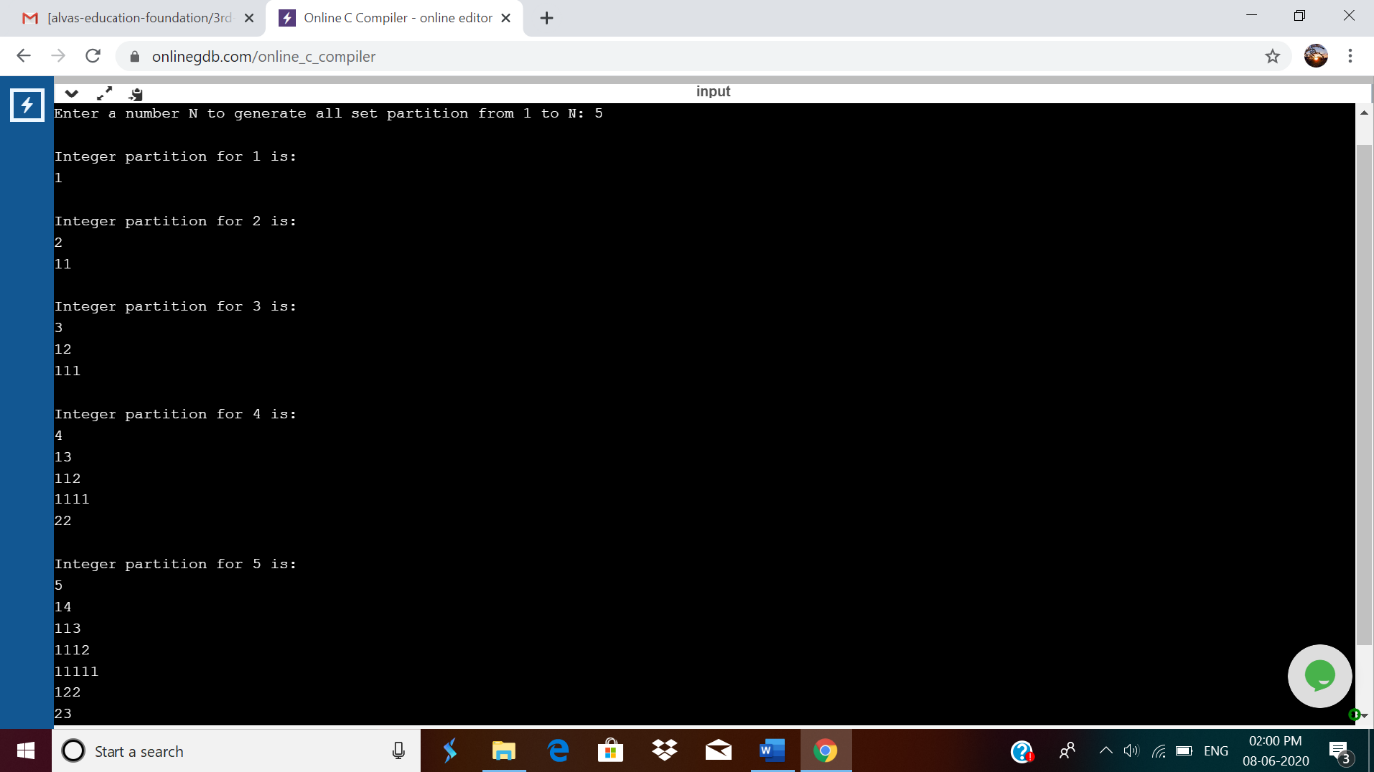

3**. Java program to delete a node from the middle of the singly linked list**

In this program, we will create a singly linked list and delete a node from the middle of the list. To accomplish this task, we will calculate the size of the list and then divide it by 2 to get the mid-point of the list. Node temp will point to head node. We will iterate through the list till midpoint is reached. Now, the temp will point to middle node and node current will point to node previous to temp. We delete the middle node such that current's next node will point to temp's next node.

public class deleteMid{

class Node{

int data;

Node next;

public Node(int data)

{

this.data = data;

this.next = null;

}

}

public Node head = null;

public Node tail = null;

public int size;

public void addNode(int data) {

Node newNode = new Node(data);

if(head == null) {

head = newNode;

tail = newNode;

}

else {

tail.next = newNode;

tail = newNode;

}

size++;

}

void deleteFromMid() {

Node temp, current;

if(head == null) {

System.out.println("List is empty");

return;

}

else {

int count = (size % 2 == 0) ? (size/2) : ((size+1)/2);

if( head != tail ) {

temp = head;

current = null;

for(int i = 0; i < count-1; i++){

current = temp;

temp = temp.next;

}

if(current != null) {

current.next = temp.next;

temp = null;

}

else {

head = tail = temp.next;

temp = null;

}

}

else {

head = tail = null;

}

}

size--;

}

public void display() {

Node current = head;

if(head == null) {

System.out.println("List is empty");

return;

}

while(current != null) {

System.out.print(current.data + " ");

current = current.next;

}

System.out.println();

}

public static void main(String[] args) {

deleteMid sList = new deleteMid();

sList.addNode(1);

sList.addNode(2);

sList.addNode(3);

sList.addNode(4);

System.out.println("Original List: ");

sList.display();

while(sList.head != null) {

sList.deleteFromMid();

System.out.println("Updated List: ");

sList.display();

}

}

}

**Output:**

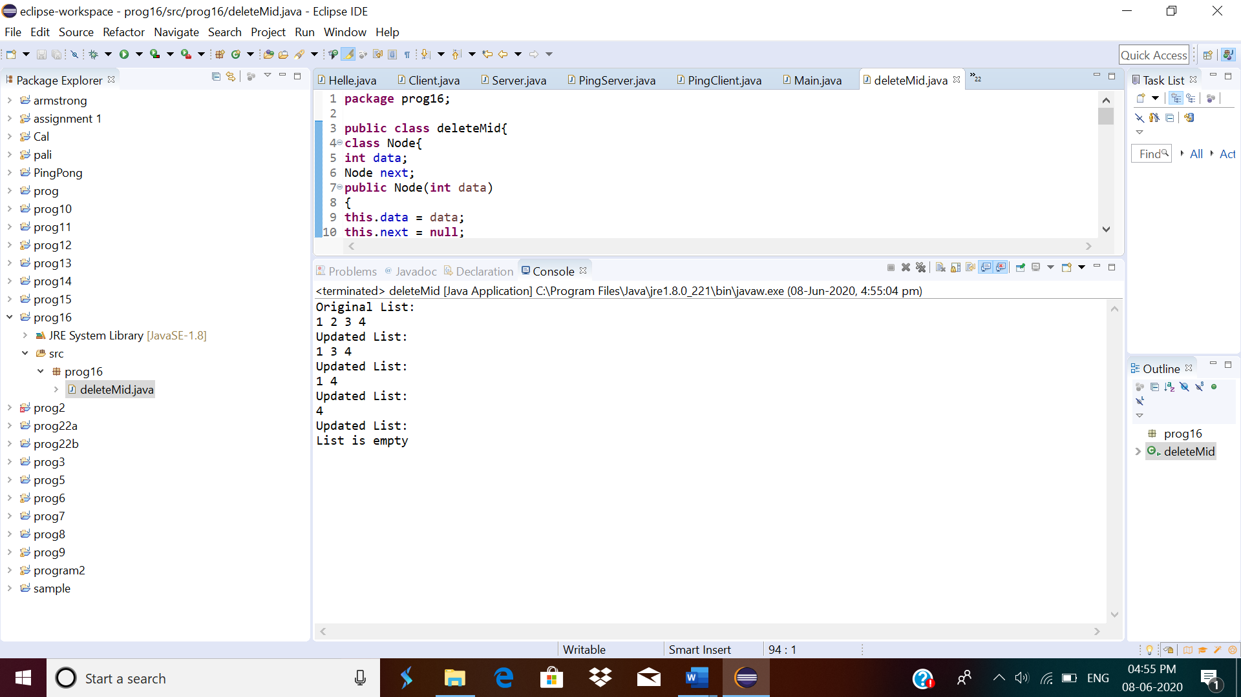

4.  Program program to find whether a string is a palindrome or not

Description:  
Write a python function that will take a string and checks whether it is a palindrome or not. Return If it a palindrome, print true else print false

Eg: String is : 'aba'  
Output: True

def isPalindrome(s):

return s == s[::-1]

s = input()

ans = isPalindrome(s)

if ans:

print("Yes")

else:

print("No")

**output:**

