**DAILY REPORT**

**Student Name :SUSHMITHA.B.POOJARY**

**Class and Sec : VI B**

**USN :4AL17CS103**

**DATE:08-07-2020**

|  |  |  |  |  |
| --- | --- | --- | --- | --- |
| **Online Test Details** | | | | |
| **Subject** | **-----------** | | | |
| **Semester** | **VI -B** | | **Duration** | **-----** |
| **% of marks** | | **-----------** | | |

|  |  |  |  |
| --- | --- | --- | --- |
| **Certification Course Details** | | | |
| **Course** | **Python for everybody** | | |
| **Certificate Provider** | **Coursera** | **Duration** | **19hours** |

**Snapshots of the daily class acitivities.**

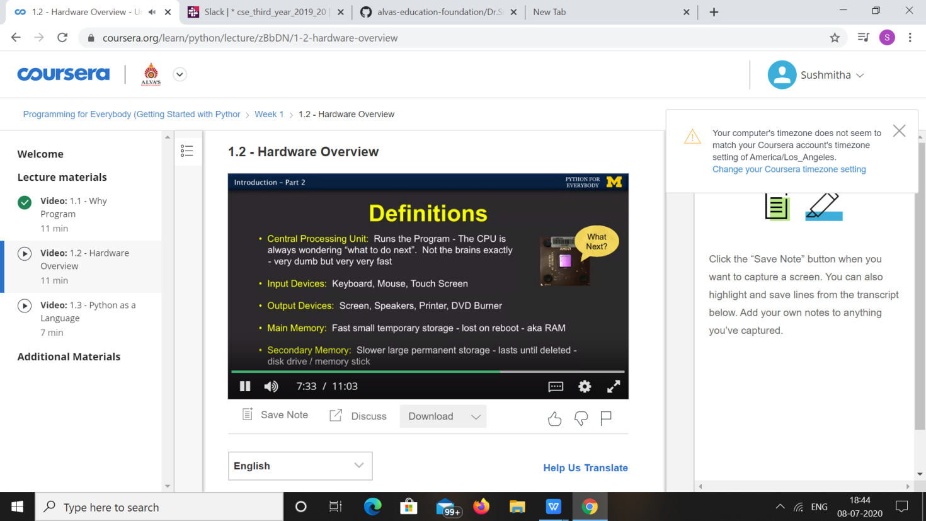

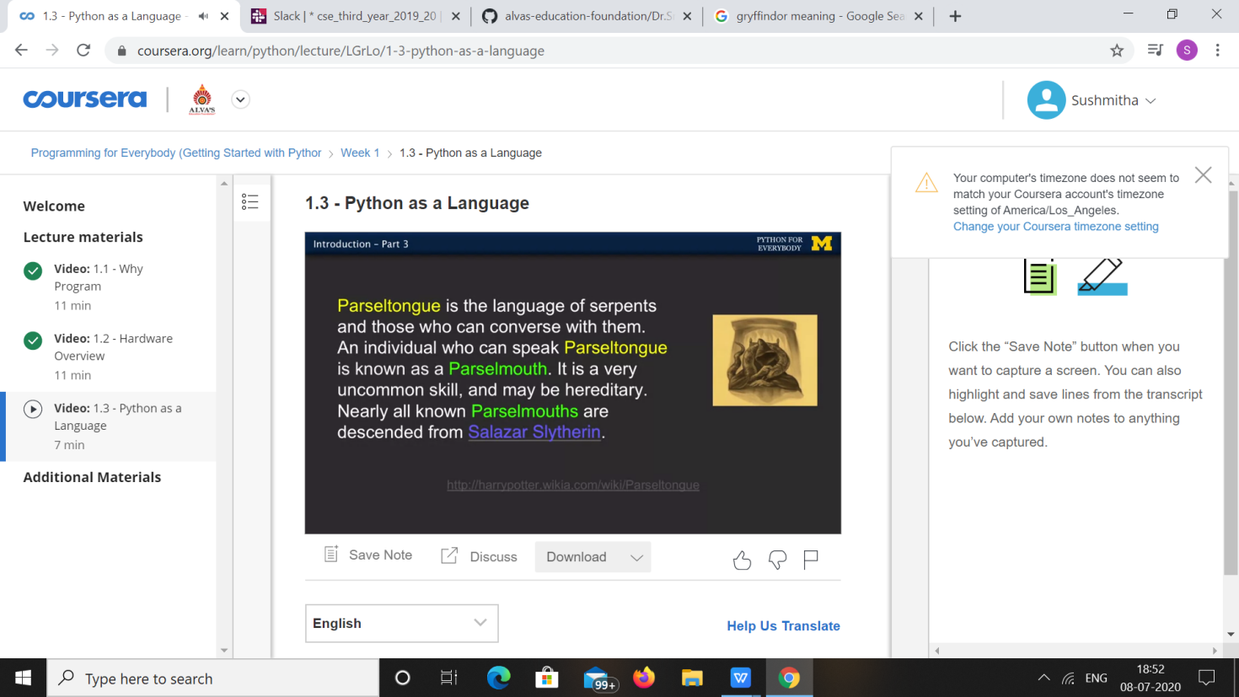

|  |  |
| --- | --- |
| **Coding Challenges** | |
| **Problem Statement:** 1.Python program to reverse a linked list. | |
| **Status:** Executed | |
| **Uploaded the report both in Github & Slack** | Yes |

**Snapshots of your response to challenge.**

1. **Python program to reverse a linked list.**

class Node:

def __init__(self, data):

self.data = data

self.next = None

class LinkedList:

def __init__(self):

self.head = None

self.last_node = None

def append(self, data):

if self.last_node is None:

self.head = Node(data)

self.last_node = self.head

else:

self.last_node.next = Node(data)

self.last_node = self.last_node.next

def display(self):

current = self.head

while current:

print(current.data, end = ' ')

current = current.next

def reverse_llist(llist):

before = None

current = llist.head

if current is None:

return

after = current.next

while after:

current.next = before

before = current

current = after

after = after.next

current.next = before

llist.head = current

a_llist = LinkedList()

data_list = input('Please enter the elements in the linked list: ').split()

for data in data_list:

a_llist.append(int(data))

reverse_llist(a_llist)

print('The reversed list: ')

a_llist.display()

**OUTPUT**

