**DAILY REPORT**

**Student Name :SUSHMITHA.B.POOJARY**

**Class and Sec : VI B**

**USN :4AL17CS103**

**DATE:08-08-2020**

|  |  |  |  |  |
| --- | --- | --- | --- | --- |
| **Online Test Details** | | | | |
| **Subject** | **------** | | | |
| **Semester** | **VI -B** | | **Duration** | **----** |
| **% of marks ---** | | **-----** | | |

|  |  |  |  |
| --- | --- | --- | --- |
| **Certification Course Details** | | | |
| **Course** | **Python for Everybody** | | |
| **Certificate Provider** | **Coursera** | **Duration** | **19hours** |

**Snapshots of the daily class acitivities.**

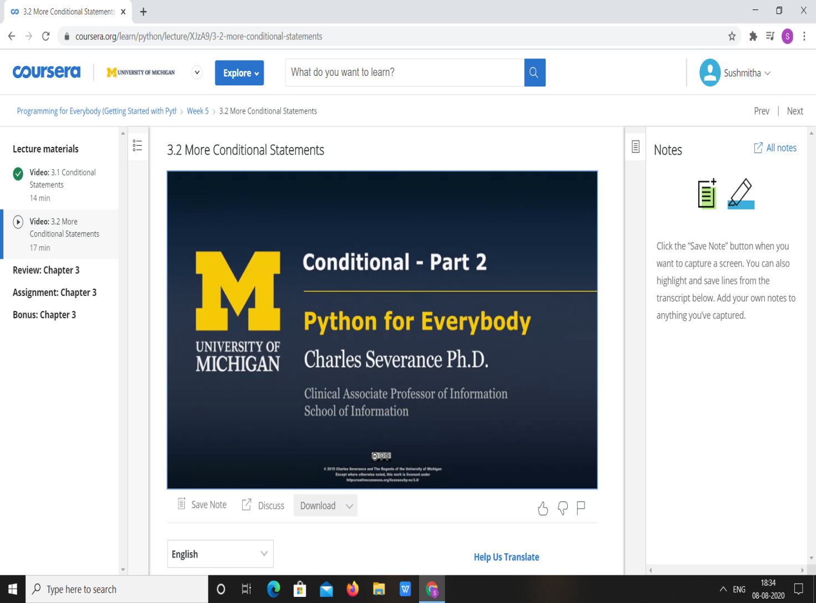

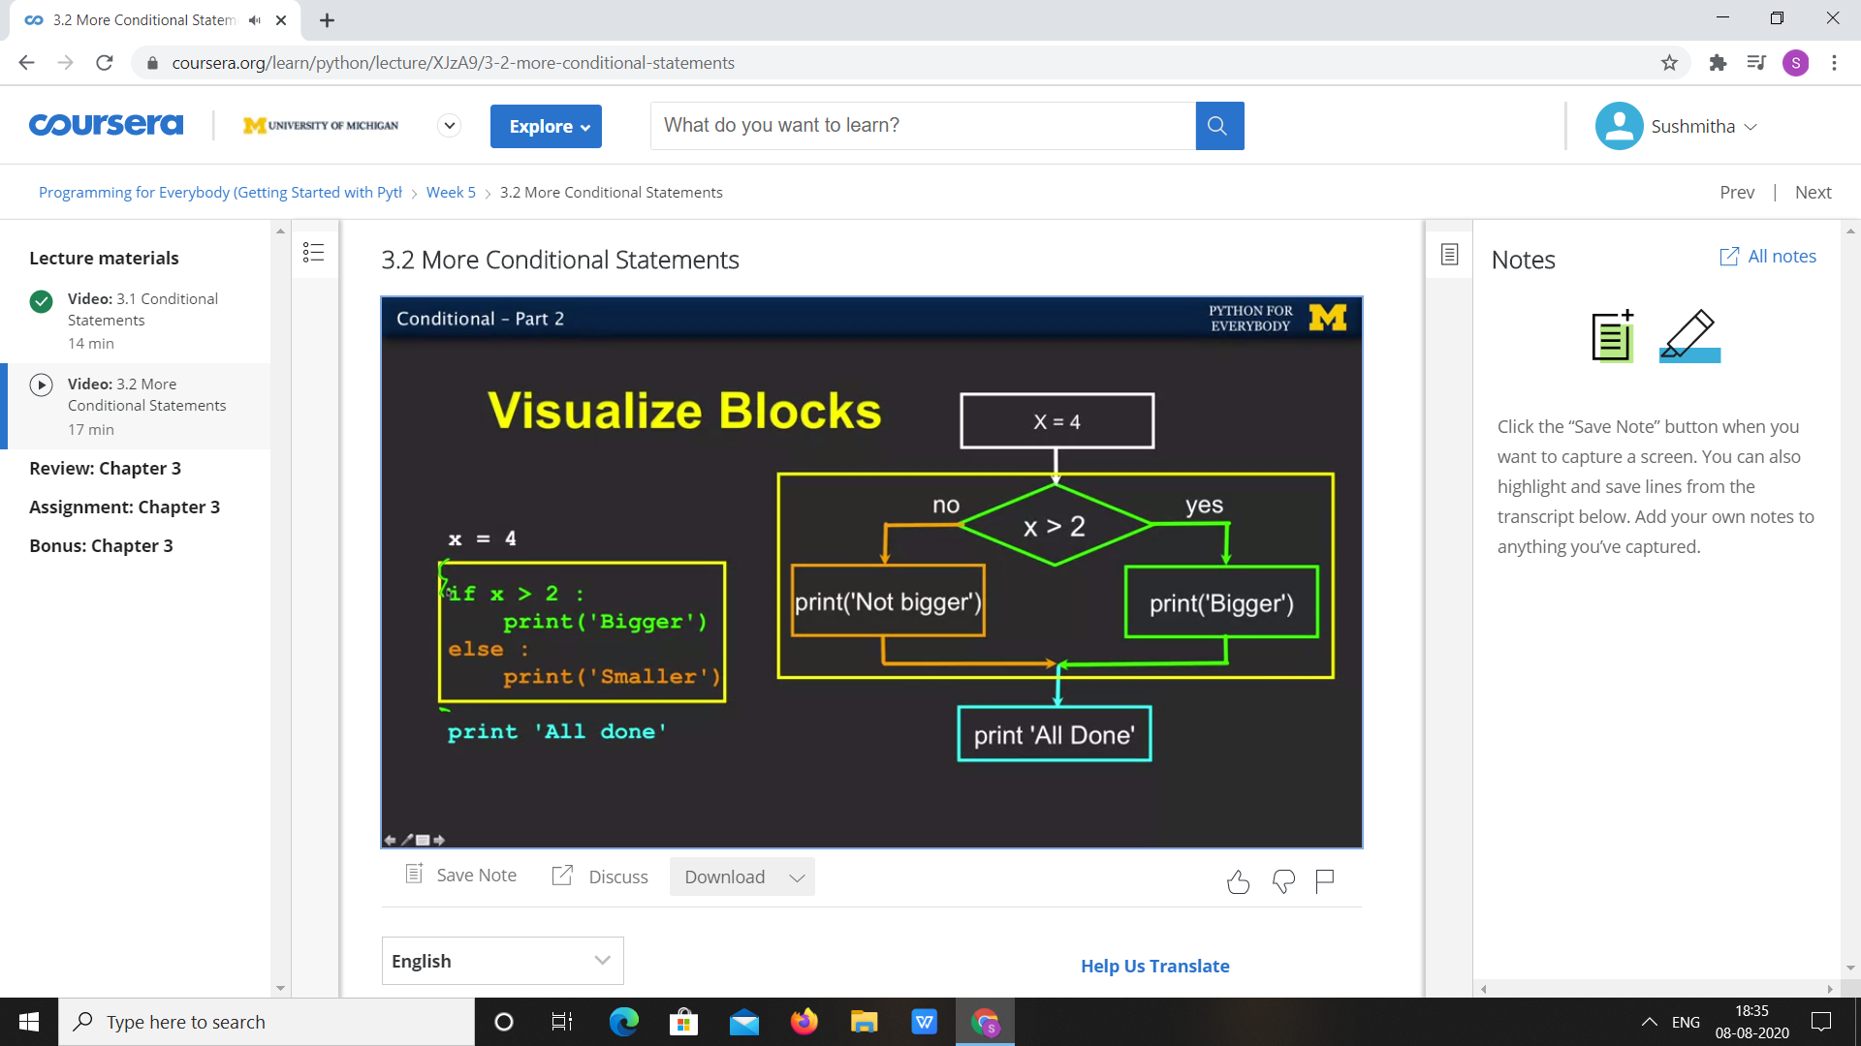

|  |  |
| --- | --- |
| **Coding Challenges** | |
| **Problem Statement:** 1.**Python program to convert float decimal to Octal number.** | |
| **Status:**  Executed | |
| **Uploaded the report both in Github & Slack** | Yes |

**Snapshots of your response to challenge.**

1. ****Python program to convert float decimal to Octal number.****

**def float_octal(number, places = 3):**

**whole, dec = str(number).split(".")**

**whole = int(whole)**

**dec = int (dec)**

**res = oct(whole).lstrip("0o") + "."**

**for x in range(places):**

**whole, dec = str((decimal_converter(dec)) * 8).split(".")**

**dec = int(dec)**

**res += whole**

**return res**

**def decimal_converter(num):**

**while num > 1:**

**num /= 10**

**return num**

**n = input("Enter your floating point value : \n")**

**p = int(input("Enter the number of decimal places of the result : \n"))**

**print(float_octal(n, places = p))**

****OUTPUT****

