1. **Write a Java Program to remove all white spaces from a string without using replace()**

**package** DuplicateCharacters;

**public class** DuplicateCharacters {

**public static void** main(String[] args){

String str = "Hello how are you";

str = str.replaceAll(" ", ""); System.***out***.println(str);

}

}

**OUTPUT**

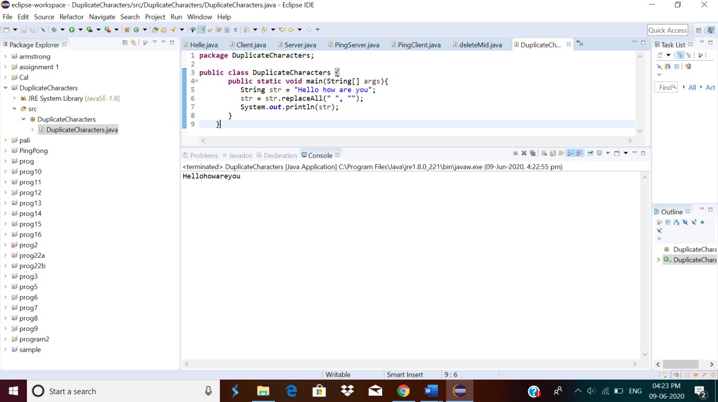

# **2.Python Program to count even and odd numbers.**

n = int(input("Enter The Number Of Elements: "))

c = 0

print("Enter The Elements: ")

for i in range(n):

if int(input()) % 2 == 0:

c += 1

print("Number Of Even Numbers:", c, "\nNumber Of Odd Numbers:", n-c)

**OUTPUT**

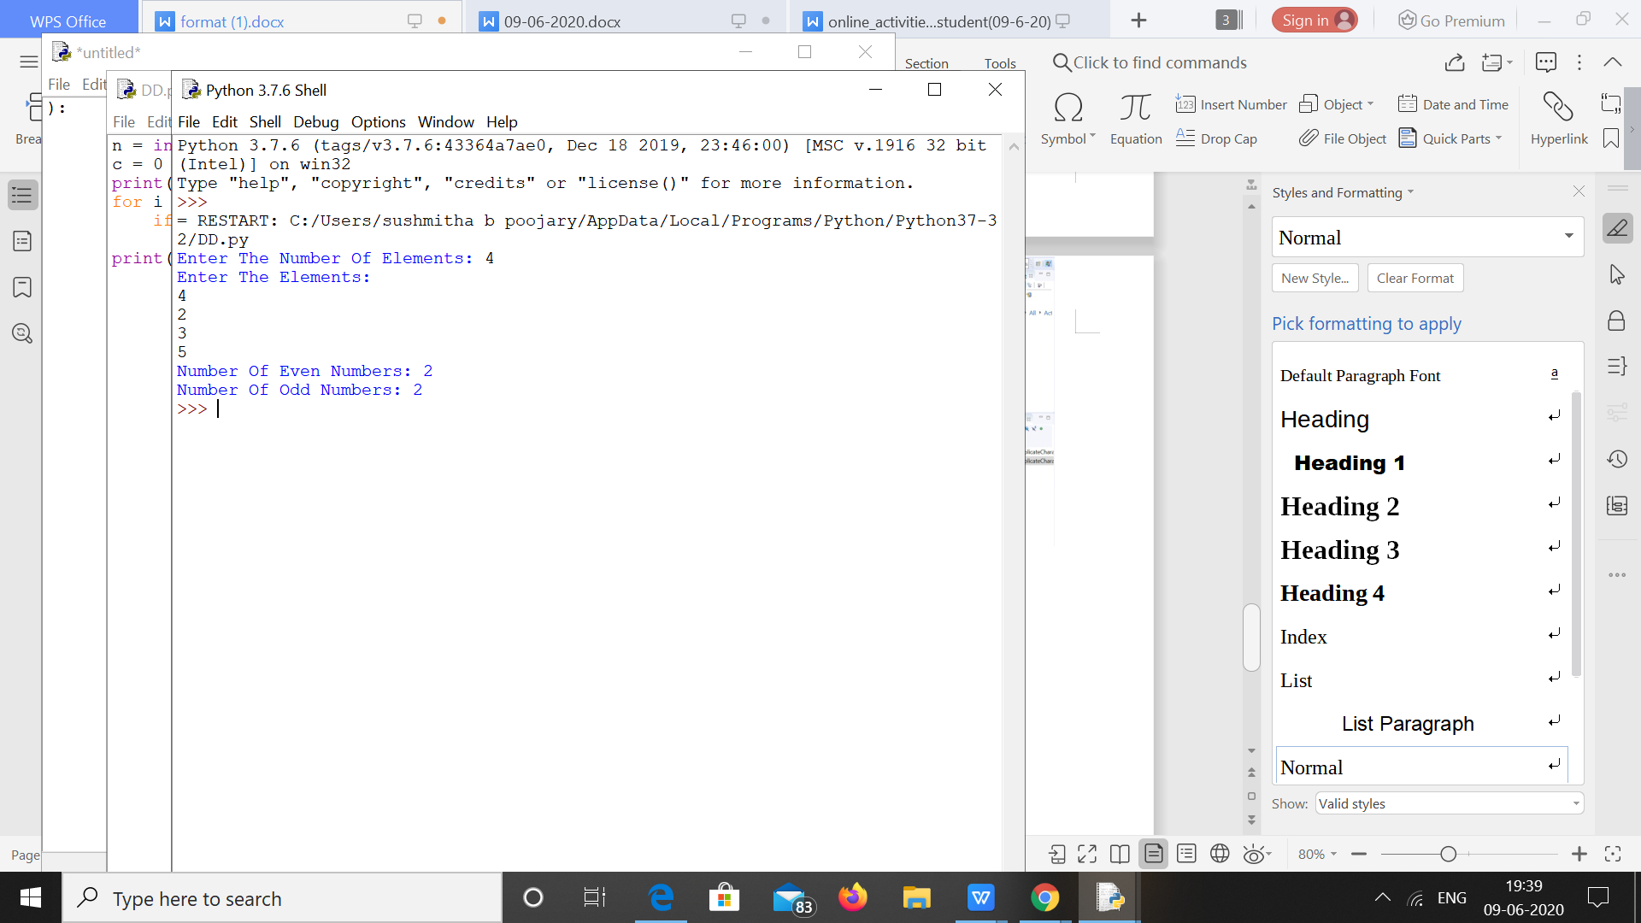

**3.Python Program to Check Whether a String is a Palindrome or not Using Recursion**

def pal(s):

if len(s) <= 1:

return True

else:

if s[0] == s[-1]:

return pal(s[1:-1])

else:

return False

a = input("Enter String:").lower()

if pal(a):

print("String Is A Palindrome")

else:

print("String Isn't A Palindrome")

**OUTPUT**

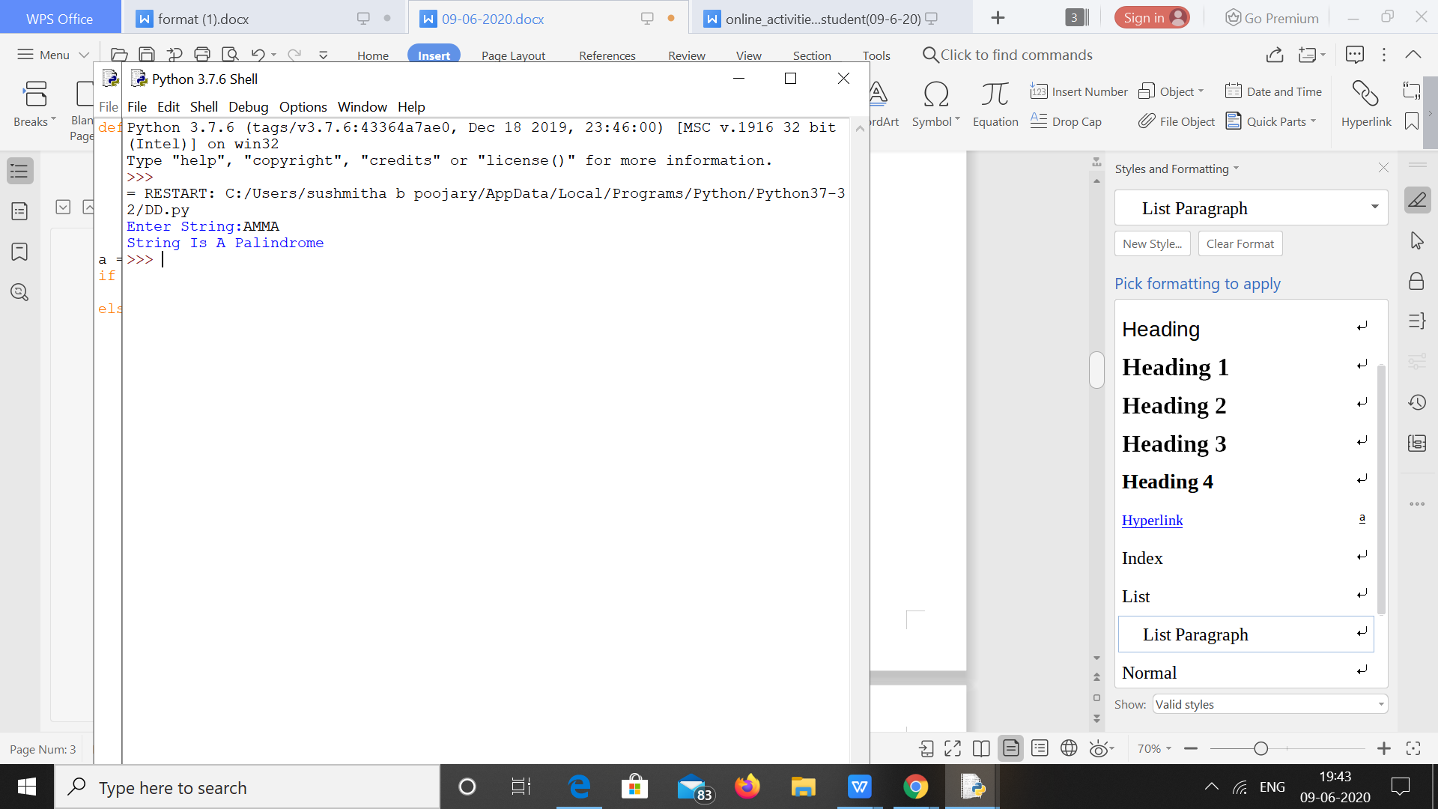

****4.Python Program to Reverse a String Using Recursion.****

def rev(s):

if len(s) == 0:

return s

else:

return rev(s[1:]) + s[0]

a = input("Enter String: ").lower()

print("The Reversed String: ", rev(a))

**OUTPUT**

