**DAILY REPORT**

**Student Name :SUSHMITHA.B.POOJARY**

**Class and Sec : VI B**

**USN :4AL17CS103**

**DATE:09-06-2020**

|  |  |  |  |  |
| --- | --- | --- | --- | --- |
| **Online Test Details** | | | | |
| **Subject** | **CNSC**  **CGV** | | | |
| **Semester** | **VI -B** | | **Duration** | **40 Minutes**  **30 Minutes** |
| **% of marks CNSC=60**  **CGV=30** | | **CNSC=26**  **CGV=23** | | |

**Snapshot of the test result**

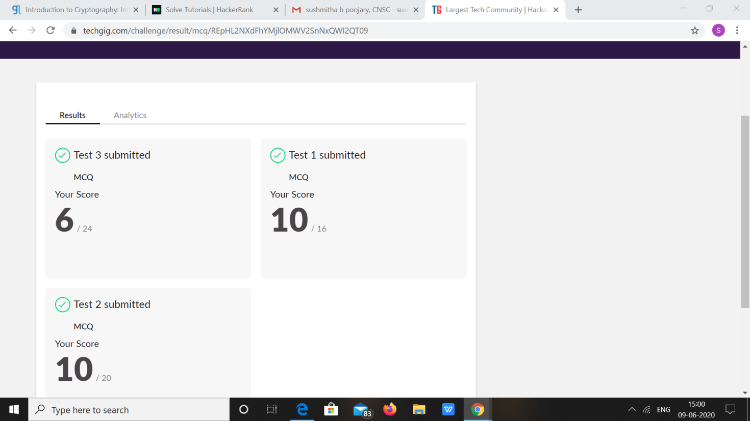

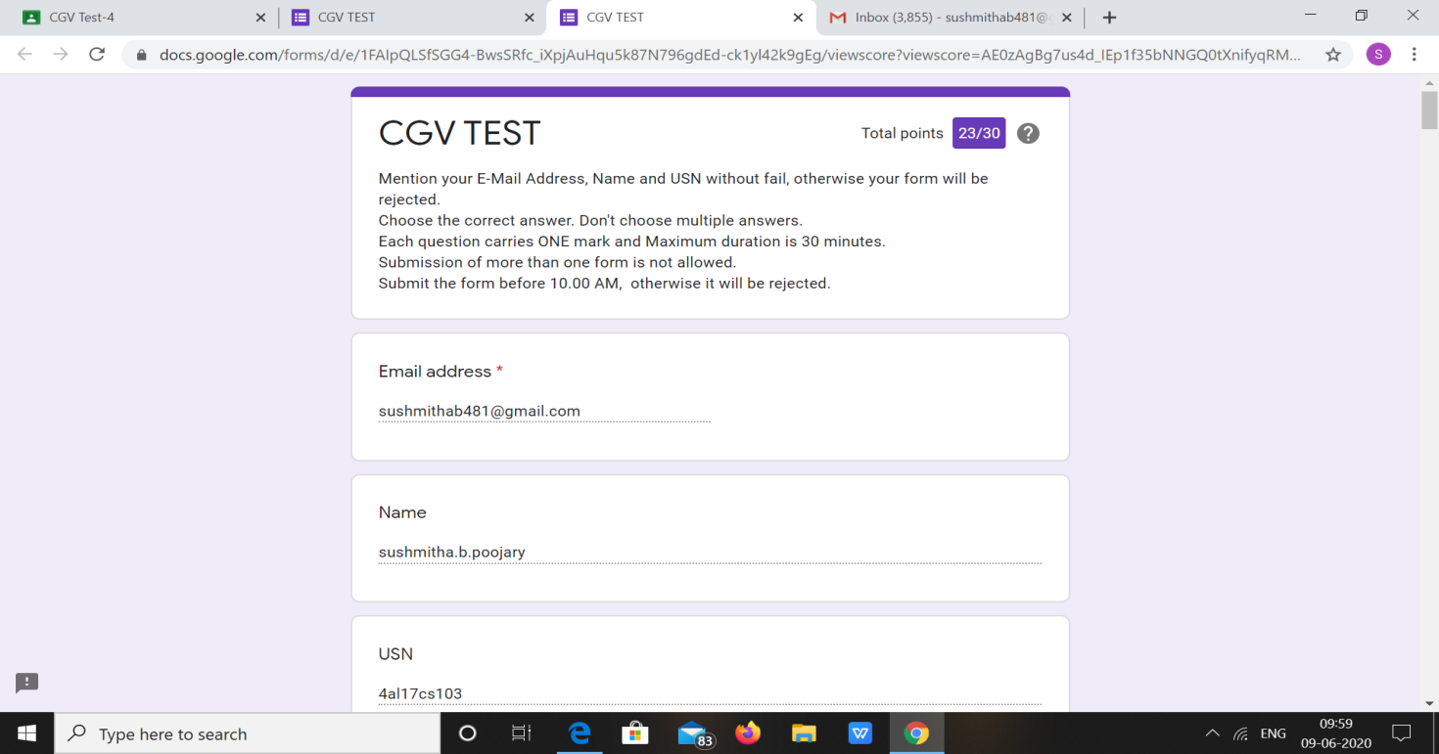

|  |  |  |  |
| --- | --- | --- | --- |
| **Certification Course Details** | | | |
| **Course** | **Introduction to Cyber Security** | | |
| **Certificate Provider** | **Great Learning** | **Duration** | **5.5hours** |

**Snapshots of the daily class acitivities**

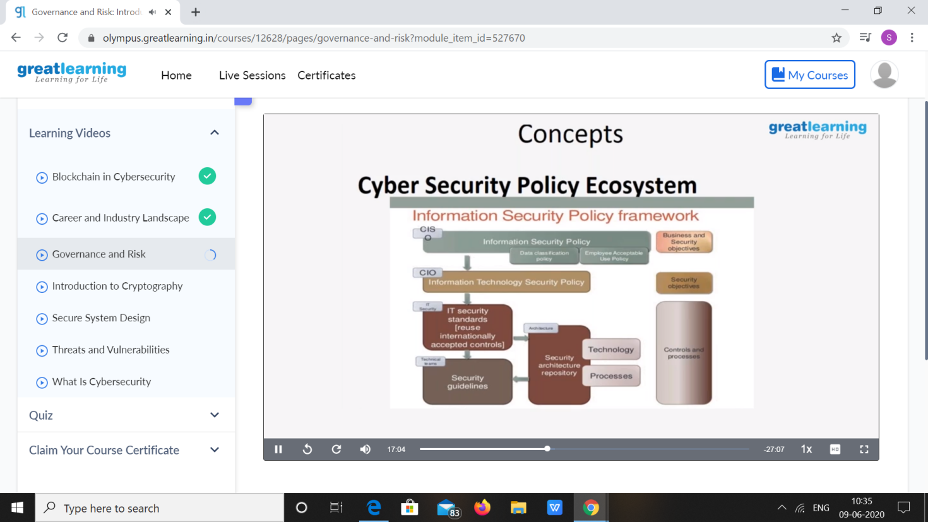

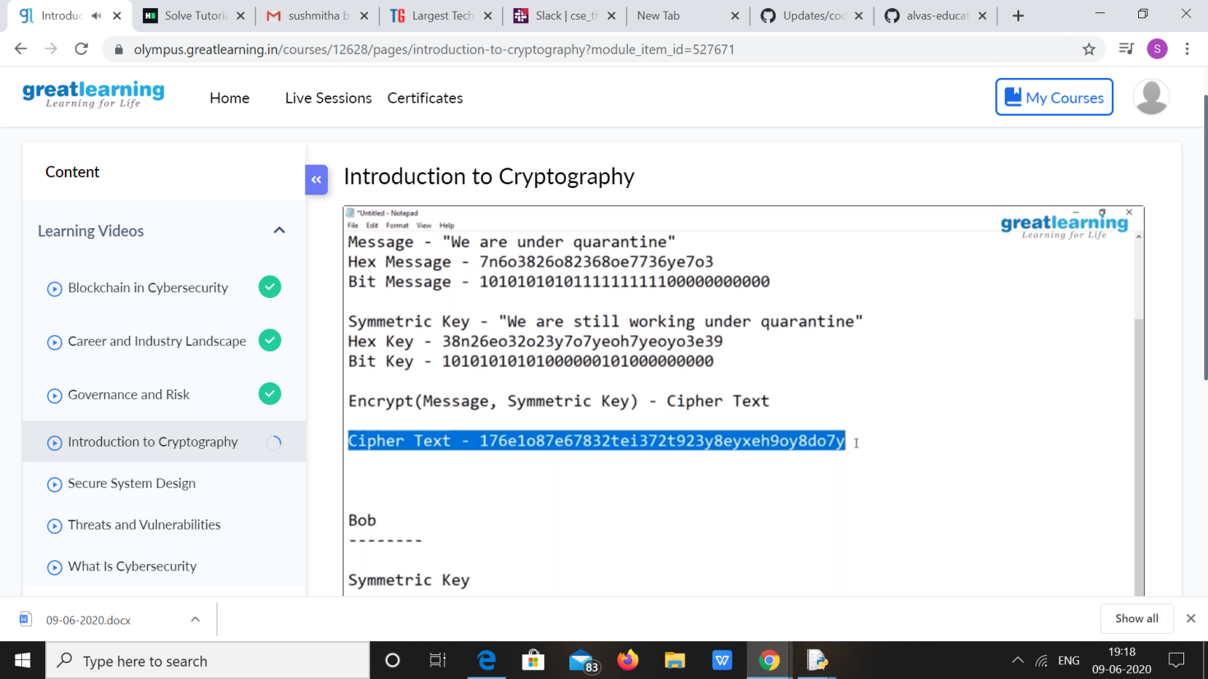

|  |  |
| --- | --- |
| **Coding Challenges** | |
| 1. **Problem Statement:** Write a Java Program to remove all white spaces from a string without using replace() 2. Python Program to count even and odd numbers. 3. **Python Program to Check Whether a String is a Palindrome or not Using Recursion.** 4. **Python Program to Reverse a String Using Recursion.** | |
| **Status: Executed** | |
| **Uploaded the report both in Github & Slack** | **Yes** |

**Snapshots of your response to challenge.**

1. **Write a Java Program to remove all white spaces from a string without using replace()**

**package** DuplicateCharacters;

**public class** DuplicateCharacters {

**public static void** main(String[] args){ String str = "Hello how are you";

str = str.replaceAll(" ", ""); System.***out***.println(str);

}

}

**OUTPUT**

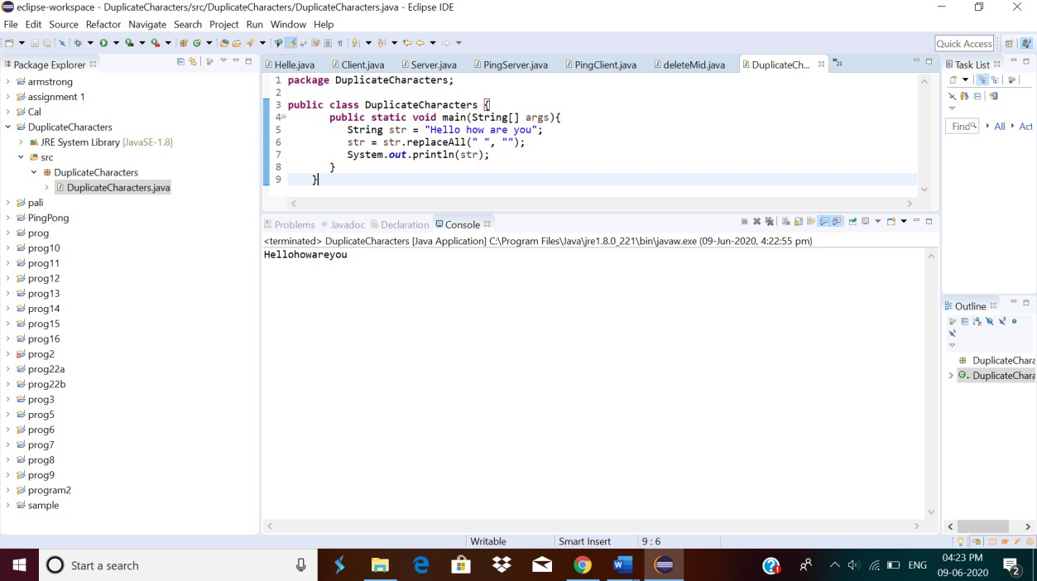

# **2.Python Program to count even and odd numbers.**

n = int(input("Enter The Number Of Elements: "))

c = 0

print("Enter The Elements: ")

for i in range(n):

if int(input()) % 2 == 0:

c += 1

print("Number Of Even Numbers:", c, "\nNumber Of Odd Numbers:", n-c)

**OUTPUT**

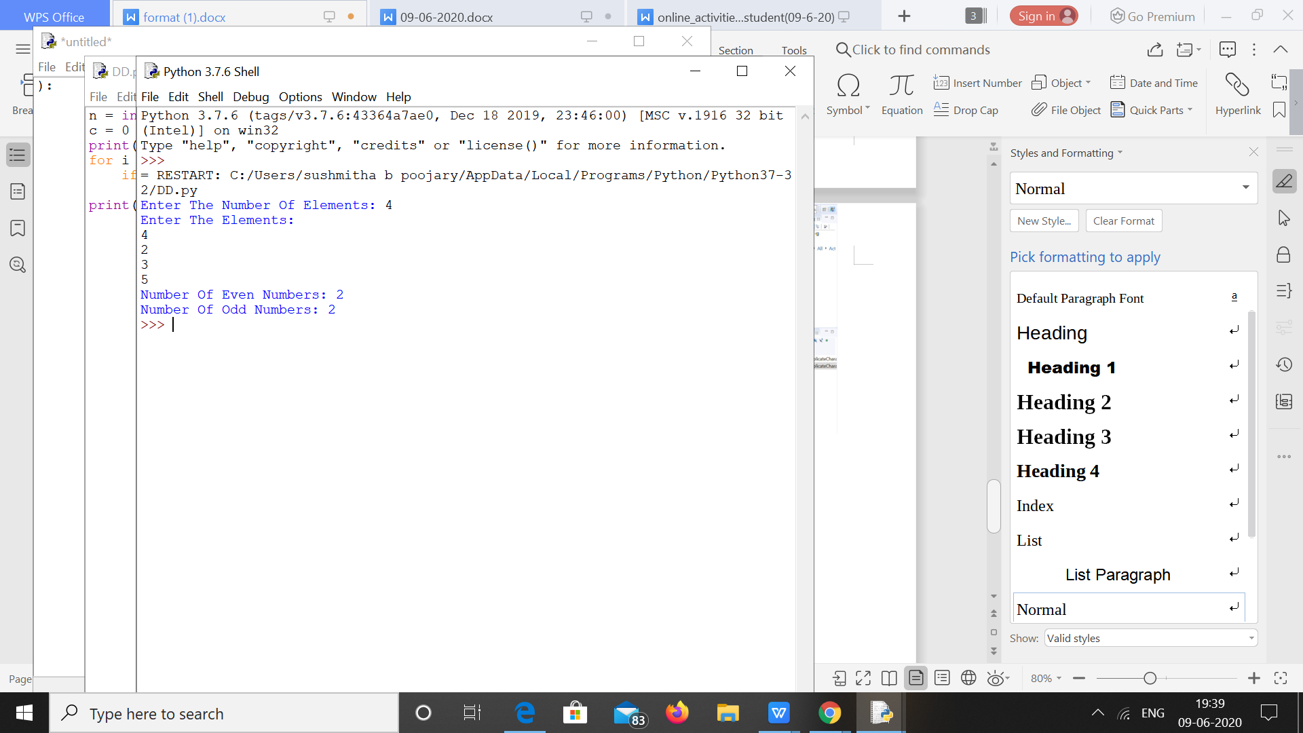

**3.Python Program to Check Whether a String is a Palindrome or not Using Recursion**

def pal(s):

if len(s) <= 1:

return True

else:

if s[0] == s[-1]:

return pal(s[1:-1])

else:

return False

a = input("Enter String:").lower()

if pal(a):

print("String Is A Palindrome")

else:

print("String Isn't A Palindrome")

**OUTPUT**

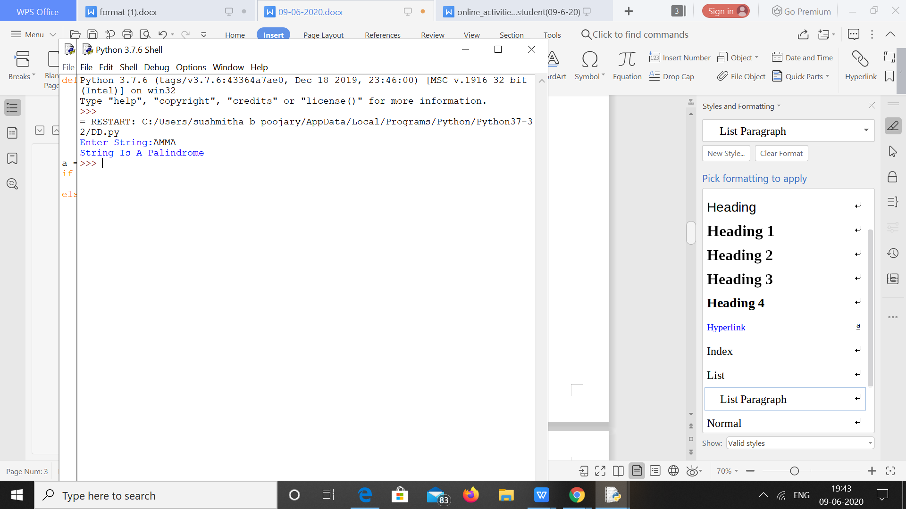

****4.Python Program to Reverse a String Using Recursion.****

def rev(s):

if len(s) == 0:

return s

else:

return rev(s[1:]) + s[0]

a = input("Enter String: ").lower()

print("The Reversed String: ", rev(a))

**OUTPUT**

