**DAILY REPORT**

**Student Name :SUSHMITHA.B.POOJARY**

**Class and Sec : VI B**

**USN :4AL17CS103**

**DATE:12-08-2020**

|  |  |  |  |  |
| --- | --- | --- | --- | --- |
| **Online Test Details** | | | | |
| **Subject** | **------** | | | |
| **Semester** | **VI -B** | | **Duration** | **----** |
| **% of marks ---** | | **-----** | | |

|  |  |  |  |
| --- | --- | --- | --- |
| **Certification Course Details** | | | |
| **Course** | **Python for Everybody** | | |
| **Certificate Provider** | **Coursera** | **Duration** | **19hours** |

**Snapshots of the daily class acitivities.**

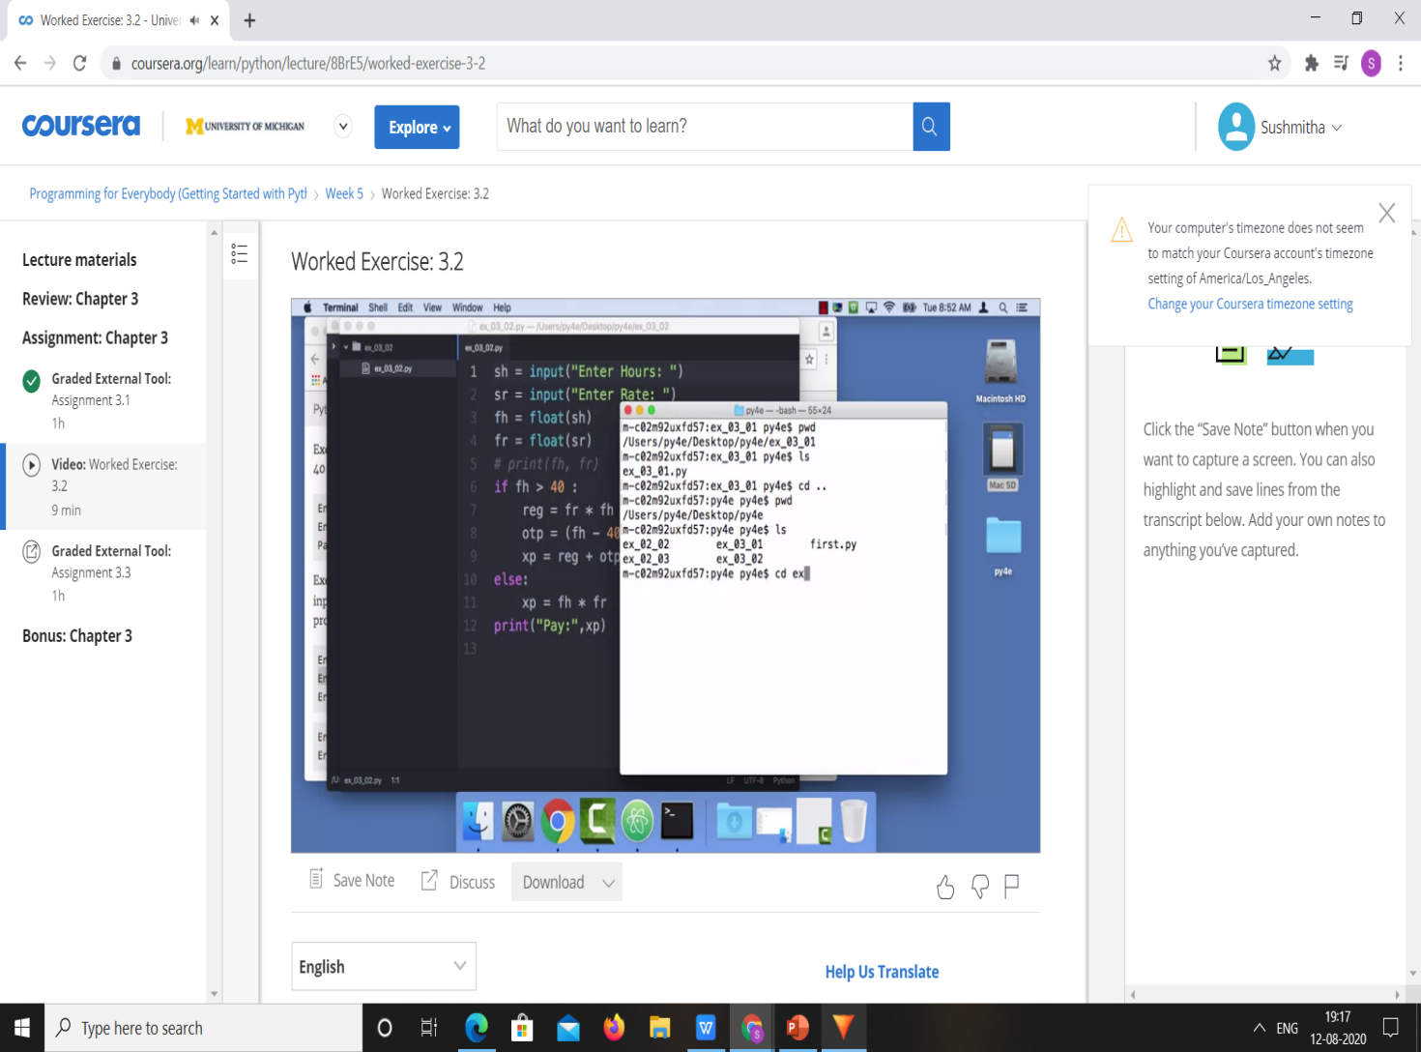

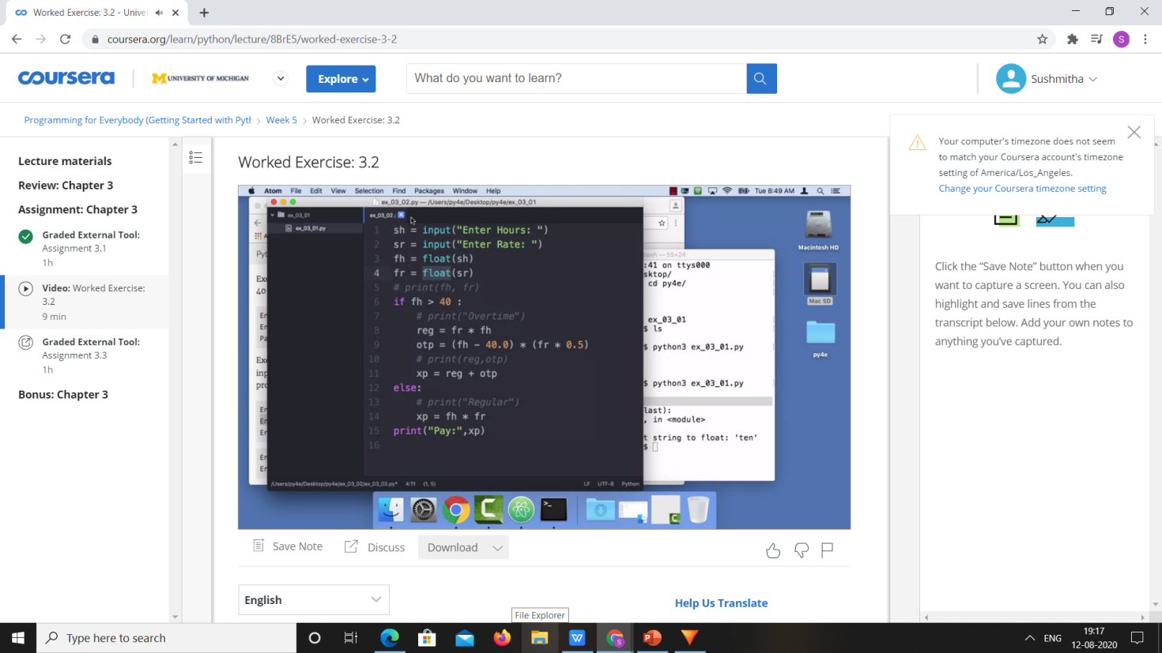

|  |  |
| --- | --- |
| **Coding Challenges** | |
| **Problem Statement:**  1.**Python Program for Triangular Matchstick Number.** | |
| **Status:** Executed | |
| **Uploaded the report both in Github & Slack** | Yes |

**Snapshots of your response to challenge.**

1. ****Python Program for Triangular Matchstick Number.****

**def numberOfSticks(x):**

**return (3 * x * (x + 1)) / 2**

**print(int(numberOfSticks(7)))**

****OUTPUT****

