**DAILY REPORT**

**Student Name :SUSHMITHA.B.POOJARY**

**Class and Sec : VI B**

**USN :4AL17CS103**

**DATE:13-07-2020**

|  |  |  |  |  |
| --- | --- | --- | --- | --- |
| **Online Test Details** | | | | |
| **Subject** | **CNSC** | | | |
| **Semester** | **VI -B** | | **Duration** | **-----** |
| **% of marks 30** | | **-----** | | |

|  |  |  |  |
| --- | --- | --- | --- |
| **Certification Course Details** | | | |
| **Course** | **Python for Everybody** | | |
| **Certificate Provider** | **Coursera** | **Duration** | **19hours** |

**Snapshots of the daily class acitivities.**



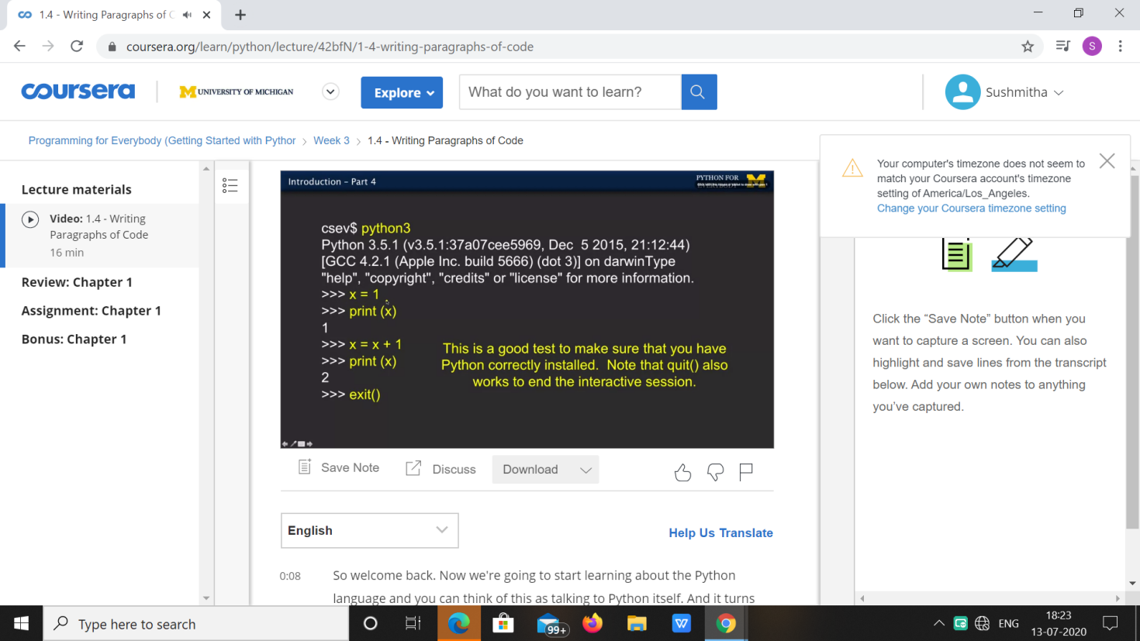

|  |  |
| --- | --- |
| **Coding Challenges** | |
| **Problem Statement: 1**.**Python Program for Coin Change.** | |
| **Status:** Executed | |
| **Uploaded the report both in Github & Slack** | Yes |

**Snapshots of your response to challenge.**

1. ****Python Program for Coin Change.****

**def count(S, m, n):**

**table = [[0 for x in range(m)] for x in range(n+1)]**

**for i in range(m):**

**table[0][i] = 1**

**for i in range(1, n+1):**

**for j in range(m):**

**x = table[i - S[j]][j] if i-S[j] >= 0 else 0**

**y = table[i][j-1] if j >= 1 else 0**

**table[i][j] = x + y**

**return table[n][m-1]**

**arr = [1, 2, 3]**

**m = len(arr)**

**n = 4**

**print(count(arr, m, n))**

**OUTPUT**

