**DAILY REPORT**

**Student Name :SUSHMITHA.B.POOJARY**

**Class and Sec : VI B**

**USN :4AL17CS103**

**DATE:13-08-2020**

|  |  |  |  |  |
| --- | --- | --- | --- | --- |
| **Online Test Details** | | | | |
| **Subject** | **------** | | | |
| **Semester** | **VI -B** | | **Duration** | **----** |
| **% of marks ---** | | **-----** | | |

|  |  |  |  |
| --- | --- | --- | --- |
| **Certification Course Details** | | | |
| **Course** | **Python for Everybody** | | |
| **Certificate Provider** | **Coursera** | **Duration** | **19hours** |

**Snapshots of the daily class acitivities.**

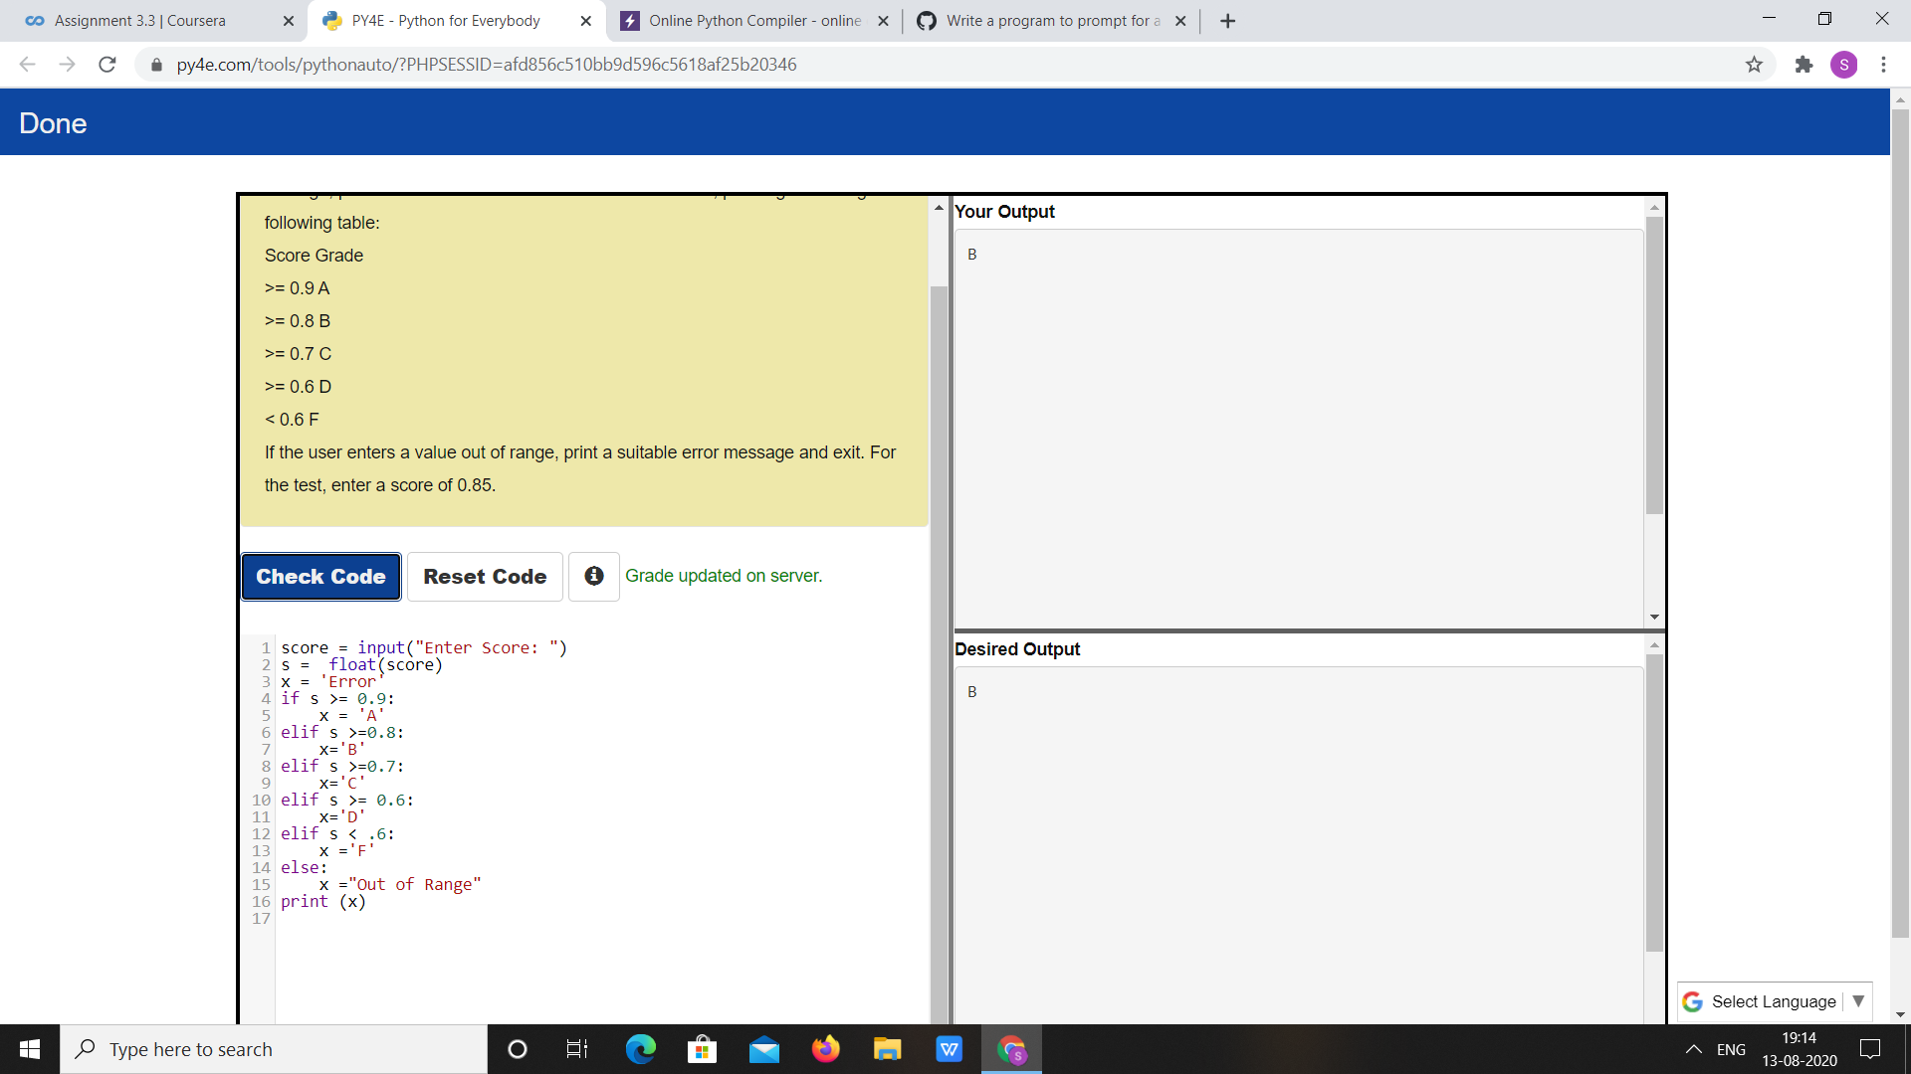

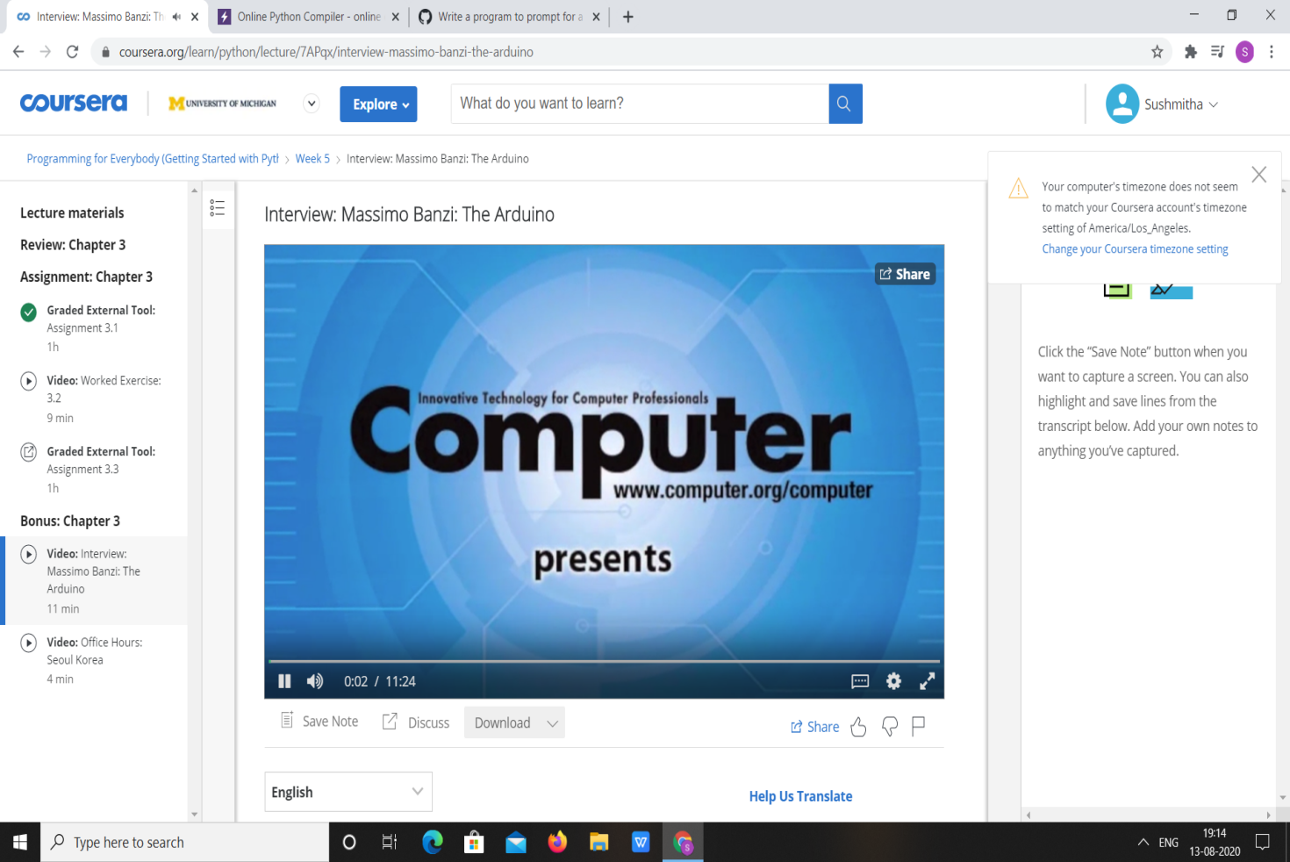

|  |  |
| --- | --- |
| **Coding Challenges** | |
| **Problem Statement:** 1.**Python Program for Legendre\’s Conjecture.** | |
| **Status:**  Executed | |
| **Uploaded the report both in Github & Slack** | Yes |

**Snapshots of your response to challenge.**

**1.**Python Program for Legendre\’s Conjecture.****

import math

def isprime( n ):

i = 2

for i in range (2, int((math.sqrt(n)+1))):

if n%i == 0:

return False

return True

def LegendreConjecture( n ):

print ( "Primes in the range ", n*n

, " and ", (n+1)*(n+1)

, " are:" )

for i in range (n*n, (((n+1)*(n+1))+1)):

if(isprime(i)):

print (i)

n = 50

LegendreConjecture(n)

**OUTPUT**

