1. **write a java program to remove specific characters in the String**  
   If the original string is "Learning never stops" and the user inputs string to remove "estp" then the it should print "Larning nvr o" as output .

import java.util.Scanner;  
public class Main{  
    public static void main(String[] args)  
    {  
        String originalstring="Learning never stops";  
        System.out.println("Original string is :  "+ originalstring);  
        System.out.println("");  
        System.out.println("Please enter unwanted characters as String");  
        System.out.println("");  
        Scanner in =new Scanner(System.in);  
        String removecharacterstring=in.nextLine();  
        String output=removeSpecificChars(originalstring, removecharacterstring);  
        System.out.println("");  
        System.out.print("Output is :  " );  
        System.out.println(output);  
    }  
     
    public static String removeSpecificChars(String originalstring ,String removecharacterstring)  
    {  
        char[] orgchararray=originalstring.toCharArray();  
        char[] removechararray=removecharacterstring.toCharArray();  
        int start,end=0;  
        boolean[]  tempBoolean = new boolean[128];  
        for(start=0;start < removechararray.length;++start)  
        {  
            tempBoolean[removechararray[start]]=true;  
        }  
        for(start=0;start < orgchararray.length;++start)  
        {  
            if(!tempBoolean[orgchararray[start]])  
            {  
                orgchararray[end++]=orgchararray[start];  
            }  
        }  
        return new String(orgchararray,0,end);  
    }  
}

**output:**

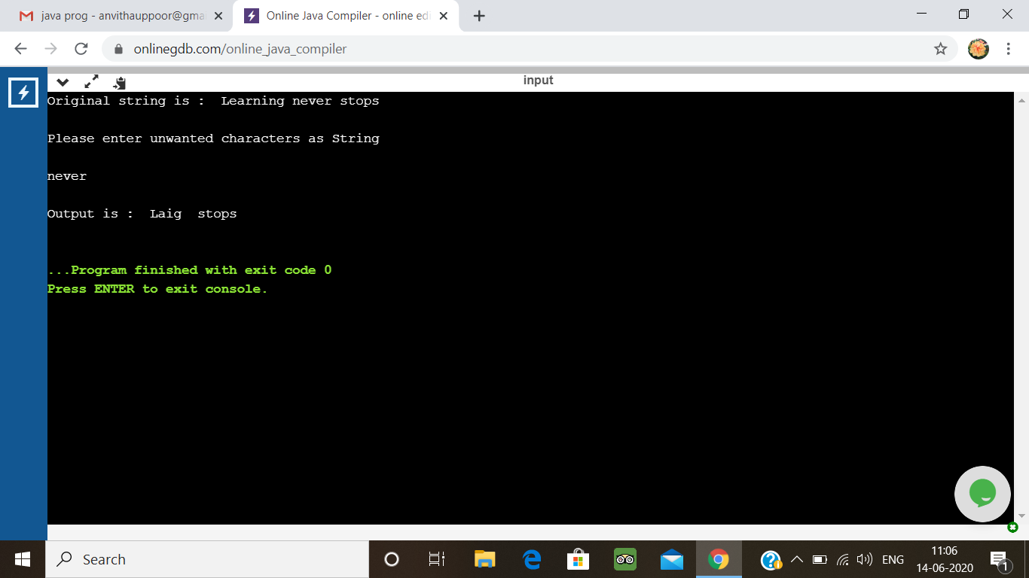

**2. Write a C Program to implement the Binary**

Have the function BinaryReversal(str) take the str parameter being passed, which will be a positive integer, take its binary representation, reverse that string of bits, and then finally return the new reversed string in decimal form. For example: if str is 47 then the binary version of this integer is 101111 but we pad it to be 00101111 (Total number of bits must be multiples of 4). Your program should reverse this binary string which then becomes: 11110100 and then finally return the decimal version of this string, which is 244.  
Examples

Input: 213  
Output: 171

Input: 4567  
Output: 60296

#include <stdio.h>

int main ()

{

int n = 0, num = 0, count = 0, rev_bits = 0;

printf ("Enter the number: ");

scanf ("%d", &n);

while (n > 0)

{

rev_bits = rev_bits << 1;

if (n & 1 == 1)

{

rev_bits = rev_bits ^ 1;

}

n = n >> 1;

}

printf ("\nThe reversed resultant = %d\n", rev_bits);

return 0;

}

**Output:**

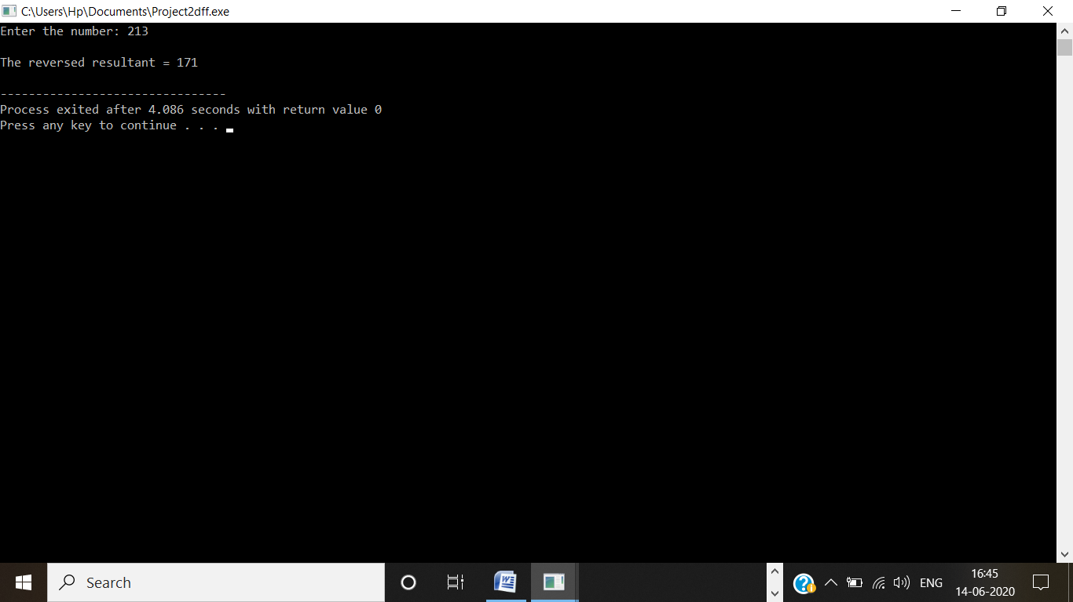

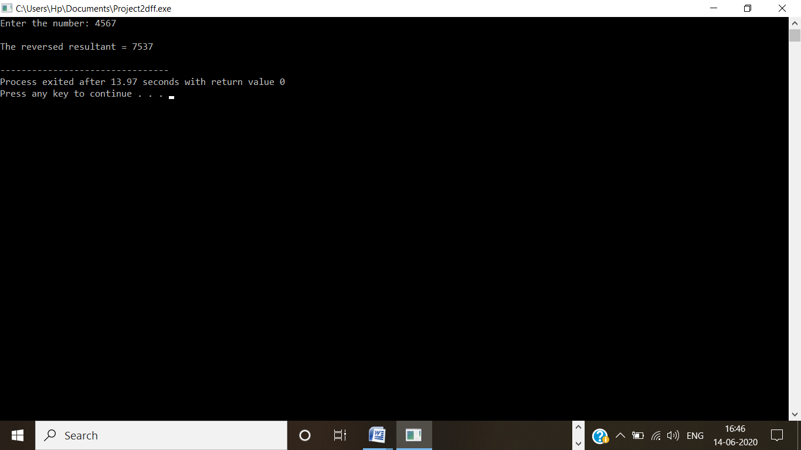

**3.** **Python Program to Take in a String and Replace Every Blank Space with Hyphen.**

s = input("Enter The String: ")

print(s.replace(" ", "-"))

**Output:**

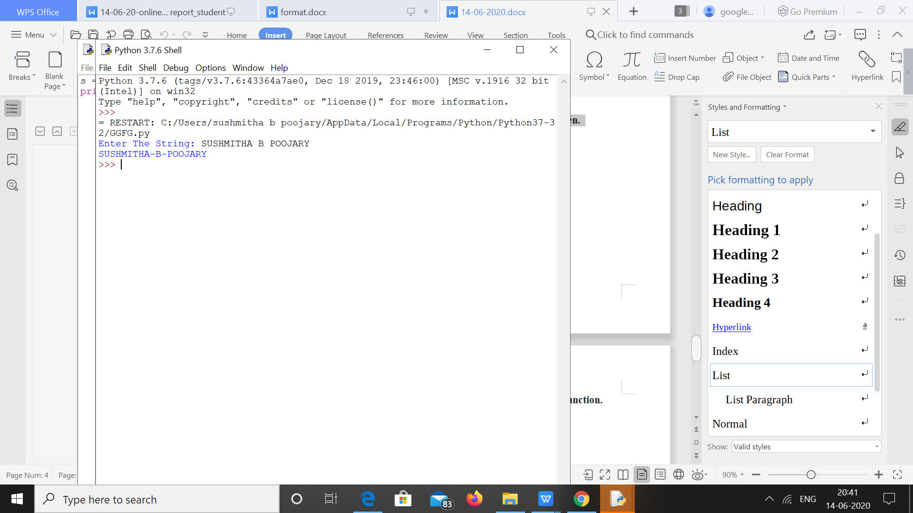

**4.** **Python Program to Calculate the Length of a String Without Using a Library Function.**

c = 0

for i in input("Enter The String: "):

c += 1

print(f'The Length Of String Is: {c}')

**Output:**

