**DAILY REPORT**

**Student Name :SUSHMITHA.B.POOJARY**

**Class and Sec : VI B**

**USN :4AL17CS103**

**DATE:14-07-2020**

|  |  |  |  |  |
| --- | --- | --- | --- | --- |
| **Online Test Details** | | | | |
| **Subject** | **OS** | | | |
| **Semester** | **VI -B** | | **Duration** | **-----** |
| **% of marks 30** | | **-----** | | |

|  |  |  |  |
| --- | --- | --- | --- |
| **Certification Course Details** | | | |
| **Course** | **Python for Everybody** | | |
| **Certificate Provider** | **Coursera** | **Duration** | **19hours** |

**Snapshots of the daily class acitivities.**

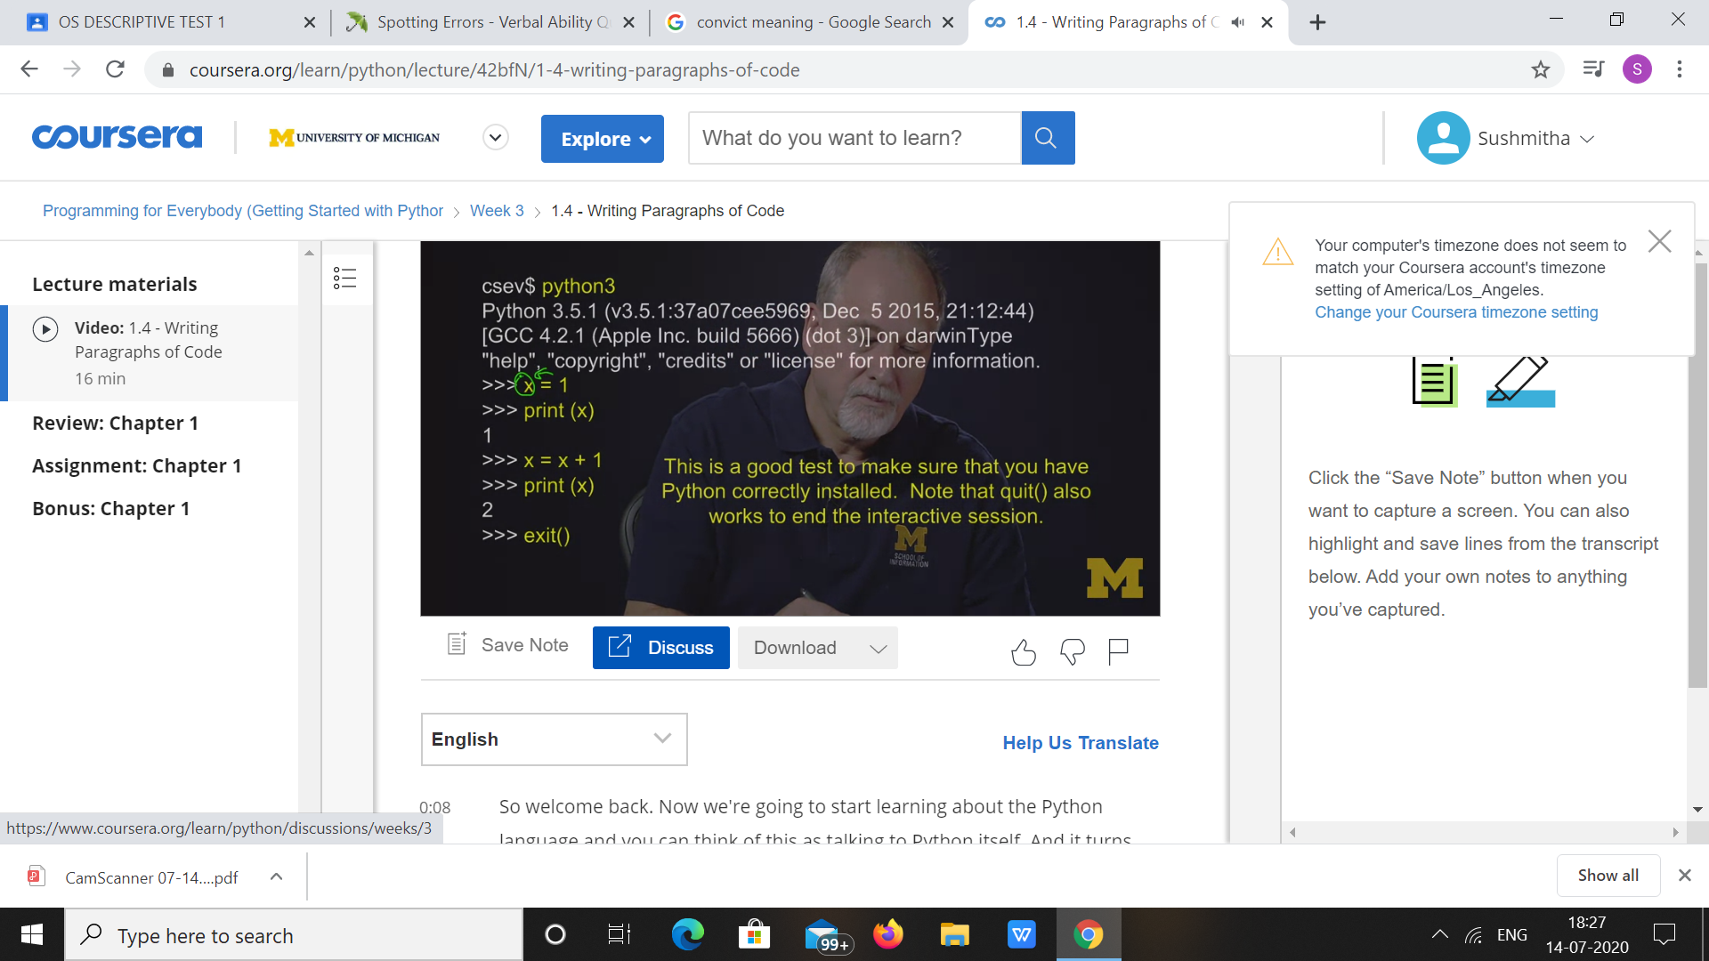

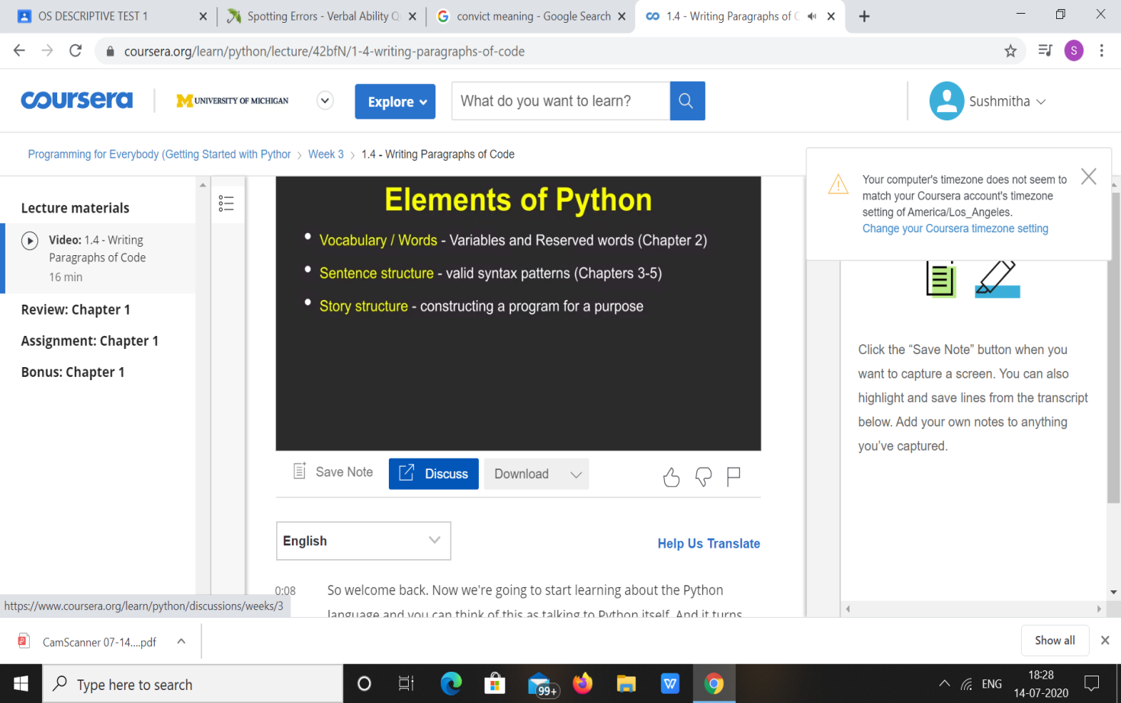

|  |  |
| --- | --- |
| **Coding Challenges** | |
| **Problem Statement: 1. Python Program for Tower of Hanoi.** | |
| **Status:** Executed | |
| **Uploaded the report both in Github & Slack** | Yes |

**Snapshots of your response to challenge.**

1. ****Python Program for Tower of Hanoi.****

**def hanoi(disks, source, auxiliary, target):**

**if disks == 1:**

**print('Move disk 1 from peg {} to peg {}.'.format(source, target))**

**return**

**hanoi(disks - 1, source, target, auxiliary)**

**print('Move disk {} from peg {} to peg {}.'.format(disks, source, target))**

**hanoi(disks - 1, auxiliary, source, target)**

**disks = int(input('Enter number of disks: '))**

**hanoi(disks, 'A', 'B', 'C')**

****OUTPUT****

