**DAILY REPORT**

**Student Name :SUSHMITHA.B.POOJARY**

**Class and Sec : VI B**

**USN :4AL17CS103**

**DATE:14-08-2020**

|  |  |  |  |  |
| --- | --- | --- | --- | --- |
| **Online Test Details** | | | | |
| **Subject** | **------** | | | |
| **Semester** | **VI -B** | | **Duration** | **----** |
| **% of marks ---** | | **-----** | | |

|  |  |  |  |
| --- | --- | --- | --- |
| **Certification Course Details** | | | |
| **Course** | **Python for Everybody** | | |
| **Certificate Provider** | **Coursera** | **Duration** | **19hours** |

**Snapshots of the daily class acitivities.**

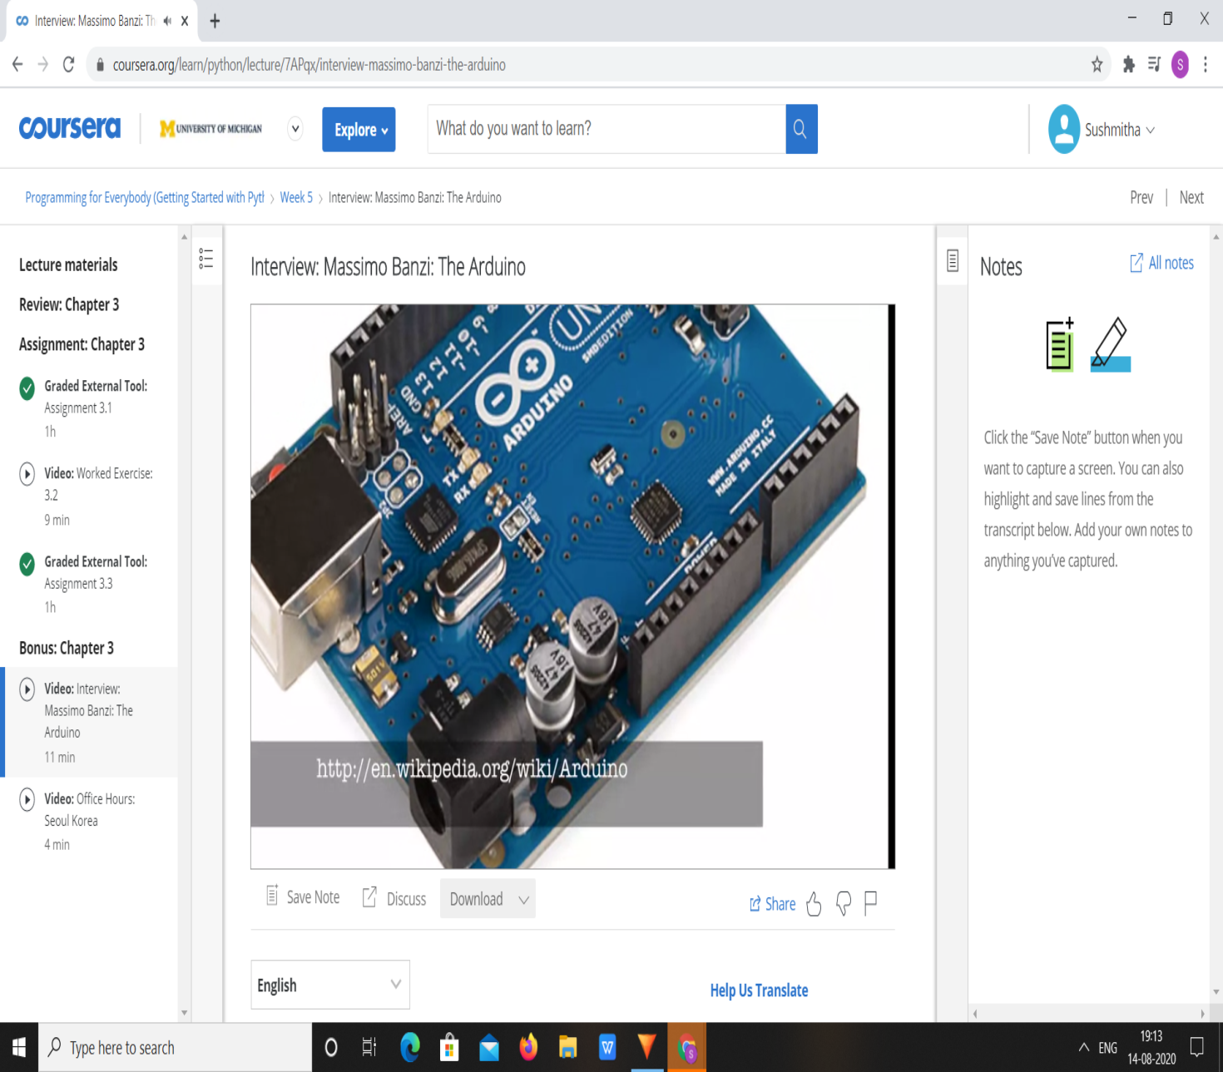

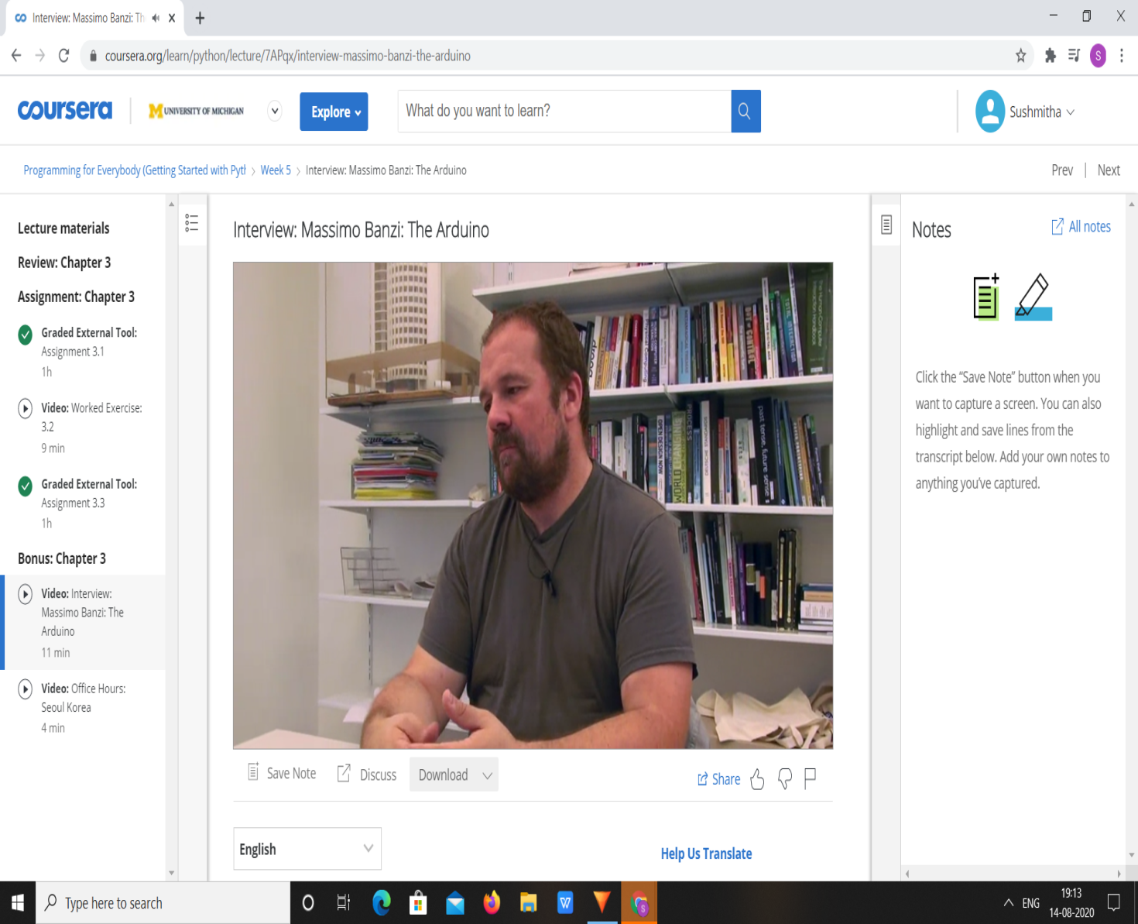

|  |  |
| --- | --- |
| **Coding Challenges** | |
| **Problem Statement:**  1.**Python program to check if a string contains all unique characters.** | |
| **Status:** Executed | |
| **Uploaded the report both in Github & Slack** | Yes |

**Snapshots of your response to challenge.**

1. ****Python program to check if a string contains all unique characters.****

def isUniqueChars(st):

if len(st) > 256:

return False

char_set = [False] * 128

for i in range(0, len(st)):

val = ord(st[i])

if char_set[val]:

return False

char_set[val] = True

return True

st = "abcd"

print(isUniqueChars(st))

**OUTPUT**

