**DAILY REPORT**

**Student Name :SUSHMITHA.B.POOJARY**

**Class and Sec : VI B**

**USN :4AL17CS103**

**DATE:15-07-2020**

|  |  |  |  |  |
| --- | --- | --- | --- | --- |
| **Online Test Details** | | | | |
| **Subject** | **OR** | | | |
| **Semester** | **VI -B** | | **Duration** | **-----** |
| **% of marks 30** | | **-----** | | |

|  |  |  |  |
| --- | --- | --- | --- |
| **Certification Course Details** | | | |
| **Course** | **Python for Everybody** | | |
| **Certificate Provider** | **Coursera** | **Duration** | **19hours** |

**Snapshots of the daily class acitivities.**

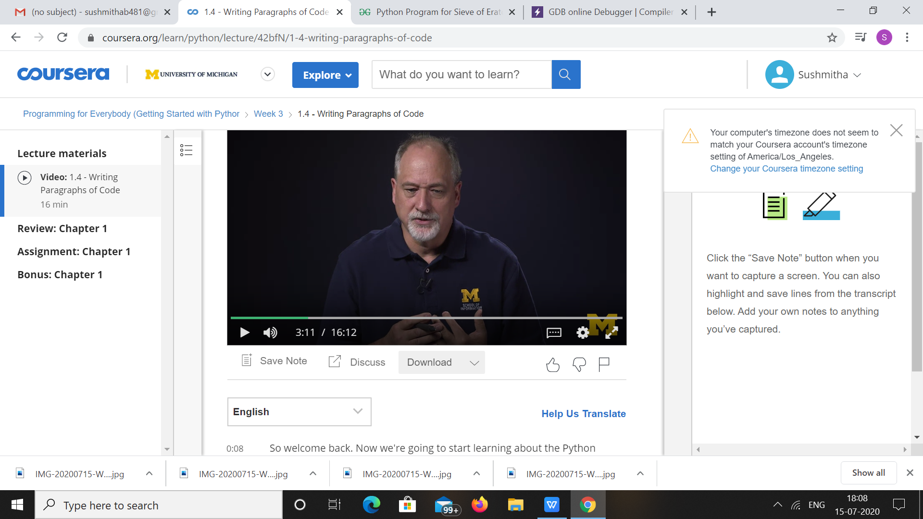

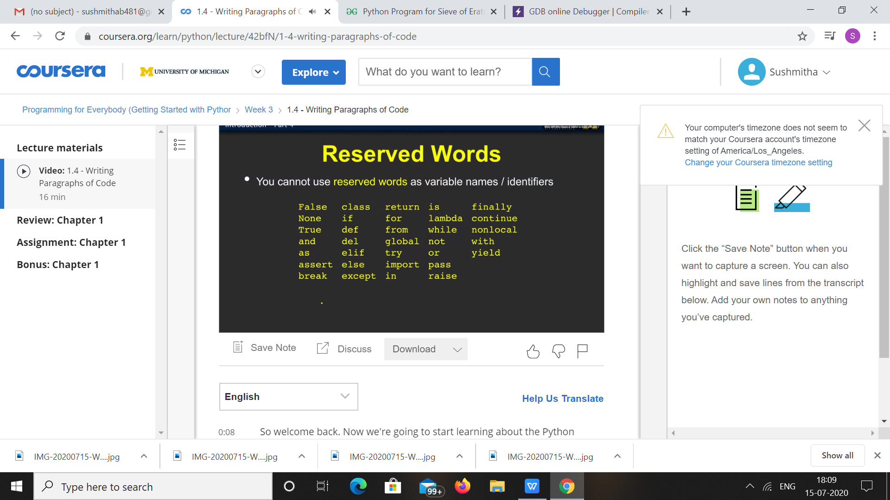

|  |  |
| --- | --- |
| **Coding Challenges** | |
| **Problem Statement: Python Program for Sieve of Eratosthenes.** | |
| **Status:** Executed | |
| **Uploaded the report both in Github & Slack** | Yes |

**Snapshots of your response to challenge.**

1. ****Python Program for Sieve of Eratosthenes.****

**def SieveOfEratosthenes(n):**

**prime = [True for i in range(n + 1)]**

**p = 2**

**while (p * p <= n):**

**if (prime[p] == True):**

**for i in range(p * 2, n + 1, p):**

**prime[i] = False**

**p += 1**

**prime[0]= False**

**prime[1]= False**

**for p in range(n + 1):**

**if prime[p]:**

**print(p,)**

**if __name__=='__main__':**

**n = 30**

**print("Following are the prime numbers smaller",)**

**print("than or equal to", n)**

**SieveOfEratosthenes(n)**

****OUTPUT****

